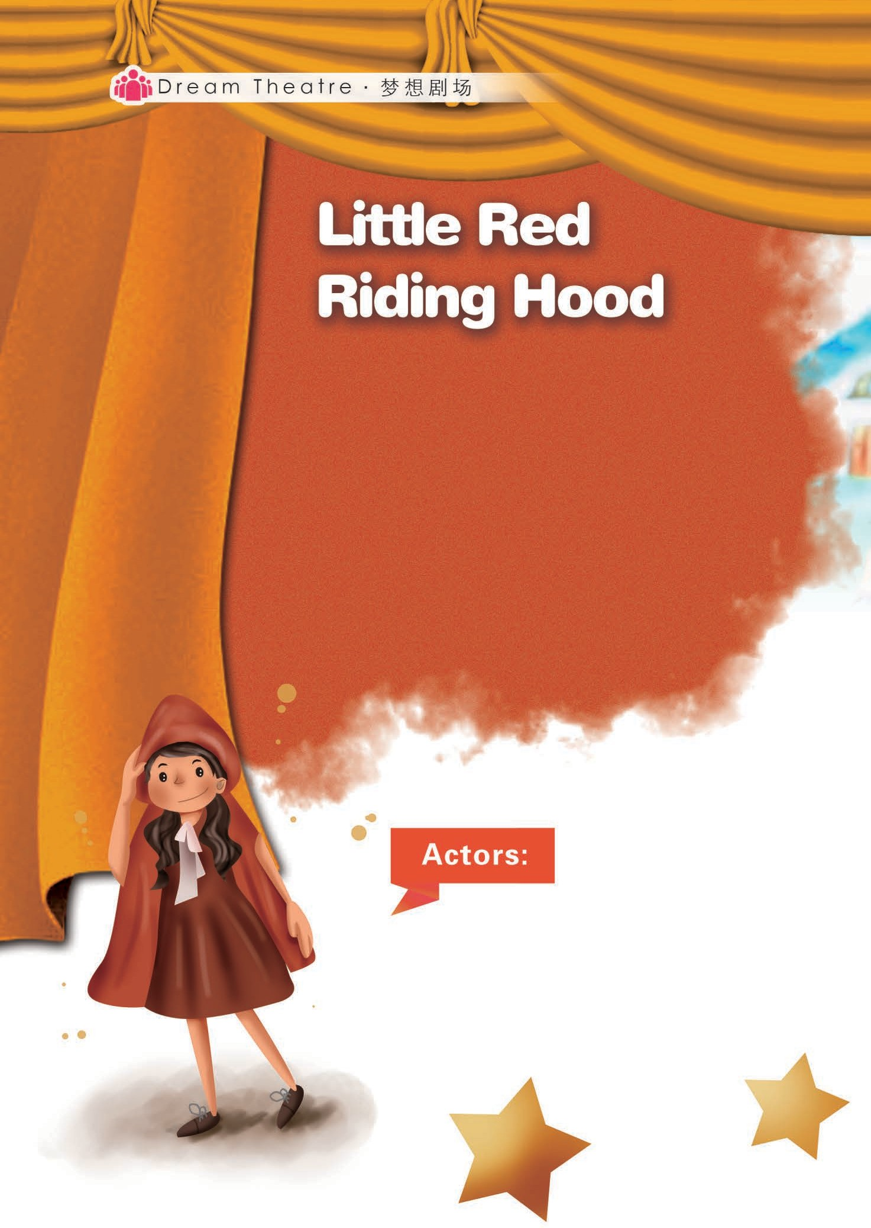

余贝贝 陈雪梅 张小露

本期剧场为大家带来情景剧《小红帽》（*Little Red Riding Hood*）。从前有个人见人爱的小姑娘，喜欢戴着外婆送给她的一顶红色天鹅绒帽，于是大家就叫她“小红帽”。有一天，妈妈让小红帽送些水果给外婆，却遇见了森林中的大灰狼。小红帽似乎早已洞悉了大灰狼的凶残，他们之间会发生怎样惊心动魄的较量呢？让我们一起欣赏江苏省兴化市垛田中心小学的同学们带来的精彩表演吧！

戚梦涵 王瑛琦 陆铭杰 高安康徐嘉奇 周 平 俞 杰 孔雅雯王 东 张增灿 韩伊莎 严诗茹

26

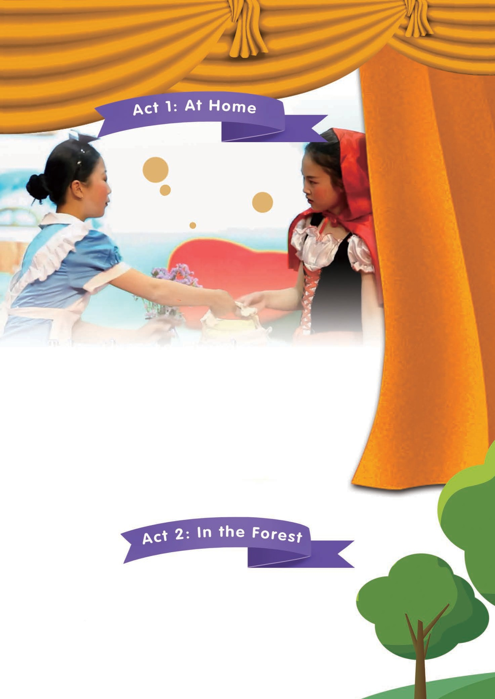

Red：Apple round, apple red, apple juicy, apple sweet. Apple, apple, I’d like to eat you. Mum, have you ever washed them?

Mum：Honey, wait a moment. Your grandma is ill. Here are some apples for your grandma. Take them to her. Be careful.

Red：Oh, I’m so sorry. Mum, don’t worry. I’ll **accompany**

（陪伴）her until she **recovers**（痊愈）.

Red：Wow! There are flowers. How beautiful! My grandma will be glad to see them.

27

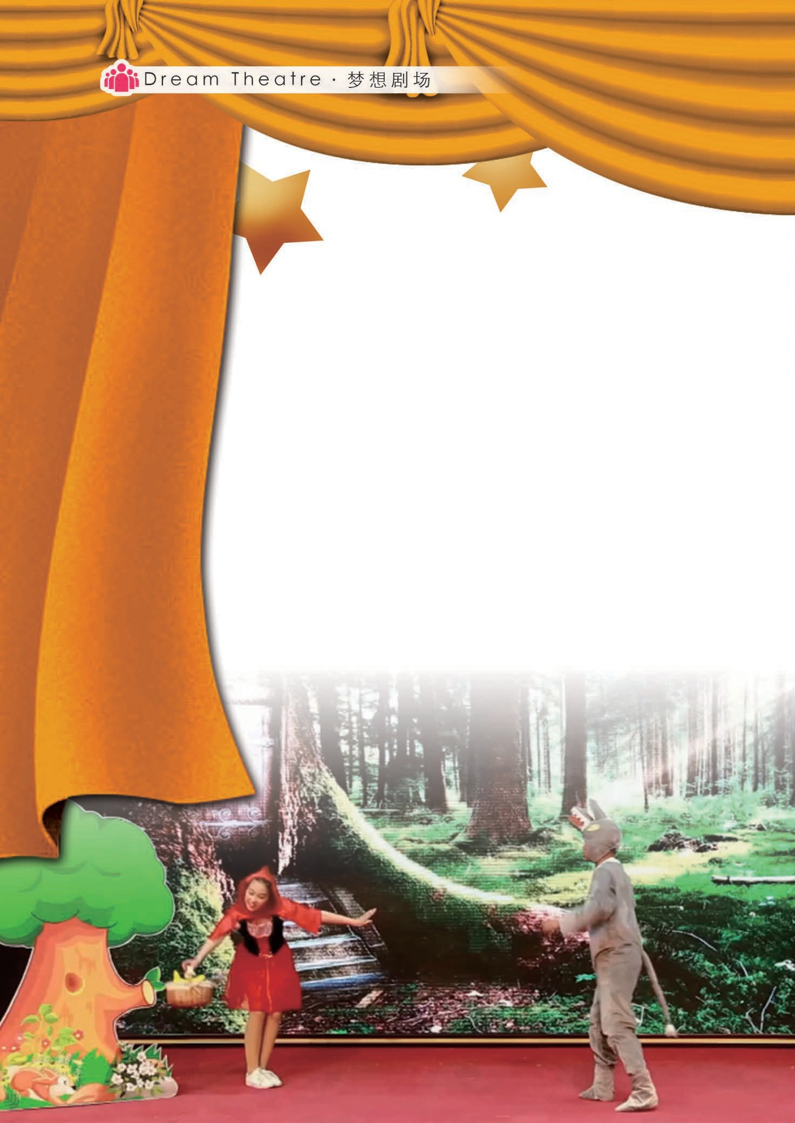

Wolf：I’m a wolf. I’m hungry. Aha! There is a little girl. Hi, where are you going?

Red：To my grandma’s home. Grandma is ill.

Wolf：（*Whispering*） I’ll eat you and your grandma.

（*Shouting*）Wait! Look, baby animals come.

Animals：Turn left, turn right, **go straigh**（**t** 直走）.

Red：Hello! My friends, what are you doing?

Animals：We are searching someone who needs help.

Red：Great! Would you come and join me? My grandma is ill. I think **there is strength in numbers**（人多力量大）.

Animals：**Our pleasure**（我们的荣幸）!

28

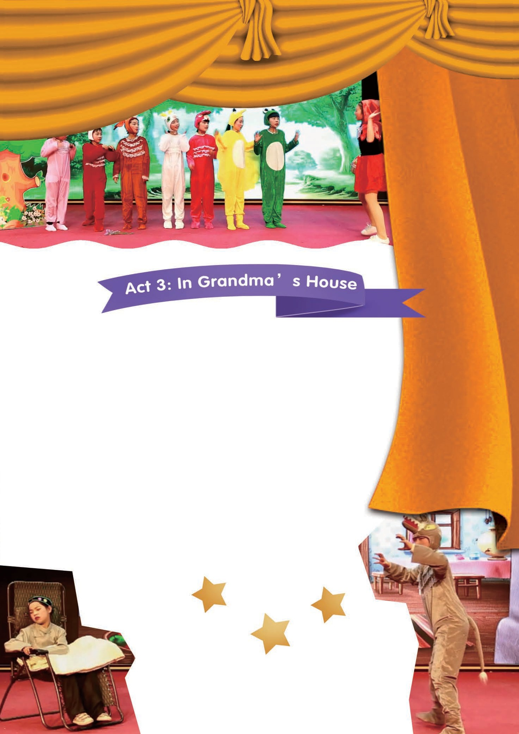

Wolf：I’m also **good-hearted**（有爱心的）. Where is your grandma’s house? I can also go with you!

*The wolf is faster than Little Red Riding Hood and other animals. He arrives first and knocks the door ...*

Grandma：Who is it?

Wolf：It’s me. I’m Little Red Riding Hood.

Grandma：Come in, my child.

Wolf：Haha, you have been **fooled**（上当了）. I will hide you in the wardrobe, and deal with the coming **rescue team**（救援队）first.

Grandma：Oh! No!

29

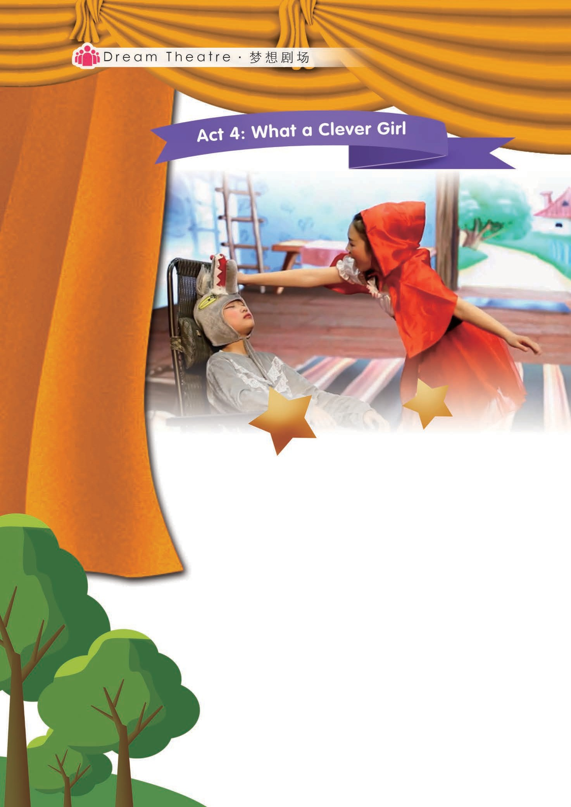

Red：Grandma, grandma.

Wolf：Who’s it?

Red：It’s me. I’m Little Red Riding Hood.

Wolf：Come in. Come in.

Red：Oh! How big ears! How big eyes! How big hands!

Wolf：Haha, you are so clever, but it’s too late! Red：Look! What a big mouth! You are the bad wolf! Wolf：I’ll eat you.

Red：No way! I have my friends behind.

30

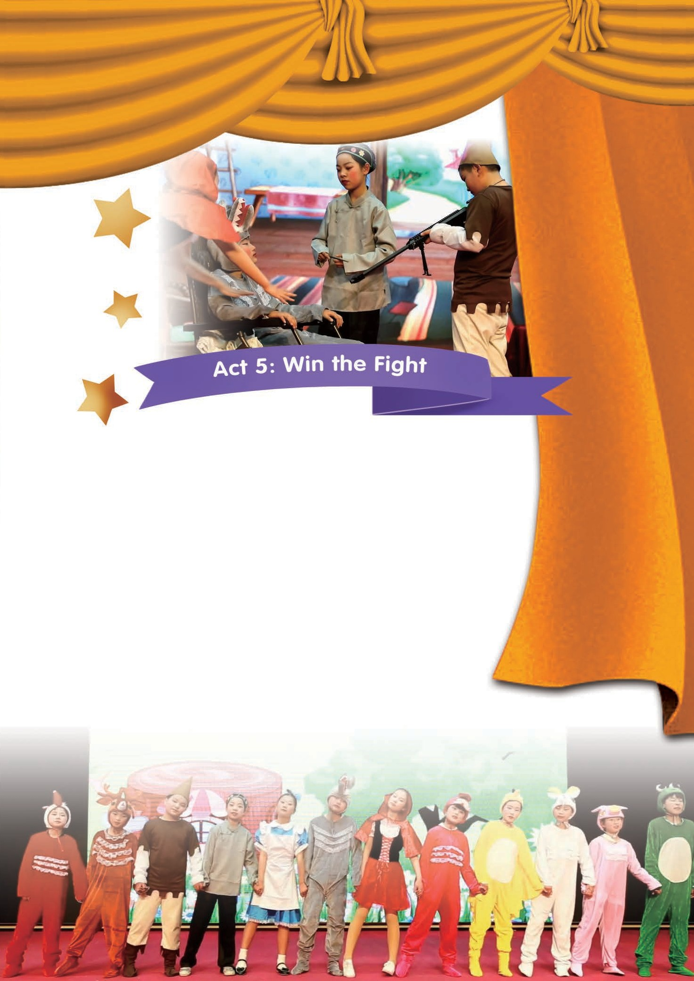

Hunter：Where is the wolf? I must be hurry! My friend is in danger.

Grandma：My child, I’m here. I’m fine.

Red：Grandma, let’s catch his arms together. He was hungry, so he ate my apple with medicine on the way home. I set a trap for him.

Hunter：The bad wolf, raise your arms!

Wolf：Don’t shot me! Please!

Animals：Never be **soft-hearted**（心软的）to this bad guy. We must protect our **life safety**（生命安全）anyway.

（The End）

31