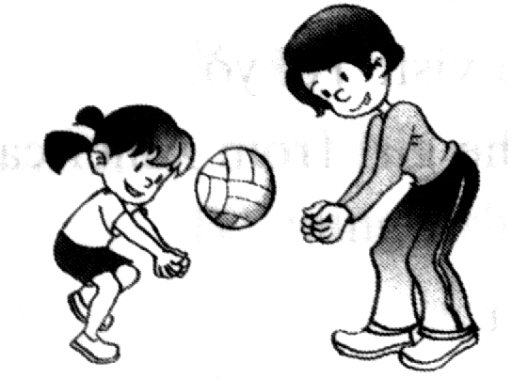
2020年10月小学五年级英语省测模拟试题
一、听力部分。(40分)

A) 听录音，选择与所听内容相符的图片，将所选选项涂黑。(听两遍，5分)
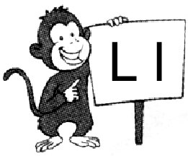
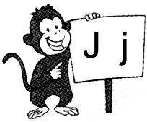
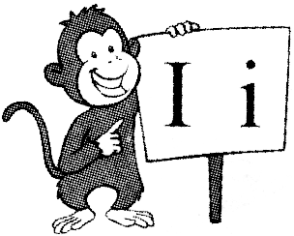
1. A. B. C.

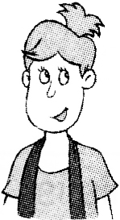
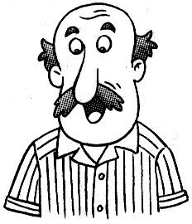
2. A. B. C.


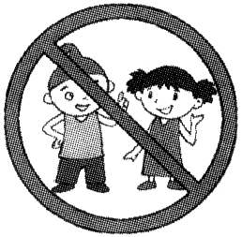
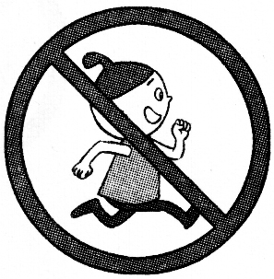
3. A. B. C.

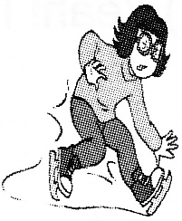
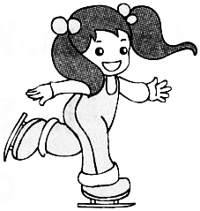
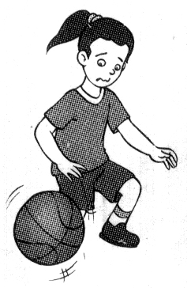
4. A. B. C.
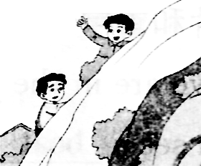
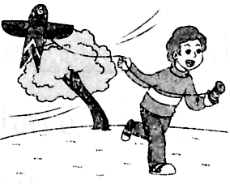
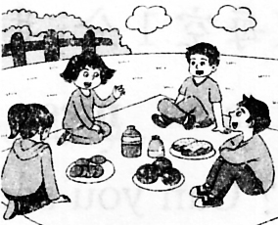
5. A. B. C.

B) 听录音，选出所听句子中含有的内容，将所选选项涂黑。（听两遍，5分）
6. A. out B. aunt C. shout
7. A. tall B. ball C. small
8. A. make B. milk C. magic
9. A. lovely B. family C. library
10. A. wake up B. hurry up C. stand up
B) 听录音，根据听到的句子，选择正确的应答。(听两遍，5分)
11. A. No, I’m not. B. No, thank you. C. No. It’s for me.
12. A. I’m two. B. I’m tall. C. I’m not small.
13. A. I like horses. B. I like Music and Art. C. I like drawing pictures.
14. A. I can see two. B. It’s in the box. C. It’s only ten yuan.
15. A. What a pity! B. Well done! C. Good idea!
F) 听录音，判断下列句子是否与所听对话内容相符，相符的将T涂黑，不符的将F涂黑。(听两遍，5分)
26. It’s Sunday morning.
27. Ben has a bad cough.
28. Ben wants to go to see the doctor.
29. Ben has a football match every Sunday afternoon.
30. Ben can’t go to have the swimming lesson this afternoon.
G) 听录音，补全下列句子，每空填一词。(听三遍，5分)
31. _________ is a _________ _________. We often go _________.
32. Tina has a new _________ for the _________. She’s so _________.
33. —Are you _______, Tim? —No. I’m ________. I want to have some ________.
二、阅读部分。（15分）
A)读句子，从括号中圈出与句中例词划线部分发音相同的单词补全句子。（6分）
1. ( Mike, Tim ) likes the ( five, six ) tigers on the kite.
2. The hot dog in the (box, home) is for (Rose, Bobby).
3. Kate, don’t ( dance, skate ) . Come and help me make a ( bag, cake ).
C)读对话，根据上下文选择合适的单词或词组补全对话，将所选内容的序号填写在相应位置。(5分)
A. easy B. Wednesday C. after school D. play basketball E. new timetable

A: Hi, Joe. Nice to see you in the new term. How many subjects do we have?
B: Seven. Look! This is our (6)_________.
A: I see. What lessons do we have this morning?
B: It’s (7)_________ today. We have Chinese, Maths and Music in the morning.
A: Do you like Maths?
B: Yes. It’s (8)_________ and fun. What about you?
A: I like Music. I like singing songs. Do you have any lessons (9)_________?
B: No, I don’t. I (10)_________ with my friends. I can play it very well.
A: You’re great.
D)读句子，从右栏中选出能与左栏相对应的句子。（8分）
( ) 1. I like watching TV. It’s great fun. A. At eleven twenty.
( ) 2. Do you have any lessons today? B. Well done!
( ) 3. Do you have lunch at home? C. Me too.
( ) 4. When do you have lunch? D. No. I have lunch at school.
( ) 5. I can play it very well. Look! E. Yes. It’s not difficult.
( ) 6. I can’t play with you today. F. Yes. I have three.
( ) 7. Can you play like this? G. Some tall trees.
( ) 8. What can you see over there? H. What a pity!
E)读对话，从方框里选择合适的句子补全对话，将所选句子的序号填写在相应位置。(5分)
A. Good idea!
B. The farm is beautiful.
C. Here’s a new one for you.
D. Sure. It’s not difficult for me.
E. What can you see over there?

Mike: Hi, Tim. It’s spring now. (11)_________ Let’s draw some pictures here.
Tim: (12)_________
Mike: (13)_________
Tim: I can see some ducks.
Mike: Can you draw them?
Tim: (14)_________ Oh, my crayon is too short.
Mike: Don’t worry. (15)_________
Tim: Thank you.
八、阅读理解。(35分)
A) 阅读对话，根据对话内容选择意义相符的图片，将所选图片选项涂黑。（5分）
A B C D E
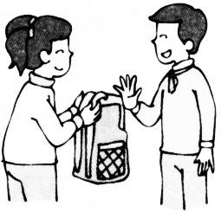
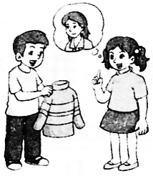
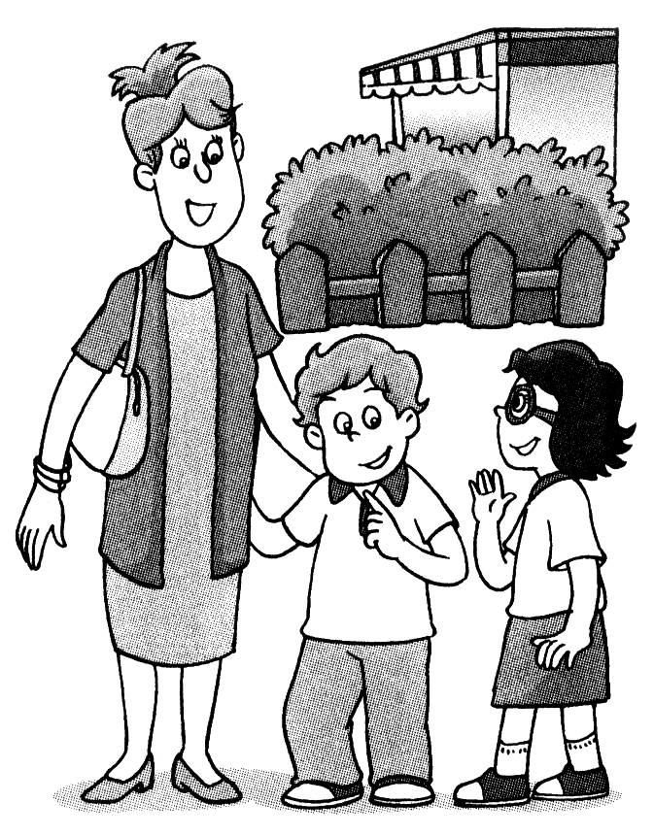
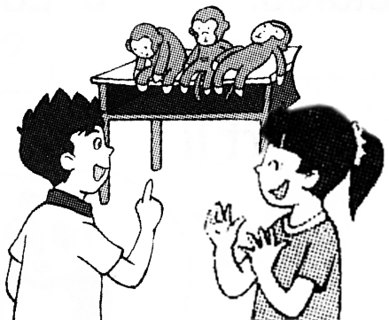
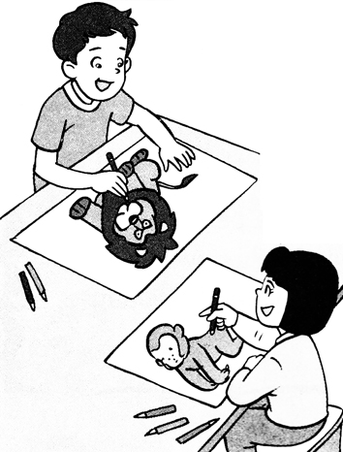

1. A: Hi, Yang Ling. This is my mum. B: Hi. Nice to meet you, Mrs Black.
2. A: Is this your schoolbag? B: No, it isn’t.
3. A: I can draw a monkey. What about you? B: I can draw a lion.
4. A: I have three toy monkeys on the desk. B: Great!
5. A: Whose sweater is this? B: It’s my mother’s.
C) 看图阅读对话，判断所给句子是否与对话内容相符，用“√”或“×”表示。(5分)
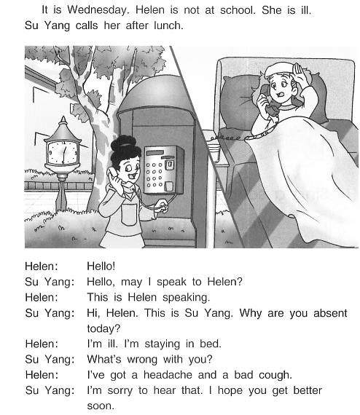
It’s Wednesday. Mary is not at school. Lily calls her after lunch.
Mary: Hello! This is Mary.
Lily: Hi, Mary. This is Lily speaking. Why are you absent today?
Mary: I’m staying in bed. I have a headache and a bad cough.
Lily: I’m sorry to hear that. Do you go to see the doctor?
Mary: Yes. He asks me to take some pills and drink much water.
Lily: That’s right. I’ll go to see you after school. You’ll be better soon.
Mary: Thank you. See you soon.
1. Mary and Lily are talking in the classroom.
2. The new word ‘absent’ means “缺席的” in Chinese.
3. Mary is ill at home on Wednesday.
4. Mary doesn’t go to see the doctor, she doesn’t like pills.
5. Lily will go to see Mary after lunch.
D) 阅读下列故事，根据故事内容选择正确的答案，将所选选项涂黑。（5分）
Tom is a teacher at a school in the UK(英国). He usually goes to France(法国) and Germany(德国) for his holidays(假期). He can speak French and German very well.
But one day Tom tells his friends, “I’m going to have holidays in China this year. I can’t speak Chinese, so I’m going to have Chinese lessons for a month(月).”
After a month, Tom’s holiday comes. He goes to China happily.
After two weeks, Tom comes back. His friends ask him, “Do you have any trouble(麻烦) with your Chinese, Tom?”
“No, I don’t.” Tom says, “But the Chinese do!”
1. Tom is a teacher in________.
A. China B. France C. Germany D. the UK
2. Tom goes to ________ for his holiday this year.
A. China B. France C. Germany D. the UK
3. Tom can’t speak ________ very well.
A. English B. French C. German D. Chinese
4. Tom stays(待) in China for ________ .
A. a week B. a month C. two weeks D. thirty days
5. “But the Chinese do.” means(意思是) ________.
A. the Chinese people don’t like Tom
B. the Chinese people can’t speak Chinese well
C. Tom’s Chinese is very good. People can understand him well
D. the Chinese people can’t understand(理解)Tom’s Chinese
E)阅读下面的一张英文海报poster，根据海报内容选择最佳答案。（6分）

Welcome to Hongshan Zoo
Hi, boys and girls! Come and see our cute pandas. The elephants from Thailand (泰国) can dance for you. The lovely bears can ride a bike. And the funny monkeys can play basketball. There are many other animals too. Do you want to make friends with them? Come on!
Tickets(票): Time:
Adults(成人): ￥60/ person Mon.-Fri. : 9:00 a. m. －5:00 p.m.
Children(Aged 1-12): ￥30/ person Sat.-Sun. : 9:00 a. m. －7:00 p.m.
Keep the park clean!
Do not touch, give food or go near the animals.
Hongshan Zoo

1. How many kinds(种) of animals are introduced(介绍) in the poster?
A. 4 B. 5 C. 6
2. The elephant is from ___________.
A. China B. the UK C. Thailand
3. The monkeys can ___________. They are funny.
A. dance B. ride a bike C. play basketball
4. Ben is eleven. His dad and mum take him to the zoo. How much should they
pay for(付钱) the tickets?
A. ￥120. B. ￥150. C. ￥180.
5. We can go to see the animals at ___________.
A. 6:00 a.m. on Monday B. 10:00 a.m. on Sunday C. 7:00 p.m. on Friday
6. We can __________ in Hongshan Zoo.
A. give some food to the tigers
B. watch the bears riding a bike
C. touch and go near all the animals
F) 看图读故事，根据故事内容顺序给图片排序，用1－4表示。（4分）
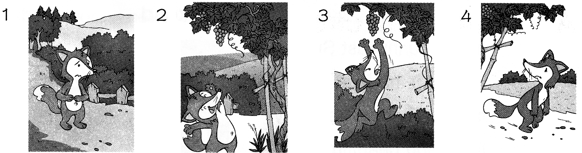

( ▲ ) ( ▲ ) ( ▲ ) ( ▲ )
One day, a fox is very hungry. He wants to look for some food.
He sees some grapes in the grapewine(葡萄藤). The fox is very happy. “I like grapes. How nice they are! They must be very sweet and juicy. I want to eat them! ”
So he jumps and jumps, but the grapewine is too tall. He can’t get the grapes.
The fox is very sad, then he says to himself, “I don’t like grapes. They’re sour(酸的). ”
G) 看图读对话，根据图意先给下列图片按内容顺序标序号，然后根据图意和上下文在横线上填写合适的单词，每空填一词。(8分)
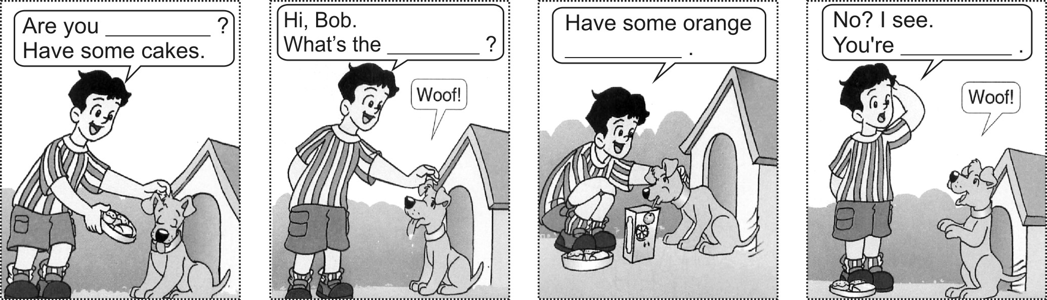

( ▲ ) ( ▲ ) ( ▲ ) ( ▲ )
三、书面表达部分。(10分)
A) 读一读，根据句意和图片提示，在四线三格内填写一个合适的单词补全句子。（5分）
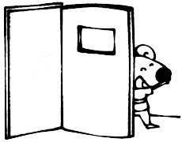
1.Ha! Ha! Here you are, Bobby. You’re ( ▲ ) the door.
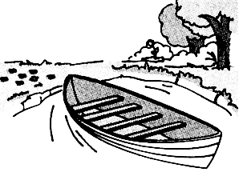
2.Look! There is a ( ▲ ) on the river.
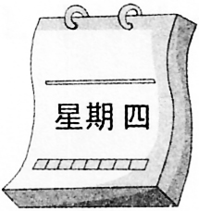
3. We have three lessons on ( ▲ ) morning.
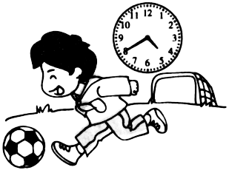
4. I usually play ( ▲ ) in the afternoon.
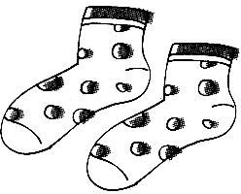
5. ―How much are the ( ▲ )? ―They’re only ten yuan.
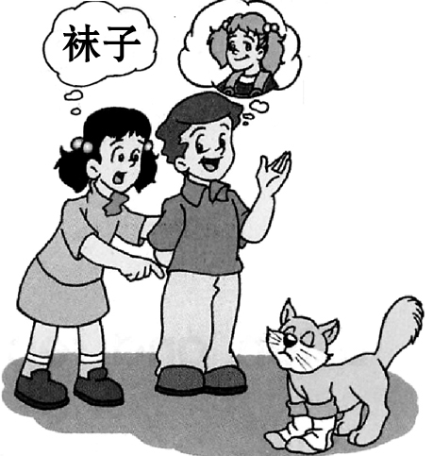
B) 看图并联系上下文完成对话填空，每空填一词。(8分)
Lily：Look at the cat, Jack. He’s funny.
Whose _________ are they?
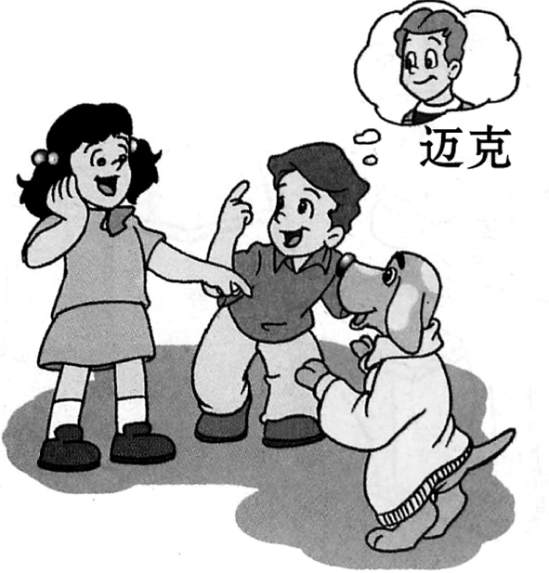
Jack: _________ Nancy’s.
Lily: I see. Look at the _________. His jacket is so _________.
Jack: It’s _________.
Lily: Haha! He looks cute.
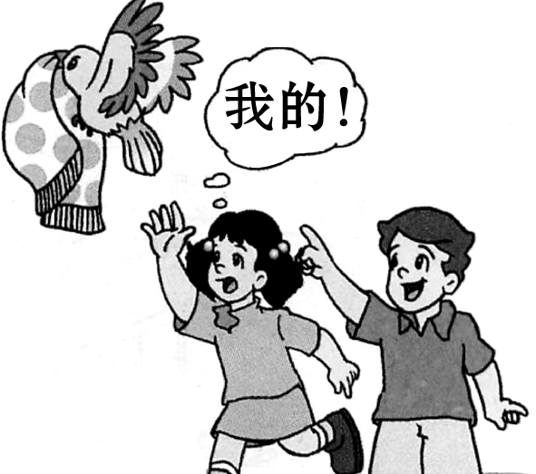
Jack: Look at that _________, Lily.
_________ scarf(围巾) is that?
Lily: Oh, dear! _________ my scarf.
C)根据图片提示，仿照范例，用4句话描述下面的图片。（5分）
例：David，6岁 仿写：Alice，12岁
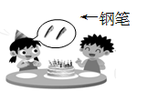


My name is David.
I’m a boy.

Now I’m six.

I want three crayons.

