**一、听录音，根据所听内容进行图片匹配，听三遍。**

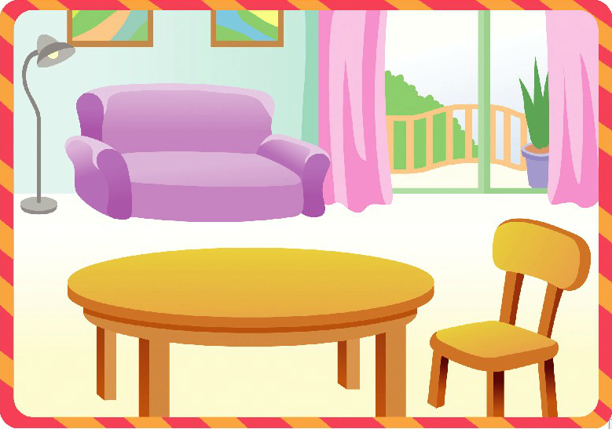

29

28

30

27

|  |  |  |  |
| --- | --- | --- | --- |
| shu.jpg | juice.jpg | car4.jpgcar2.jpgcar3.jpg | u=3455459748,3732298565&fm=23&gp=0.jpg |
| [A] | [B] | [C] | [D] |

27______________ 28_______________ 29________________ 30 ______________

听力文稿：

Look, this is the living room. There is a big door. There is a sofa between the door and the lamp. It’s purple. There is a table beside the chair. There are some books on the chair. There is a glass of juice on the table. I like juice. There is an egg on the table. This egg is big. There are some toy cars beside the sofa.

**二、阅读理解。**

|  |  |  |
| --- | --- | --- |
| Mason’s Clothes Store | | |
| Clothes | Color | Price |
| Socks | white, blue | ＄4 |
| Pants | black | ＄11 |
| Sweater | red, white | ＄8 |
| T-shirt | red, green, black | ＄7 |
| Hat | black, red | ＄6 |

根据上面的表格来做下列各题的选择填空。

(   )1.Which is the cheapest (便宜的)of all?

1. Hat.      B.T-shirt.      C. Pants.       D. Socks.

(   )2. How much are two sweaters and a hat?

1. ＄14       B.＄20          C.＄21         D.＄22.

(   )3. You can buy ______ in Mason’s Clothes Store.

1. black pants    B. a blue sweater  C. a green hat   D. red socks

(   )4.You like red and you only have ＄6.You can buy _____.

1. a sweater      B. a hat         C. a T-shirt    D. none (全无)

(   )5. You only have sixteen dollars. You can buy _______.

1. a sweater and a pair of pants. B. two T-shirts and a pair of socks.

C.two sweaters.       D. a sweater and two hats.

三、**阅读短文，给下列各图排序。**

This is Li Datong. He is eleven years old. He is in Grade Five. He usually gets up at 6:30 and he has breakfast at 7 o’clock. He goes to school by bus from Monday to Friday.

It is Saturday today. There is no school. He is going to visit his grandparents with his father and mother. They are waiting for the bus at the bus-stop. The bus is coming. Now they are at the door of his grandparent’s house. The old people are so glad to see them. They will have lunch together. In the afternoon they will visit the park nearby.

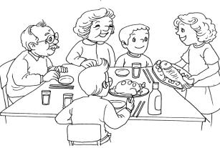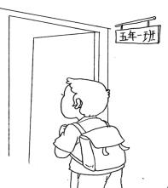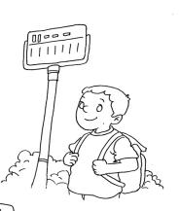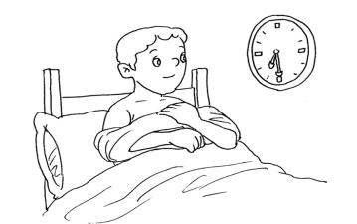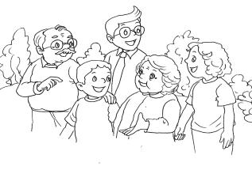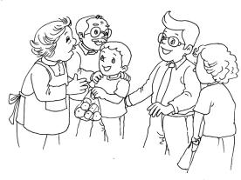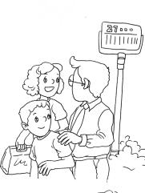

（ ） （ ） （ ） （ ）

（ ） （ ） （ ）

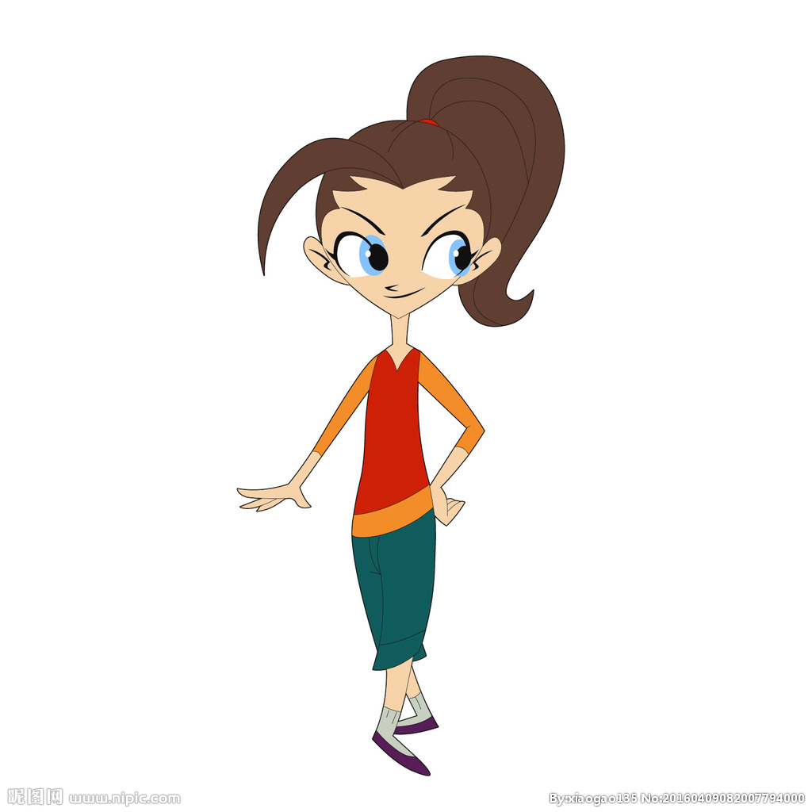**四、仿写句子。**

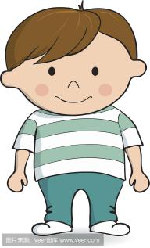

Look at the boy. ______________________________

He’s fat and short. ______________________________

His hair is short. ______________________________

His eyes are small. ______________________________

His mouse is big. ______________________________