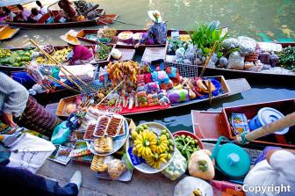

I have shopped in some very strange and interesting places. The best place I have ever been to is the Damnoen Saduak Floating Market. It is located about 80 km from Bangkok, Thailand. The market is over 100 years old and has hardly changed since then.
What made my visit to this market so special is that the whole market is on a canal and the brightly-dressed merchants sell their goods from their colorful boats. The day when I was there there were hundreds of boats crowded together, where you could buy everything from fruit and vegetables to clothes toys and even cooked meals. If you wanted to buy something you could either wait on the banks of the canal and the boats passing by or you could hire your own boat and join in the fun!
It wasn’t just the sights, though, that made this visit such an unforgettable experience. This market offers a feast to the senses! All around me were the sounds of wooden boats bumping together and the noisy chatter of the crowd. I had never been to a place with so many different smells: the aroma for fresh ground spices, exotic fruit and vegetables, seafood and meats, all mixed with the mouth-watering fragrance of fresh cooked Thai delicacies.
When I finished my shopping for the day, I felt tired but excited and happy. It was certainly an experience I would never forget. If you are ever in Thailand, you should definitely visit the floating market. It’s a unique experience.

