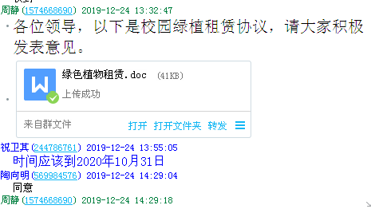

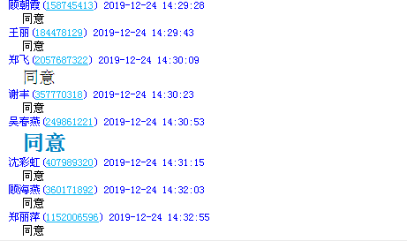

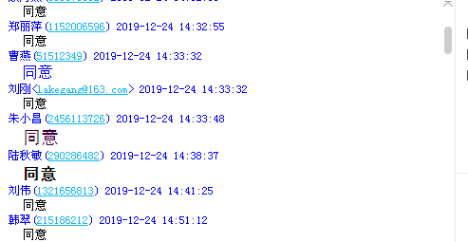

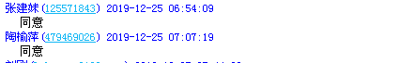

C:\Documents and Settings\Administrator\Application Data\Tencent\Users\1574668690\QQ\WinTemp\RichOle\W%{NDA6Y{1`}CQ8]E2H%YKJ.png