初中英语课外报刊阅读教学设计
学校 | 常州市滨江中学 | 时间 | 2020.9.29 |  | 设计者 |  | 施 静
授课学校 | 滨江中学 | 班级 |  |  | 七6班
课题 | 21世纪英语报（初一）第2期 Respect what you’re eating
主题语境 | 人与社会 人与自我——节约粮食
文本分析 | 本课是一节倡导节约，避免舌尖上的浪费的报刊阅读课。文章主要包括三部分：食物浪费的现状，一个番茄的故事以及解决食物浪费的方法。重点词汇主要涉及respect, reduce, food waste等。本文侧重价值取向的启发，希望学生通过本课学习，体会到珍惜粮食的必要性和责任感。
学情分析 | 首先，初一的学生求知欲强，学习积极性高。但是他们没有系统的接触过报刊阅读，因此在阅读中获取细节信息的能力有限，需要教师提供帮助和搭建清晰的支架；此外，因词汇量和句型结构有限，在整合知识、逻辑推理和分析论证观点，以及批判评价方面的能力都比较欠缺，因而在学生表达观点方面需要教师耐心引导。
教学目标 | 在本课结束时，学生能够：  - 获取梳理文中有关食品浪费的事实性信息；  - 了解文章的结构特征，概括、整合、阐述番茄成为餐桌食物的步骤。  - 通过阅读文章，获取关于减少食品浪费的方法的现实信息。  4、再次深度阅读文章中部分段落，根据写作手法来推测作者态度。  5、能够针对现实生活中食品浪费现象，通过讨论对文本内容进一步思考，并阐述自己的观点。  6、利用本课所学的语言并结合自身，提出减少食品浪费，让世界更美好的倡议和做法。
重点、难点 | - 深度理解本课文本内容和文章结构。  - 指导学生在分析文章的基础上联系实际提出建议，并形成健康向上的价值观。
Procedure | Teacher’s activities |  |  | Students’ activities |  | Feedback  & aims
Step1  吸引注意,积累语言 | Pre-reading  1. Free talk  Talk about the poem, and ask Ss where they can see it in life? Why?  - Presentation  Show some pictures  (1)Have you seen these in your life?  (2) What are they about？  (3）Predict（预测） how much the food is wasted. |  |  | Talk about the poem (CW)  Watch and think.  (IW)  Tell their feelings and choose a answer  (IW) |  | 创设情境，引出主题。  激活学生已有的关于生活场景的认知和经验。
Step2  导出目标,生成结构. | while-reading  Task 1  - Let ss read the text and try to Know how much the food is wasted in a school/China/ in the world.  Let Ss ask and answer in pairs like this:  A: How much food is wasted in Heng Yang No.1 Middle School / … / …?  B: …  2. Read again and find  - How much food is 35 million tons of food?  - What about 1.3 billion tons of food？  - Think further:  Why does the writer(作者）use so many numbers here?  A. Let people see the food waste more clearly.  B. Many numbers can make strong contrast [ˈkɒntrɑːst ]（对比）  C. Make people know that food waste is very serious(严重）. |  |  | Read, fill in the blanks and make a dialogue.  (IW&PW)  Read, find some details, and translate. (IW)  Think and tell ideas or choose the answers. |  | 关注阅读方法指导，了解文本结构
Step3  回忆相关知识，初步运用结构。 | while-reading  Task2  - Watch a short video and answer a question.  - Read the story of a tomato and answer two questions:  - To get a tomato, what do we need to do?  - How do you feel about this process(过程)？  - Read again and think further  What other resources does it take to get a tomato? |  |  | watch and answer (IW)  Read and answer (IW)  Read and answer question(IW&PW) |  | 通过快速阅读，  明晰文章结构  细节理解文本内容，获取基本事实性信息，概括、整合文章内容，在问答的过程中实现语言和知识的内化。
Step4  呈现刺激性材料，活用结构。 | Task3: Help to reduce the food waste  1.Can you find some ways by reading?  2. Brainstorming(头脑风暴）：  Who else can help? What about us students? |  |  | Read and answer questions(IW&PW) |  | 学生通过阅读找出文章给出的当现代做法，然后联系实际展开头脑风暴，深度思考。
Step5  引发期待行为，强化结构 | Pair work: make an interview  Choose one scene from the four to interview some people, and get to know what they can do to reduce the food waste. |  |  | Ask and answer (PW) |  | 实际场景训练，锻炼逻辑思维
Step6  提供反馈评价，巩固结构 | Group work: write a proposal  Give some advice  Invite more people to join the“Clear your plate” campaign(光盘行动)  Homework  - Polish their writings and post them in their communities.  - Search more ways to reduce food waste online. |  |  | Discuss, finish the writing and give a presentation.  (GW) |  | 巩固并整合所学的语言和内容，并整体感知。  联系现实生活，提出可行性建议，加强德育浸润，实现迁移创新。
板书设计 | Resect what we’re eating  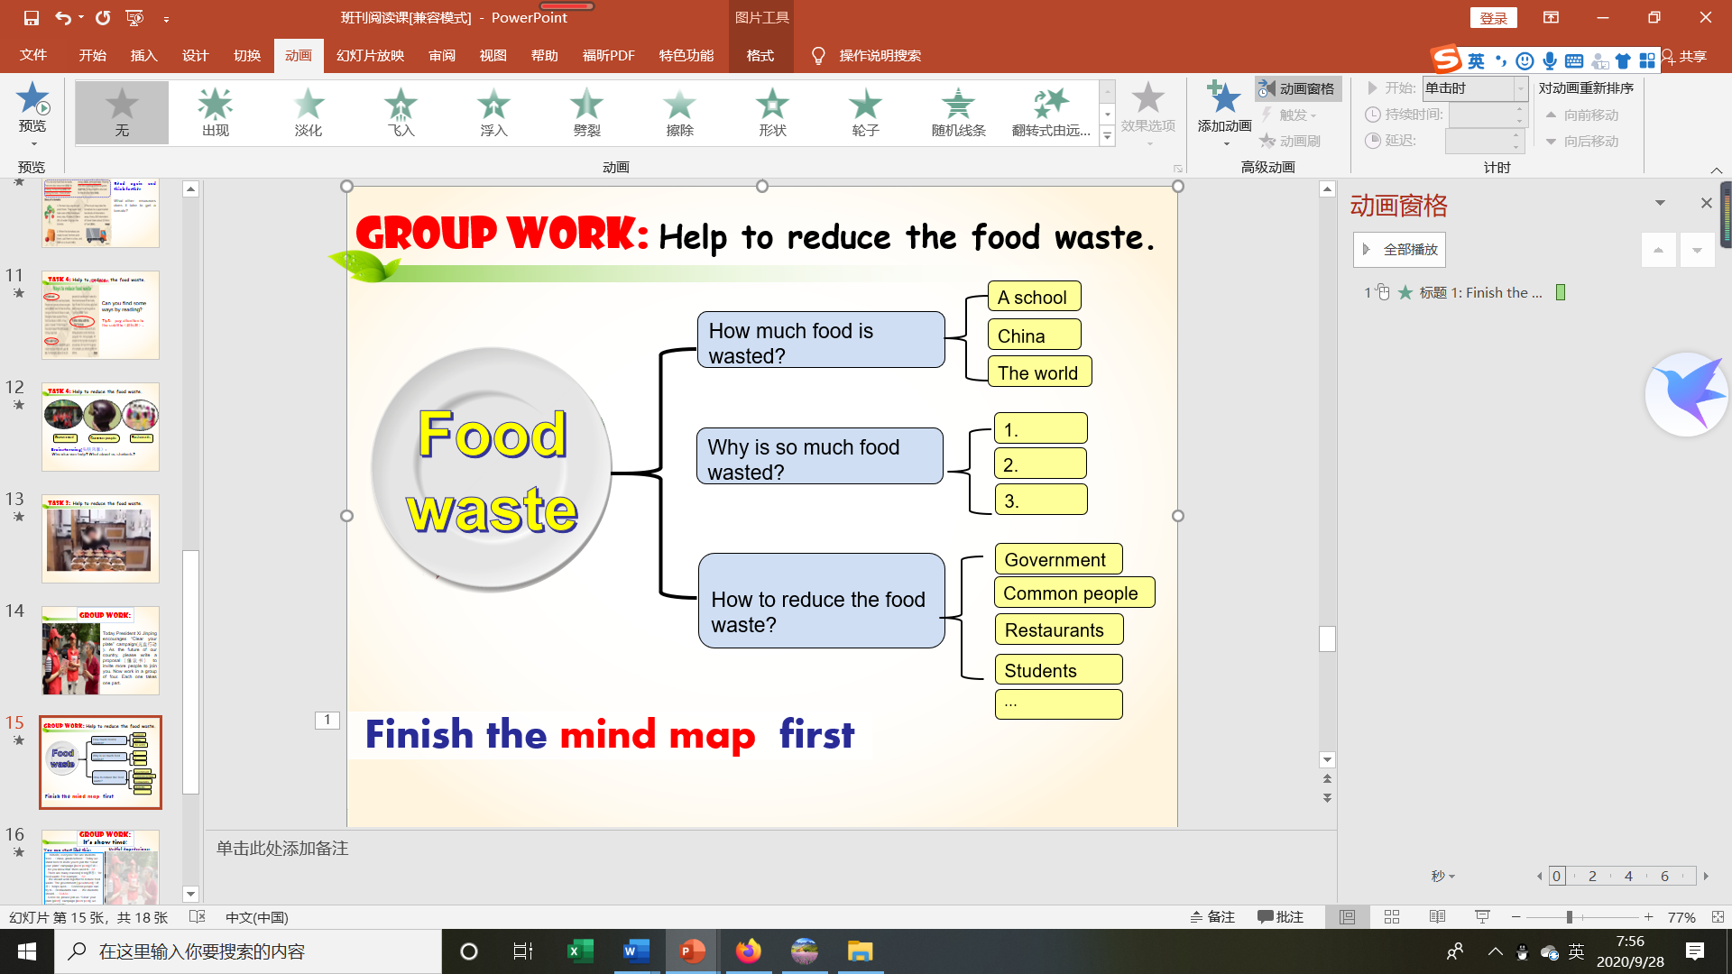  New words:  respect [rɪˈspekt]  finish [ˈfɪnɪʃ] 喝光，吃完  meal [miːl] 饭，餐  waste [weɪst] 浪费  change [tʃeɪndʒ]改变
教学反思

