**Mary Queen of Scots**

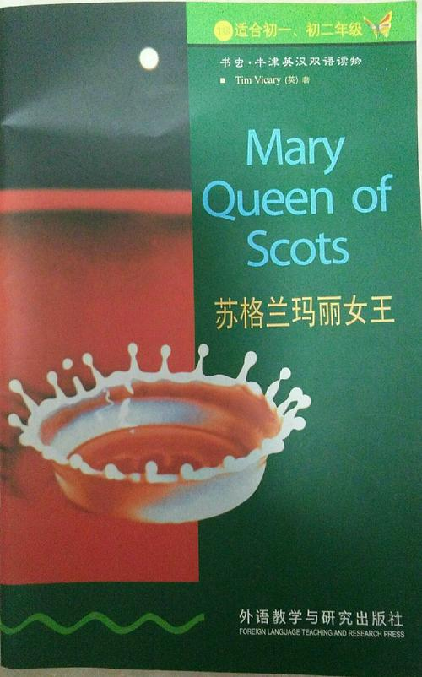**I watched *Reign* two years ago. The TV Series are about Mary, Queen of Scots. Recently I read a book it named Mary- Queen of Scots. The writer is Tim Vicary .**

**This book is about a letter which Mary Queen wrote of Scots wrote to her son James. She wanted to tell something about her life to her son. The book told us the whole life of Mary Queen of Scots.**

**She was the only surviving legitimate child of King James V. She was six days old when her father died and made her Queen of Scots. Her mother, Mary of Guise with her daughter was crowned nine months later**

**In 1558, she married Francis, Dauphin of France, who ascended the French throne as Francis II in 1559. However, Mary was not Queen of France for long;**

**At last Queen Elizabeth I, whose kingdom she hoped to inherit. Elizabeth, however, ordered her arrest, because of the threat presented by Mary, who was considered the rightful ruler of England by many English Catholics.**

**People say that Mary is a dangerous person and a bad woman but I don’t think so. Through the book I knew that she was a really person but she was misunderstood may be just because the belief. Scotland people don’t like her just because she was a catholic and they were protestant. She was a catholic but she did not hate protestant and did not kill them even did not stop them to their protestant churches. But why they don’t understand her?**