Unit 6 Sunshine for all
Welcome to the unit
Teaching aims:
To understand the meanings of special groups of people.
To cultivate students’ sympathy and the ability of taking care of others.
Teaching steps:
Step 1 New words
Present some pictures and teach the new words.
Step 2 Free talk
- Ask the students to talk about the questions below:
Have you ever been a volunteer?
Have you ever helped people who need help?
Step 3 Welcome to the unit
- The Class 1, Grade 8 students have found some pictures of people who need help.
Write the correct words under them. Then put a tick in the boxes if you have ever helped these people.
blind, deaf, disabled, elderly, homeless, poor
Keys: 1. disabled 2. poor 3. blind
4. elderly 5. homeless 6. deaf
- Amy and Daniel are talking about people who need help. Listen to the recording
and answer the following question：
How can we help homeless people?
Keys: Give them food and clothes. Write to the local government.
- Work in pairs and discuss the people in Part A. Use the conversation in below as a
model.
Amy: What are homeless people, Daniel?
Daniel: Homeless people don’t have their own places to live.
Amy: How can we help homeless people?
Daniel: We can give them food and clothes.
Amy: Are there any other ways to help them?
Daniel: Yes. We can write to the local government. They can provide special places for homeless people to stay.
Step 4 Free talk
- Ask the students to talk about the question:
Would Eddie and Hobo like to help people in need?
Step 5 Comic strip
- Listen and answer the questions.
What is Hobo doing?
Will Eddie support him?
How does Hobo want Eddie to help?
Keys: 1. He is training to be a volunteer for the Olympic Games.
2. Yes, he will.
3. He needs some more food to eat at work.
- Act the dialogue out.
Step 6 Language points
1. I’m training to be a volunteer for the Olympic Games.
train v. 训练；培训
e.g. If you train hard, you'll make a good footballer.
你要刻苦训练就能成为优秀的足球运动员。
2. It’s meaningful to do something for the Olympics.
It’s meaningful to do sth. for sb. 为某人做某事是有意义的
e.g. It’s meaningful to do something for children in poor areas.
为贫困地区孩子做些事是很有意义的。
3. I want you to help me.
want sb. to do sth. 想要某人做某事
e.g. Parents want us to study hard everyday.
父母想要我们每天努力学习。
4. I need some more food to eat at work.
(1) need sth to do sth 需要某物来做某事
e.g. I need some tools to finish the work. 我需要一些工具来完成这份工作。
(2) some more food 更多一些食物
数量意义词+more+名词: 表更多……
e.g. two more apples 再两个苹果
5. Homeless people don’t have their own places to live.
无家可归的人没有自己的地方住。
to live：动词不定式做定语修饰前面的名词。
e.g. have something to eat有一些吃的东西
6. They can provide special places for homeless people to stay.
provide sth for sb 为某人提供某物
=provide sb. with sth.
e.g. He was very poor because he’d to provide food for seven children.
他很穷，因为他要给七个孩子提供食物。
Step 7 Exercises
Ⅰ. Complete the sentences.
1. It’s _____________ (mean) to help people in need.
2. My father needed a pair of scissors ___________ (cut) out some pieces of cards.
3. I don’t have enough money ___________ (go) travelling.
4. He is a _________ (able) person. He lost one of his legs in a car accident.
Keys: 1. meaningful 2. to cut 3. to go 4. disabled
Ⅱ. Translate the following sentences.
1. 我们怎样帮助盲人呢？
2. 工作时我需要更多一些食物吃。
3. 我正在训练成为奥林匹克的一名志愿者。
4. 为奥林匹克做些事情很有意义。
5. 有没有其他的办法帮助老人？
Keys: 1. How can we help blind people?
2. I need some more food to eat at work.
3. I am training to be a volunteer for the Olympic Games.
4. It’s meaningful to do something for the Olympics.
5. Are there any other ways to help the elderly?
Step 8 Homework
Recite the dialogue between Eddie and Hobo.

Reading I
Teaching goals:
To know the basic knowledge of the Special Olympics World Games.
To grasp some common reading skills.
To enhance the students' passion for volunteering.
Teaching steps:
Step 1 Revision
翻译下列句子。
(1) 我认为你的父母不会支持你。
(2) 如果人人都为残疾人提供帮助，这个世界将会变得更美好。
(3) 为什么不给当地政府写信求助呢？
(4) 当一名志愿者是很有意义的，对吗？
Step 2 Presentation
Get the students to read the new words follow the teacher or the tape recording.
training n. 培训；训练
silver n. 银，银牌
coach n. 教练
gold n. 黄金，金牌
Words study
1. task n. 任务，工作
e.g. How long will it take to finish this task? 完成这项任务需要多少时间?
2. background n. 背景
e.g. The mountains form a background to this photograph of the family.
这幅家庭照的背景是群山。
3. expect vt. & vi. 期待；预料
e.g. We expect writers to produce more and better works.
我们期望作家们写出更多更好的作品。
4. chance n. 机会
e.g. Is there any chance of getting tickets for tonight?
有可能弄到今晚的票吗？
5. similar adj. 同样的；类似的
e.g. Their house is very similar to ours, but ours is bigger.
他们的房子和我们的十分相像，但我们的要大些。
6. necessary adj. 必须的；必要的
e.g. It is necessary to remember these facts.
记住这些事实是很有必要的。
7. closely adv. 密切地
e.g. We shall follow closely the development of the situation.
我们将密切注意形势的发展。
8. achieve vt. 实现；达到
e.g. You will achieve your ambition if you work hard.
如果你努力，你的抱负是可以实现的。
Step 3 Free talk
Get the students to talk about the following topics and present the topic of this lesson.
How can we help people with intellectual disabilities?
We can volunteer for the Special Olympics World Games.
Have you heard this event?
Can you tell me something about it?
Step 4 Skimming
Skim the article and answer the following questions:
1. What is the name of the volunteer?
2. What do volunteers need to do for the Special Olympics World Games?
Read the article; write a T if a sentence is true or an F if it is false.
1. Liu Ming was a volunteer in the 2007 Special Olympics World Games. ____
2. Liu Ming knew what to expect before he became a volunteer. ____
3. There were only a few events in the 2007 Special Olympics World Games. ____
4. There were over 40,000 volunteers for the 2007 Special Olympics World Games. _____
5. Li Hai was born with intellectual disabilities. _____
6. Li Hai was sure to win the swimming competition. ______
Step 5 Intensive reading
Get the students to read the article again and more carefully then divide the article into four parts.
Read the article carefully. Fill in the blanks with the correct numbers of the paragraphs.
Main points Paragraphs
1. An introduction to the Special Olympics World Games _____
2. Liu Ming’s experience _____
3. Liu Ming’s feelings about the event _____
4. What volunteers do for the event _____
Read Para 1&5 and answer:
（1）What does Liu Ming think of his experience of volunteering for the Special Olympics World Games?
（2）How do athletes and coaches feel like?
（3）What can volunteers do for those special athletes?
Read Para 2 and answer:
（1）Who has a chance to show skills to the world?
（2）What kinds of events do they include?
（3）Are those events similar to those in the Olympics?
Read Para 3 and answer:
（1）How many people volunteered for the 2007 Special Olympics World Games?
（2）Was it necessary to train the volunteers before doing the tasks?
（3）What can volunteers do for the Special Olympics World Games?
Read Para 4 and answer:
（1）What did Liu Ming do for the young boy?
（2）What's the most important thing to Li Hai?
（3）What was the result of Li Hai's competition?
（4）How does he feel now? Why?
Replace each of the underlined parts with a word or phrase.
Simon: Have you heard of the international sports festival for people with intellectual disabilities?
Annie: Yes, and I know some people offer to help without getting paid for the event. How do they help?
Simon: They give up their time when they’re not working or busy to provide help and support. I read about one volunteer. He was the person who provided swimming lessons for a boy called Li Hai.
Annie: Did Li Hai win first prize?
Simon: No. He finished fourth, but he feels more sure he can do better now.
Annie: It’s great to help those special athletes make their dreams come true.
Simon: Yes. Maybe that’s why this event is so different from other usual games!
Answer the questions with the words in the report.
Amy: What are the Special Olympics World Games for?
Simon: They give (1) ________ and (2) ______ with intellectual disabilities a (3) _______ to show their skills to the world.
Amy: Where were the 2007 Special Olympics World Games held?
Simon: They were held in (4) _________.
Amy: What events are included in the Special Olympics World Games?
Simon: They include many events (5) ___________ those in the Olympic Games, such as basketball, football and swimming.
Amy: Are there any volunteers for the Special Olympics World Games?
Simon: Yes. They get to help those special (6) __________ realize their dreams.
Amy: Is it interesting to become a volunteer?
Simon: Yes, of course. Being a volunteer for such an (7) ________ is often an amazing (8) ____________.
Step 7 Homework
1. Recite the new words in the article.
2. Find some information of the Special Olympics World Games.

Reading II
Teaching aims:
To understand the uses of the important phrases and sentences in the article;
To get some further information about the article
Teaching steps:
Step 1 Revision
根据句意及首字母或中文提示填空。
1. Many students don't know how to ___________ (实现，达到) a balance (平衡) between study and hobbies.
2. As an a________, you shouldn't act like a child.
3. Many a_________ took part in the Olympic Games in 2012.
4. Those guests he has invited come from different ___________ (背景).
5. He has tried three times, but we still decide to give him a fourth c________.
6. Liu xiang's _________ (教练) is very strict (严格的) with him.
7. I'm ___________ (自信的) that I can work out the hard maths problem.
8. Who do you _________ (期待，盼望) to help you?
9. I think it's __________ (必要的) to do morning and eye exercises every day.
10. Have you decided to take the ________ (任务)?
Step 2 Presentation
Retell the article.
Liu Ming ______________ for the Special Olympics World Games in Shanghai, back in October 2007. He thinks it was the most amazing _____________ of his life. The Special Olympics World Games give ________ and ______ with __________ disabilities a chance to show their skills to the world. They include many events __________ to those in the _______, such as basketball, football and _________. ________ 40,000 people ________ up their spare time for the event.
It's ___________ for volunteers to receive ________ before doing the tasks.
Liu Ming was the swimming _________ for a young boy called Li Hai. To him, the most important thing is not to win a ________ or a silver, but to take part.
He feels more ____________ because of the Special Olympics World Games.
The Special Olympics World Games also make ___________ and volunteers from different ____________ feel like part of one big family.
Step 3 Language points
1. volunteer for the Special Olympics World Games
为夏季特奥会做志愿者
volunteer vi. & vt. 志愿做，义务做
volunteer for ... 志愿做……；主动做……
e.g. No one volunteered for cleaning the henhouse.
没有人主动去清理鸡舍。
volunteer to ... 志愿做……；主动提出……
e.g. He volunteered to water our plants.
他主动提出给我们的植物浇水。
volunteer n. 义务工作者；志愿者
e.g. Schools need volunteers to help children to read.
学校需要义务工作者帮助儿童阅读。
【拓展】 the Special Olympics World Games 世界特殊奥运会
世界特殊奥运会是一个为全世界智力缺陷儿童及成年人提供体育训练和比赛的国际体育运动民间团体。成立于1968年，其主要任务是帮助和推动世界各国开展智障人体育运动。上海举办了2007年第12届世界夏季特奥会。中国是亚洲第一个举办该项赛事的国家。
2. The Special Olympics World Games give children and adults with intellectual disabilities a chance to show their skills to the world.
特奥会给有智力缺陷的孩子和成人一个向全世界展示能力的机会。
（1）句中的with intellectual disabilities 为后置定语，修饰children and adults。介词短语作定语一般要后置。如：
The key to my bicycle is missing.
我的自行车钥匙丢了。
（2）句中的chance 意识是“机会”，名词。如：
Please give me a chance to explain.
请给我一个解释的机会。
短语by chance意为“偶然地；碰巧”。
e.g. I met one of my old friends by chance yesterday.
【运用】根据汉语意思完成下列英语句子，每空一词。
1) 你曾经给过他不止一次机会吗？
Did you ever give him more than ________ ________?
2) 这件事是偶然发生的。
It happened ________ ________.
3. They include many events similar to those in the Olympics, such as basketball, football and swimming.
特奥会包括很多与奥运会类似的项目，如篮球、足球和游泳。
短语similar to those in the Olympics为后置形容词短语， 用于修饰events。similar 意思是“相似的，类似的”。be similar to 意为“与……相似 / 相仿”。 如：
His teaching style is similar to that of most teachers.
他的教学风格和多数教师相似。
be similar in 表示“在某方面相似 / 相仿”。
e.g. The two houses are similar in shape.
这两个房子在形状上相似。
【运用】根据句意，用恰当的介词填空。
1) Your views on education are similar ______ Mr Wang’s.
2) The two cars are similar only _____ color.
4. Over 40,000 people gave up their spare time for the 2007 Special Olympics World Games.
give up 意为“放弃”，其后可接动词-ing形式。
e.g. Nick’s father had to give up smoking because of his illness.
give up后还可跟名词(短语)。
e.g. Ed’s mother gave up her job to look after him.
注意：代词作give up的宾语时要放在give和up之间。
e.g. This is a good chance. I won’t give it up.
【运用】根据汉语意思完成英语句子，每空一词。
1) 杰夫已经放弃学法语了吗？
Has Jeff _______ ____ _________ French?
2) 请不要放弃他们。
Please don’t ______ ______ _____.
5. Then they provided support for the athletes and helped make the event a great success.
然后志愿者们为运动员提供支持，使本届特奥会取得很大的成功。
（1）句中的support可以用作名词或动词，意思是“支持”。如：
Thank you for your support. 谢谢你的支持。
Thank you for supporting me. 感谢你支持我。
（2）动词help后接另一动词，中间可以省略to。如：
They helped stop the fire.
他们帮忙灭了火。
6. He was born with intellectual disabilities.
他生下来就有智力问题。
短语be born with 意思是“生来具有……”。如：
He was born with a weak heart. 他生来心脏虚弱。
7. It's very brave of him to join the competition.
他参加竞赛真的很勇敢。
句型It's + adj. + of sb. to do sth. 通常表示说话人对客观事件的惊讶、兴奋、懊悔、难过等感叹情绪。该句型中用作表语的形容词常见的有如下几类:
（1）表示聪明或愚蠢的形容词,有clever, wise, foolish, stupid, silly, unwise, dumb(愚笨的), absurd (荒谬的)等。如：
It’s silly of him to do such a thing.
他竟干出这样的事, 真是愚蠢!
（2）表示正确或错误的形容词, 有 right, wrong, correct, incorrect 等。 如:
It was right of her not to come here.
她没有来这儿, 太对了!
（3）表示好坏等品性的形容词, 此类词较多, 有 good, nice, kind, sweet, friendly, lovely, wonderful, jolly(快活的), bad, unkind, naughty, wicked(坏的,邪恶的)等。 如:
It’s friendly of you to come and see me.
你能来看我, 真够朋友!
（4）表示褒义或贬义色彩的形容词, 有brave, polite, careless, selfish等。如:
It was brave of you to manage to do it.
你居然能做成这件事, 真勇敢!
8. To Li Hai, the most important thing is not to win a gold or a silver, but to take part.
对李海来说，最重要的东西不是赢得一块金牌或银牌，而是参与。
no t … but … 不是……而是……
e.g. PE is not my favourite, but Music.
我最喜欢的不是体育而是音乐。
9. Li Hai tried his best and finished fourth.
李海尽了最大努力并取得第四名。
当序数词表示名次时，其前面的定冠词通常可以省略。如：
Who won (the) first prize?
谁获得了一等奖？
10. “It’s great for us to work closely with these special athletes. You get to help them achieve their dreams,” says Liu Ming.
“能和这些特殊运动员们近距离共事真的很棒。你有机会帮助他们实现梦想。” 刘明说。
句中的achieve意思是“达到（某目标、地位、标准）”。如：
He finally achieved success. 他终于成功了。
Step 4 Exercises
I. 用所给词的适当形式填空。
1. I didn’t expect him _____________ (come).
2. You have only one chance left ___________ (try).
3. He feels __________________ (confident) than before.
4. This is _____________________ (exciting) experience in his life.
5. You should give up ___________ (smoke). It’s bad for your health.
6. They will receive special _____________ (train) before leaving school.
7. Do you know the famous film star __________ (call) Jackie Chan?
8. It’s very meaningful to work ___________ (close) with the workers.
9. Many ______________ (volunteer) ________________ (volunteer) to help those people in Ya’an Earthquake.
10. She is sure ________ (win) the swimming competition.
II. 翻译下列句子。
1. 当一名志愿者是很有意义的。
2. 他们为运动员们提供帮助和支持。
3. 因为参加了这次比赛，他比以前感到更加自信了。
4. 我们应该给残疾人机会来向世界展现他们的能力。
5. 特奥会包括很多与奥运会相似的比赛项目，如足球和游泳。
Step 5 Homework
1. Retell the article.
2. Review the language points in this article.
3. Finish the exercises in the workbook.

Grammar
Teaching aims:
To understand the differences between "It's + adj. +to-infinitive", "It's + adj.+ for...+to-infinitive" and "It's + adj. +of...+to-infinitive" .
To use these sentence structures to make sentences.
Teaching steps:
Step 1 Presentation
Teach the new words.
donate vt. 捐献
charity n. 慈善，慈善机构
organization n. 机构，组织
blood n. 血
Step 2 Lead in
Answer the questions about the reading part.
Is it fantastic to work as a volunteer?
Is it important to support the Special Olympics World Games?
Yes. It is fantastic to work as a volunteer.
Yes. It is important to support the Special Olympics World Games.
Step 3 Grammar explanation
Section A
1. Explain:
It is | adjective | to-infinitive
It is | fantastic | to work as a volunteer.
It is | important | to support the Special Olympics World Games.
We use It is + adjective + to-infinitive to express what we think about something.
该句型中的形容词表示不定式所具备的特征或客观情况。如：cheap, convenient, dangerous, difficult, easy, exciting, expensive, important, interesting, necessary, normal, possible, useful, wonderful。
2. Present the table on Page 84.
Ways to help
Amy is thinking about what she can do to help society. Help her use the words in
brackets and those in the box to make sentences.
donate give help keep plant take care of
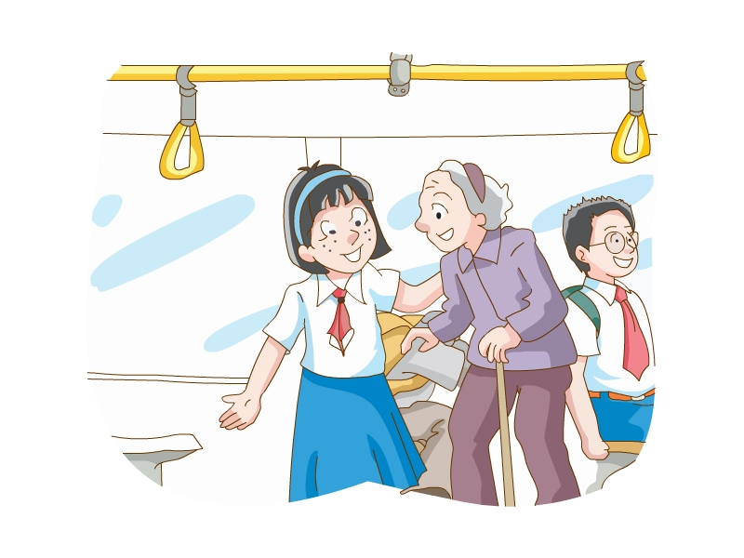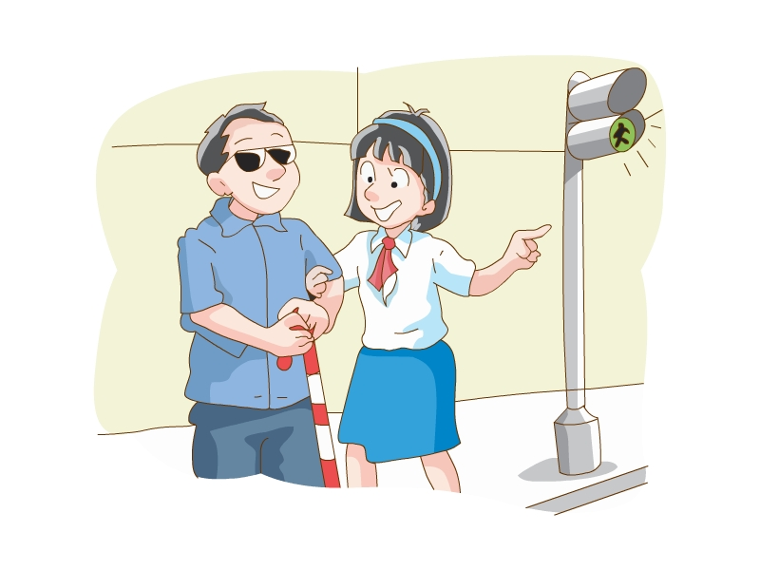
(right/seats/the elderly/to) (good/blind people/cross the road)
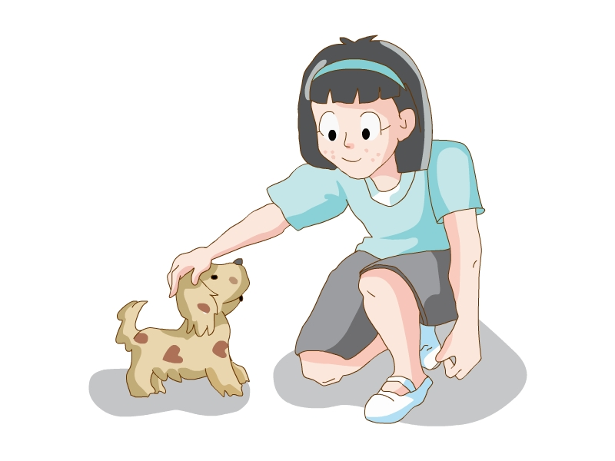
(helpful/money/to charities) (proper/ a lost pet)
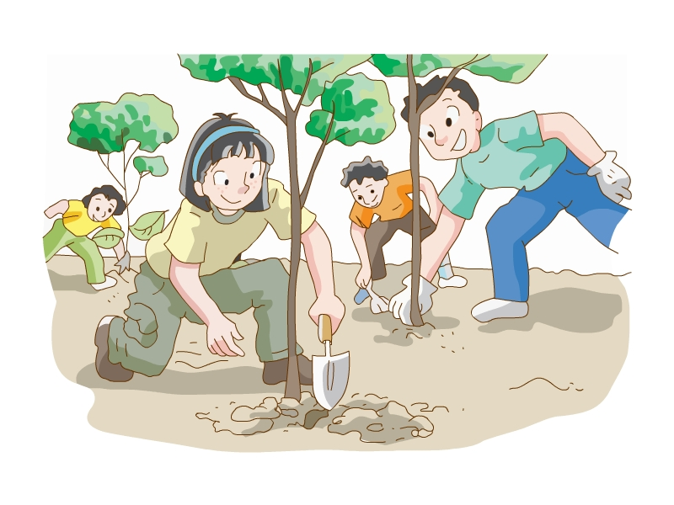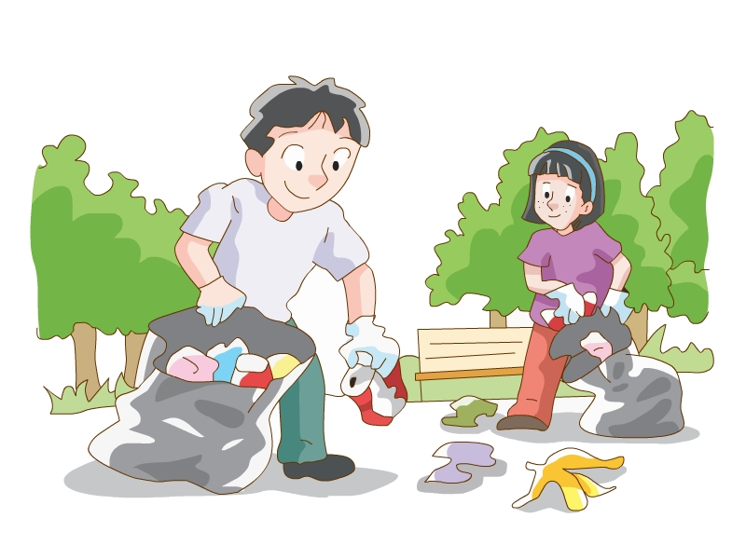
(important/ more trees) (necessary/parks/clean)
- Check the answers.
It's right to give seats to the elderly.
It's good to help blind people cross the road.
It's helpful to donate money to charities.
It's proper to take care of a lost pet.
It's important to plant more trees.
It's necessary to keep parks clean.
Section B
It's meaningful for us to do something for people who need help.
对我们来说为需要帮助的人做些事情很有意义。
1. Explain:
We can add for someone to specify who we are talking about.
It is | adjective | for | someone | to-infinitive
It is | important | for | people | to learn good manners.
It is | difficult | for | Li Hai | to win the competition.
It is | possible | for | her | to work for the charity on Saturday.
for引出逻辑主语
2. Present the table on Page 85.
Asking about the volunteer work
Simon is a volunteer now. He works for people with intellectual disabilities. Amy is asking him about his work. Complete their conversation with the phrases in the box.
easy for people fantastic for me important for us impossible for organizations necessary for volunteers wonderful for you
Amy: Why do you want to be a volunteer?
Simon: Because any help would mean a lot. Many organizations provide help for
people with intellectual disabilities, but it's (1) ___________________ to do volunteers.
Amy: It’s (2) __________________ to be a volunteer. Do you need experience?
Simon: No. It’s not (3) ____________________ to have any experience, but it’s very (4) ______________ to be kind and friendly.
Amy: What are your tasks?
Simon: I’m in the sports group. I chat with them, help them practise and make sure
they’re safe. I think it’s (5) ______________ to work with these special people.
Amy: Do you have any trouble talking to people with intellectual disabilities?
Simon: Yes, a little. We need to be more patient. However, it’s very (6) with them.
3.Check the answers.
impossible for them wonderful for you necessary for volunteers
important for us fantastic for me easy for people
Work out the rule!
We can use _________________ (subject pronouns, object pronouns) after for.
Keys: object pronouns
Section C
1. Explain
It's kind of you to do something for people who need help.
你能为需要帮助的人做些事情真的很善良。
We can use It is + adjective + of... + to-infinitive to express what we think of someone's actions.
It is | adjective | of | someone | to-infinitive
It is | kind | of | these  volunteers | to work in their spare time.
It is | brave | of | him | to take part in the competition.
该句型中的形容词描述的是人的特征、品质等。如：brave, careless, clever, foolish, generous, good, helpful, honest, kind, nice, polite, silly, stupid, wrong。
- Present the table on Page 86.
Good or bad?
Mr Wu wants to know what the Class 1, Grade 8 students think about the actions below. Help them organize their thoughts by rearranging the words below to form sentences.
1) carless/ the tap/ the boy/ to/it is/running/leave/of
__________________________________
2) the girl/it is/bad/of/pick flowers/in the park/to
___________________________________
3) wrong/it is/of/drop litter/to/the people/ everywhere
____________________________________
4) of/kind/it is/to/donate blood/the young man/to people in need
____________________________________
5) smoke/to/not right/it is/the man/of /in public places
____________________________________
- Check the answers.
It is careless of the boy to leave the tap running.
It is bad of the girl to pick flowers in the park.
It is wrong of the people to drop litter everywhere.
It is kind of the young man to donate blood to people in need.
It is not right of the man to smoke in public places.
Step 4 Language points
1. donate ... to ... 捐……给……
donate money to charities
给慈善机构捐钱
donate blood to people in need
给有需要的人献血
e.g. It's kind of you to donate these clothes to Project Hope.
你把这些衣服捐给希望工程真善良。
2. experience 经验，经历
表示经验时是不可数名词，表示经历时是可数名词。
e.g. The greatest teacher is experience. 经验是最好的老师。
Please tell us your experiences in America.请你告诉我们你在美洲的经历。
3. have trouble (in) doing sth.
做某事有麻烦
e.g. Do you have trouble in learning English? 你在英语上有困难吗?
相关短语：
have no trouble in doing sth 做某事没困难
have some trouble in doing sth 在做……方面有困难
Step 5 Summary
1. We use It is + adjective + to-infinitive to express what we think about something.
2. We can add for someone to specify who we are talking about.
3. We can use It is + adjective + of... + to-infinitive to express what we think of someone's actions.
Step 6 Exercises
I. 用所给单词的适当形式填空。
1. Is it ____________ (mean) to protect the environment?
2. It's _________ (help) of him to help the old woman carry the basket.
3. It's necessary to be __________ (friend) to animals.
4. It's careless of him ____________ (make) so many mistakes.
Keys: meaningful, helpful, friendly, to make
II．完成句子。
1. 他对老年人大喊大叫是没有礼貌的。
2.志愿者们对运动员友好是很有必要的。
3.有时我们和智力有障碍的人交谈有困难。
Answers:
1. It’s rude of him to shout at the elderly
2. It’s necessary for volunteers to be friendly to athletes.
3. Sometimes we have trouble talking to people with intellectual disabilities.
Step 7 Homework
Finish the exercises in the workbook.

Integrated skills
Teaching goals:
To grasp some basic skills of Listening.
To talk with partners about the topic in Speak up.
Step 1 Revision
翻译。
1.钓鱼真有趣。
2.对我来说帮助他是必须的。
3.他真聪明，解决了这个难题。
4.他们这样做真是愚蠢。
Keys: It is interesting to go fishing.
It is necessary for me to help him.
It is clever of him to solve the problem.
It is foolish of them to do so.
Step 2 Warming up
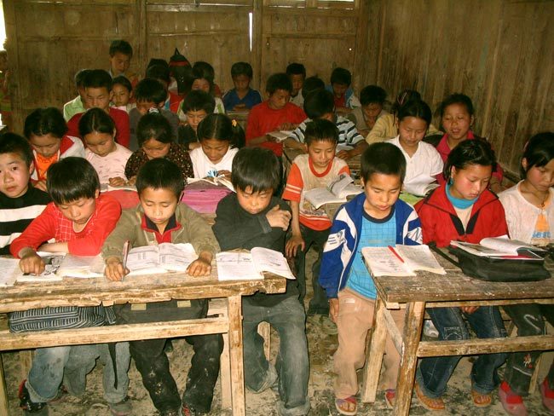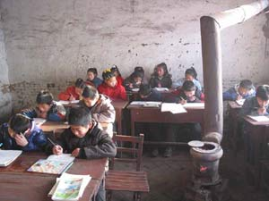
What can you see in the pictures?
What can we do to help those students?
Step 3 Free talk
Get the students to talk about the following questions:
Have you or your family ever been a volunteer?
How was it?
Step 4 Listening
1. A1 Peter's cousin Judy is telling him about a volunteer project. Listen carefully. Help Peter answer the following questions by choosing the correct answers.
1) What is Judy?
a A college student
b A primary school teacher.
2.) Where is she going?
a South-west China
b North-west China.
3). Why is she going there?
a For a volunteer project
b For a training plan.
4) What will she do there?
a Teach in a primary school.
b Work in the fields.
5) How long will she stay there?
a For one year.
b For three months.
6) How can Peter and Judy keep in touch?
a By writing emails.
b By talking on the phone.
Keys: a b a a a b
2. Pair work
What’s school like? What’ll Judy do at the school? Can you guess?
A2 Judy is talking to Peter on the phone about her experience. Listen to their conversation and help Peter complete his notes.
School: a very (1)_______ school in a (2)__________ area only
(3)______ classroom
Students: live in villages (4)________walk for more than (5)_______ to get
to school
Judy's life: teaches them Chinese, (6)_______ and Maths teaches them (7)______after class gives them a lot of (8)______
What she thinks: meaningful to learn more about (9)______________ of China helpful to (10)_______ the children there
Keys: small mountain six far away an hour English songs books the poor areas teach
3. A3 Peter is writing about Judy and the village school in his diary. Help him complete his diary entry with the information in Parts A1 and A2.
My cousin Judy has taken part in a (1)________________ in her college. She works as a primary school (2)________ in North-west China for (3)_________.
The school is very (4)_______. There are only (5)______________ in the school. Most of the students live (6)_________ and they have to walk for more than (7)________ to get to school.
Judy works hard there. She teaches them Chinese, (8)________ and Maths. After class, she sometimes teaches them (9)________. She also gives them (10)____________ to read.
Judy thinks it is meaningful for college students to learn more about (11)_______________ of China. It is also helpful of them to (12)_______ the children there. In this way, they can help the local people improve their lives.
Keys: volunteer project teacher one year small six classrooms
far away an hour English songs a lot of books the poor areas
teach
Step 5 Speak up
As a middle school student, how can you help people in your daily life?
The Class 1, Grade 8 students are talking about how to help others in their daily lives. Let’s listen to their conversation.
Free talk: How can we help people in our daily life?
Step 6 Listen and answer
How many ways are mentioned(提到) in the dialogue?
How can we help homeless people?
Keys: Four.
We can give food to them.
Step 7 Dialogue practice
1.Work in pairs and talk about this topic. Use the conversation as a model.
2. Act the dialogue out!
Step 8 Language points
1. in mountain area 在山区
e.g. Most children in city don't like to live in mountain area.
绝大部分城里的孩子不喜欢住在山区。
2. keep in touch 保持联络
e.g. Wherever you go, keep in touch with me, please.
无论你去哪里，请与我保持联络。
3. daily life 日常生活 day (n.) --- daily (adj.)
e.g. 日常英语 daily English 日报 daily newspaper
4.save our pocket money
储存我们的零花钱
此处save的意思为“储存”，如：
If you save money now, you will be able to buy a car soon.
如果你现在存钱的话，你不久就能买小汽车了。
Step 9 Exercises
I. 根据首字母或中文提示填空。
1. She is going the ______________(西北方) of China.
2. The local people hope to ___________ (提高) their lives.
3. We should help those people in need in our d______ life.
4. Simon d________ his pocket money to the disabled person yesterday.
5. These ____________(组织) need plenty of volunteers.
Keys: north-west improve daily donated organizations
II. 完成句子。
1.为何不把你的零花钱捐给需要的人呢？
Why not ___________ your pocket money _____ people _____ _______?
2.周末在社区中心当志愿者很有意义。
It's _____________ to _______ ______ a volunteer _______ community centre at the weekend.
Keys: donate to in need
meaningful work as at
Step 10 Homework
Make up a new dialogue on how to help people in need.

Study skills
Teaching aims:
- To understand the importance of organizing ideas before writing.
- To know the main parts of an article.
- To organize ideas in different ways according to the type of writing.
- To grasp some common methods of writing.
Teaching steps:
Step 1 Revision
翻译下列短语。
1. 在周末 at the weekend
2. 超过，多于 more than
3. 改善他们的生活 improve their lives
4. 在我们的日常生活中 in our daily life
5. 节约你的零花钱 save your pocket money
6. 把某物捐献给某人 donate sth. to sb.
Step 2 Free talk
Get the students to talk about the topics:
Can you tell a moving story?
How can we tell the story very well?
Step 3 Presentation
1. Tell the students:
An article is often made up of three parts: Introduction, main body and conclusion.
However, we can organize our ideas in different ways according to the type of writing.
- Introduce four different methods of writing.
- Present “Time order”.
Explain: We use this method when we write about an experience or an event.
Present the topic in the book.
Get the students to think about more topics.
- Present “Space order”.
Explain this method in the same way as “Time order”.
Introduce the rest two methods in the same way. Get the students to talk with their partners about more topics.
- Do the exercise on Page 89.
Mr Wu gives the students some topics and asks them to choose a suitable way to organize their ideas. Help them choose the best way for each topic. Write A, B, C or D in the box.
1 A day at Hong Kong Disneyland
2 Good reading habits are important
3 Teenagers' after-school activities
4 My dream home
5 Changes in my hometown
6 It is fantastic to be a volunteer
Keys: A C D B B C
Step 4 Writing
Write a short passage about your trip. Using one of the type of writing we have learnt.
Sample writing:
A trip to Beijing
This summer vacation, I went to Beijing. It was a very great city!
First, we went to the Great Wall. Like its name, it was very great. We can see many mountains around.
Next, we ate the Beijing roast duck, it’s so delicious.
Then we went to visit Tian'an Men Square. It was also fantastic.
Finally, we lived in a small house in a Beijing hutong, it was a traditional Beijing building called 'four-section compound'.
I enjoyed myself a lot.
I love Beijing!
Step 5 Homework
- Learn how to organize ideas according to the type of writing.
- Preview the next lesson.

Task
Teaching aims:
To know how to write a letter asking for help.
To write a letter asking for help.
Teaching steps:
Step 1 Revision
We’ve learnt about groups of people who need our help in this unit. Get the students to tell us who these people are and how we can help them?
Step 2 Warming up
Get the students tell: other people who need our help.
Then present some new words: survivor, disease, operation.
Step 3 Writing
1. Get the students to answer the questions:
What are the main parts of an article?
How can we organize our ideas before writing?
2. Peter wants to write a letter to ask for help. Present Peter’s ideas of his letter.
Introduction | Who needs help?
Main body | Information about the person or group in need  What kind of help do they need?  How can we help?
Conclusion | Thanks for help
3. Listen to Part B on page 90 and answer the questions.
1) What is wrong with Xiao Wei?
He has a serious blood disease.
2) What kind of help do his family need?
The need money for Xiao Wei’s operation.
3) How can we help Xiao Wei?
We can donate money.
4. Read Peter’s letter and answer the questions.
1) How does Peter write such a letter?
2) What is the main idea of each paragraph in Peter’s letter?
5. Tell students the writing tips:
Before writing, it’s necessary for us to organize our ideas first. When we write a letter for help, we need to tell others two points:
- who needs help
- how we can help
Step 4 Language points
1. He has been ill in hospital since last month.
他从上个月开始生病住院了。
本句用的是现在完成时，表示从过去某一时间开始一直持续到现在的动作或事情。
e.g. They have worked here since 1975.
他们从1975年开始就在这工作了。
2. have a serious disease
有严重的血液疾病
表示“生……病”通常用动词have。如：头疼 have a headache
3. as soon as possible 尽可能快的
e.g. 请尽快把书还给我。
Please return my book as soon as possible.
4. lose one's life 失去生命，丧生
e.g. 许多人在这个地震中丧生了。
Many people lost their lives in the earthquake.
5. Many hands make light work.
人多力量大。
6. give a helping hand 伸出援助之手
7. get well 康复
句中well是形容词，表示“健康的”。
e.g. —Are you OK?
—Yes. I'm well.
—你好吗？
—是的，我很好。
Step 5 Discussion
- Discuss in pairs: who you want to help and what you can do.
Give some ideas:
- Someone with a serious disease
- People in poor areas
- Blind and deaf people
- The elderly
- Children without parents
- Earthquake survivors
2. Present some questions:
1) Who needs help?
2) How do these people probably feel?
3) What do these people need?
4) How can we help these people?
5) What can we give them?
6) How can we raise money for them?
7) What can we do with this money?
8) What can we ask others to do for these people?
9) Who should we write to?
3. Useful expressions:
- Dear classmates/friends/parents/ neighbours
- Let me tell you a little about …
- ... need our help.
- We must do something to help.
- I have an idea. I plan to …
- Please help me …
- You can help by …
- I hope you will …
- It will cost ... To ...
- ... do/does not have enough money for ...
- It is important/dangerous/... for ... to ...
- If all of us can give a helping hand, ...may...
- Thank you for your help/support.
Step 6 Exercises
Translation.
1. 他生病住院是因为一种严重的血液病。
He was ill in hospital because of a serious blood disease.
2. 他们没有足够的钱做这样一个手术。
They don't have enough money for such an operation.
3. 对他来说尽快做手术是很重要的。
It's important for him to have the operation as soon as possible.）
4. 人多力量大。
Many hands make light work.
5. 如果我们都能伸出援助之手，他可能很快就会康复。
If all of us can give a helping hand, he may get well soon.
Step 7 Homework
1. Remember the words and phrases in the lesson.
2. Write a letter asking people to help. Use the useful expressions and sentences.

