新桥实验小学 英语 学科教学设计
五年级英语下册 |  | 第 3单元 | 课题：Asking the way |  | 日期： 3月23 日
班级：五（1）（2） |  | 人数： | 课时：第三课时 |  | 执教：袁铮
一、教学目标：
1.复习问路方式：How do I get to the ...? Go along ... Turn left/ right at ...
2.了解更多有关问路和指路的表达方式。
3.能够听懂、会说、会读卡通故事中出现的词汇：film, wait for, stop, full, over.
4.能够整体理解并初步表演卡通对话。
5.能了解现实生活中存在的“Traffic jam”现象，为改善这种现象，从我做起。
6. 能了解英美人对“卫生间”的不同说法，了解中国对于厕所的不同说法，感受中西方文化的差异，时代的变迁。
二、教学目标设计依据：
1.内容分析：
卡通部分讲述的是Bobby和Sam想去电影院看电影，相处三种不同的出行方式，由此引出的问路对话，复习巩固故事部分的重点句型。语音部分是关于字母组合sh的发音，由sheep, ship, shoe, shop四个单词和一首小诗歌的提供载体，让学生在反复读和感悟中，自我总结字母组合sh的发音。
2.学生分析：
通过前两课时的学习巩固，学生对指路问路句型已经基本能够运用，但在交际对话中，时常会出现一些语法错误，因此在本课时的教学过程中，除了注意对新内容的讲解，帮助学生理解卡通内容，还需要加强对本单元重点语句的操练，以及介词用法的强调。
教 学 过 程
活动板块 | 教师活动 |  |  | 学生活动 |  | 交流预设
Step 1 Revision | 1.Revise the words about places and the phrases about asking and telling the way.  2. Free talk  T: I often go to the cinema. I like seeing films. How about you?  T: I often go to Xingmei Guoji Cinema at weekends. It’s on Tianmu Road, on the 7th floor of Jinying Shopping Centre.  T: My home is also on Tianmu Road. It’s not far from the cinema. I often go there by bus. First, I get on the bus at No. 2 People’s Hospital and I get off the bus at Jinying Shopping Centre Stop. The cinema is on my left.  3. Ask about the students’ way to the cinema.  T: Where’s your home?  T: How do you get to the cinema?  4. I can ask and tell/ show the way.  Know more about the ways to ask and tell the way.  Where’s ...?  Where do/ does ... live?  Can you show me the way to ...?  It’s very near. You can go there on foot.(指路时分较近路线和较远路线。)  It’s far from here. You can go by taxi.  Which bus is for ...?  How many stops are there? |  |  | Look and say.  S: I …  S: How do you get to Xingmei Guoji Cinema?  S: It’s on ... Street/ Road.  …  Pairs work.  学生根据板书make a dialogue. |  | 看图复习本单元的单词、语法。  Free talk环节，以师生自身角度出发，结合实际，谈谈路线，学生结合自身实际，运用所学知识将实际路线表达出来，同时也可以邀请其他同学进行路线绘制，看看两者最终呈现是否一致。  I can tell the way要求学生综合输出，进行自我归纳并进行交际对话，老师通过板书将重点句型进行整体呈现，并让学生根据板书进行比较不同路线。
Step 2  Cartoon Time | 1. T: We like seeing films. So do Bobby and Tina. Look.  Look, what are they looking at?  Yes. They’re looking for the way to the cinema. Do you have any questions?  Q: How many ways do they choose to get to City Cinema? Can they see the film? Why?  What film is it?  2. Watch the cartoon and find the answer:  3. Reading  4.Discussion:  - Discuss in groups.  - Check out.  5. Try to give a name to the story.  6. Tasks:  - Read the story in 4s.  - Dub for it in 4s.  - Act it in 4s. (合作给故事起个名字，适当设计新的结尾。） |  |  | Ss: Bobby and Tina want to see a new film.They want to go to City Cinema.  S:A map.  S: How do they get to the cinema?  Q: What can we do to stop the traffic jam? |  | 从我们自身引入本单元文本学习，了解Bobby和Tina的故事。  让学生自己提问，培养学生的问题意识，根据这些问题，也能帮助学生更好地理解文本内容。  开放性问题，我们该怎么去防止交通拥堵，提升学生的意识高度。
Step 3  Culture time | T: It takes Bobby a lot of time to get to the cinema. Bobby is not fine. He wants to go to the toilet now.  - Q: How can bobby ask the way?  -- Excuse me, Where’s the toilet?/ How can I get to the toilet? /Can you show me the way to the toilet? ...  2. Learn the part.  - Look and say;  - Expand: In the US we call a “toilet” a “restroom”.  - Expand: The differences among “WC”, “toilet” and “restroom”. |  |  | S: toilet  Tell Bobby the way to the toilet.  restroom; rest |  | 由Bobby自身故事做了引申，引入culture time，带领学生了解不同国家对卫生间的不同的表达方式。
Step 4  Consolidation | - Play the game on P17of Workbook: Look, read and find  - Ticking  3. Classwork: Workbook Period 2 left.
板书设计
Unit3 Asking the way
Asking the way: Showing the way:
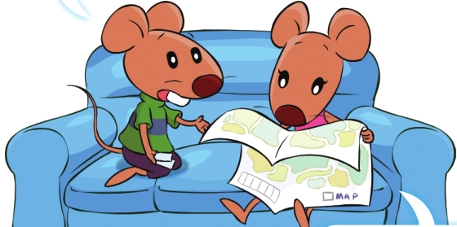

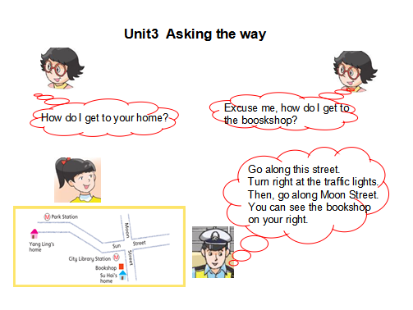
Excuse me,
How do I get to the …? where’s the ...? *It’s on ... Street/ Road.
Can you show me the way to …? It’s far/ near...
Which bus is for …? Go along ... Turn left/ right ...at ...
How many stops are there? We can go by bus/ taxi/ metro.√
get on/ off the ... at ...Statio

