新桥实验小学 英语 学科教学设计
五年级英语下册 |  | 第 4单元 | 课题：Seeing a doctor |  | 日期： 3月27 日
班级：五（1）（2） |  | 人数： | 课时：第二课时 |  | 执教：袁铮
一、教学目标：
1 能够准确回答story time 中的问题；
2 能理解并掌握运用Grammar time中人称代词宾格的用法和情态动词should的用法及规则；
3 能围绕Fun time中的图片进行pair work,。
二、教学目标设计依据：
1.内容分析：
Grammar time 涉及三个方面的内容：1、医生询问疾病用语以及主语发生变化时的问答句。2、建议用语。3、名词的复数否成规律。Fun time 版块出示了四组词组，词组旁边标注了相应的标志，让学生用教材给出出的对话进行角色表演，是对story time的复习和巩固。
2.学生分析：
通过回顾上学期所学内容，以及第一课时的学习，学生对疾病类单词已经有了基本的掌握，也会用What’s the matter ....？来询问对方，但是在交际运用中难免有些孩子还是会犯错，因此本课时结合grammar time和fun time对句型进行操练，加强学生对重点句型的理解。
教 学 过 程
活动板块 | 教师活动 |  |  | 学生活动 |  | 交流预设
Revision 1 | 1. Play a game.  Do you like playing games?  Let’s play a game “clown slide”, pay attention to the rule ,are you ready?  ,look at these words ,(read together)Can you put them in the right places ?  2. magic eyes. please look at the pictures and say the phrases as quickly and loudly as you can.  3. in the story, we know that Su Hai and Mike are both ill .They go to the hospital to see the doctor. Well ,What’s wrong with them? Here are some questions for you. Think carefully ,please.  1.What’s wrong with Su Hai?  2. What should Su Hai do? |  |  | 根据出示的单词快速说出同类单词。  Apple, China, run, I, me  I: you, he, she, we,…  Me: you, him, her, us…  Su Hai has a fever.  Su Hai should have a rest.  Su Hai should take some medicine.  Su Hai should drink some warm water. |  | Play a game，调动课堂氛围，激发学生积极性，并在这个环节复习单词。  Magic eyes加强学生对单词的理解，进行图文匹配。  通过几个问题引领学生回顾story time文本内容，学生利用should进行重现Su Haier的故事，同时操练了重点句型。
grammar time | let’s take a look at these sentences again. Can you find any differences?  From the story, we know Su Hai had a fever .well, what about Mike ?Here are three questions.  1.What’s wrong with Mike ?  2. What shouldn’t Mike do?  3. What should Mike do?  Look at these sentences ,let’s try to fill the blanks ,  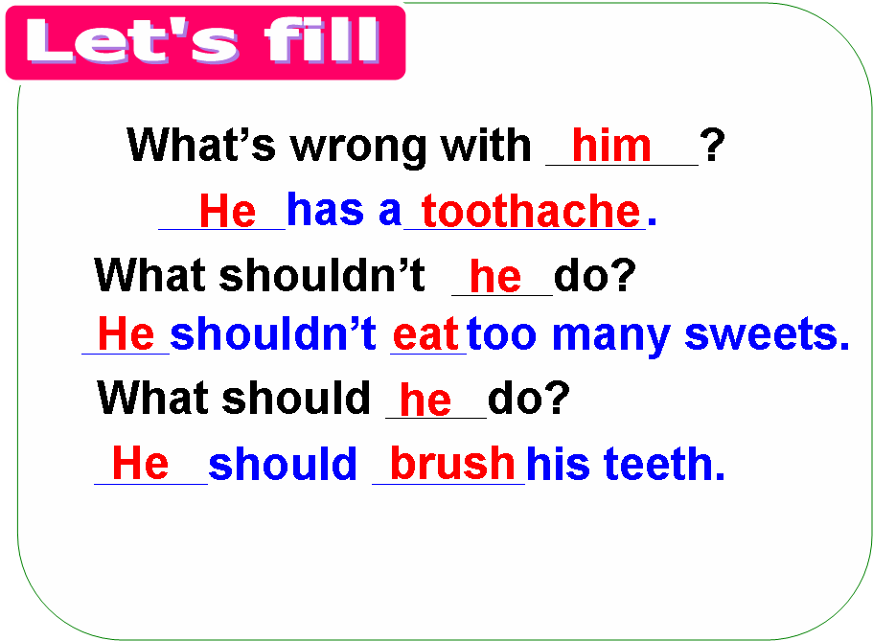 |  |  | Su Hai 换成了she 和her.  Mike has a toothache.  Mike shouldn’t eat too many sweets.  Mike should brush his teeth.  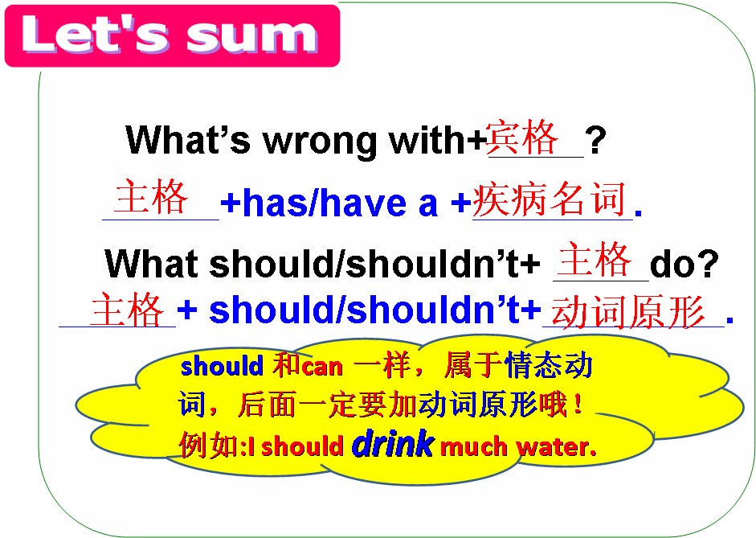 |  | 通过不同句子的比较分析，让学生发现不同。  通过几个问题回顾Mike的故事，并归纳出表示建议的句型should和shouldn't。  学生观察这几个句型，并讨论发现  句中人称代词主格和宾格的用法。
Fun time | Look at this girl, She looks uncomfortable. What’s wrong with her?  Please look at the pictures of page40  A : What’s wrong with him ?  B: He has a toothache.  A: what shouldn’t he do?  B: He shouldn’t eat sweets and eat before bedtime.  A: What should he do?  B: He should brush teeth before bedtime. |  |  | She has …  Ask and answer:  A : What’s wrong with her?  B: She has a ….  A: What should she do?  B: She should …. .  A: What shouldn’t she do?  B: She shouldn’t ….  Work in pairs. |  | 巩固操练关于疾病类的单词和句型。  把教材中的四幅图，由选择词组转化为学生两两对话，再一次巩固句型问答。
Consolidation | Mike likes eating sweets. Look at this boy, his name is Pangpang ,He likes eating sweets .He is always hungry. But he is not happy. Do you know why, let’s listen  Do you want to help him ?OK ,write a letter to him . |  |  | He is too fat .  Hello ,Pang pang.  Nice to meet you . I’m . I’m sorry to hear that. I want to help you. First, You shouldn’t . Next ,you shouldn’t . Then, you should . If you do that ,I’m sure you’ll be thin soon. |  | 纸上谈兵终觉浅，本课时最后要求学生动笔写一写，将本单元学习的建议用语言写下来。
Homework | 1 . Read and try to recite the story .  2. Finish “Think and write” .

