新桥实验小学英语学科教学设计
六年级上 册 |  |  | 第四 单元 | 课题：Road safety |  |  | 日期3月 16日
班级：六1，六2 |  |  | 人数：42，43 | 课时：1 |  |  | 执教：沈秀华
一、教学目标：
- 在情景中整体理解Story time的内容。
- 在 Storytime 的学习过程中掌握有关道路交通方面的新词 road, light, zebra crossing, pavement, look out for, easily, rules, follow，体会情态动词must及其否定must not 的用法，并能简单区分形容词safe,名词safety及副词safely的不同。
- 能用正确的语音语调朗读Story time。
- 能理解道路安全知识，尝试用英语说说道路交通规则。
- 能牢记过马路的交通规则，树立安全意识。
二、教学目标设计依据：
1.内容分析：通过怎样安全过马路引出了全文，首先要寻找斑马线，其次看交通信号灯，懂得红灯停，绿灯行。如果附近没有斑马线，要安全过马路的话，可以走人行道或选择和其他人一起过马路，但也要注意观察前后左右的车辆。

2.学生分析：学生虽然有一定基础，但本单元对他们来说存在很大难度，没有五年级新版教材的基础，教师需要更细的指导。首先充分利用书本，根据书本上的图片让意和形结合，充分调动学生的感知，让学生学的愉快而轻松。其次，让学生以旧带新，并且新旧结合，滚动复习，拓展语言运用面。最后丰富学生的语言知识，通过模仿角色进行表演的方式让学生真正用到所学语言。
教 学 过 程
时间 | 活动板块 | 教师活动 |  |  | 学生活动 | 交流预设
 | 常规积累 | 出示一组名词，动词，形容词 |  |  | 学生朗读，并发现规律，尝试举例。拓展
 | 活动一  ……  活动二  …… | Teach: road , safe, safety, safely, cross, rules  - Free talk: T: How do you go to school? How does your mother\father go to work?  T: 总结 ： Every day, we walk or drive on the road.  2. Look at some pictures. (看一些行人、司机图片)  - Look and judge. Are they right? Ss: Yes, yes, yes! \No. no, no!  - Lead-in: T：揭题：Today we are going to talk about “Road safety”. |  |  | S: On foot or by bike\bus\car  There are many busy roads in the cities. How can we cross the roads safely?  （让学生表达自己已有的生活经验，了解学生的语言基础。）  Ss: 学生自由说说交通规则：eg: We must look for a zebra crossing. We must look at the traffic lights. | 用How...提问，激发学生已有的学习经验，回忆有关交通的单词，并进入本课学习内容。  学生根据教师提供图片或单词或提示语独立观察思考，并向全班分享自己的理解，其他学生补充。  独立阅读思考指名回答  达成目标1

时间 | 活动板块 | 教师活动 | 学生活动 | 交流预设
 | 活动三  ……  Step 3 Post-reading | 学习课文第一部分  T: How can we cross the roads safely ？Let’s learn from the storytime.  - Read freely  - Try to answer with “first…,then…”  - Read together  - Teach: green\red man  T: What is green man? What is red man? What do they mean?  The policeman tells us. Let’s read and act.  4）Read and act the policeman.  T: When the light is green , that means we can cross the road  When the light is red, that means we must not cross the road.  What about the yellow man?  自读课文，学习课文第二部分  T:But sometimes you cannot find a zebra crossing near you.How can we cross the road safely?  看图讨论，学习课文第三部分  呈现课文第三部分的两张插图(加上一幅奔跑穿过马路的同学)  T: What can you see in the pictures?  T: Is it safe?  Why?  So what rules do you know?  T: We must follow the rules and stay safe on the road!  4. 整理理解，巩固  1. Today we learnt some rules about road safety.  Let’s sum up.（板书并附上图片）  - Look and say.(书上 P38 )  回到开头提供的图片，用英语描述解释 Why yes.\ Why no.  1. Learn some proverbs about the road safety.  Never forget about safety.  Safety is as simple as ABC--- Always Be Careful. | 学生自读完之后用自己的语言归纳。  Finish the form:  Ss: （根据学生已有知识经验）It means “wait”  That is to say.Red man means stop, green man means go, yellow man means wait.  - Read freely. And try to get the main imformation.  - Line down the answers of these queations.  Questions：  ①Where must we wait before we cross the road?  ②What should we do when we wait?  ③How should we look out for the traffic?  ④Is it a good idea to cross the road with other people? Why?  - Checkout the answers.  回答问题并完成表格信息。  Ss: Some boys are playing football by the road. A boy is skating\running on the road.  Ss: Because there are many cars and bikes on the road.  Ss: We must not run or play on the road.  1) Watch and repeat.  2) Reading the text.  3) Think and write.( 书上P 38)  Rule1: look for a zebra crossing,…  Rule2: wait on the pavement,…  Rule3: don’t run or play on the road.  (Learning tip: The pictures can help you cross the road safely  T: What must you do to cross the road safely?  Ss: We must…  T: What must you not do on the road?  Ss: We mustn’t… | 教结构：When there is a zebra crossing, To cross the road safely ,first....., then..., next..., finally.......  用已经学会的结构，对没有斑马线的情况下， 如何安全过马路，用first..., next...,then.... Finally...进行描述。
  No zebra crossing
  Wait on the pavement.
  Look out for cars and bikes.
  Look left first, then right and then left again
  Cross the road with other people.
  At the zebra crossing
  first | Look at the traffic lights
  then | Wait for the green man
 | 三、练习设计 | 1) Read the story time fluently（ Read well ）.  2) Collect more rules about “Road Safety.” |  | 练习指导
板书设计： Unit 4 Road Safety
Rule1：We must look for a 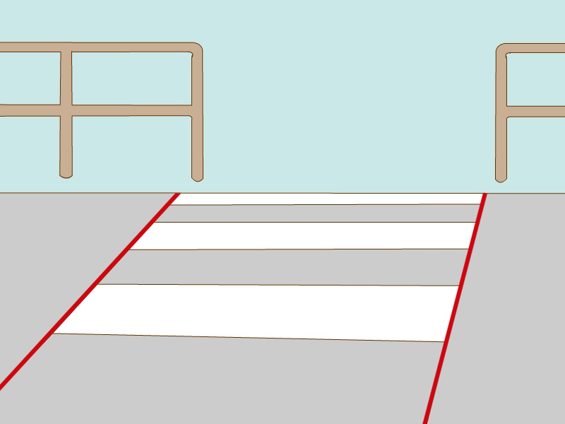 and look at the 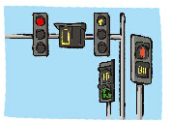.
Rule 2：We can wait on the 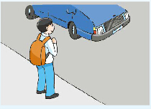 and look out for cars and bikes.
We can also cross the road with 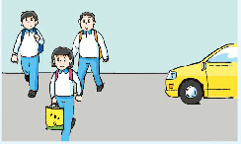.
Rule 3：We must not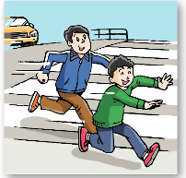 or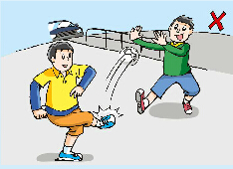 on the road.

新桥实验小学英语学科教学设计
学校： |  |  |  | 班级：六（1）（2）班 |  | 人数：42，43 |  | 日期:3.17
课题：6B Unit 4 Road safety (period 2) |  |  |  |  |  | 教时：2 |  | 执教： 沈秀华
一、教学目标：
1.复习story time 相应单词和词汇：green man、red man、a zebra crossing、wait on the pavement、play on the road、traffic lights…
2.学习句型What must you do on the road? I must… / What must you not do on the road? I mustn’t…
3. 通过海报的制作，培养学生自己遵守规则并监督他人遵守规则的公民意识。
4. 在教学中培养学生的观察能力、想象能力、探究能力、思维能力、表达能力等。
二、目标制定依据：
1、教材分析：
本单元围绕“行路安全”这一话题，呈现了若干行路规则和安全知识，旨在引导学生树立正确国马路的安全意识。这一话题与学生的生活紧密相关，教师在教学过程中可以联系生活实际，鼓励学生认识更多交通标识。本版块是一个关于安全行路的知识问答游戏，要求学生小组活动，一人充当小交警，进行提问，其他学生用must和mustn’t表达在马路上行走时要注意的事项，即必须做的事情和不能做的事情。教师可以将本次作为story time的巩固活动，也可以拓展场景，如：教室、宿舍、食堂、教室、校门口等，以便让学生开展更多的操练活动。并在教学过程中介绍中英两国不同的道路通行制。
2、学情分析：
本单元的教学内容贴近学生的生活，具有教育性和话题性。本班大部分学生学习积极性较高，思维比较活跃，也擅于表达，但也有一部分学生学习态度不够端正，在学习中有畏难情绪，还有一部分学生善于书面表达但羞于口头表达，本节课完全采用小组合作的方式制作海报，给了每一个学生动手动脑的机会。
教 学 过 程
Time | Procedure |  | Teacher’s activities |  | Learners’ activities |  | design idea
5  min | Pre-reading |  | 1．Review  2．Ask and answer  3．Play a game |  | - Say the words and phrases.  - Answer the questions.  - I’m a policeman. |  | 通过游戏复习第一课时的单词和词组并复习句型：What must you do on the road? I must…  What must you not do on the road? I mustn’t…
25min | While-reading |  | 1. Think and say  Help the family from the UK.  2. Culture time  3. Complete the poster of classroom rules.  4. Put up the poster  5. Try to say |  | - You must…  You mustn’t  总结语法规律  描述规则和规定有以下三种句式：can/should/must加动词原形 名词、名词短语 祈使句Don’t…  - In the UK…  In China…  How to drive in different countries?  The road safety in history.  3. Think and write.  4.put up the poster  - Talk about the rules in different places. |  | 让学生在帮助来中国参观的英国家庭的过程中让学生复习行路安全，以及句型： You must…You mustn’t…  巧妙地在游戏中拓展中西方交通化知识。并把文化知识作为阅读语篇，提高学生的阅读能力。  从行路规则自然过渡到教室规则，先让学生感知海报的基本形式，为接下来学校内其他区域的海报制作奠定基础。  让学生先分组讨论学校里哪些地方还需要海报，并进行规则的内容的讨论，为海报的制作打下基础。
10min | Post–reading  Assignment |  | 1. Make a poster.  2. Show the posters  Homework  1.Try to make the posters perfect(完美) and put them on the places.  2. Follow the rules by yourselves and ask other people to follow them.  3. Try to get more information about the road safety. |  | 1. Make a poster.  2. Enjoy the posters  Rule：将学生分成五人一组，仿照Fun time范例，三人分别演Sam, Bobby 及 Tina提出问题，由另外两人演小导游替他们解决问题。  Work in groups |  | 通过小组分工合作的方式让学生完成海报，在制作海报的过程，促使每个学生得到发展。  在展评海报的过程中让学生学会欣赏，学会认识自己的不足，学习他人的优点。  让学生美化海报并贴在相应的区域，监督自己和他人认真执行，培养学生的公民意识。并让学生获取更多的行路安全矮的知识，培养学生手机资料的自主学习能力。
Blackboard writing |  | 6B Unit 4 Road safety (period 2)  New words  Classroom rules  New phrases
新桥实验小学英语学科教学设计
六年级上 册 |  |  | 第四 单元 | 课题：Road safety |  |  | 日期3 月17日
班级：六1，六2 |  |  | 人数：42，43 | 课时：3 |  |  | 执教：沈秀华
一、教学目标：
1. 能用正确的语音语调朗读cartoon，在熟读的基础上分角色朗读。
2. 能了解中外交通规则的差异。
二、教学目标设计依据：
1.内容分析：通过跟读磁带，让学生了解到在陈述句里某些单词要重度，让学生在读中思，在思中学。为了能更好地掌握学生的学习状况，本单元在Ticking time的设计时，明确了教学目标。通过练习和操练让学生能直观地认识到自己的不足。

2.学生分析：
根据书本上的图片让意和形结合，充分调动学生的感知，让学生学的愉快而轻松。其次，让学生以旧带新，并且新旧结合，滚动复习，拓展语言运用面。最后丰富学生的语言知识，通过模仿角色进行表演的方式让学生真正用到所学语言
教 学 过 程
时间 | 活动板块 | 教师活动 |  |  | 学生活动 | 交流预设
 | 常规积累 | 出示各国的国家名称 |  |  | 朗读国名
 | 活动一  ……  活动二  ……Step2.Culture time | Greeting  Listen, read and judge  Rules:Say yeah, yeah, yeah, if you think it is true.  Say No, no, no, if you think it is false.  Judge the last sentence above.  T: Is it true?  T: Yes, in China, people drive on the right side of the road. |  |  | You go to school by bus.  We must cross the road on the zebra crossing.  We can’t wait for the green man.  The driver can drive after drinking.  First get on, then get off.  We mustn’t play on the road.  We mustn’t look at the traffic lights.  We must cross the road safely.  We walk on the left side of the road.  Ss: No. We walk on the right side. | 给予各种情景，了解正确过马路的方法，并能用语言描述。  独立朗读思考  师个活动作示范  两两讨论，班内交流思考结果，教师适当评价。  用已有的情景，引入本课的文化部分，了解各国的交通规则。

时间 | 活动板块 | 教师活动 | 学生活动 | 交流预设
 | 活动三  ……  Step 3 Cartoon time | But ,there are two places, they are not like this. Do you know where they are?  1.T: Now Bobby and Tina wants to get out Let’s watch the cartoon and answer the questions.  T: We must look at the traffic lights and cross the road with other people, drivers can see you easily.  Encourage the Ss to collect the information from the whole text.  The bus stops two times. The bus stops the first time, because there is a red light. The second one ,because some elephants are crossing the road.  4.T: What can you find from this story? | Read the Culture time and find them.  Learn the new words: except, Macau.  Q1:Where do Bobby and Tina want to go?  Q2 How do they get there?  Q3: How many times does the bus stop? Why?  2. Read the cartoon and answer the questions.  The bus stops two times, why ?  Ss: We must follow the traffic rules. Before outing, we must choose the right traffic tools. | Cartoon time的学习，让学生自主阅读，找准关键词，理解文本。并学习复述文章内容。
 | 三、练习设计 | 练习内容设计  Retell the story.  Bobby and Tina go to see their aunt Alice. They call aunt Alice. Aunt tells them they can take a bus to get there. They gets on the bus. They see many cars on the road. They’re going fast. The bus stops, because there is a red lights. Later the bus stops again, because there are some elephants crossing the road. |  | 注意三单形式的正确运用
板书设计：Unit4 Road safety
drive on the left\right side of the road
except Hong Kong and Macau
take the bus get on

新桥实验小学英语学科教学设计
六年级上 册 |  |  | 第四 单元 | 课题：Road safety |  |  | 日期：3月 18 日
班级：六1，六2 |  |  | 人数：42，43 | 课时：4 |  |  | 执教：沈秀华
- 教学目标：
- 按要求掌握本单元单词、句型和日常用语。
- 理解所学情态动词的用法，在做习题的过程中巩固运用。
- 能够在表演和复述故事的过程中体会语言的运用。
- 通过Checkout time和Ticking time的学习来评价自己本单元的学习情况。
二、教学目标设计依据：
1.内容分析： 这一课时涉及到两部分，第一部分Cartoon time, 讲述的是Bobby和Sam 一起去坐公交车看望他们的阿姨，一路上讨论着安全行驶规则，涉及到以下知识点：（1）关于交通安全准则的词组；（2）含有情态动词的句子以及其用法，这一部分涉及到的语法知识点较多，通过设置悬念等方法，激发学生学习的热情。
2.学生分析：在字母发音上要让学生学会方法，自己归归类，自己总结发音规律，方便记忆。同时也要指导学生练习单词重音和句子重音，培养学生的朗读节奏和语感。

教 学 过 程
时间 | 活动板块 | 教师活动 |  |  | 学生活动 | 交流预设
 | 常规积累 | 1. Greetings: Date/Weather.  2. Revise the story in Cartoon time  3.PK time. |  |  | Talk about the rules on the road and at home. Boys use the sentence: We must….. Girls use the sentence: We mustn’t… | 利用书上的图片，指名个别组进行全班交流  教师和学生适当评价。  指名读，其它学生和教师评价
 | 活动一  ……  Step1.revision  活动二  ……  Step2. Checkout time and Ticking time | 1. Free talk  T: How are you this morning?  Nice to meet you.  How do you come to school?  Do you know any traffic rules? Can you tell us?  What must you do to cross the road safely?  What must you not do on the road?  Which side of the road do you walk?  - Read and circle  - ) Ask and answer  出示课文红人、绿人挂图  T：Can we cross the road? (红灯)  T：Can we cross the road? (绿灯)  出示斑马线的图 |  |  | 回答问题  Act the cartoon  Ss: No, you can’t. You must wait.  Ss: Yes, you can. | 通过各种问题的快速操练，复习已学句型，将复习和新授结合。  根据情境，将课文内容进行整合复习，进行语段输出。

时间 | 活动板块 | 教师活动 | 学生活动 | 交流预设
 | 活动三  ……  Step 3 Ticking time  Step4.Consolidation | T: Must I walk on the zebra crossing to cross the road?  2)Read and circle  checks.  3) Make dialogues.  T: You are in the library now, please make dialogues with Can I\ Must I…?  T: This is our classroom. It is beautiful. Try to make our classroom better, we must make it clean and tidy（整洁）。 We must follow the rules everywhere.  We must not throw the rubbish.  We must （not） …  Teacher checks.  1. Make Park rules ，Family rules, Library rules …in groups.  2.做《补充习题》 | Ss: Yes, you must.  Look at the pictures , read and circle. Work in groups.  Work in groups.  Think and write  Complete the poster with “must” and “must not”.  Complete alone, then check in groups.  Read the rule loudly. (注意对个别单词的重读)  (通过上面的教学，小组内互相评价) | 引导学生将已学的知识进行整合，能用已学知识编一完整的对话。
 | 三、练习设计 | I’ll Show You the Way  A driver: Hello, sir. I want to go to the Moon Hotel. Do you know it?  An old man: Yes ,let me get on, I’ll show you the way.( They drive about ten miles, and come to a small house.)  An old man: Stop here!  A driver: But this isn’t a hotel.  An old man: No, this is my house. And now I’ll show you the way to the Moon Hotel. Go back nine miles. Then you’ll see the Moon Hotel on the left.  回答问题：  - Where does the driver want to go?  - Where does the old man take him?  - Why doesn’t the old man stop the driver when they pass the hotel?  4. How many miles does the driver go to the Moon Hotel altogether? |  | 引导学生进行有效朗读，正确回答问题。
Unit 4 Road safety
Our classroom rules

