2019～2020学年度第一学期期中质量调研
九年级英语试题
2019.11
（考试范围: 至牛津初中英语9上 Unit4）
注意事项：1．本试卷共10页，满分100分。考试时间90分钟。
2．请将答案全部填写在第8—10页的答题纸上，在1—7页上答题无效。
第一卷（共71分）
一、听力（共20小题；每小题1分，满分20分）
A) 听下面10段对话。每段对话后有1个小题，从题中所给的A、B、C三个选项中选出最佳选项。听完每段对话后，你都有10秒钟的时间来回答有关小题和阅读下一小题。每段对话读两遍。
1. Which animal sign are the two speakers talking about?
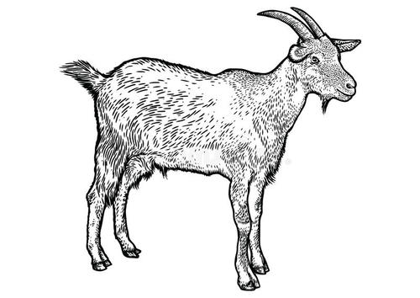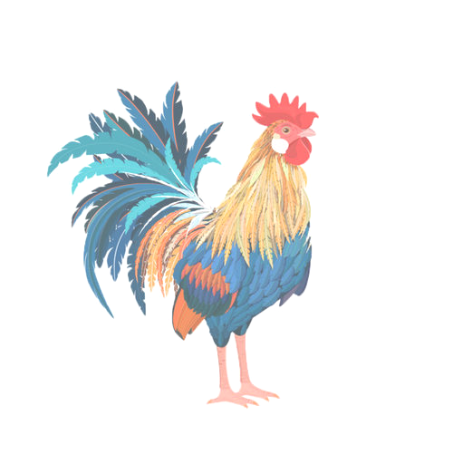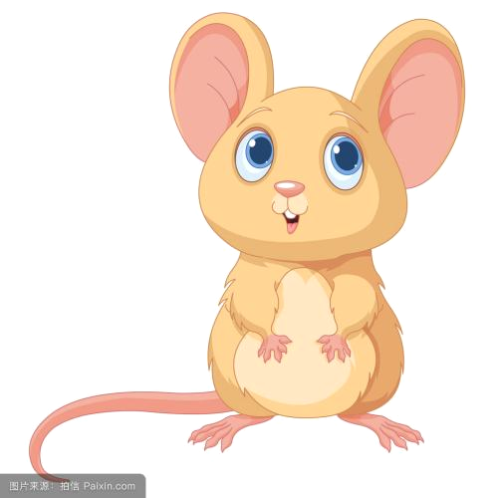
2. How does Millie feel now?
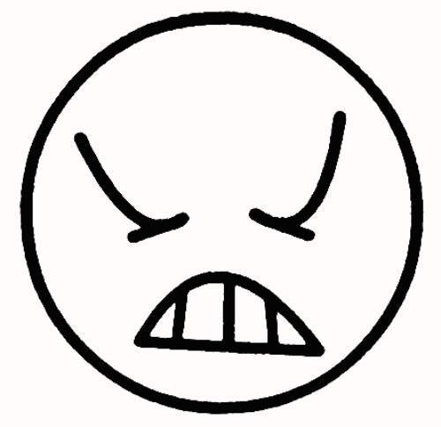
3. What’s the girl’s problem?
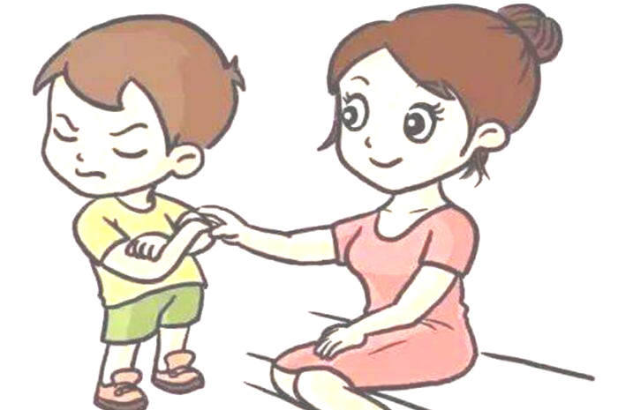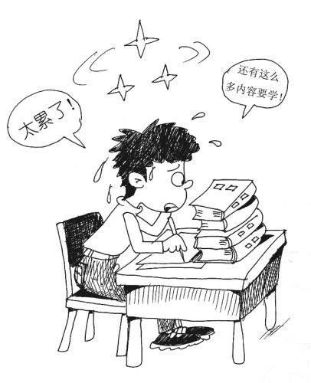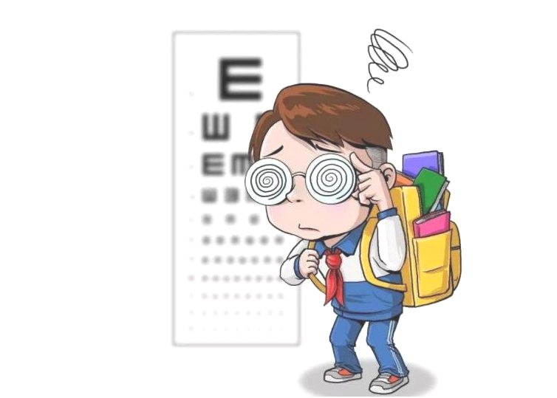
4. What job is suitable for Mike and Sam?

5. What does the boy advise the girl to do?
A. To do some exercise. B. To have a good sleep. C. To listen to some light music.
6. What can’t the boy do after 9:00 p.m.?
A. He can’t watch TV.
B. He can’t play computer games.
C. He can’t play the piano.
7. Why didn’t the man catch the plane?
A. Because he didn’t start early.
B. Because he didn’t know the way to the airport.
C. Because the traffic was too heavy.
8. What colour should Sandy use?
A. Grey. B. Black. C. Yellow.
9. How often does the bus come?
A. Every 3 minutes. B. Every 5 minutes. C. Every 8 minutes.
10. What can we learn from the dialogue?
A. The girl has finished her Science homework.
B. The boy has finished his Maths homework.
C. The boy has finished his English exercises.
B）听对话或独白。每段对话或独白后有几个小题，从题中所给的A、B、C三个选项中选出最佳选项。听每段对话或独白前，你将有时间阅读相关小题，每小题5秒钟。听完后，每小题你仍有5秒钟的时间来选择你认为最合适的答案。每段对话或独白读两遍。
听第一段对话，回答第11—12小题。
11. What’s the matter with Molly?
A. She has a headache. B. She fails in the exam. C. She feels sad.
12. What kind of problems are the two speakers talking about?
A. Traffic. B. Noise pollution. C. Overwork.
听第二段独白，完成信息记录表第13—15小题。
A visit to Mauritius (毛里求斯)
Country | Mauritius is an island country with 13 around it.
Sports | You will see people playing beach volleyball, fishing and swimming.
The most  Beautiful moment | When you enjoy the white beaches, beautiful 14 and clear water,  you may think you are in heaven.
Languages | 15 .
13. A. sea B. mountains C. rivers
14. A. sunshine B. sunrises C. sunsets
15. A. English, French and German B. English, German and Japanese C. English, French and Russia
听第三段独白，回答第16—20小题。
16. Where was Bruce Lee born?
A. In Hong Kong. B. In America. C. In Beijing.
17. Whom did Bruce Lee first appear in a film with at the age of two?
A. His mother. B. His brother. C. His father.
18. What was Bruce Lee interested in after going back to Hong Kong?
A. Chinese kung fu. B. Dancing. C. Acting.
19. When did Bruce Lee make the film Enter the Dragon?
A. In 1941. B. In 1966. C. In 1973.
20. How old was Bruce Lee when he died?
A. 30. B. 33. C. 35.
二、单项填空 （共10小题；每小题1分，满分10分）
从A、B、C、D四个选项中，选出可以填入空白处的最佳选项。
21. — Let’s go to see a film this weekend. Shall we go on Saturday or Sunday?
— ________ is OK. I’m not free at weekends.
A. Each B. Either C. Every D. Neither
22. As a student, you can ________ when having exams.
A. not be too careful B. be not careful enough
C. not care enough D. be enough careful
23. — Can you guess if Mike ________ swimming with us this afternoon?
— I think he will go with us if he ________ free.
A. goes; is B. will go; will be C. will go; is D. goes; will be
24. If you ________ for computer games, you will feel sleepy in class the next day.
A. pick up B. give up C. stay up D. take up
25. The sales of Huawei Mate 30 have reached an amazing number ________ we know it.
A. after B. before C. when D. since
26. — Excuse me, could you please tell me ________?
— Yes. There is a history museum.
A. how often do you go to the history museum
B. are there any good museums in Changzhou
C. how long it takes to get to the history museum
D. if there are any good museums in Changzhou
27. — Why didn’t you answer my call?
— Sorry. I ________ an old friend and we ________ all the time.
A. have met; are talking B. have met; were talking
C. met; are talking D. met; were talking
28. When I am feeling angry, I prefer ________ around the lake ________ myself down.
A. to walk; than calm B. to walk; to calm C. walking; to calming D. walking; than calm
29. — I will take you to Venice if you finish reading the book Merchant of Venice and pass the test.
— Is it a ________? I’m sure I’ll go there with you.
A. promise B. chance C. trick D. treat
30. — I hate watching TV ads. It’s just a waste of time.
—________. They are the last program I ever want to watch.
A. Good idea B. That’s OK C. I can’t agree more D. That’s not the case
三、完形填空（共12小题；每小题1分，满分12分）
阅读下面短文，掌握其大意，然后从每小题所给的A、B、C、D四个选项中，选出可以入空白处的最佳选项。
One day, a professor(教授) entered the classroom and asked his students to prepare for a surprise test. Students waited anxiously(焦虑地) as the professor 31 the question papers, with the text facing down as usual. After a while, they turned the page over. To everyone's surprise, there were no 32 , just a black dot (点) in the center of the page. The professor, just explained, “I want you to write what you 33 there.”
The students, confused, got started on the inexplicable (令人费解的) task.
At the end of the class, the professor 34 all the answer papers and started reading each one of them aloud in front of all the students. All of them, with no 35 , described the black dot, trying to explain its position in the middle of the paper, etc. After all had been read, the classroom was silent. The professor continued to explain,
“I’m not going to grade this. I just wanted to give you something to 36 . No one wrote about the 37 part of the paper. Everyone focused on(集中注意力于) the black dot, and the same happens in our 38 . We have a white paper to watch and enjoy, but we always focus on the dark dot. Our life is a 39 given to us with love and care and we always have reasons to celebrate: nature renewing itself every day, good friends around us and the miracles(奇迹) we see every day.
40 , we keep focusing only on the dark dots: the health problems that trouble us, the lack of money, the 41 relationship with colleagues(同事), the disappointment with a friend, and etc.
Compared to(相比较) everything we have in our lives, the dark dots are very 42 . But they are the ones that pollute our minds. ”
31. A. handed out B. turned up C. gave up D. pointed at
32. A. exercises B. choices C. questions D. scores
33. A. remember B. imagine C. study D. see
34. A. collected B. finished C. marked D. chose
35. A. excuse B. doubt C. exception D. explanation
36. A. look for B. think about C. care for D. turn on
37. A. big B. black C. beautiful D. white
38. A. lives B. classrooms C. colleges D. studies
39. A. strength B. gift C. stress D. lesson
40. A. However B. Therefore C. Besides D. Moreover
41. A. close B. poor C. special D. strong
42. A. dark B. round C. small D. dirty
四、阅读理解（共12小题；每小题2分, 满分24分）
阅读下面短文，从各题所给的A、B、C、D四个选项中，选出最佳选项。
A
Trip 1 Black Bear Count
There have been fires in this area in the last few years and the Office of the National Park is not sure how many black bears are still living. Some bears have been seen since the fires, and the Office has asked for young people to help count them. The whole trip will last three hours. Bookings(预订) necessary.
Cost: Free When: May 8
Trip 2 Garland Valley
Bring your drink and lunch for this walk in a beautiful area of the Blue Mountains. Garland Valley is close to the town of Garland but is part of the National Park. Many wild animals live in this area, including many rare birds. This is a great walk for bird-lovers. The trip lasts four hours. Bookings necessary.
Cost: $ 15 When: May 8, May 15
Trip 3 Flashlight Adventure
Put on your warm clothes, bring a flashlight and a pair of glasses, and come for a night walk along the Dungog Valley. A guide will lead the tour. Many of the animals you will see on this trip can only be seen at night. The guide will tell you about the lives of the animals you see. Numbers are strictly limited on night trips, so be sure to book early. This walk lasts two and a half hours.
Cost: $ 12 When: May 8, May 15, May 22
Equipment(装备) to be needed:
• Please bring enough water and food for all walks.
• Wear good walking shoes — no high heels.
• Wear a hat for day walks.
• Dress warmly for night walks.
• Children must be with an adult.
• Make sure your flashlight works well and bring extra batteries(电池) for night walks.
• Follow all instructions from guides during the walks. The mountains are a dangerous place.
Bookings:
• Bookings for the above trips can be traded by telephone (8934847) or on the Internet at www. Bluemountaintour.com.
43. Where are these trips?
A. In a large city. B. In a park in the mountains.
C. In a special kind of zoo. D. In three different countries.
44. On which trip might you see animals that sleep during the day?
A. Black Bear Count. B. Garland Valley.
C. Flashlight Adventure. D. None of the trips.
45. Which of the following is NOT necessary for the three trips?
A. Good walking shoes. B. A pair of glasses.
C. Food and water. D. A sleeping-bag.
46. What kind of article is this passage?
A. A news report. B. An advertisement.
C. A going-out plan. D. A travelling guide.
B
Q: There is a Chinese idiom(习语) “loumajiao”. It means that a secret has been revealed. Where does the idiom come from?
A: In one story, “loumajiao” is connected to Empress (皇后) Ma. She was the wife of Zhu Yuanzhang, the first emperor of the Ming Dynasty.
In the past, people thought small feet were more beautiful than big feet. So young girls would bind (捆绑) their feet to prevent them from growing bigger.
But the young Ma liked to practice martial arts (武术). She didn’t want to bind her feet. So her feet grew larger than other women’s feet.
After she became empress, Ma hid her feet under a long gown (袍子). One day, when she was sitting in a palanquin (轿子) near a busy street, a strong wind blew her gown up. She was not able to hide her feet in time. Many people saw her feet and quickly spread the word across the country. The idiom “loumajiao” comes from this story.
However, research shows that “loumajiao” may have in fact come from a kind of ancient celebration.
The qilin is a mythical creature(虚构的生灵) that stands for good luck. In ancient times, people would paint a “qilin skin” on a large piece of cloth. They put the cloth on a horse so that the horse would look like a qilin. However, the horse’s feet were hard to cover up and could easily be seen. So as time passed, “loumajiao” came to mean “revealing a secret”.
47. What does the underlined word “reveal” probably mean?
A. 传播 B. 隐藏 C. 泄露 D. 分享
48. Empress Ma __________.
A. didn't like martial arts B. hated binding her feet
C. the only wife of Zhu Yuanzhang D. liked to wear long gown
49. Which of the following is TRUE according to the passage?
A. There are three stories connected with “loumajiao”.
B. The qilin is a symbol of good luck and much wealth.
C. “Loumajiao” has a history of more than 1000 years.
D. There are no ways to prove the origin(起源) of “loumajiao”.
50. Where may you read this article most probably?
A. In a culture newspaper. B. From a science report.
C. In a western story. D. From a social survey.
C
When I learned that my 71-year-old mother was playing Scrabble — a word game — against herself, I knew I had to do something. My husband suggested we give her a computer to play against. I wasn’t sure my mother was ready for it. After all, it had taken 10 years to persuade(说服) her to buy an electric cooker. Even so, we packed up our old computer and sent it to my parents’ home. And so began my mother’s adventure(冒险) in the world of computers.
It also marked the beginning of an unusual teaching task for me. I’ve taught people of all ages, but I never thought I would be teaching my mother how to do anything. She has been the one teaching me all my life: to cook and sew, to enjoy the good times and put up with the bad. Now it was my turn to give something back.
It wasn’t easy at the beginning. There was so much to explain and to introduce. Slowly but surely, my mother caught on, making notes in a little notebook. After a few months of Scrabble and other games, I decided it was time to introduce her to word processing. This proved to be a bigger challenge to her, so I gave her some homework. I asked her to write me a letter, using different letter types, colors and spaces.
“Are you demanding(要求) with your kindergarten pupils?” she asked.
“No, of course not,” I said. “They already know how to use a computer.”
My mother isn’t the only one experiencing a fast personal growth period. Thanks to the computer, my father has finally got over his phone allergy(过敏反应). For as long as I can remember, any time I called, my mother would answer. Dad and I have had more phone conversations in the last two months than we’ve had in the past 20 years.
51. What does the writer do?
A. She is a cook. B. She is a teacher.
C. She is a housewife. D. She is a computer engineer.
52. The writer decided to give her mother a computer __________.
A. to let her have more chances to write letters B. to support her in doing her homework
C. to help her through the bad times D. to make her life more enjoyable
53. The writer asked her mother to write her a letter __________.
A. because her mother had stopped using the telephone
B. because she wanted to keep in touch with her mother
C. so that her mother could practice what she had learned
D. so that mother could be free from housework
54. After the computer was brought home, the writer’s father __________.
A. lost interest in cooking B. took more phone calls
C. played more games D. began to use it
五、任务型阅读（共5小题；每小题1分, 满分5分）
阅读下面短文，在表格内的空白处填入合适的答案(每格限填一词)。
There are many things you can do to keep friendship strong forever.
Trust is very important in keeping any relationship strong and long lasting. If you trust the person whom you have a good relationship with and the other person also trust you in the same way, then you two have a good relationship.
You can remember important dates of your friends such as their birthdays and wish them or give gifts to them on the special days. Friendship is not about money. You can find something small and inexpensive for their gifts or send online cards.
A friend should also always help others even when it is not very convenient. Being together with and being helpful to your friends always make your friendship deeper.
Sometimes distance makes relationships even closer. So, if you are far from your friends, there are many ways you can remain in touch. If there is anything that makes you happy, share it with your friends. Listen to their thoughts as well. If they have achieved something noticeable, congratulate them and celebrate with them.
I have seen good friendships go missing when there is unhealthy competition between two friends. Though this may not happen in many cases, it is better to keep this idea in mind since it may happen to you.
As far as I have seen and experienced, it will be better not to either lend money to or borrow money from your good friend. Of course, you have to do this with friends sometimes. But, attention should be paid so that your friendship may not end.
55 to Keep Your Friendship
Tips | Details
Something  should be  done | * Don’t 56 your good friend so that he or she will treat you the same way.  * Give your wishes, gifts or greetings to your friends on their birthdays.  * Be ready to give a 57 to your friends as much as possible.  * Use modern technology to contact your friends far away. Share the happiness with your friends. Congratulate your friends on their 58 and celebrate them together.
Something  should not  be done | * Don’t try to compete with each other in an 59 way.  * Don’t lend money to or borrow any money from your good friend, otherwise it may end the friendship.
2019～2020学年度第一学期期中质量调研
九年级英语答题纸
2019.11
第一卷 (共71分)
一、听力（共20小题。每小题1分，满分20分）
题 号 | 1 | 2 | 3 | 4 | 5 | 6 | 7 | 8 | 9 | 10
答 案
题 号 | 11 | 12 | 13 | 14 | 15 | 16 | 17 | 18 | 19 | 20
答 案
二、单项填空（共10小题。每小题1分，满分10分）
题 号 | 21 | 22 | 23 | 24 | 25 | 26 | 27 | 28 | 29 | 30
答 案
三、完型填空（共12小题。每小题1分，满分12分）
题 号 | 31 | 32 | 33 | 34 | 35 | 36 | 37 | 38 | 39 | 40 | 41 | 42
答 案
四、阅读理解（共12小题。每小题2分，满分24分）
题 号 | 43 | 44 | 45 | 46 | 47 | 48 | 49 | 50 | 51 | 52 | 53 | 54
答 案
五、任务型阅读（共5小题。每小题1分，满分5分）
55． 56． 57．
58． 59．
第二卷（共29分）
六、词汇运用（共8小题；每小题1分, 满分8分）
（A）根据句意，用所给单词的适当形式填空。
60. Little Tom often turns to his father for ____________(suggest) when meeting with problems.
61. If the problem can be __________(peace) solved, we can avoid (避免) a lot of trouble.
62. Mr. Li is humorous enough to make his speech especially __________(live).
63. The loud sound of the thunder broke the __________(silent) of the summer night.
（B）根据句意及所给汉语提示完成单词拼写。
64. The little dog is one of his most __________ (宝贵的) presents sent by his friends.
65. My father thinks cars made by __________(德国人) have good qualities.
66. Though he was strongly__________(反对)your idea, he couldn’t offer his own advice.
67. — What colour did he like when he was a little boy?
— I can’t tell. But I know that he __________(宁愿选择) green clothes when he was tired.
七、请用所给动词的适当形式填空（共5小题；每小题1分, 满分5分）
68. Look! The rain __________ (stop). Let’s go home at once.
69. I don’t know what I should pay attention to __________ (improve) my study.
70. What do you think __________ (happen) to John if he finds his car has been stolen?
- —Why didn’t you go to Millie’s party yesterday evening?
—Well, I planned to go, but I __________(not invite).
- My brother __________ (fall) off the bike and hurt himself badly.
八、句子翻译（共6小题；每小题1分, 满分6分）
73. 你能告诉我这篇文章可以分成几部分吗？
Could you tell me _____________________________________________________________?
74. 这个五岁的女孩昨天与美国朋友交谈毫无困难。
This _____________________________________________________ foreign friends yesterday.
75. 她宁愿被嘲笑，也不愿说出真相。
She would _____________________________________________________________ the truth.
76. 你能想象没有手机的生活是什么样子的吗？
Can you__________________________________________________________mobile phones?
77. 好好复习你所学的内容能使你更容易得高分。
_________________what you have learnt __________________________________________.
78. 玛丽成功地想出了一些创造性的点子来确立领先地位。
Mary __________________________ with some creative ideas _________________________.
九、书面表达（满分10分）
请以The person I admire most 为题，写一篇英文短文，向校报投稿。你可以参考下列表格，也可以自由发挥。
Part 1 | Brief introduction
Part 2 | Why you admire him/her most
Part 3 | Your thoughts or hopes
注意：1. 表达中不得提及真实校名、班级和姓名。
2. 字数100左右（标题已给，不计入总词数）。
The person I admire most
(10词)
(20词)
(30词)
(40词)
(50词)
(60词)
(70词)
(80词)
(90词)
(100词)
(110词)
(120词)

