译林版小学五年级英语下册阶段调研测试题
考试时间：45分钟 满分：100分
班级 ______ 姓名 _______得分______
一、语音（共8分）
A）从每组词中选出一个其中划线部分读音与其他两个不相同的选项。（共4分）
( ) 1. A. growing B. orange C. morning
( ) 2. A. sheep B. teach C. chicken
( ) 3.A. drink B. driver C. try
( ) 4.A. this B. those C. lesson
B）选用划线处读音相同的单词填空完成句子，并使句意完整。（共4分）
1. It’s spring now. They want to ______ some food and drinks to have a picnic. (bring, drink)
2. Look! There is a toy panda on that yellow ______. Helen likes it very much. (chair, headache)
3. In the morning, some birds are in the trees. (singing, spring)
4. Amy is watching a toy in a toy shop. (sheep, shirt)
二、词汇与句型（共52分）
A）选择最佳答案，并将其序号填入题前括号内。（共12分）
( ) 1. _____ Sunday afternoon. Jim isn’t at school.
A. That’s B. He’s C. It’s
( ) 2. --- Where are you, Bobby? --- Jim and I _____ music.
A. are listening to B. am listening to C. listening to
( ) 3. School is over. Tom is ______ the blackboard and Su Hai is _____ the floor.
A. sweeping, cleaning B. washing, making C. cleaning, sweeping
( ) 4. --- Why can’t you go to the park with us? --- Sorry, but I’m too _____.
A. happy B. busy C. fat
( ) 5. --- _____ is the soup, Jack? --- It’s too hot.
A. How B. What C. Why
( ) 6. --- _____ black shoes are they? --- I think they’re Liu Tao’s.
A. What B. Who C. Whose
( ) 7. --- Why does Helen look so sad? --- She ______.
A. can’t go to the zoo B. likes fairy stories C. comes home now
( ) 8. John is _____ in his study and he _____ drawing.
A. writing, isn’t B. read, can’t C. plays, doesn’t
( ) 9. --- Where’s Jim? --- He’s helping Lucy to _____ her schoolbag in the playground.
A. look at B. look for C. look like
( ) 10. Jim, there _____ some juice and eggs in the fridge.
A. has B. are C. is
( ) 11. --- Where is the City Library? --- It’s just _____ the shoe shop.
A. next to B. near to C. in front to
常州市五年级下册阶段测试第1页共4页

( ) 12. Usually Mike and his mother go to the park _____.
A. on their feet B. by bikes C. by metro
B）根据句子意思用所给单词的适当形式完成句子。（共12分）
1. Lily lives in Beijing with her ________ (parent) now.
2. Helen sometimes helps wash the ________ (dish) after dinner.
3. --- How is the soup, Kitty? --- It ________ (smell) nice.
4. Watching TV too ________(many) is bad for our eyes.
5. It’s 6:30 in the morning. Wang Bing is ________ (get) up in his bedroom.
6. --- Come here and sit next to ________ (I), Jim. --- All right, thank you.
7. John has a toothache and he can’t eat ________ (something).
8. --- How do you like the cap? --- Vey nice and it fits me _______ (good).
9. --- Who _______ (teach) you Math? --- Mr. Ma does.
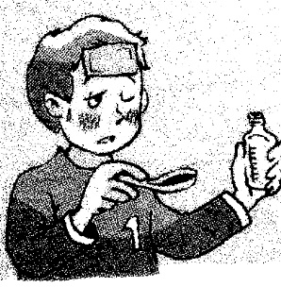
10. Come here, Jim. They are your new jeans. Try _______ (they) on.
11. Mike is ill and he should _______ some _______ .
C）选用方框中的短语完成句子,把序号填在前面括号内。（共6分）
A. cleaning his car B. is very busy C. what are D. in his garden E.on foot F. so sweet
( ) 1. --- Where are they and ______ they doing? --- They are flying kites.
( ) 2. The pests like the grapes because they are _______.
( ) 3. It’s 3: 00 in the afternoon and Mike’s father is _______.
( ) 4. David can’t come to your party because he ______ today.
( ) 5. Now Mr. Ma is growing flowers ______.
( ) 6. Lucy’s home is near her school, so she often goes to school ______.
D）从右栏中找出能与左栏相匹配的项。（共6分）
( ) 1. Where is Su Hai? A. No, she’s drawing eggs.
( ) 2. Is Su Yang reading English? B. No, there aren’t.
( ) 3. Are there many flowers on your desk? C. No, but sometimes I do.
( ) 4. Why is Mr. Black so angry? D. The pests are eating his grapes.
( ) 5. Do you often help sweep the floor at home? E. She’s picking grapes.
( ) 6. How are Bobby’s grapes? F. They’re so big and sweet.
E）看图完成对话。（共7分）
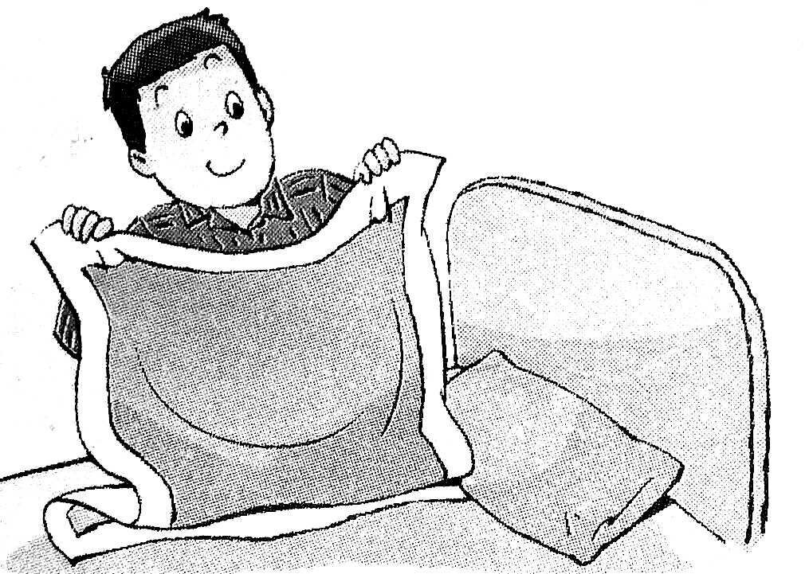
A: Look at the boy in the picture. Who is he?
B: He i______ Liu Tao.
A: Oh, what is he doing?
B: He is m______ the bed. Do you often make the bed?
常州市五年级下册阶段测试第2页共4页

A: No, but sometimes I do.
B: Do you often help to d_____ the housework (家务)?
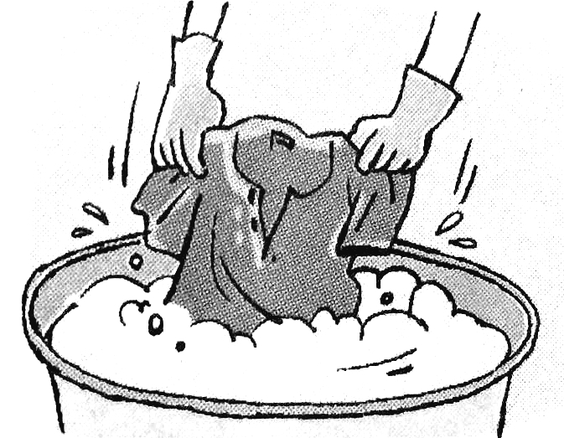
A: N_____, but my sister Liu Ying does.
B: Oh? What does she often d_____?
A: She often helps to wash the c_____.
B: Do you often help to wash clothes?
A: Sorry, I d_____.
F）按要求完成句子。（每线一词一分，共7分）
1. Sam is busy helping his father clean the car outside. (对划线处提问)
_______ Sam ______ outside (在外面)?
2. --- What are you doing? --- Sam and I ________ _______ (在游泳). (2—3译成英语)
3. The bus is ______(满的). Let’s not _______ _______ (上车).
三、语言综合实践。（共40分）
A）完形填空。（共6分）
Jim is a teacher at Yucai Primary School in Changzhou. He 1 English. He is from America. His father and mother are not in 2 . They are in America. Changzhou is very nice and Jim likes 3 very much. His school is very nice, too. The other teachers and the other 4 are all very friendly. On Sundays Jim often goes to parks 5 his Chinese students. Jim can speak a little Chinese. He is very 6 in China.
( ) 1. A. studies B. teaches C. likes
( ) 2. A. China B. America C. the US
( ) 3. A. that B. this C. it
( ) 4. A. workers B. students C. farmers
( ) 5. A. and B. from C. with
( ) 6. A. happy B. tired C. sad
B）阅读短文，根据提供首字母写出单词完成短文。（共6分）
Peter is an office (办公室) worker and his office is f_____ from his home. So he gets up very early e____ day. He works from Monday to Friday. Every morning, he g____ up at 6:00, then he has breakfast. After breakfast, he goes to his office b_____ metro. Peter has lunch at 12:00. At about 5:00 in the afternoon, he comes b_____ from work. Peter likes reading but he doesn’t like doing housework. Usually he watches TV in the e_____. After that, he goes to bed at about 9:30.
C）根据短文内容判断下列句子的正（T）误（F）。（共10分）
Mr. Ford sees a sweater in a shop window. Because it is cheap (便宜), he decides to buy (决定买) it.
When he gets home he puts the sweater on. It fits him very well and he is very happy with it.
In the afternoon, he goes out to work in his garden. It soon begins to rain (开始下雨) and Mr. Ford has to run into the house. He runs quickly, but he still (还是) gets wet (淋湿). Then his sweater starts to shrink (开始收缩)！It
常州市五年级下册阶段测试第3页共4页

gets smaller and smaller (变得越来越小). Soon it is so tight that he can’t breathe (太紧而不能呼吸).
Finally, with great difficulty (艰难地) and the help of his wife (妻子的帮助), he gets out the sweater.
( ) 1. Mr. Ford decides to buy a cheap sweater.
( ) 2. The sweater doesn’t fit Mr. Ford.
( ) 3. Mr. Ford runs slowly so he gets wet.
( ) 4. The sweater gets smaller and smaller.
( ) 5. His wife helps him take off (脱下) the sweater easily.
D）根据短文内容，选择正确的答案。（共10分）
John is a happy boy and he likes to make jokes (开玩笑). His classmates (同学) like him because he often makes them laugh (惹他们笑) for a long time.
One Sunday, a new student comes to his class. The student says that his younger brother Tom never (从不) laughs. No one and nothing (没有人和事) can make Tom laugh. John doesn’t believe (不相信), so he asks the student to bring Tom to his home. John tells (给---讲) Tom many funny (滑稽) stories. Everyone laughs, but Tom doesn’t. Finally, John has to give up (放弃). At last (最后), the student tells (告诉) John, “Tom is deaf.”
( ) 1. John’s classmates like him because _____.
A. he is deaf B. he often makes them laugh C. he likes to make jokes
( ) 2. The new student says that his younger brother _____.
A. never laughs B. likes laughing C. Sometimes laughs
( ) 3. John tells ______ many funny stories.
A. his classmates B. Tom C. his new classmate
( ) 4. Does John make Tom laugh?
A. Yes, he does B. No, he doesn’t C. It’s difficult to say
( ) 5. The word (词) ‘deaf’ means (意思是) ______.
A. 瞎子 B. 聋子 C. 跛子
E）书面表达。（共8分）
星期六上午，Helen, Sam 和他们的父母都在家。他们都很忙，以下是他们各自的活动，请你按以下提示组织一篇不低于7句的短文。（开头和结尾已写好，不计入总句数）.
1. Helen 在做作业， 不在扫地；
2. Sam喜欢看电视，但他现在在扫地；
3. Helen’s 父亲有辆小轿车，现在它在擦小轿车，不在看书；
4. Sam’s 母亲喜欢做家务，现在在厨房做午饭，她很忙。
It’s Saturday morning. Helen, Sam and her parents are all at home. Helen _______________and she _______________ her homework. Sam likes ________________ but now he _________________. Helen’s father has a car and now he _______________ and he isn’t ________________. Sam’s mother likes . Now she ________________in the kitchen. They are all busy at home.
常州市五年级下册阶段测试第4页共4页
常州市小学五年级英语下册阶段测试题参考答案
一、
A) 1. 1—4 BACB
B) 1.bring 2. chair 3.singing 4.sheep
二、
A) 1—12 CACBA CAABC AC
B) 1—12 parents / dishes / smells / much / getting / me / anything /well /
teaches /them/take medicine
C) 1—6 CFABDE
D) 1—6 EABDCF
E) 1—7 is / making / do / No / do / clothes / don’t
F) 1—3 What’s, doing / are, swimming / full, get on
三、
A) 1—6 BACBCA

B) far / every / gets / by / back / evening
C) 1—5 TFFTF
D) 1—5 BABBB
E) 略。

