**教 案**

周春寅

课题：经济大危机与罗斯福新政

教学目标：了解1929—1933年资本主义世界经济危机、罗斯福、《全国工业复兴法》、罗斯福新政。通过1929-1933年世界经济危机爆发的原因、特点及作用影响的分析，逐渐培养综合分析历史事件和历史现象的能力。通过对罗斯福其人及新政措施、作用、影响的分析，逐渐培养正确认识和评价历史人物、历史事件的能力。

重点：1929-1933年资本主义世界经济危机爆发的原因和影响。

难点：罗斯福新政的影响

教学特色：全英文教学

时间：2019年4月26日上午第3节(星期五)

地点：九1班

教学过程：

Today we will study lesson 6: ***The Great Depression and The Roosevelt New Deal.***

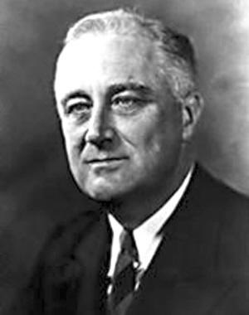  
Look at this photo. ***Who is he? S: Roosevelt .***

***He was a famous president, why? What historical contributions did he make?***

***S: He implemented the New Deal and made many contributions during World War . He led the American people slowly out of the difficult.***

***He was the 32nd president of the United States(1933-1945) and a central figure in world events during the mid-20th century, leading the United States during a time of worldwide economic crisis and world war.***

***The only American president elected to more than two terms, he forged a durable coalition that realigned American politics for decades.***

***Such a great man comes among us and comes to our class. We are cheering and clapping.***

***Background***

***The Great Depression---a sever worldwide economic depression***

***The failure of President Hoover̓ reform***

***Keynesianism***

***The voice of the calls for reform is rising.***

***(Let us read this sentence together.)Roosevelt as the Presedent of the United States.***

***In the early 1930s, on a cold winter night, a coal miner̓s family.***

***The child asked his mother:Why don’t we make a fire at home?***

***Mom replied: Because dad lost his job.***

***The child asked: Why did dad lose his job?***

***Mother replied: Because there is too much coal.***

***Let’s perform this dialogue. First ,I will play the mum, you play the child together.Ok?ok,Let us try.You start.***

***Next,boys play the child, girls play the mum.***

***Now, we need two students to play this dialogue.Who can try?***

***Students play the dialogue.Thank you for your wonderful performance.***

***The blind production of capitalism leads to overproduction and economic crisis.***

***The great economic crisis that began in the United States quickly swept across the capitalist world.***

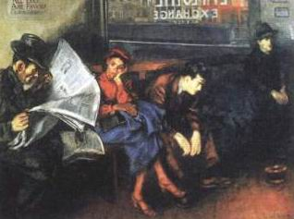

***Unemployed Americans are anxiously waiting. Let us read together.***

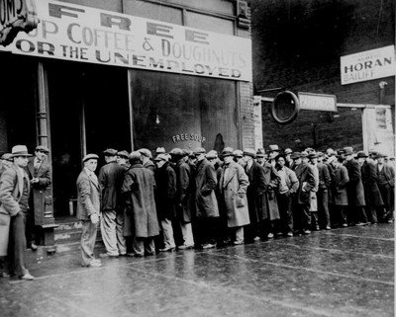

***Unemployed Americans form a long line. Let us read together.***

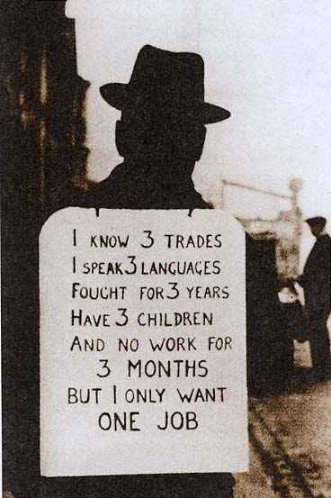

***This is a job seeker on the street, with billboards hanging on his body.***

***Who can read these sentences?***

***Let us read these sentences togethe rmotionly.***

I know 3 trades, I speak 3 languags, fought for 3 years, have 3 children, and no work for 3 months. But I only want one job.

***Franklin Roosevelt̓s election aroused people̓s hopes, smiles and confidence in life, won him the election and became the 32nd president of the United States. On the day when he was swon in, nearly 100,000 people braved the cold to listen to his speech.***

This is his inaugural address

***This great Nation will endure as it has endured, will revive and will prosper. So, first of all, let me assert my firm belief that the only thing we have to fear is fear itself---nameless, unreasoning, unjustified terror which paralyzes needed efforts to convert retreat into advance.***

***In every dark hour of our nation life a leadership of frankness and vigor has met with that understanding and support of the people themselves which is essential to victory. I am convinchced that you will again give that support to leadership in these critical days.***

***Let us simulate(perform) his speech. Who can try?***

***Let us read the red part of his speech together.***

***We will take this sentence as our motto and encourage ourselves all the time.***

***With the trust and support of the people, they still need strong means and methods to get through the crisis.***

***content***

***The New Deal was a series of federal programs, public work projects, financial reforms, and regulations enacted in the United States during the 1930s in response to the Great Depression.***

***The programs focused on what historians refer to as the “3Rs”: relief for the unemployed the poor, recovery economy back to normal levels, and reform of the financial system to prevent a repeat depression.***

***First , rectify the financial system. Roosevelt ordered the bank to close temporarily , while straightening out through the establishment of the Federal Savings Guarantee Corporation to restore the bank̓s credit.***

***Second, strengthen the industrial planning. Congress passed the industrial rehabilitation law requiring business to establish fair competition rules and regulations to prevent blind competition and overproduction.***

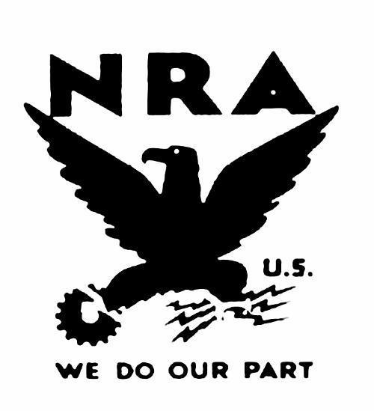

What is this? It is the l**Blue eagle sign .**

***All the business that abserve by the law(NRA:National Recovery act) hang the Blue Eagle sign.***

***Roosevelt said:“This country has a unity that I have not seen with you since April 1917.”***

***Continue to study the third part of the content***

***Third, adjust agricultural policy. Farmers were awarded to compress output , for restricting agricultural production, overcoming overproduction to raise agriculture prices and improving agricultural production environment.***

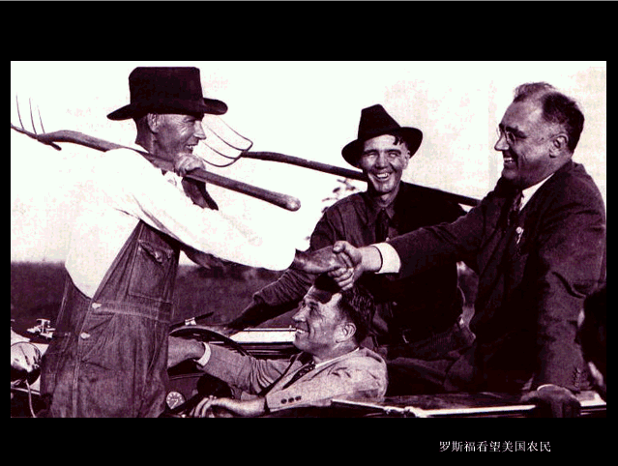

***Roosevelt visits American farmers.***

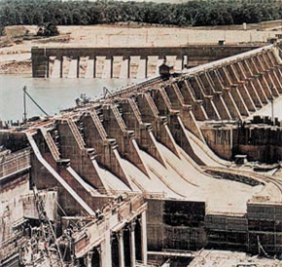

***Tennessee Valley Authority***

***Tennessee River Water Conservancy Project***

***This was the work relief of the New Deal.***

***Fourth, implement the “welfare—to –work”. The Roosevelt administration while relieving the unemployed by the Federal Emergency Relief Act, implemented the labor welfare policy, and set up public works, to reduce unemployment and thus stimulate production and consumption and stabilize the social order.***

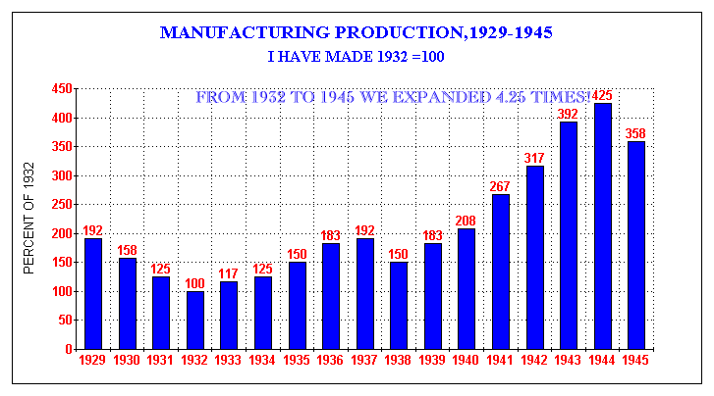

What conclusions can we draw?

***U.S. Economy Recovered***

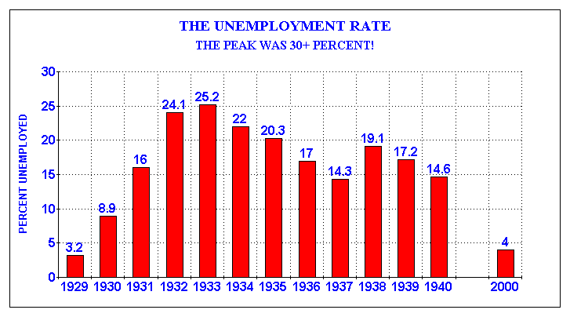

Look carefully. What conclusions can we draw?

***People’s lives have been improved .The social order was stabilized.***

***We can see the effect of the new policy.***

***Influence***

***New Deal was a systematic, radical reform within the capitalist system in order to rescue dying capitalism. Roosevelt̓s New Deal is the model that Westen society succeeds against economic crisis. New Deal was a systematic, radical reform within the capitalist system in order to rescue dying capitalism. Roosevelt̓s New Deal is the model that Westen society succeeds against economic crisis***

Summary of this lesson

***Roosevelt New Deal***

**background ：The great depression**

**Content measures ：Rectify the financial system**

**Strengthen the planning guidance for industry**

**Adjust agricultural policies**

**Implementation ofWork Relief**

**Social welfare**

**Characteristics ：Strengthening State intervention and guidance in economy**

***Influence：It enabled the United States to survive the great economic crisis and had a profond impact on the capitalist world.***

***Without changing the nature of capitalism ,the fundamental contradictions in American society cannot be solved.***

***Do some exercises:***

***1.Roosevelt’s New Deal measures, are mainly “new”( )***

***Ａ.It took the form of nationalization***

***Ｂ.Free enterprise system has maintained capitalism***

***Ｃ.The social welfare system has been generally implemented***

***Ｄ.The way the state intervenes in the economy is adopted***

***2、Roosevelt said:“In order to correct the serious shortcomings of our economic system forever, we rely on the new application of the old democratic order.”This shows that ：（ ）***

***A．Policy adjustments made on the premise of maintaining the capitalist system***

***B．To eliminate the economic crisis by increasing the degree of state monopoly***

***C．On the premise of protecting the interests of capitalists,improve the situation of workers and small producers***

***D．The state exercises macrocontrol over the economy and expands the composition of the state-owned economy***

***Summary of this unit***

* ***The Golden Age of Capitalist Development***
* ***The Great Depression***
* ***Get rid of the crisis and find a way out***
* ***New Deal ,such as u.s.***
* ***German,japanese fascist regimes***
* 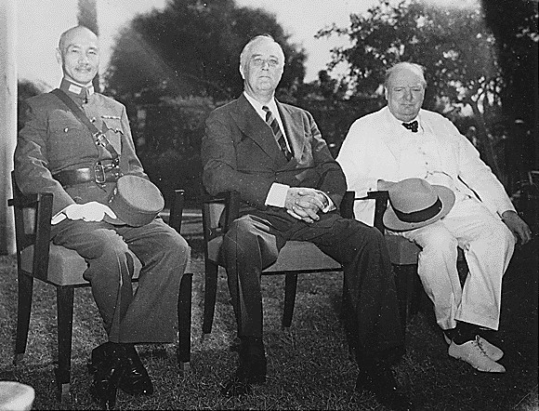
* ***This is a precious photo taken during World War‖***

***Who is he?***

* ***Churchill,England***

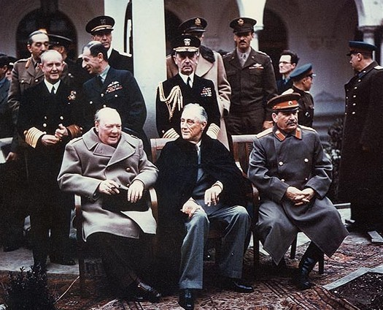

***They are Yalta Conference's Big Three***

***Who is he?***

***Stalin in the Soviet Union***

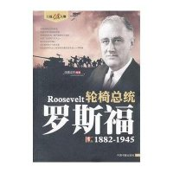

***He is the only US president in a wheelchair.***

***He is the most popular U.S. president after Washington and Lincoln.***

***We salute this great man of the century together!***