内容 | Mimi the Superhero
学校 | 武进区湟里中心小学
设计者 | 范勤霞 | 年级 | 四年级
文本解读
内容选自《丽声北极星分级绘本》第二级上，属于School Subjects范畴。全文113字。绘本故事大意：Mimi喜欢读连环漫画，也喜欢超极英雄。她在本子上把自已画成了强壮的、勇敢的、有超能力的超极英雄。她把画的本子分享给朋友们看，遭到了嘲笑。她觉得特别沮丧，想躲起来，于是走到了墙后，发现了着火了，她非常勇敢地敲响火警警铃，并大声呼叫。Mimi的举动让大家获得了安全，成为了同学们眼中真正的超极英雄。
学情分析
四（5）班的学生是从四年级上学期开始学习绘本的，上学期学习了丽声北极星分级绘本第一级上六本绘本，下学期学习了第一级下六本绘本。从四月十号开始用故事结构图的模式学习第二节上的绘本《Tortoise and His Friends》、《A Quiet House》,使学生习惯这种模式下的语言结构和搭配方式，帮助学习理解内容，加深记忆。
教学目标
1.知道阅读前的准备工作内容与意义，逐步养成良好的读前习惯
2.能抓住“文眼”Superhero进行大胆推测与想象。
3.分享自已学习的单词与学习的方法。
4.尝试用故事结构图梳理故事脉络，了解故事大意。
5.初步尝试抓取关键事件，理解故事的发展动态。
6.能学会看图片细节，解文本与图片的深层意义。
7.尝试用英语表达不同的观点。
教学过程
 | 教师活动 |  |  | 学生活动
Step1  Pre-reading | - Choose:  Today we’ll read a new picture book.What do you think you need to prepare before reading?Please choose.  ( ) a pen or a pencil ( ) a notebook  ( ) a paper dictionary or an e-dictionary ( ) a ruler  ( ) a cup of tea ( ) a piece of paper  ( ) some snacks ( ) colour pens or highlight pens  2.Ask the students to share:  - Show the picture book and ask the students to talk about the cover.  Q1:What is Superhero in your mind?  Q2:The title Mimi the Superhero，Do you have any puzzles or questions to ask about it ?  Q3:What happens to her? Try to have a guess. |  |  | Share:  I need……to underline the new words or new sentences.  I need……when I can’t read the new words.在这里可以列举一些能通过自然拼读的单词如notebook herself，让学生分享另外一种学习方法。  I need……to write something important.  I need……to draw a story map.  I need……to make marks where I like or I think important or useful  The title is .  The book is written by .The writer of this  There is a picture on the front cover.  I can see  I have a question about the……  ……  为了让学生有聚焦的话题和相关语言的储备，之前推荐学生阅读绘本《Super Sam》《Jack the Hero》  S:They’re cool, strong, helpful friendly, kind, tall,they can fly here and there……  S:Why is Mimi the superhero?  Can she fly?  Is she super?  She helps……  ……
Step2:While reading | First reading:读故事大意  1.What happens to her? Let’s read aloud.  （设置问题悬念激发阅读期待，让学生进行第一次阅读分享，在学生互相之间的说与听的过程中完成对故事的第一次理解。）  2.Show some pictures and ask the students to put them in order.  3.Show the story line.  T:Page 2 tells us Mimi loves superheroes.It is beginning of the story, and Page 15 tells us she really is a superhero,it is ending . But why is Mimi really a superhero?Which picture can tell us?  A.What can you see? What can you hear?What can you imagine about this picture?  (抓取关键图片指导学生看图,让学生知道的绘本图的重要性与看图的方法，并以图文方式形成板书)  Pictures are useful,they can tell us more than words.  Second reading: 看图品细节  Ask the students to read the story silently and watch the pictures carefully, try to choose some of them to talk about.  Third reading:绘故事结构图  T:From sharing the pictures,we know a lot about the story.Please read the story fast and find the key events and finish the story structure.  - Ask the students to finish the story structure.  - Ask the students to show and retell the story by the story structure.  3.Show the teacher’s story structure.  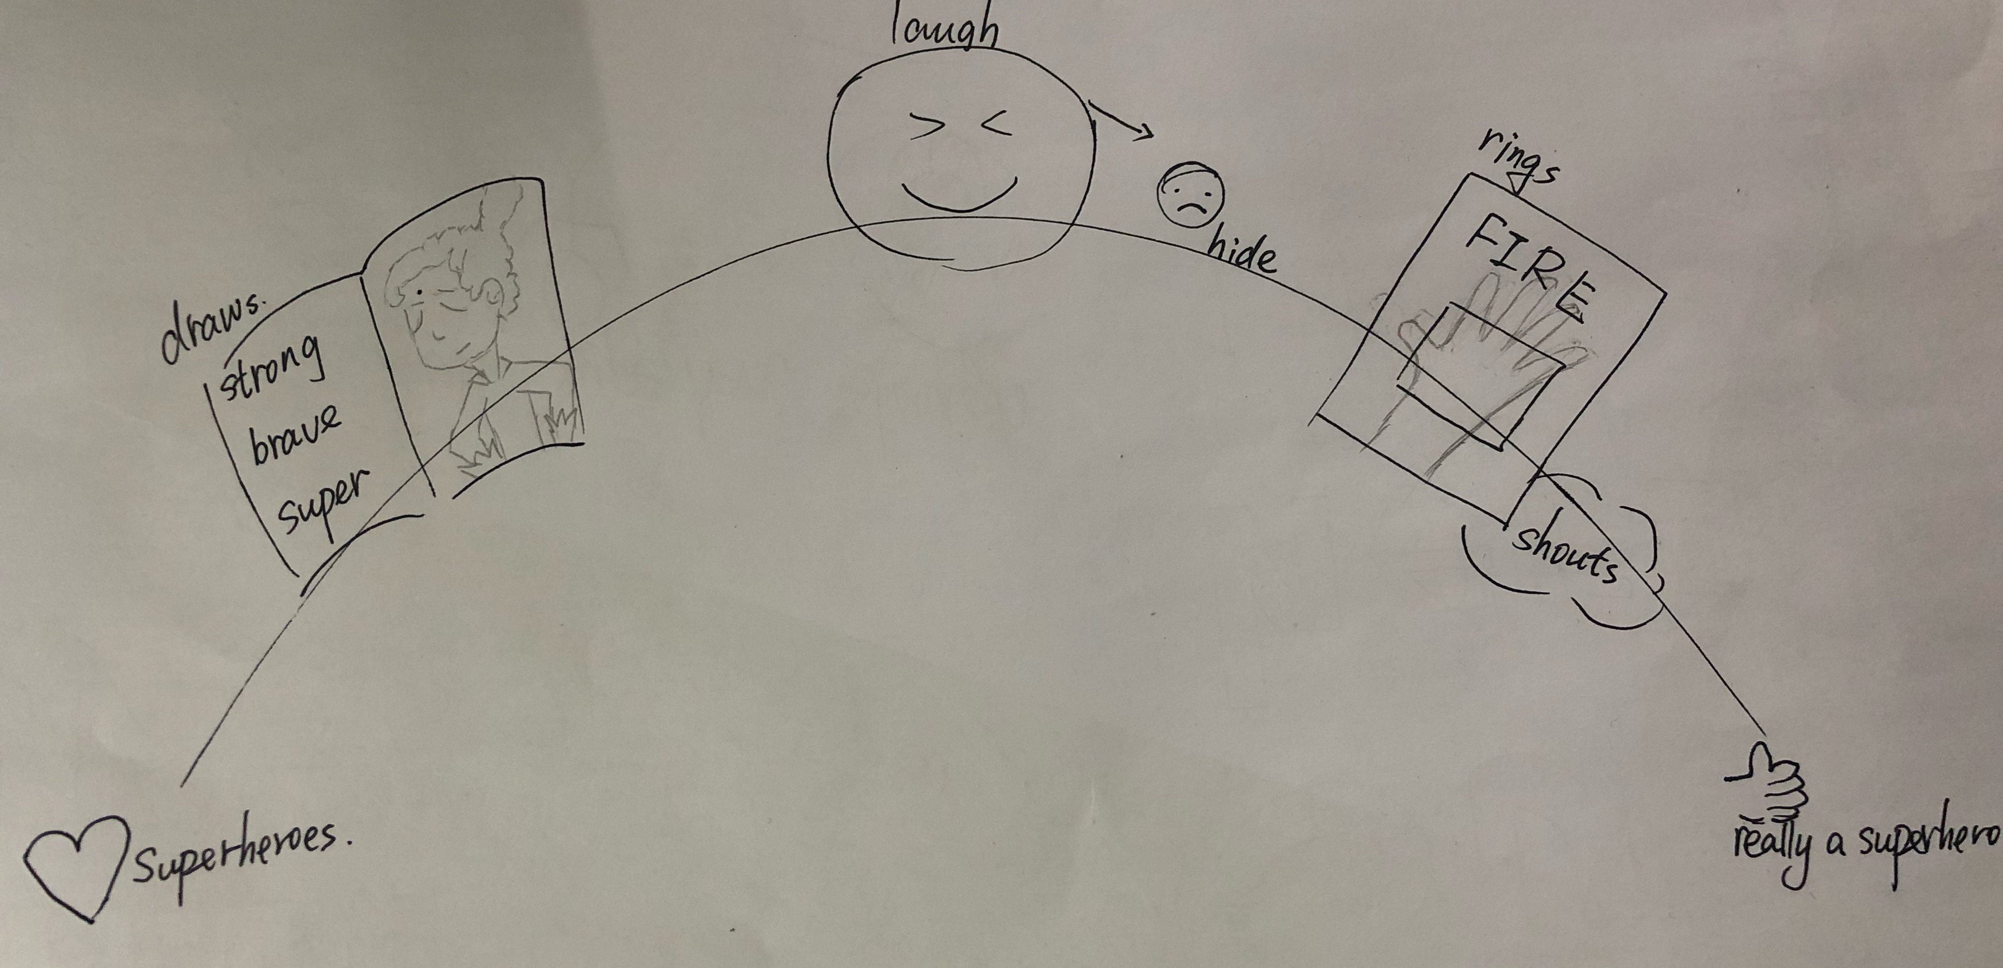  4.Ask the students to choose one of events to talk about it or act it out in groups. |  |  | S:Mimi ……  Put the pictures in order.  Finish the story structure.  Share:I’d like to talk about the picture on Page  I want to share something about Page  Finish  Share：  Mimi loves……，Mimi draws ……，Mimi shows……She sees……，She shouts……，  She rings……  say something about it or act it out用喜欢的方式以小组的形式呈现
Step3  Post reading | Talk about superheroes  T:Mimi is a student, she is not tall, strong or super,but she is very brave,she helps others away from danger.  Do you have a superhero in your life?Who?Why?  This part can make students form their own ideas |  |  | Share:  My father is a superhero in my eyes,because……

