内容 | Mimi the Superhero
学校 | 武进区湟里中心小学
设计者 | 范勤霞 | 年级 | 四年级
文本解读
内容选自《丽声北极星分级绘本》第二级上，属于School Subjects范畴。全文113字。绘本故事大意：Mimi喜欢读连环漫画，也喜欢超极英雄。她在本子上把自已画成了强壮的、勇敢的、有超能力的超极英雄。她把画的本子分享给朋友们看，遭到了嘲笑。她觉得特别沮丧，想躲起来，于是走到了墙后，发现了着火了，她非常勇敢地敲响火警警铃，并大声呼叫。Mimi的举动让大家获得了安全，成为了一位真正的超极英雄。
教学目标
1.知道阅读前的准备工作内容与意义，逐步养成良好的读前习惯
2.能从绘本封面提取更多的信息，并能围绕相关信息进行大胆推测与想象。
3.分享自已学习的单词与学习的方法。
4.尝试用故事结构图梳理故事脉络，了解故事大意。
5.选择自已喜欢的篇章细读并表达自已的理解。
6.尝试用英语表达不同的观点。
教学过程
 | 教师活动 |  |  | 学生活动
Step1  Pre-reading | - Choose:  Today we’ll read a new picture book.What do you think you need to prepare before reading?Please choose.  ( ) a pen or a pencil ( ) a notebook  ( ) a paper dictionary or an e-dictionary ( ) a ruler  ( ) a cup of tea ( ) a piece of paper  ( ) some snacks ( ) colour pens or highlight pens  2.Ask the students to share:  3.Show the picture book and ask the students to talk about the cover.  4.Talk about superheroes.  T:What do you think of Superheroes?  5.Talk about the title.  T:The title Mimi the Superhero，Do you have any ideas to share or any questions to ask about it ? |  |  | Share:  I need……to underline the new words or new sentences.  I need……when I neet new words that I can’t read.  I need……to write something important.  I need……to draw a story map.  I need……to make marks where I like or I think important or useful  The title is .  The book is written by .The writer of this book is  The painter is .  Is the chief editor.  This book is about .  The press is  This is book is in“ ” Lever  ……  There is a picture on the front cover.  I can see  The character is  S:They’re cool, strong, helpful friendly, kind, tall,they can fly here and there……  S:Why is Mimi the superhero?  Can she fly?  Is she super?  What can she do?  ……
Step2:While reading | What happens to her? Let’s read it silently.  - First reading(read silently):get a general idea with three or four or more sentences.  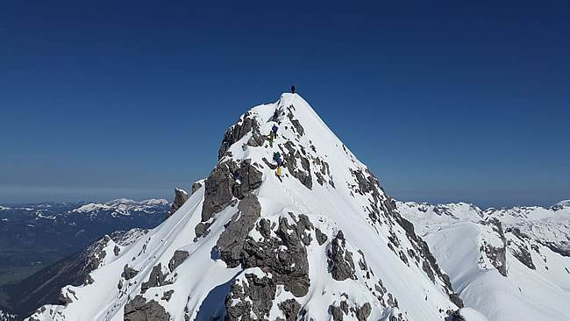  Mimi……  在交流的过程中有涉及的新单词可让他们分享一下学习方法。  T:Laugh is a new word here,can you share your learning way.  T:Page 2 tells us Mimi loves superheroes.It is Exposition, and Page 15 tells us she really is a superhero,it is Resolution. Let’s read and try to find out Rising Action , Climax and Falling Action.  - Second reading(read out):make marks and try to understand the new words,then get the details.  1)Ask the students to find out Rising Action , Climax and Falling Action and show the tips.  Reading tips:  A. Read loudly.  B.Highlight all the new words.  C.Find out Rising Action , Climax and Falling Action.  D.Make a mark where you like best.  Page 1 : Exposition  Page ?—Page ? : Rising Action  Page ?—Page ? : Climax  Page ?—Page ? : Falling Action  Page15 : Resolution  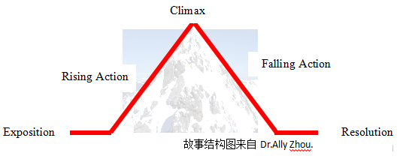  2）Ask the students to share  - Talk about the favourite part  Third reading:(read in pairs)think and discuss  Mimi is a student, she is not tall, strong or super,but she is very brave,she helps others away from danger.Please read the book with your partner together, and discuss with her/him What is “Superhero”? Who is the superhero in your eyes?  This part can make students form their own ideas |  |  | Mimi loves superheroes.She draws herself as a superhero in the notebook. She shows it to her friends, they laugh and Mimi is sad.  S: Yes. Laugh is on Page It means , I learn it from/ I know the meaning from (the picture / the sentence/the dictionary)  Share:  I think Rising Action is from Page to Page It tells us  I think Climax Action is from Page to Page It tells us  I think Falling Action is from Page to Page It tells us  I like best.  say something about it or act it out用喜欢的方式以小组的形式呈现  Share:  Everyone can be a superhero.  If you are very helpful, you always help others ,you’re a superhero,too.  ……  My father is a superhero in my eyes,because……
Step3  Post reading | Draw a story map about what you learn in this reading lesson. |  |  | Finish it after class

关于Dr.Ally Zhou的故事结构图有以下几点说明
- 教学中所运用的故事结构图是Dr.Ally Zhou英语阅读的研究成果。Ally是英国语言教育博士，美国大学终身教授。Mimi the Superhero这个绘本是一个具有Exposition,rising action,climax,falling action,resolution典型的情节性特征的故事。有以superhero贯穿首尾的情节主线，有散落在段落中的小高潮，有发展跌宕起伏情节：喜欢superheroes,画成superhero，被朋友laugh，勇敢地发出火警信号，成为大家眼中superhero。在单纯中有曲折，在简单中有反复的一波三折，不断给孩子们带来审美幸福与愉悦。
- 在上此课节前，北极星二上的其它五本绘本《Zob at School》、《Tortoise and His friends》《A Quiet House》《Dinner for a Dragon》《Puppy in a box》尝试让学生用Exposition,rising action,climax,falling action,resolution故事结构图去梳理故事内容。让学生熟悉Exposition,rising action,climax,falling action,resolution这些专用术语并会使用。因为目前学习的绘本较为简单，可以根据绘本内容进行有选择的设计。

