I have a robot
教学目标：
1. 能正确理解语篇，初步掌握语篇中的生词：caterpillar，beep, roll, blink, giggle
- 通过阅读，对语篇进行分析并获取有用信息。
- 能综合已有的语言积累设想未来的机器人。
- 让学生明白机器人虽然能做很多事情，但它们没有感情，人类才是最聪明的有感情的生物。

教学过程
- 读前活动（pre-reading activities）
      - Greetings
T: How are you, children?
Ss: I’m fine. And you?
T: I’m so happy to meet you again. Do you like toys? Can you tell me any words about toys? What is your favorite toy? Now Miss Pan will show you a toy. Please guess what it is. (由拼图游戏引出robot一词)
      - free talk
T: Can you tell me what it is?
Ss:
T: Yes, Do you like robots? Do you have a robot? Is it a new one or an old one? What color is it? What can your robots do?
（设计意图：由问题引出短文）
- 读中活动（While-reading activities）
- Brief introduction (绘本简介)
T: Today Miss Pan will guide you to read a picture book. It’s about a robot. Can you guess the title?
T：please read the title together.
（设计意图：由猜故事标题，激发学生学习兴趣。）
2. Read and choose整体阅读
T: Please read it quickly, and then choose the main idea.
(设计意图：选择故事大意，检测学生的阅读效果。)

3.Read, find and guess解决生词:
T: Please read it again, and circle the new words. Try to understand the meaning according to the pictures and context.
- Beep: a short, high sound that acts as a signal.
Listen and judge.(听音判断)

- caterpillars: they are round and long like worms, but have six legs. They may be brightly colored.
Is this a caterpillar? / Are they caterpillars?

- giggle: laugh in a silly or nervous way
In Picture ___, the boy is giggling.

- roll：make sth turn over and over
____ is rolling.

- blink：close and open the eyes very quickly
please blink your left/right eyes.
We can blink, but can fish blink?
（设计意图：根据图片与上下文，理解生词。）
- Read and answer(分段细读)
P 2: Read these two sentences with emotion.
P 3: What can my robot say? ---“beep, beep”
Can your robot say that? --- Yes. / No.
What can your robot say? --- Fire! Fire!
What can you say? --- a lot of things.
P4: Can you say“Beep, Beep”? --Yes, of course.
What can “I” say? ---I can say “beep”, too.
Can “I” say more difficult words? --- Yes, I can.
What’s the difficult word? ---“Caterpillar”
Can you say difficult words like that? ---

P 5: Please look, what can my robot do? ---roll in a circle
Can it stop?
Can “I” roll in a circle? ---Yes, I can.

P 6: What else can I do? ---stand on hands.
Compare : Robot can _____. I can ____, too. I can even _____.
(Robot can say “beep”. I can say that, too. I can even say “caterpillar”.
Robot can roll in a circle. I can roll, too. I can even stand on hands.)
T: So my robot can do many things. And I can do, too. I even do more!
（设计意图：教师指导学生细读文本，知晓robot和I能做事情。同时提炼can句型，并进行扩句。）

P 7---P9:
First please listen and point.
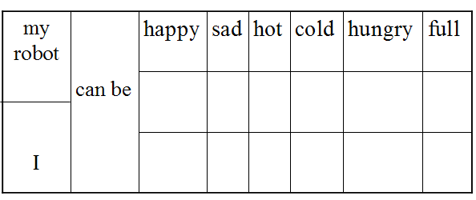
Now this time, please read from page 7 to page 9, and then finish the table using tick√or cross ×.

Check the answer.

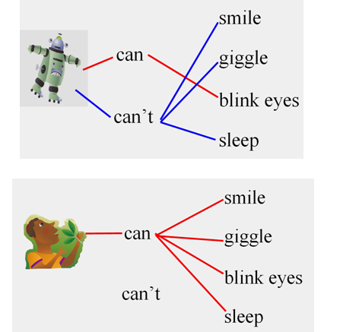
P10—p12: Please read and match.
T：Can you tell me the differences between my robot and “I”.
（设计意图：通过阅读，分别找出robot与I之间的不同。）

P12: I can do many things, too.
I can even ______.
（设计意图：突出主题，my robot maybe is clever. But I can feel and I can do more. So I am the best.）
三、读后活动（post-reading activities）
1. retell the story
（设计意图： 根据板书，复述故事，检测学生的阅读效果）
2T: Actually we know robots can do many things. Can you guess what robot can do in the future? Please design and finish the sentence.
T: It’s time for you to show your pictures and sentences.
（设计意图：培养学生创新思维，运用所学知识进行拓展。）
3T：You really did a good job! Now I want to share you a short movie. Please tell me what robot can do now.
( make noodles swim play the violin play football )
( sing songs cook sweep the floor play chess )
（设计意图：帮助学生了解更多关于现代的robot的功能， 提高学生学习兴趣，激发学生进一步表达。）
4 T: Do you want this kind of robot? Why or why not.
Robots can do many things, but they can’t feel because they are only machines. I / We can feel and we can do lots of things. So we are the best.
（设计意图:帮助学生认识虽然机器人可以做很多事，但它们没有感觉，人类才是最了不起的。）
板书设计：
