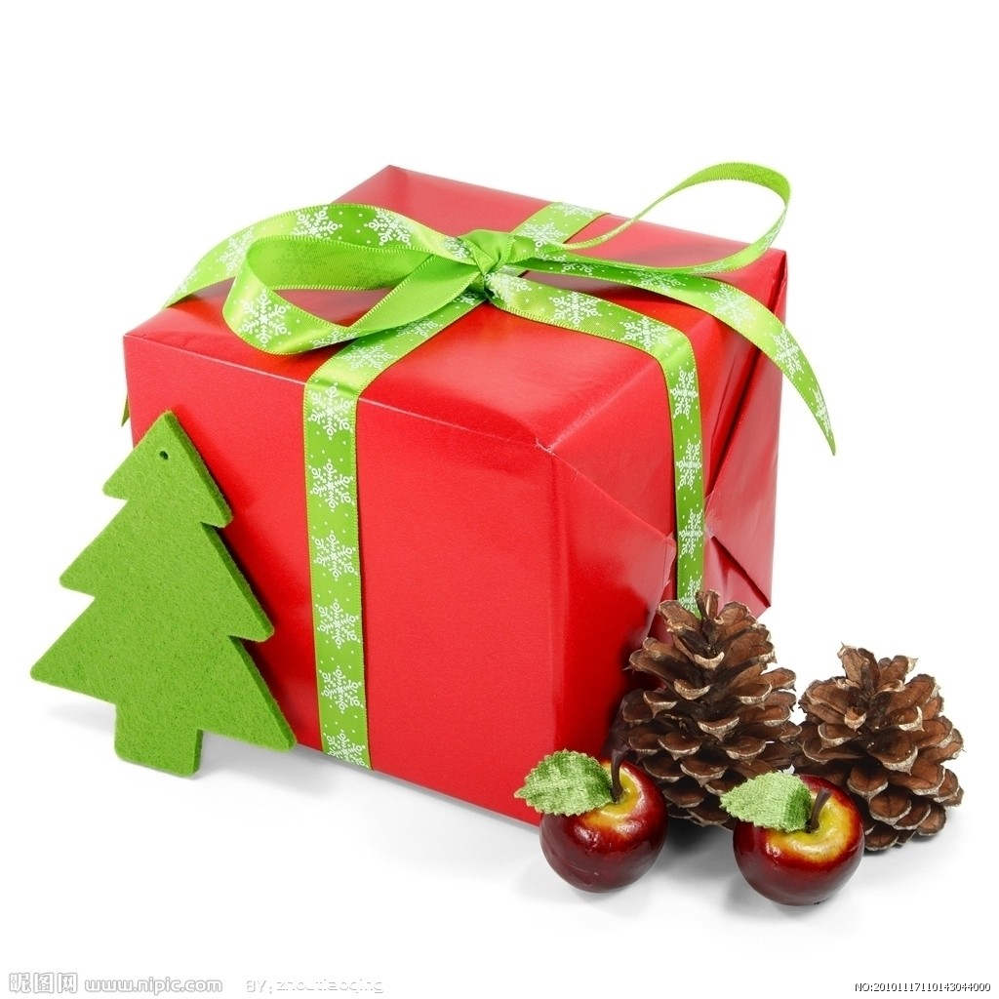
I want
I know
I think
surprise
Five little monkeys bake a birthday cake

SURPRISE

