奔牛初中八年级英语第二次阶段测试
出题人 郭晓 2015.12
一、选择题 (20分)
( ) 1. Not only the students but also the teacher _______early in this school.
A. get up B. gets up C. getting up D. are getting up
( ) 2. —_________ did you weigh when you were born?
—My mother says I weighed only 3 kilograms at birth.
A. What B. How much C. How many D. How heavy
( ) 3. — Are there any tomatoes in the fridge? — _________.
— What’s in the fridge then? —_____________.
A. Nothing, None B. None, Nothing
C. None, None D. Noting, Nothing
( ) 4. The number of wild lions in Africa (非洲) _________ much smaller than before.
A. is B. are C. has D. have
( ) 5. —My mobile phone dropped into the water when I was walking along the river bank.
—_________！
A. Great B. What a pity C. Sounds good D. Lucky you
( ) 6. He stopped looking after the homeless animals ______ his bad health.
A. instead of B. because of C. because D. instead
( ) 7. You must be very tired. Why not_________ a rest?
A. stop taking B. stop to take
C. to stop taking D. to stop to take
( )8. I think ____necessary for us ____the endangered animals and plants.
A. it； protect B. its； to protect
C. it’s; protecting D. it； to protect
( )9.Do you write a report_______ wild animals_______ danger for the newspaper?
A. about; on B. on; in C. to; from D. in; with
( )10. My grandmother told me___ walk quietly and___ wake my father up.
A. not to; to B. to; not to C. not to; not to D. to; to
( )11. 30 per cent of the students in our school_______ girls.
A．is B．are C．have D．has
( )12. The number of giant pandas is becoming_______ because there are_______ living areas for wildlife.
A. fewer and fewer; less and less
B. smaller and smaller; less and less
C. fewer and fewer; smaller and smaller
D. smaller and smaller; fewer and fewer
( ) 13. Let's do something_______ for wildlife in the world.
A. make some space B. making some spaces
C. to make some spaces D. to make some space
( )14. He went carefully through his homework_______ make mistakes.
A. as a result B. in order that C. in order not to D. in order to not
( )15. _______ binoculars helps you see the things far away more ________ .
A. A; clearly B. A pair of; clearly C. /; clearly D. A pair of; clear
( )16. It's a perfect room for your parents_______.
A. to live B. living C. live in D. to live in
( )17. You will be late for school ______you don’t get up early.
A, but B. if C. and D. or
( )18 There's no empty seat on the bus. Can you make ______for the old lady? A. seat B. a room C. space D. place
( )19. Henry keeps exercising every morning..______, he looks healthier and healthier.
A. As a result B. In order to C. However D. Moreover
( )20. Our government is trying to provide homeless people ______special shelter______ stay.
A. with； to B. with； for C. for； to D. for； with
二、完形填空（10分）
If you want your life to stand for peace(和平) and kindness, it's helpful to do kind, peaceful things.
We live in the country near San Francisco. It is a very beautiful place. But people throw rubbish out of their 1 when driving on the roads. I think that will destroy the beauty.
I 2 pick up rubbish near our house with my two children. My daughters often say to me in a happy 3 , "There is some rubbish, Daddy. 4 the car." And then we will pull the car over and pick it up. It may seem strange, but we 5 it. We pick up rubbish in parks, on sidewalks, almost 6 .
Once I saw a stranger(陌生人) picking up rubbish like us. He smiled at me and said, "I 7 you do it, and it seemed like a good idea."
Picking up litter is only one of the things we can do to 8 others. You can do other things like holding a door open for people or visiting lonely elderly people in nursing homes(养老院). Things like these are 9 but helpful.
These little acts of kindness can help you know how 10 it feels to be kind and helpful.
( ) 1. A. houses B. rooms C. windows D. buildings
( ) 2. A. never B. seldom C. often D. sometimes
( ) 3. A. sound B. smile C. cry D. voice
( ) 4. A. Drive B. Find C. Move D. Stop
( ) 5. A. dislike B. enjoy C. miss D. keep
( ) 6. A. anywhere B. nowhere C. inside D. outside
( ) 7. A. made B. believed C. thought D. saw
( ) 8. A. encourage B. help C. follow D. tell
( ) 9. A. interesting B. dangerous C. difficult D. small
( )10. A. sorry B. sad C. good D. shy
三、阅读理解（15分）
(A)
Jilin is a good place. It is in the north-east of China. On the north of it is Heilongjiang, the south is Liaoning, the west is Inner Mongolia and the east is North Korea(朝鲜).
It has a long and snowy winter. Usually the winter here starts from October and lasts(持续) for six months. Every year people come here for the Ice Lantern Festival and the winter sports.
Changbai Shan is the first mountain in the north-east of China. There is a lot of snow on the main mountain-"Baitou Shan" all the year, so it is named "C. hangbai Shan". It has great forests on it. There are tigers, deer, black bears and many other animals in the forests and there are a lot of hot springs (泉) and more than l,500 kinds of plants. On the very top of the mountain is Tianchi. If you come to the lake, you might see the monster(水怪) in it.
There is also a great waterfall(瀑布) where the Songhua River comes from.
Another place in Jilin is Xianghai in Tongyu County(县). There are more than 100 pieces of wetlands here. And they are of different sizes. There are 170 kinds of birds, some fish that we can't often see and over 250 different herbal(草药) plants and trees here.
( ) 1. Which is the right map?
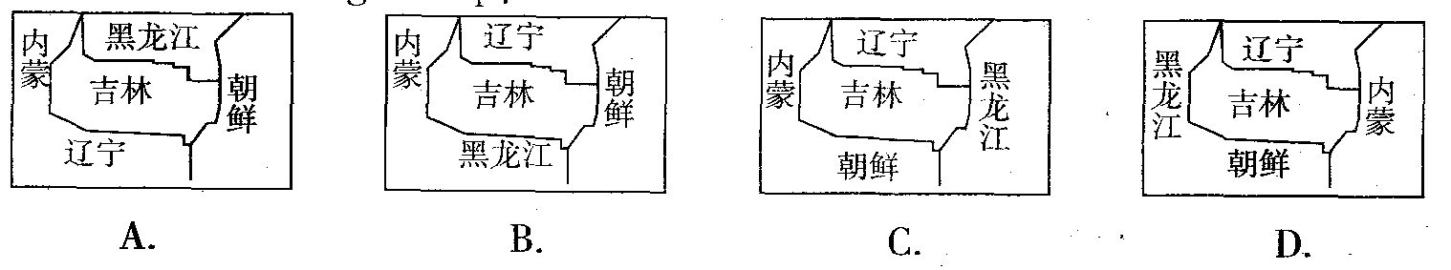
( ) 2. Winter in Jilin is from _______ to _______.
A. January; April B. September; December
C. October; April D. November; May
( ) 3. Which of the following is true?
A. Because of the snow on the top of the main mountain, people named it Changbai Shan.
B. There are tigers, bears and other animals in the hot spring.
C. Tianchi is a lake in the forest at the foot of the mountain.
D. Songhua River comes from the lake of the mountain.
( ) 4. What can we see in the wetland in Tongyu County?
A. Different kinds of birds. B. All kinds of fish.
C. Huge monsters. D. North-east tigers.
( ) 5. The writer doesn't tell us _______ in the passage.
A. the neighbors of Jilin B. the temperature in winter in Jilin
C,. the famous mountain in Jilin D. where there are herbal plants in Jilin
(B)
There are several ways you can find out about the countries and places you wish to visit. You can talk to friends who have traveled to the places, you can go and see a colour film about them, or you can read a travel book.
It seems that there are three kinds of travel books. The first are those that give a personal, subjective(主观的) idea of travels which their writer has got himself. These books can be useful if the writers share their traveling experiences with others. The second kind are those books which give objective(客观的) information of things to be done and seen. If a cultured person has written such a book about the facts of a place, then it is more useful. The third kind are those books which are called “a guide” to some place or other. If they are good, they will describe and explain the place in detail. Like the first kind , they can be interesting and exciting, but their main purpose is to help the reader plan his travel in the most practical way.
Whatever kind of travel book you choose, you must make sure that the book does not describe everything as interesting, exciting or fantastic. You must also keep an open eyes on its date of publication(出版) because travel is very practical matter and many things change quickly in the 21st century. Finally, you should make sure that it’s easy to find the useful information for you travel.
( )6. The passage was written to introduce_______.
A. travel maps B. travel books C. travel films D. travel places
( )7. The writer of the first kind of travel books gave his ideas after he _______.
A. traveled B. read books C. a lot of experience D. surfed the Internet
( )8. The underlined phrase “a cultured person”means a person with ________.
A. a good appearance B. a good education
C. a lot of experience D. a lot of money
( )9. The date of publication must be noticed because ________.
A. the prices of travel books may be different
B. the writers of travel books may be different
C. the information in travel books is always the same
D. the information in travel books is always changing
( )10. According to the passage, it is best to read ______ before traveling to a place of interest.
A. the first kind of travel books B. the second kind of travel books
C. the third kind of travel books D. some travel articles in newspaper
(C)
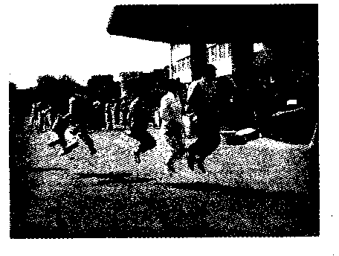
During the years of game making, there have been a number of games. Many old games have gone since modern games came out.
Teachers at a primary school asked their students to write articles about
games they knew and were surprised by the results. Half of the 50 children in one of the classes wrote about online games.
It is easy to see that traditional games like hide-and-seek and jump rope
games are unfamiliar to m any of today's schoolchildren. They like to play
computer games, especially in the cities, with the rising popularity of TV, the Internet, video and online games.
An educationist said, "Traditional games used to be so popular, but over just a few years, kids have forgotten them. It's sad."
The games that many parents once played were generally outdoor activities which were enjoyed by students during breaks or after school. They usually needed several partners and just a little space.
Jump rope games, for example, have always been popular in many countries around the world. A kind of jump rope game, played with rubber bands(橡皮筋) which are connected together to make a long rope, is played in many countries.
Rubber band jumping was once very popular in primary schools. Girls loved playing this game. It can help kids practise their jumping skills and develop coordination(协调性), and also help them meet lots of friends.
It is common these days to see primary school students spending their breaks in the classroom. They are busy with their studies.
"When we were young, we played many different outdoor games, but today's children don't know what to play or how to play," a 40-year-old mother said. "They don't know what teamwork is."
Being worried by the situation, educational officers have tried to make some programmes to educate children on traditional games.
( )11. How are traditional games today?
A. Today's children don't like traditional games.
B. Traditional games are missing one by one.
C. Traditional games aren't so easy as computer games.
D. Modern games are more useful than old games.
( )12. The meaning of the underlined word "unfamiliar" here is "_______"
A. not known B. not helpful C. unimportant D. not interesting
( )13. The traditional games like hide-and-seek and jump rope games_______.
A. can be played only in schools
B. can be played only outdoors
C. usually need a few partners
D. need a very large space
( )14. Today's schoolchildren don't know how to play traditional games mainly because_____.
A. they are busy with their studies
B. they don't like them at all
C. their parents don't let them do that
D. the games are difficult to learn
( )15. Which of the following is the writer's opinion?
A. Traditional games should take the place of modern games.
B. Schoolchildren shouldn't be busy with their lessons.
C. Without playing traditional games, children don't know what teamwork is.
D. The whole society should try to educate children on traditional games.

四、任务型阅读 阅读下面的短文，根据短文内容完成表格中所缺信息，在答题卷上相应的横线上填写答案，每空限填一词。(本题共5分)
The haze season is back. How much do you know about haze? Haze can also be called “Smog”. The word “smog” is from the words “smoke” and “fog”. It is a kind of air pollution(污染) mostly because of cars and factories.
Smog will do great harm(伤害) to your health. It can make you cough and have skin and eye problems. It seems that we can do nothing to stop it, but only wait until the wind blows all the smog away. However, there are some easy ways to stop it hurting you. Here are some of them.
1. Don’t do exercise in the open.
Exercising in the open makes you breathe(呼吸) deeply, and you will take in the particles(颗粒物) deep into your lungs.
2. Stay indoors and keep the air clean.
If you can, just stay in your room and keep the doors and windows closed. Remember to air your room twice a day, you can open the window at noon or at night for half an hour.
3. Wear a mask.
Paper and cotton masks can not help you in the haze weather. Some special masks, such as N95 masks, can keep you from breathing in the particles in the air.
4. Change your diet.
Scientists find that vitamin A, C and E can greatly help protect your eyes, nose and lungs. So eat more green vegetables and fresh fruit every day. What’s more, do not eat food with too much fat.
The haze weather
What is haze? | It means smog, a kind of smoky and 1 weather.  It is a kind pollution caused by cars and factories.
What is the harm? | It is bad for our health.
2 can we prevent the haze? | Don’t 3 outside.
2 can we prevent the haze? | Stay indoors as much as possible 4 the doors and windows closed.  Remember to open the windows for a while to keep the air clean.
2 can we prevent the haze? | Wear a mask to stop taking in the particles.
2 can we prevent the haze? | Change your diet. Vitamins can make you healthy. So, please eat more vegetables and fruit and 5 meat.
五、词汇检测（14分）
A 根据下列句子及所给汉语注释写出空缺处各单词的正确形式。（7）
1. He_______(带领) this old woman across the road and left.
2. The poor man couldn't_______(描述) what he saw because he was very afraid that time.
3.I have been to the village three times to enjoy_______ (自然）beauty(美景).
4. My cousin enjoyed her_______(停留) in Shanghai very much. She said she wanted to visit it again.
5. The theme park is a _______ (完美的）place to go walking after supper.
6. I feel very sorry for your loss. Please _____________ (接受) my help.
7. My mother is_______（记录）how much money she spent on her new clothes.
B 用所给单词的正确形式填空。（7）
8. He answered the question ______________ (correct),so he failed to get first.
9. Many animals are in danger. They need our ___________(protect).
10. Great ___________ (change) take place in our hometown.
11. He got ____________ (terrible) ill, but the doctor saved him at once.
12.Thank you for your ____________ (kind). Your are really helpful.
13.His father looked __________(angry) at him because he lied to him again.
14. The ___________ (report) says 30 people lost their lives in the big fire.
六、用所给动词的适当形式填空。（6分）
1. The doctor advised me _____________ (not get) up early in winter.
2. You’d better _____________ (not paint) the room blue, or it will make you feel sad.
3.If you work hard, you ___________ (catch) up with your classmates.
4. We should do something to stop the weather from _________ (get) hotter.
5. _________ (take) beautiful photos, he decided to climb up the tall tree.
6.We can’t find Mr. Li. I think he ____________ (wait) for his wife at the bus stop.
七、句子翻译 （15）
1我们应当立刻采取行动保护大熊猫。
2.蜜蜂可以沿他们去时的相同线路返回。
3.我们应该像一个团队一样合作。
4事实上，这种动物主要以食昆虫为主。
5.这会导致野生动物越来越少的生存空间。
6.这个保护区能为野生动物提供食物和庇护所。
7.请随身带个笔记本以便把你见到的写下来。
8.盐城自然保护区是各种植物和珍稀鸟类的家园。
9.你知道学好英语的重要性吗？
10.这大楼占地约1000平米。
八、书面表达(15分)
假设你叫卫华，上周从报纸上看到了鸟类卫士俱乐部( Bird Guard Club)的招聘广告，你想加入该俱乐部来保护鸟类。请根据你的个人信息表，给俱乐部李先生写一封80词左右的申请信。信的开头和结尾已给出，不计入总词数。
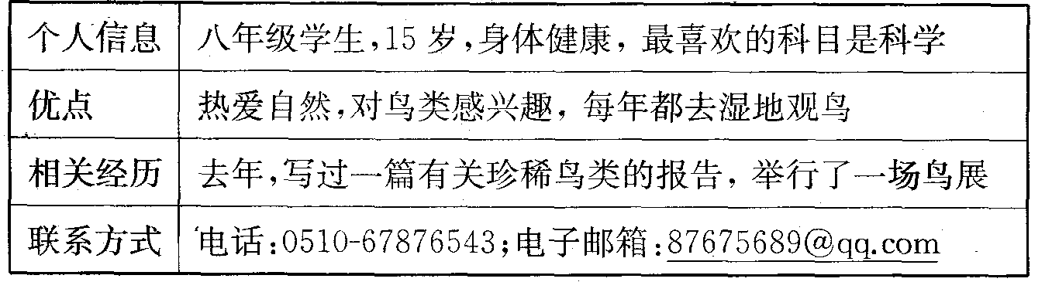
Dear Mr Lee,
I read your ad in the newspaper last week. I'm writing to tell you I'd like to become a member of the Bird Guard Club.
__________________________________________________________________________________________________________________________________________
__________________________________________________________________________________________________________________________________________
__________________________________________________________________________________________________________________________________________
__________________________________________________________________________________________________________________________________________
Yours sincerely,
Wei Hua

奔牛初中八年级英语第二次阶段测试
答卷纸 2015.12
一、选择题 (20分)
1 | 2 | 3 | 4 | 5 | 6 | 7 | 8 | 9 | 10
11 | 12 | 13 | 14 | 15 | 16 | 17 | 18 | 19 | 20
二、完形填空（10分）
1 | 2 | 3 | 4 | 5 | 6 | 7 | 8 | 9 | 10
三、阅读理解（15分）
1 | 2 | 3 | 4 | 5 | 6 | 7 | 8 | 9 | 10 | 11 | 12 | 13 | 14 | 15
四、任务型阅读(5分)
1.____________ 2.___________ 3.___________ 4.___________ 5.__________
五、词汇检测（14分）
A 根据下列句子及所给汉语注释写出空缺处各单词的正确形式。（7）
1._______________ 2.______________ 3._____________ 4.______________
5.______________ 6. ______________ 7._______________
B 用所给单词的正确形式填空。（7）
8._______________ 9.______________ 10._____________ 11.______________
12.______________ 13. ______________ 14._______________
六、用所给动词的适当形式填空。（6分）
1.____________________ 2.__________________ 3.__________________
4.____________________ 5._________________ 6. __________________
七、句子翻译 （15）
1我们应当立刻采取行动保护大熊猫。
____________________________________________________________________.
2.蜜蜂可以沿他们去时的相同线路返回。
____________________________________________________________________.
3.我们应该像一个团队一样合作。
____________________________________________________________________.
4事实上，这种动物主要以食昆虫为主。
____________________________________________________________________.
5.这会导致野生动物越来越少的生存空间。
____________________________________________________________________.
6.这个保护区能为野生动物提供食物和庇护所。
____________________________________________________________________.
7.请随身带个笔记本以便把你见到的写下来。
___________________________________________________________________.
8.盐城自然保护区是各种植物和珍稀鸟类的家园。
_____________________________________________________________________
_____________________________________________________________________.
9.你知道学好英语的重要性吗？
___________________________________________________________________ ?
10.这大楼占地约1000平米。
____________________________________________________________________.
八、书面表达(15分)
假设你叫卫华，上周从报纸上看到了鸟类卫士俱乐部( Bird Guard Club)的招聘广告，你想加入该俱乐部来保护鸟类。请根据你的个人信息表，给俱乐部李先生写一封80词左右的申请信。信的开头和结尾已给出，不计入总词数。
Dear Mr Lee,
I read your ad in the newspaper last week. I'm writing to tell you I'd like to become a member of the Bird Guard Club.
_______________________________________________________________________________________________________________________________________(20)
________________________________________________________________________________________________________________________________________(40)
________________________________________________________________________________________________________________________________________(60)
________________________________________________________________________________________________________________________________________(80)
Yours sincerely,
Wei Hua

