思维与文化的体验之旅
—译林英语5下《Unit8 Birthdays》第一课时教学设计
江苏省常州市新北区新华实验小学 邹丽娟 邮编 213127
【教材简解】：
本课时选自译林版英语五年级下册第八单元《Birthdays》第一课时Story Time板块。通过两年多的英语学习，五年级的学生已经具备了结合生活进行简单交流的能力。本单元主要围绕“过生日”这一话题，通过询问生日的具体日期及谈论生日所做的事情展开对话，交流中涉及到一般现在时的特殊疑问句。本课时主要呈现Su Hai和Mike过生日的不同场景，让学生了解中西方文化中不同的生日风俗习惯。文本结构清晰，内容贴近学生生活，适合学生交流。
【目标预设】：
- 能正确听、说、读词汇：birthday , April, March,eat noodles,play games等和日常交际用语：When’s your birthday? My birthday is on…/What do you do on your birthday? I usually...
- 能通过观察图片和猜测文本，学生尝试主动提问获取自己想知道的信息；能尝试画一画文章的思维导图，并能根据导图说一说主人公的生日。
3、能在理解文本的基础上准确地、有感情地朗读课文。
4、能初步运用本课所学的词汇和句型谈论自己或他人的生日。
5、能了解中西方文化不同的生日风俗习惯，感受不同文化下生日的快乐和美好。
【教学重点】：
1、能在理解文本的基础上准确地、有感情地朗读课文；能在思维导图的帮助下尝试复述文本。
2、能初步运用本课所学的词汇和句型谈论自己或他人的生日。
【教学难点】：
阅读文本和观察图片，能画一画文本的思维导图，并能根据导图简单说一说Mike或Su Hai的生日。
【设计理念】：
《英语课程标准》强调在义务教育阶段的英语课程承担着培养学生基本英语素养和文化意识、发展学生思维能力的任务。本课笔者采用“任务型”和“体验型”教学法，注重学生思维的发展和学习能力的提升。文本解读依托教材但不囿于教材，活动设计源于教材而又高于教材，充分挖掘教材资源，为学生拓展学用渠道，通过不断优化思维品质促进英语学习，提高学生的综合语言表达能力。
【设计思路】：
本设计围绕“思维”“语言”和“文化”三个维度展开。阅读前创设“生日”的大情景，师生亲近交流，激活思维起点；阅读中以开放性的问题预测文本，观看动画整体感知，关注思维的整体性；阅读中创造性地利用插图设计思维导图，细节理解文本，关注思维的开放性和生成性；然后完善思维导图，体验不同国家的文化,关注思维的独特性。阅读后有效利用小组采访活动，关注思维角度，拓展学生的学用渠道，进一步达成优化思维品质、提升语用能力和培养文化意识的多重效果。
【教学过程】：
Step1. Greetings and Introduction. 亲近交流，激活思维起点。
T: Hello, I’m your new teacher today. Do you know sth. about me?
S: You are ….
T: Yes. Look, now here’s a Name Card for you. You see, I’m an… I work in ....I like drawing and reading. And Number 9 and 12 are my lucky numbers. Do you know why?
S:......
T: Because it it my birthday. My birthday is on the 12th of Sept.(PPT呈现中英文的生日日期。) What do you think of a birthday?
S1: Birthday cake.
S2: 蜡烛。（Birthday candles）
S3: Birthday party.
S4: Birthday present.
S5: 面条。（Birthday noodles）.
S:.....
T: You know a lot about birthday. OK, today we will learn...(揭示课题)
【设计意图】：在Free talk的过程中营造英语学习的氛围，拉近师生的距离。通过教师的Name card 进一步了解教师，由lucky number引出birthday。之后以开放性的问题谈论生日，教师以简笔画的形式快速呈现学生所提到的生日物品，为后面的新课学习铺垫。自然过渡，揭示课文主题。
Step 2:Pre-reading .
1.The dates of the birthday 解决关键知识点，关注思维的生长点。
T: You know a lot about birthday. The 12th of Sept is my birthday. Look at this Calender. It is the 12th of September. (Teach the 12th of September) Boy and girls,when’s your birthday ?
(1).以两个学生的生日为例，了解生日日期的表达：the...(date) of ...(month)
(2).利用日历，依次出现1-10，11-20，21-30的基数词和序数词，观察并学习序
数词的用法。
(3) Ask and answer in pairs:
A: Wnen’s your birthday?
B: It’s /My birthday is on the...of ....
【设计意图】：从了解教师生日始感知生日期初步表达形式，后到了解学生的
生日，学习序数词和日期的表达，最后生生问答，初步运用交流，为进一步学习文本打好基础。
Step 3.While-reading.
1.Look and ask . 创造性地利用插图，关注思维的开放性。
T：Look at our Friends. What do you want to know about them?(出示文本中遮掉大部分信息的第一幅插图。如下图。)
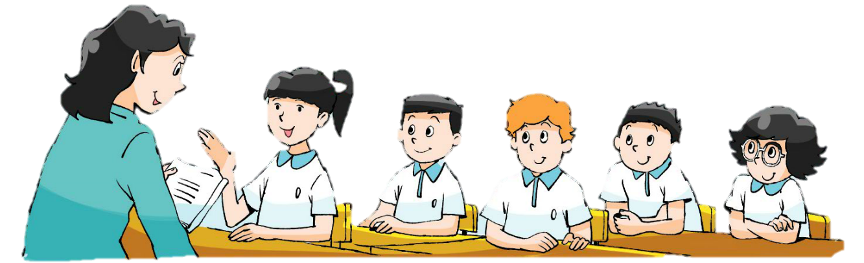

S1/2/3/4：Who are they?/Where are they? What are they doing?...
S5:They are Miss Li and...
S6:They are in the classroom.
S7:They are having an English lesson.
T:Good. Guess,what are they talking about in the lesson? How do you know?
S1:Maybe they are talking about birthdays. Because...
(在教师与学生交流的过程中，PPT适时出现第一幅图的另一部分信息。)
【设计意图】：教师创造性地利用课文第一幅插图，逐步出现图片信息，同时以开放性的问题引导学生主动提问和获取信息，培养了学生思维的开放性。预测文本，自然导出本单元课题。
2. Watch and say. 借助视频理解文本，关注思维的整体性。
T: Good,I agree with your ideas. Whose birthdays are they talking about?
S: Su Hai’s and Mike’s Birthdays.
T: Yes. But think more, Whose birthday is it too? How do you know that？
S: It’s Su Yang’s birthday ,too. Because they’re twin sisters.
T: Good. What do you want to know about their birthdays?
S1:When are their birthdays?
S2:What do they do on their birthdays?
S3: How...?
【设计意图】：借助视频整体理解文本，了解故事的主人公。让学生在观看视频后解决大问题，然后在交流中引出小问题。小细节在于交流中解决图片中一个隐藏的信息——Su Hai’s birthday is Su Yang’s birthday,too.
3、Read,underline and fill ( Picture1). 细节处理文本，关注思维的生成性。
(1). 运用阅读技巧，初构思维导图
T:Good questions.First, let’s know more about the twins’ birthday.When, and what do they do and where?
Tips:1.Read in details and underlines. When”——”；What”~~”.
2.Meet the new words, use the pictures and text.

S1:Su Hai’s and Su Yang’s birthday is on the 11th of May.
S2:They usually have a big dinner with... at home.They eat noodles. After that, they play with Kitty. (Teach:Noodles）
教师在学生回答问题的同时同步生成板书，形成思维导图的初图。（如图下）

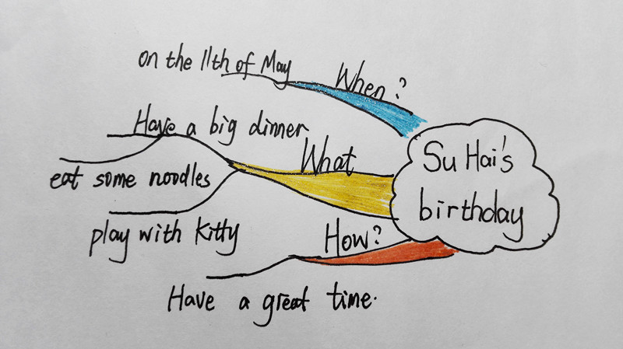

(2). 交流中的思维碰撞，感受中国生日内涵
T：Why do Chinese People eat noodles on their birthdays?（Ss discuss）
S1：Noodles mean长寿(long life).
T: Yep. In China, the long noodles are symbol of long life.And you see their big dinner. How do you think of their birthday? Happy?
S:They are happy/They have a great time.
T: They spend with their families at home. The birthdays in China always warm and full of love.
【设计意图】：利用阅读技巧，细节阅读文本。先以双胞胎的生日经历，梳理
文本信息，生成思维导图初图。在思考“生日面”的由来中碰撞出思维的火花，感
受和体验中国生日文化内涵。
4.Read , discuss and draw.(Picture2) 有效小组合作，关注思维的独特性。
(1) 小组合作阅读，尝试思维导图。
T: Look at this thinking map about twins. You can see some information about
them.Can you read the next text and draw a thinking map about Mike？
Tips: First，read in details and use different lines to underlines .
Next, discuss in groups and draw the thinking map together.

(学生自读文本，模仿或创新画一画Mike的假期生活思维导图；同桌讨论准
备汇报,教师巡视指导。)
(2) 读后合作交流，完善思维导图。
T:When’s Mike’s birthday? What does he do on that day?
Group1：It’s on the 8th of April. He always have a party with friends.First,they ...,
then ... and ....（请两组学生在投影上展示他们组的思维导图。)
T:Yes，Mike's birthday is on... They ....
(在学生小组汇报时学习have a party, birthday cake, play games.并逐步完成板书
上的另一半思维导图。)
(3) 同向思维交流，感受西方生日内涵。
T: Guess what does Mike do before he eats the birthday cakes?
S: Sing a song/Make a wish./Blow out the candles...
T: And then eat it,right？Let’s think, why does he eat a birthday cake？（It means
“Lucky”and the monsters will stay away from you.）How about Mike’s birthday？
S: They are happy,too./They have a lot of fun.
T: Mike spends birthday with his friends together.And it is full of funny and happy.
【设计意图】：小组合作阅读文本，以前半部分的思维导图为蓝本，学生将
阅读中提取的信息，用思维导图的形式画一画、写一写Mike的生日经历，完成一
张自己设计和制作的思维导图。教师在汇报中完成板书上另外一部分思维导图。最
后以同向问题再次师生交流，感受和体验西方生日文化内涵。
5.Read after the tape 教师朗读指导，注重学生语音语调训练。
6. Say something about the text. 有效利用导图，提高思维运用的灵活性。
学生根据板书和思维导图复述文本。
7. 视频资源欣赏，体验不同生日文化。
T:Su Hai and Mike Come from different countries, so they have different
birthday customs.Look, there are many birthdays of other countries. Such as Japan,
France,Korea and so on...(PPT出示多个国家的生日风俗。)
Different countries,different birthdays;different birthdays ,but same wishes.
【设计意图】：2011版课程标准指出：英语中蕴藏着丰富的文化内涵。欣赏不同国家的生日文化，找到文化的不同点和情感的共通点，体现了语言学习与文化意识形成的相辅相成。本环节设计，是本课语言学习和文化体验相互融合的重要体现。
Step4. Post-reading.
1. Your birthdays 联系生活实际，回忆和感悟生日初衷。
T：Everyone has birthday, and Chinese people even have two birthdays. What do
you on your birthdays?
S1: I usually have noodles and eat a birthday cake.
S2: I sometimes eat birthdays with friends at school.
S3: I have noodles and birthday cakes with my families.
S4: I often watch films with my parents.
S5:...
T: Nowadays, our Chinese birthdays are more and more international. But
another important thing is the birthdays is your mother’s day，too！Don't forget to say“Thank you”to mom dearly.
【设计意图】：从学生的生活经历入手展开讨论，回忆一下自己平时生日时常做的事情。让学生了解到，随着人们视野的开阔，中西文化的不断融合，我们中国人现在生日庆祝的方式更加地多元化和时代化。同时，让孩子们在庆祝自己生日的同时，不忘感恩母亲，自然地进行情感教育。本环节起到承上启下的作用，既是承接上一环节对生日文化感受，也是为下一环节的task活动积累语言。
2. Make an interview. 关注思维角度，拓展学生的学用渠道
T:And do you know sth. about your friends’ birthday？How to ask them?
Ss:When’s your birthday?/What to you do on your birthday？/Where do you have
a big dinner?/ Who comes to your birthday party?/How is your birthday? Do you usually....?...
T: You have many good questions. Now let’s interview your friends’ birthdays and
show it to us,OK? You have two choices.
Task1. Use the information to design a form.
Task2. Have an interview and make a thinking map like that.
Arms:1.小组讨论，快速决定一个Task来完成。
2.小组内合理分工，齐心协力完成Task。
3.自主选择汇报方式。

【设计意图】：通过教师预设，从提问的角度激发进一步激发学生的思维;为学生设计不同层次和难度的实践任务，为学生实际运用语言提供多样的操作路径。任务一可以是根据学生已有经验，利用表格形式采访和整理采访信息，任务二是学生现学现用今天的思维导图，文图结合的形式整理和提炼搜集的信息。
Step 6.Homework: 自主作业设计，学习活动有向延伸
1.Read and retell Story Time.(★)
2. Know your parents’ birthdays and make cards for them. (★★)
3.Make a Thinking Map of your friend’s birthdays by yourself.( ★★★)
【设计意图】：课后作业是对本节课学习的巩固和延伸。开放性的家庭作业
设计，学生可以根据自己的学习水平选择相应不同难度梯度的作业练习。同时教
师又提供反馈评价的方式，鼓励学生选择具有挑战性的作业练习。
【板书设计】：
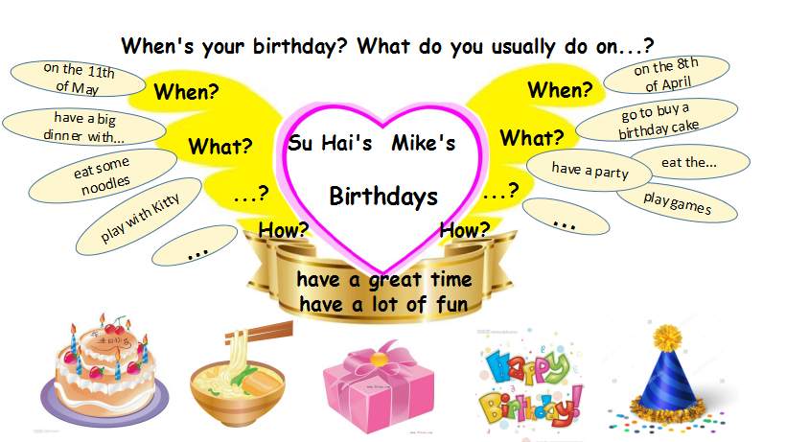
Unit8 Birthdays

【设计意图】：本板书既是课堂教学内容的提炼和总结，也是情感体验的最后升华。教师用个人擅长的简笔画形式，将板书上的思维导图“画龙点睛”——以代表love的心形翅膀设计整体主题板书。升华情感教育，完美地进行新课收尾。在学生尝试绘制朋友生日的思维导图时，也可以提供借鉴作用。

