小学英语五年级下册期末检测卷
班级＿＿＿＿ 姓名＿＿＿＿＿＿ 成绩＿＿＿＿＿
测验时间: 50分钟 全卷80分 (听力部分20分,基础知识60分)
一、听力。（共20分。A节每小题0.5分，B、D节每小题1分，C节每格1分）
A） 选出所听到的内容，并将其序号填入题前括号内。（4分）
（ ） 1. A. busy B. easy C. fancy
（ ） 2. A. pretty B. prince C. present
（ ） 3. A. cough B. cold C. coat
（ ） 4. A. work B. walk C. wash
（ ） 5. A. Monday B. Tuesday C. Thursday
（ ） 6. A. two fifty B. three thirty C. three ten
（ ） 7. A. get on B. get off C. get to
（ ） 8. A. drive away B. go away C. run away
B）根据所听到的对话和问题，选出正确的答案，并将其序号填入题前括号内。（5分）
（ ）1. A. By taxi. B. On foot. C. By car.
（ ）2. A. She’s eating meat. B. She’s cooking meat. C. She’s cooking soup.
（ ）3. A. Yes, she does. B. No, she doesn’t. C. Sorry, I don’t know.
（ ）4. A. He says “Thank you.” B. He draws pictures C. He makes a card.
（ ）5. A. Saturday. B. August 25th C. August 24th
C）听对话，根据你听到的内容给下列图编号。（5分）




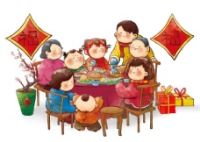
（ ） （ ） （ ） （ ） （ ）
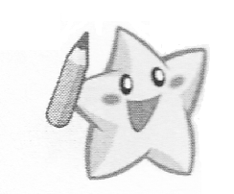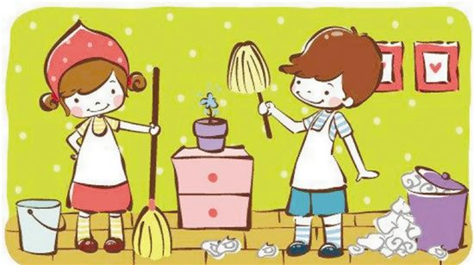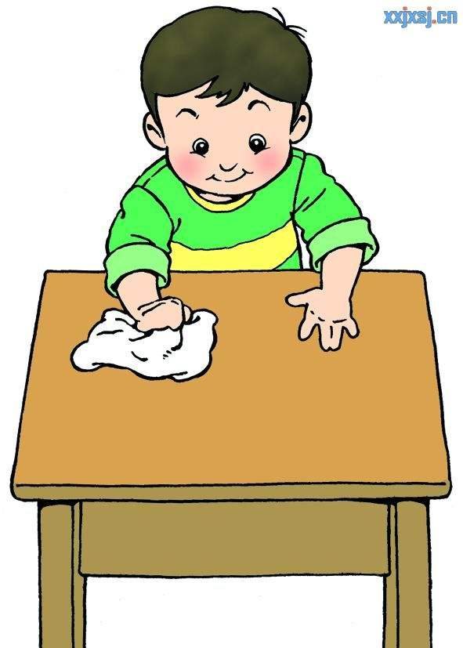D） 听短文，根据所听内容，在相应的表格中打“√”。(6分)
Rose
Bill
Bill’s sister
Julie
Julie’s brother
二、语言知识。（共32分。A－D节每题1分）
A）圈出划线部分读音相同的单词。（5分）
1. The girl in a white dress shouts ‘Trick or treat’ for sweets.
2. Mike shows his model ships to his teacher Mr. Wang.
3. Charlie talks about Christmas with his e-friend in China.
4. Miss Smith doesn’t like the weather in summer.
5.On fine days, people usually fly kites in the park.
B） 选择最佳答案，并将其序号填入题前括号内。 （10分）
( ) 1. —_________ do you get to South Street?
— I live near Renmin Park. So I can get there __________.
A. Why; by bus B. Where; by bike C. How; on foot
( ) 2. — ＿＿＿＿ your father often _________ the Internet?
— Yes. He often does it at weekends.
A. Does; surf B. Does; surfs C. Do; surfing
( ) 3. There ________ any tomatoes on the table, but there _______ some tomato juice.
A. are; are B. aren’t; is C. aren’t; are
( ) 4. Look at the woman ________ Bill’s right. She _____________some coffee.
A. on; drinks B. in; is drinking C. on; is drinking
( ) 5. Mr. Strong is ________ PE teacher. He teaches _______ PE this term.
A. our; we B. their; them C. we; us
( ) 6. Lily has a toothache________ she drinks __________ sweet juice.
A. because; too many B. so; too much C. because; too much
( ) 7. People also call the Dragon Boat Festival the Double _________ Festival.
A. Seventh B. Fifth C. Ninth
( ) 8. Paul’s temperature is 102 ℉. What should he do?
A. He should go to school. B. He should eat creams. C. He should go to the hospital.
( ) 9. — Oh, my coat is wet!— _______________________
A. Put it on. B. Take it off. C. Try it on.
( )10. In _________, children like reading fairy tales. People like drinking coffee. There are many bald eagles in the sky
A. Canada B. the UK C. the US
C） 选择方框中的短语，并用正确形式填空。（有一项多余）。（10分）
A. smell nice B. taste good C. have a picnic D. be good for E. go to work F. look for
G. some bus stops H. walk dogs I. ask…for help J. play basketball K. take some medicine

1. Jim likes sports and he is good at ________________________.
2. The soup __________________. I can’t wait to have it.
3. Some of the beautiful mushrooms __________________us. We can’t eat them.
4. Joe has a bad cold. After meals, he should _________________________.
5. I don’t know how to read this new word. I want ______________ Mr. Green ____________.
6. What a fine day today! Mary goes out and _____________________ with her family.
7. My father ______________________ because it’s Saturday today.
8. ---Are there _____________________ near your house? ---Yes, there are six.
9. Pets are popular in our family. People like ________________________ in the morning or after dinner.
10. Look at Bob! He _____________________ some water in the fridge because he’s thirsty.
D）阅读对话，选择对话中合适的内容，并用正确的形式填空，每空一词。（7分）

Kitty: What are you doing, Grandma?
Grandma: I’m making some tea. Would you like some?
Kitty: Yes, please. How do you make tea, Grandma?
Grandma: Well, first, I boil the water.
Kitty: What’s next?
Grandma: I put some tea in the teapot. After that, I pour the hot water into the teapot.
Kitty: And finally?
Grandma: I pour the tea into the cups and we can drink the tea now!
Kitty: Mmm, it tastes great!
Kitty is in the kitchen with her __________. Grandma is ________ some tea. Kitty wants to know about how to _______ tea. Grandma __________ her the steps(步骤). First, she ______ the water. Next, she puts some tea in the teapot. ________, she pours the hot water into the teapot. Finally, she pours the tea into the cups. Kitty likes the tea because it tastes________.

三、语言综合实践 。（共28分。AB节每空1分，C节每题2分， D节8分。）
A）今天是小猪Piglet的生日，他正在给他的朋友们写邀请函。（5分）
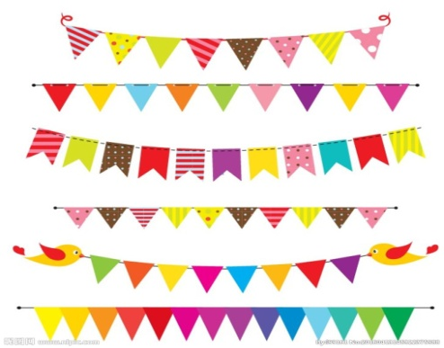
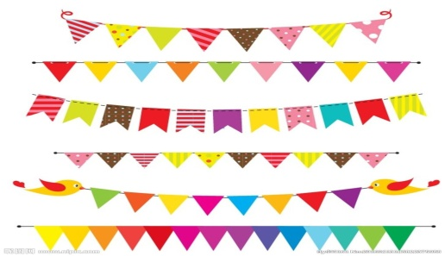
Invitation
Dear f________,
I’m going to have a birthday p_______ at Mr. Al’s h________.Would you like to join(加入） us?
Date: 27th J________(Wednesday)
Time: please w_____ for my call
Come and have fun!

B）在小猪Piglet寄上的邀请函中，附带了一张地图，仔细观察，完成下面的练习。(5分)
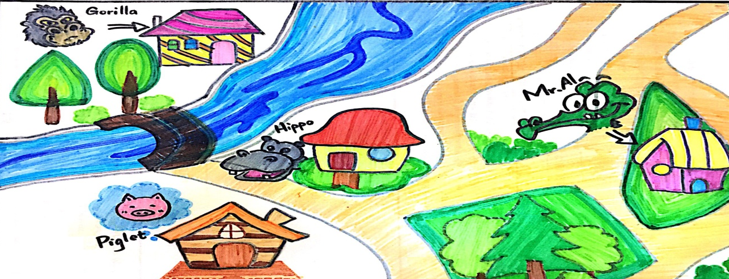

（ ）1. From the map, how many animals are there in the forest?
- Three B. Four C. Five
（ ）2. _________ doesn’t live by the river.
- Gorilla B. Hippo C. Mr. Al
（ ）3. _________ lives far away from Mr. Al’s house.
- Piglet B. Gorilla C. Hippo
（ ）4. Gorilla wants to visit Mr. Al. How does he get there?
- Go across（越过） the river, and then go along the road. Turn right at the first Y crossing（Y岔路口）.
- Go across the river, and then go along the road. Turn left at the first Y crossing.
- Go across the river, and then go along the road. Turn left at the first Y crossing and then turn right at the next Y crossing.

（ ）5. What does this sign mean?
N N S
- W E B. E W C. W E

S S N
C ) 阅读文章，判断正误，正确的写T，错误的写F。（每题2分，共10分）
Mr. Black likes to be exact (准确). One day when (当) he is walking in the street, a man comes to him and asks, “Excuse me, but where’s the new bookshop?” “ The new bookshop? You have to cross the bridge (走过桥) and then turn right .” Mr. Black says. “ Is the bridge long?” The man asks. “ Yes, it’s about thirty meters (米).” The man thanks him and goes to the bridge. Suddenly (突然), he hears someone running after him. “Stop!” Mr. Black is shouting. “I’m sorry, I just remember (正好记起) the bridge is forty meters long. If (假如) you go thirty meters and then turn right, you’ll fall into (掉进) the river.”
( ) 1. Mr. Black is an exact man.
( ) 2. The bridge is thirteen meters.
( ) 3. Mr. Black stops the man because they are friends.
( ) 4. The man wants to go to the new library.
( ) 5. The man falls into the river.

D）请你以“My favourite festival”为主题，写一写你最喜欢的节日， 包括以下几个方面：what is your favourite festival? When is it? What do you usually do at this festival?等方面不少于8句。（8分）

______________________________
_______________________________________________________________________________
_______________________________________________________________________________
_______________________________________________________________________________
_______________________________________________________________________________
_______________________________________________________________________________
_______________________________________________________________________________

