小学英语四年级下册期末检测卷（2018.6）
班级＿＿＿＿ 姓名＿＿＿＿＿＿ 成绩＿＿＿＿＿
测验时间: 50分钟 全卷80分 (听力部分20分,基础知识60分)
- 听力。（共20分，A、B、C节每小题1分。）
A）听录音，根据你所听到的内容在正确的图片下打“√”。
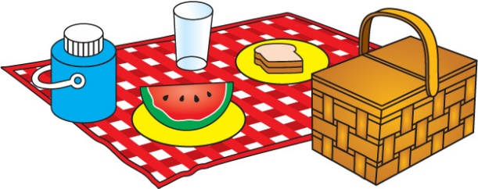 1. 2. 3.

( ) ( ) ( ) ( ) ( ) ( )
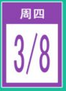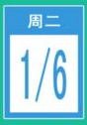 4. 5. 6.

( ) ( ) ( ) ( ) ( ) ( )
B）听录音，选择正确的应答，将序号填在括号内。
( ) 1. A. Yes, please. B. I’d love to. C. What a pity!
( ) 2. A. Hi, Bobby. B. No, he’s at school. C. All right.
( ) 3. A. It’s Helen’s. B. Yes, it’s Helen’s. C. They’re Helen’s.
( ) 4. A. No, this is Mike. B. Yes, I am Mike . C. Yes, this is Mike.
( ) 5. A. Yes, it is. B. No, it isn’t. C. Yes, it’s warm.
C)听录音，根据你所听到的内容将人物和活动用线连接。（连对应图片的黑点）




1. 2. 3. 4.

● ● ● ●

A. ● B. ● C. ● D. ●


D）听录音，填入对话中所缺单词。
A: Hi, Helen. How are you now?
B: _________so good. I’m ___________.
A: I’m sorry to ____________ that. Take __________.
B: Can I come to see you after ___________?
A: Sure. See you tomorrow
B: See you.

二、语言知识。（共30 分，A节每小题1分，B－E节每空1分。）
A）选择划线部分发音相同的单词完成下列句子。
1.What subjects do you like? I like ______ and__________. (English, Chinese, Music, white )
2. Look! The __________is in the __________ . (open, dog, home, box )
3. What’s on the__________? There’s a __________. (table, panda, hand, cake )
4.I have a green _______ and a __________ book. ( pen, me, red, three)
5.Go________and show Rose your ___________.(home, not, hot ,nose)
B）根据图片和句意的提示,用单词的正确形式填空。
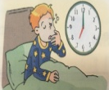
1. I usually _________ up at seven.

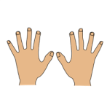
2. -What’s the matter with you? -My_____________ hurt.

3.Her _________ is too long.

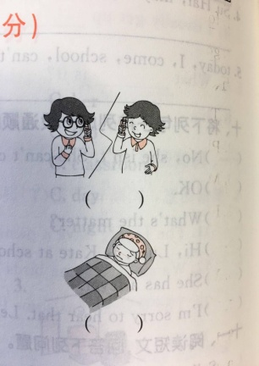
4.He is too thirsty and ________.

5. -____________I speak to Yang Ling.?-Yes, this is Yang Ling speaking.
C）单项选择，从A、B、C、D四个选项中，选出最佳选项。
( ) 1. The tall boy ______ big ears is my brother.
A. in B. with C. at
( ) 2. — _____ your father a teacher? —______, he is a farmer.
A. Is; Yes B. Are; Yes C. Is; No
( )3. —Can I help you?— ____________.
A. Yes, you can B. No, you can’t C. Some juice, please
( ) 4. —_______ is that white car? —It’s Mr. Green’s.
A. Who’s B. Who C. Whose
( ) 5. —_________ do you wake up? —At seven in the morning.
A. What B. when C. What time
( ) 6. —Look at our robots. —_________ !
A. Good idea B. Well done C. Thank you
( ) 7. We can see some monkeys _______ the trees.
A. in B. at C. to

( ) 8. —I’m _______, Mum.—Here’s a ______ for you.
A. hungry; pie B. hungry; egg C. hungry; juice
( ) 9. —Is this a pencil case?— _____________.
A. Great B. I think so C. How nice
( )10. —Look, there is a small_____ near the lake. Shall we go ______? —OK!
A. boat; boating B. boating; boat C. boat; boat
D）根据句意选择方框中的词语并用正确形式填空。（有一项为多余）
- have a look B. have a try C. make a salad
D. a bad cough E. some flowers F. What a pity!

1.They like salad, and they__________________in class.
2. -Draw a tiger is very difficult.-Yes, but I want _______________ .
3.I’m not good, I have____________.
4.--Can you see some flowers in the picture? --Sorry, I can’t see _____________________.
5.--We don’t go to the party.--____________!
E）将下列句子重新排列，组成一段完整的话，并将编号填在相应的括号内。
A.At eleven,I have lunch with my parents in the restaurant（饭店）, because today is my birthday.
B. This is my day!
C. Today is Sunday. In the morning,I do my homework at home.
D. After lunch, they give me some presents. I’m so happy.
E.In the afternoon ,I go to the park and fly kites . I go home at seven in the evening.

（ C ）--（ ）--（ ）--（ ）--（ ）
请根据短文内容说一说小作者的一天是怎么样的一天？ It’s a _________ day.
三、语言综合实践 (共30分)
A) 根据表格信息，判断正误，正确的填（T） 错误的填（F）（每小题2分）
Ben’s New timetable
 | MON | TUE | WED | THUR | FRI
AM | English | Maths | Maths | English | Chinese
AM | Maths | Chinese | English | Maths | English
AM | Chinese | Swimming | History（历史） | Basketball | Maths
PM | Computer Studies | Stem(科学、技术、工程、数学) | Music | Art | Music
PM | PE | Science | Table tennis | Reading | Social science

( ) 1.This is Mike’s new timetable.
( ) 2.He has nine subjects this term.
( ) 3.He has a science lesson on Tuesday afternoon.
( ) 4. Everyday he has a Maths lessons
( ) 5.His school life is colourful(丰富多彩的）.
- 请阅读绘本内容，完成相应的练习。（a题每空1分，b题每题2分）
a. 看绘本《What I like about Spring》，将图文匹配，把序号填到图下的括号内。
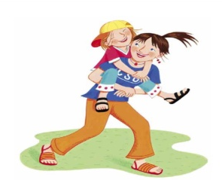
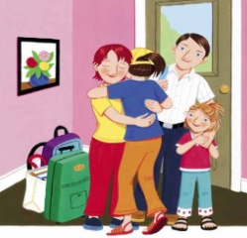
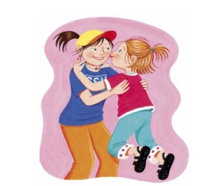
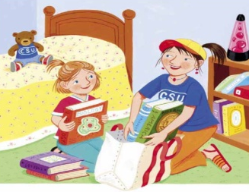

（ ） （ ） （ ） （ ）
- In spring, my sister Liz goes home from school. Mom, Dad and I are so happy to see her.
- I kiss Liz. “I miss(想念）you, my dear sister” I say.
- Liz talks about her school. She reads books every day! “Let’s play now,” Liz says.
- “All right. Let’s go!” I am so glad Liz is back. I like spring!
b) 阅读绘本，选择正确的答案，填在题前括号内。
( )1.How many people are there in Liz’s family ?
A. two B. three C. four
( )2.Liz goes home in__________.
- Summer B. Spring C. Autumn
( )3.Liz is my _________.
- sister B. brother C. cousin
( )4.What does Liz do at school every day?
A. She goes swimming. B. She reads books. C. She draws pictures.
( )5.According to the picture book(根据绘本内容），Liz’s family are ______ in spring.
A. fine B. nice C. glad
C) Liz也想了解一下你最喜欢的季节以及这个季节中让你感到快乐的事。试着来写一写吧！(不少于6句）（6分）
What I like about___________
____________________________________________________________________________________________________________________________________________________________________________________________________________________________________________________________________________________________________________________________________________

