小学英语三年级下册期末检测卷
班级＿＿＿＿ 姓名＿＿＿＿＿＿ 成绩＿＿＿＿＿
测验时间: 50分钟 全卷80分 （听力部分30分,基础知识50分）
一、听力。（共30分，A、B、C、D、E小节每空1分）
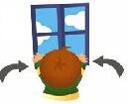
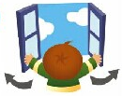


A）听录音，圈出你所听到的图片前的序号A或B。
1. | A | B | 2. | 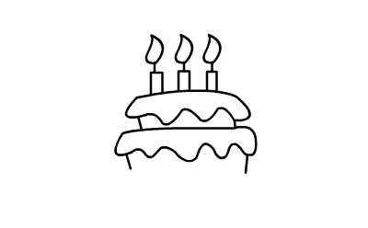  A |   B
3. | 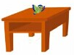  A | 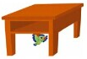  B | 4. | A |   B
5. | 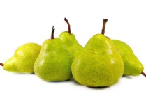  A | 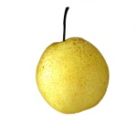  B | 6. |   A | B
B）听录音，用阿拉伯数字给下列图片编号。
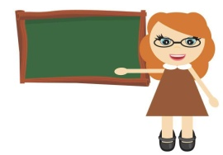 |  | 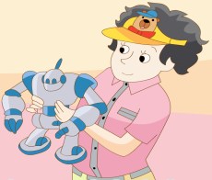 | 
（ ） | （ ） | （ ） | （ ）
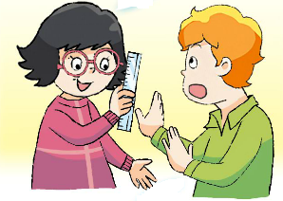 | 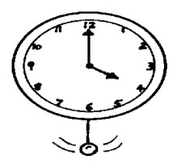 | 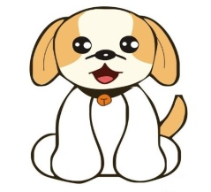 | 
（ ） | （ ） | （ ） | （ ）
C）根据你所听到的句子，选择正确的答语。
（ ） 1. A. It’s a crayon. B. They’re crayons.
（ ） 2. A. Yes, it is. B. Yes, they are.
（ ） 3. A. She’s beautiful. B. He’s nice.
（ ） 4. A. It’s ten. B. I’m ten.
（ ） 5. A. Thank you. B. I’m sorry.
D）听录音，给下列句子排序。
（ ） 1. Is it in the lunch box?
（ ） 2. What a nice cake!
（ ） 3. Here’s your breakfast.
（ ） 4. Don’t be late.
（ ） 5. Please open the book.
E）听录音，填入空缺的单词。
1. Don’t ___________ in ___________ .
2. The football is _________ the _________.
3. –How old is the___________? --She’s ___________.

二、语言知识。（共32分，A每空2分，B、C、D小节每空1分）

A）根据提示，完成句子（每空一词）
1.--Who’s this ___________ ( )? --She’s my aunt.
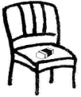
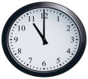
2.It’s __________ o’clock.（ ). It’s time for __________.
3.--What’s this ___________ the ___________ ( ) ? --It’s a rubber.
B）单项选择，请从A、B、C选项中选出最佳答案，填在题前括号内。
（ ）1.--What’s this? --It’s_______ English book．
A．a B．an C./
（ ）2. -- ________is your sister? --She’s in the library.
A. Who B. Where’s C. Where
（ ）3. -- Is this ________ magic clock? --________, it isn’t.
A. you; No B. your; Yes C. your; No
（ ）4. --I’d like a jacket, please. --______ the red one?
A. Where’s B. What about C. Is that
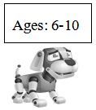
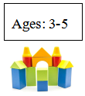
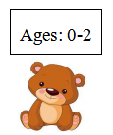
（ ）5. Liu Tao’s cousin is two,he can buy（买） __________ for his cousin in the toy shop.
A. B. C.

（ ）6.--Here’s a toy car for you, Ben.
--Thank you. But I want______ a robot.
A. to B. 不填 C. for
（ ）7. --What are these? --_______ my _______.
A. It’s; rulers B. They’re; ruler C. They’re; rulers

（ ）8. It’s time for class. Please say “______ ” to Miss Li.
A. I’m sorry. B. Good morning. C. Sit down.
（ ）9.--Guess, what is in the bag?
--A book.
--Sorry, _________.
A. you are right B. you are out C. it is a book
（ ）10. --Hello, ______Sam. Look at the picture. This is ______!
A. I; I B. I’m; me C. I’m; my
C）根据句意，选择方框中的单词或短语，填序号。（有一项多余）
A. Hurry up B. new robots C. in the bag D. What E. this is F. how G. they are
- ___________ a happy family! I love my family.
- ________! Don’t be late.
- The pens are _____________.
- Are these toys? No, __________ pencils.
- Look, __________ your new cap!
- I can see two ____________on the floor.
D）将下列句子排列成完整的对话, 将序号写在下面横线上。
- Look! This doll is for you! B. Wow, a big cake! I like it!
C. What time is it, Mum? D. I’d like a doll.
- Great! Thank you, Mum. F. It’s six o’clock. It’s time for dinner.
G. Happy birthday, Nancy. Make a wish!
C

- 语言综合实践。（共18分，A、B小节每空1分, C小节7分）

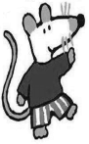
A）小老鼠Maisy 带领好朋友Bobby 参观农场。请根据对话内容判断，正确的写T，错误的写F。

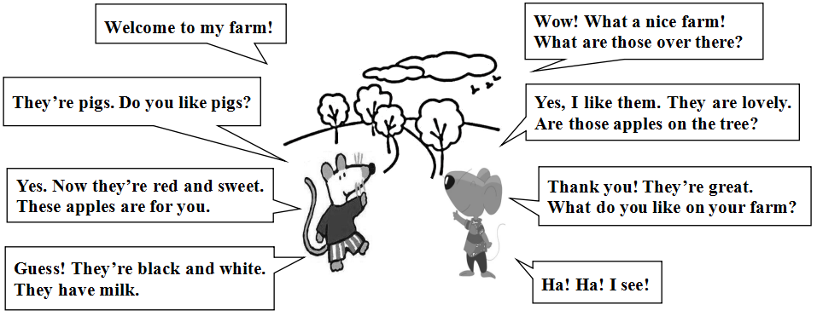
1. ( ) Maisy and Bobby are on Bobby’s farm.
2. ( ) Bobby likes lovely pigs.
3. ( ) The sweet and green apples are for Bobby.
4. ( ) Maisy likes ducks on the farm.
5. ( ) They are happy.
B）阅读绘本《Maisy’s morning on the farm》，并匹配合适的图片，并将序号写在题前括号内。
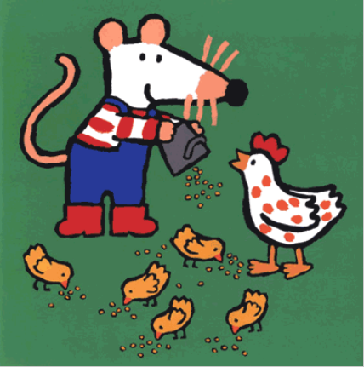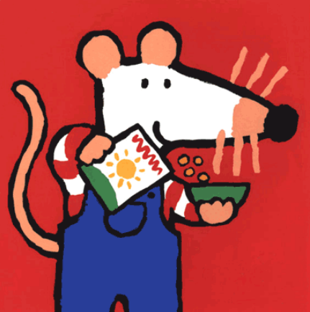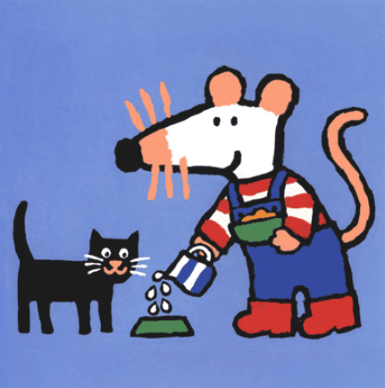

A B C
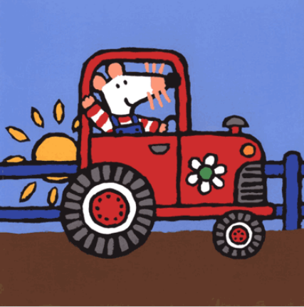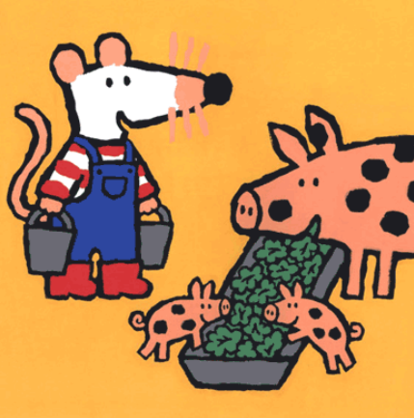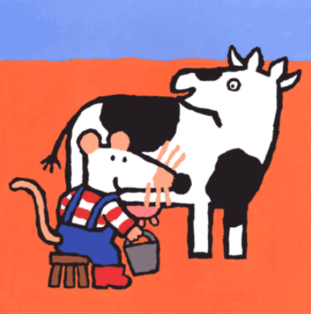

E F G
( ) 1. Maisy wakes up（醒来） early. There’s some work to do on the farm.
( ) 2. Here, chickens（鸡）! Come and have your breakfast.
( ) 3. Next Maisy feeds（喂养） the pigs. They’re hungry!
( ) 4. It’s time to milk the cow（挤牛奶）. Moo!
( ) 5. Now it’s time for breakfast. Maisy puts cereal （燕麦）and milk in her bowl（碗）.
( ) 6. Little black cat wants milk, too.
C）Maisy和Bobby在一起欣赏着农场的图片，请你替换划线内容，描述下另一幅图片吧！
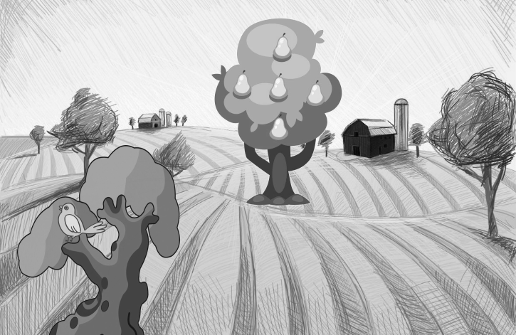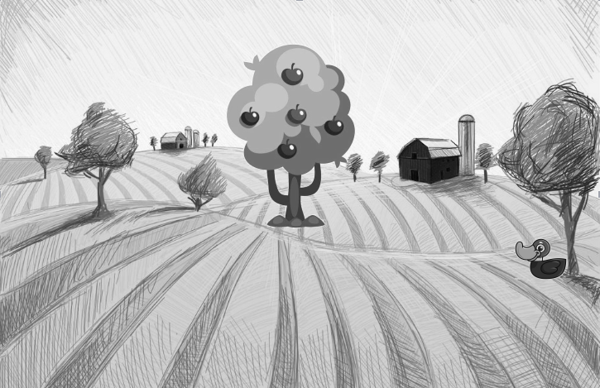
Look at this picture. ___________________. __________________._________________. __________________. _________________!

Look at this picture. This is a duck. It’s under the tree. These are apples. I want an apple. I love this picture!

