4B Unit 8 第一课时教学设计
华罗庚实验学校 吉扬
Teacher’s Activity | Students’ Activity | note
Step1 Warming-up  1. Perform magic  - T: I know you are the students of … Primary School, right? But do you know me ? Do you have any questions to ask me ?  - T: Today I’m not a teacher. I’m a student in a magic school. Do you know Harry? He’s my good friend. We are in the same school. Today is the Open Day of my school. (teach open day)You can go to my school. Welcome to my school.  - T: Let’s go. Look! How is my school?  T: There are many windows here. So I think it’s bright too. ( teach bright b-right )  T: I think you all like my school, right? Do you want to be a student in the magic school?  T: it’s not easy. We should finish some tasks.  Step2 Tasks  Task 1 Magic ears  T: What room is it? (teach music room) See? The door is closed. You should listen and answer “What’s in the music room?”  1. piano (listen to the song)  T:(Show the picture) Who is right? Hands up. Great! You’ve got magic ears.  T: How many pianos can you see? So we should say There is…  - violin  T: I like violins very much. Sometimes I play the violin. (teach sometimes. Some-time-s)  - guitar  (listen to the song)  T: Let’s have a look. Yes or No? Good. I like the song . sometimes I ________ .  T: Do you sometimes play the guitar?  T: What do you sometimes do ?  T: Wonderful. You did well. See? Well begun, half done.  Task 2 Magic eyes  T: Let’s go to Task 2. OK? What room is it? (teach library) What’s in the library?  1. computers  T: Let’s have a look. Oh, Some computers.(teach computer) How many computers can you see?  T: We should say “There are… ”.  2. bookcases  (bus---buses watch---watches  fish---fishes waitress---waitresses  glass—glasses nurse---nurses )  3. T: What’s in the bookcase?  a book-- three books-- some books  T: how about this picture?  T: Yes, we also can say “lots of books”  T: I’ll show you the library. There are lots of other things in the library.  T: Good. I’m a little tired. Let’s have a rest in the rest room. OK?  Oh, it’s a magic room, too.  Task 3 magic brain  T: We are almost to win. Which room will we go？  T: This time, I’ll see if you have magic imaginations. Talk with your partner and imagine what’s in the classroom?  T:(show the picture of classroom）  See? There’s a magic TV.  Sometimes we watch cartoons in  Class. Do you like watching car-  toons?  - What’s in Ben’s School.  T: Listen again and answer  - What’s in the classroom?  T: listen to P3  - What’s in the music room?  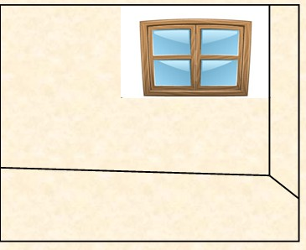  （teach “near”）  - What’s in the library?  Read after the cartoon.  Task 4 Magic imagination  1. T: Can you design your magic room? First I’ll show you my magic room.  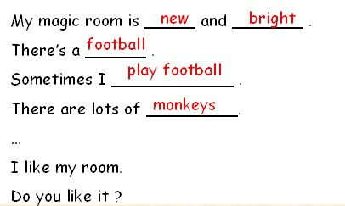  2. Try to make a dialogue  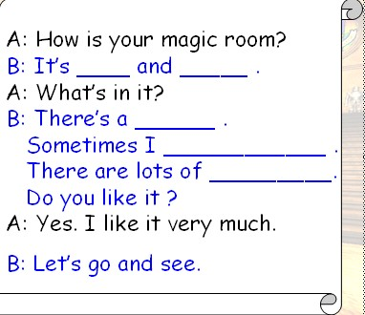  Step 3 Consolidation  - Welcome to the magic school.  Where there is a will, there is a way!  - Summary  (1) 合成词 （compoundword）  (2) new way of asking and answering  3. Homework  Talk with your friends about your magic rooms | Ss: (surprised and excited)  S1: Where are you from?  S2: What’s your name?  S3: What’s your job?  …  Ss:（read open day）  引导学生说：let’s go to magic school.  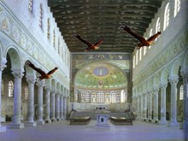  S: It’s big/new/pretty/… How nice!/big!/…  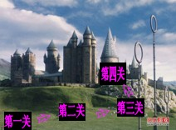  S: a piano./ …  (T用 There is a piano 进行重复，向其渗透there is)  Ss: one.  Ss: (learn)There is…  Ss: (read) sometimes  some times  Ss: There is a guitar.  Ss: Sometimes I play the guitar.  S: Yes, I do./ No, I don’t.  Sometimes I …  S: There’s a …  Ss: Three.  (learn to say) There are some … .  (one by one)  S: There are some bookcases.  S1: There are many books.  (learn lots of)  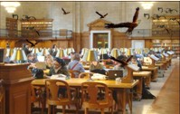  Ss: What’s in the library?  S1: There are lots of … .  S1: What’s in the room?  S2: There are some/lots of…  Ss: Classroom?  Practice in pairs  (learn blackboard)  Ss Watch the cartoon about U8 A  S1: There is a classroom, music room and a library.  There’s a ____, a ________ and some _________.（try to catch the key words and fill in the blanks）  (learn songbooks)  There are _____ ______ and ______ _____ _______.  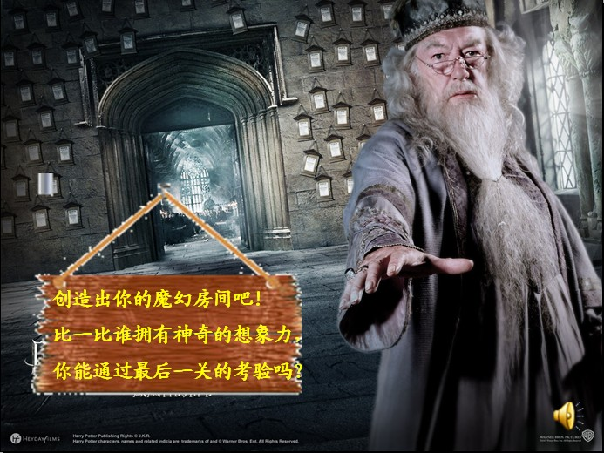  Sometimes blackboard  Bookcase songbook  …  Ss: storybook, copybook,  grandfather, pencil-box  …学生归纳了很多合成词。 | 表演魔术，学生一下子就被吸引过来。  创设了一个全新的情境。学生觉得新奇并特别感兴趣。  用充满魔幻神秘的图片让学生身临其境。吸引学生加入到魔法学校来。  招生简章。以任务为主线，明确提出目标任务。闯关成功后可以成为魔法学校的成员。学生兴趣盎然，参与性极高。  第一关“Magic ears”魔力耳。通过听各种乐器，能运用there is … 完成交际。  自然过渡，由I like…过渡到  Sometimes I ….  学习sometimes时，采用拆分教学。  先由老师整体呈现sometimes I play the violin.到学生填词 sometimes I ______.再到完全由学生造句练习，逐步熟悉并掌握sometimes的用法，  第二关“magic eyes”  通过遮物制造信息差，进行交际。  library是U6中的新单词。由于是U8提前教学，所以这个单词也是作为新单词出现。有必要教学生认读。  bookcases的发音是本课的一个难点。为了学生能更好的掌握/iz/的读音，教师归纳了不少学生已经学过的单词。让学生边读变悟出读音规律。  在学习lots of时，教师先分别呈现一本书，三本书和一些书的图片。然后呈现lots of books 让学生对这些量词有视觉感受.  教师事先准备好一个空房间的PPT，学生边听边摆放钢琴和歌本的位置。  PPT中录制了魔法学校的校长的声音，让课堂气氛再一次掀起高潮。饱含热情的完成最后一个任务。  经过老师的示范后，学生们早已跃跃欲试，都能给出精彩的答案。能够成功的掌握并运用本课新学。同时使得本课这个magic主题得到升华。最后的汇报让学生回归对话形式输出。

