Fun in the sea
武进区芙蓉小学 梁伊丽
Step 1 Warm up
- Introduction
T:Hello,boys and girls.I’m your new teacher today.I’m from Furong Primary School, our school is not big but beautiful. Look! They’re my lovely students. They’re in Grade Six too. This is me, their lovely teacher. I like travelling. This summer holiday, I went to Thailand, I like the sea, I played on the beach.I saw some seagulls, they flew over the sea. I saw many sea animals in the sea.
Learn:beach, seagull
- Watch a video :《What animals are in the sea?》
T：What did you see in the video?
(展示 “octopus,whale, shark,swordfish,jellyfish,starfish, coral reefs, ”图片)
【设计意图：通过一则海底生物小视频，激发学生对这篇绘本故事的学习兴趣，同时渗透海洋生物词汇。】
Step 2 Learn about the story
- Get to know the cover
T:Today, we will read a picture book. First, let’s look at the cover of the book.
Students observe the cover and answer some questions.
Q1: What can you get from the cover?
Know:Tony, coach- Eric
Q2: What do you want to know about the story?
Students ask some questions about the book.
(Who? Where? When? How?What?Did? )
Q3: What does “fun” really mean?
【设计意图：培养学生根据图片获取信息的能力；让学生带着问题有目的地学习绘本。】
- Learn Scene One (P4-7)
（1）Students observe the pictures and answer:
Q1：Where did they go ?
Learn:Great Barrier Reef
Q2: What did they do on the beach?
Phrases: play volleyball, enjoy the sunshine, play in the sand
（2）Let’s read.
Tony and his family went to the Great Barrier Reef for summer holiday. On the beach,Tony played volleyball with his brother. His parents enjoyed the sunshine. His sister and little brother played in the sand. Some seagulls flew over the sea.How beautiful!
【设计意图：利用节奏感强烈、学生较感兴趣的rap，化解难点，同时营造快乐的课堂氛围，使学生迫不及待地进入故事。】
- Learn Scene Two (P8-19)
（1）Watch and answer(看9~18页的动画)
Q：What sea animals did they see?
Learn :angelfish, octopus, swordfish, shark, coral reefs, seahorse
（2）Know about the angelfish
PPT播放动态效果：Tony , Tony’s brother, coach Eric在海底潜水，迎面游来了一群可爱的神仙鱼。播放音频“Look, what are those?”
T: What are those？
S: They’re angelfish.
T: Do you like them? Why ?
S: Yes, I do. Because they are cute/beautiful/lovely/colorful···
T: Do you want to take them home? (angelfish: cute, difficult to keep at home)
Tips: 适合水温：26度~32度，对水质的要求很高哦！
【设计意图：利用PPT将静态的绘本图片制成动态效果，创设真实生动的情景，让学生宛如身临其境，激发学生学习的热情，引导学生参与课堂教学活动。】
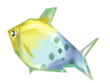
板书：

cute
difficult to keep at home

feature
特点
appearance
外形

（3） Know about the octopus
PPT动态效果：墨液散开
①Q: What happened? What is it? How does it look ? What can it do?
②Introduce and act（同桌合作，一人扮演章鱼，一人介绍）
A：It's···
It has···
It can···.
It···.
B: 扮演章鱼，动作、表情生动，演出特点！
③What aspects are mentioned?这些关键词描述了哪些方面呢？
板书：
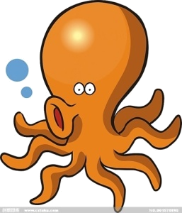

eight long arms
dangerous
when in danger, shoot ink

appearance
外形
feature
特点
feature
特点

【设计意图:让学生归纳描述章鱼的关键词描述了哪些方面，初步了解可以从哪些方面描述海洋生物，培养学生的综合语言表达能力。】
- Know about the swordfish, sharks,seahorses and coral reefs.
①自读P12-19，完成表格。
- Swordfish
PPT动态效果：章鱼飞快地游走，Eric大叫：“Look, What a big fish!”一只剑鱼游了过来。
- Shark
墨液逐渐散开，后面还尾随了一只鲨鱼。
- Seahorses
- Coral reefs
②Work in groups:Ss read P13~P14 and try to introduce the swordfish and the sharks. （两人一组，选择其中一种鱼， 结合自己的观察与了解，画出mind map,并尝试介绍。）
It's···. It has···. It can···. It···.（引导学生从外形与特点方面进行介绍）
【设计意图:学生了解可以从哪些方面描述海洋生物后，运用介绍。操练并培养学生的综合语言表达能力。】
- Read with the tape
Step 3 Production
- Make a conclusion (P20-21)
Q: What does “fun” really mean?
【设计意图：与本节课学习绘本封面时提的问题相呼应，升华主题。】
- Watch and discuss
T: But the Great Barrier Reef is smaller than before. What happened?
Watch the video of the Great Barrier Reef.
Discuss: What should we do to protect the reefs, the sea and the Earth?
【设计意图：情感教育，升华主题，培养学生保护生物、保护地球的意识。】
- Tell the story about Chinese river dolphin.
- Make a reading card for this picture book.
Step 4 Homework
- Finish the reading card and share the story with your friends and parents.
- Try to know more information about sea animals.
- Read more picture books after class.
板书设计：
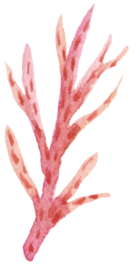
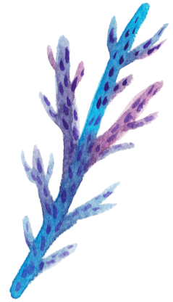
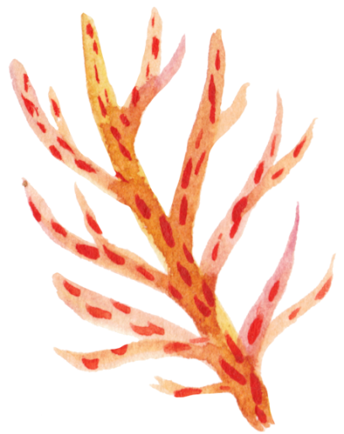
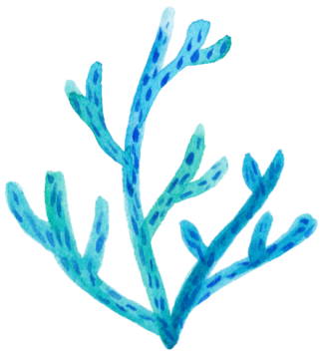
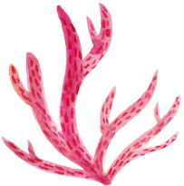
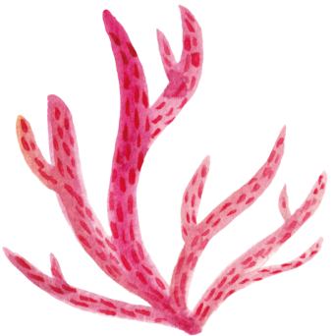

Fun in the sea
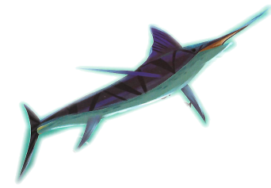
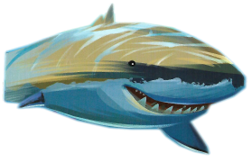
angelfish
octopus
swordfish
shark
coral reefs
seahorse

