Step1: Warming-up
1.Sing the song: Do you like purple grapes?
2.Free talk
T: Do you like purple grapes?
S: Yes, I do.
T: Look, I have some purple grapes. Let’s count.
How many grapes do I have?
S: You have…grapes.
T:I have 12 grapes. What do you have ?
3.Pair works
A：Do you have any …?
B：Yes, I do /No, I don’t.
A: How many… do you have? / What do you have？
B: I have …
【设计意图：通过上一单元的歌曲导入，复习数字1-12，引出have句型的结构，初步应用How many……？和What do you have？】
Step2 Pre-task
1. About Miss Wang
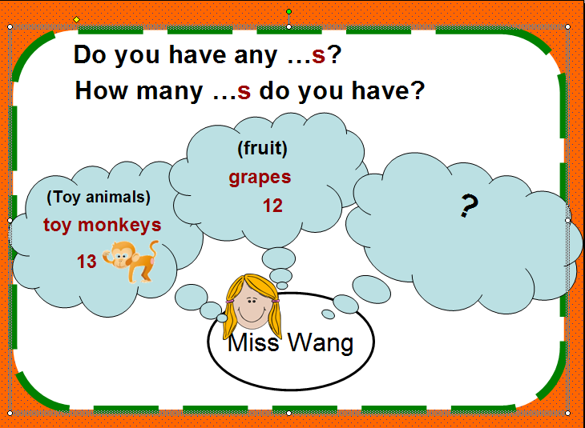

T: You know Miss Wang has 12 grapes , What else do I have? Can you ask me?
S1:Do you have any …?
S2: How many …s do you have?
T: Yes , I have some toy monkeys. I have 13 monkeys.
(1)Learn the word “thirteen”
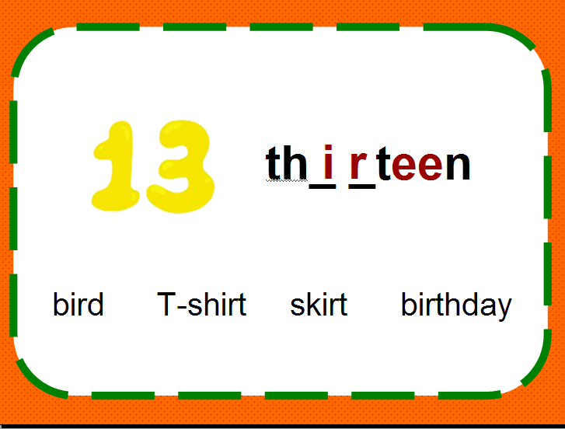

Can you read these words? So can you complete “thirteen” and read it?
Read and say
(2)Learn the word “sticker”
T: Let’s have a look ,what do I have?
Stickers
Learn and read
T: How many? Let’s count
S: 跟着老师数数
2. Let’s learn the numbers
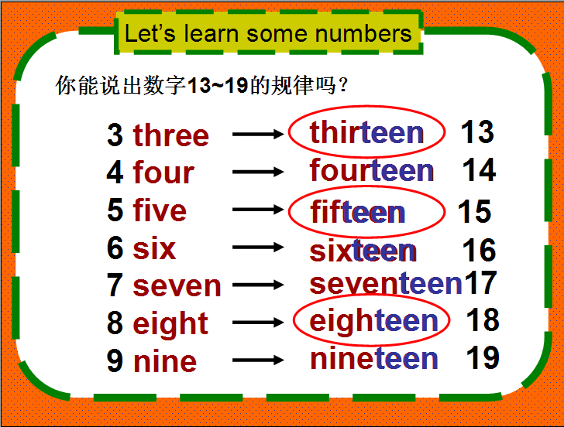

- Find the rules
- How many stickers do I have?
Fifteen.
【设计意图：通过英语老师的名片，让学生用学过的句型设问，在问与答之间巧妙地解决数字和单词sticker的学习，把学习的主动权交给学生，让学生在产生问题、发现规律、解决问题的过程中主动建构知识体系】
Step 3 Task 1
- Watch and answer
T: Who has 15 stickers too? Let’s watch cartoon
S1: Helen has 15 stickers.
- Listen and fill
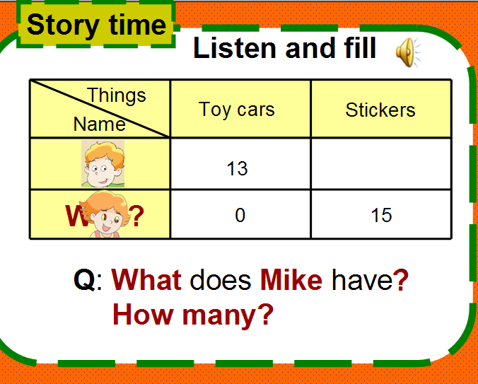

Mike has 13 toy cars.
T: Do they like their toys?
S: Yes, they do.
T: Right. And they are very beautiful.
Learn :very beautiful
- Read and find
Task:自读课文，找出文中以Can…开头的句子。联系上下文,猜一猜它们是什么意思?
（1）找出Can I have a look? Can I have one?及回答Yes./Sure
（2）学习该句型，分析2个have及one的意思
【设计意图：story time板块文本的处理通过对文本整体切入，然后到文本的具体分析，使课堂更有顺序与层次感，同时使得学生对文本的学习与掌握也更到位。】
Step 4 Task 2
1.Listen and repeat
Note intonation 注意语调
2.Read and act
（1）Read in pairs
（2）Act the dialogue
【设计意图：通过整体听读、模仿，再到小组之内的朗读和表演，呈现由扶到放的过程，关注文本语音语调的准确性和对人物情绪的体验感悟，在读和演的表现中互相评价，反馈提升】
Step 5 Task 3
- Work in groups :Choose one to act
(1)National Day is coming , you invite your friends to your home and show them your toys , please make a dialogue and act it out .
(2)Love sail : Show your things and make a dialogue
2. 互评反馈
【设计意图：给出情境，根据小组的爱好选择一个编有意义的对话，是对学生本课所学知识的巩固和提升，学生在互相讨论、交际、评价中加深对句型的理解。】
Step 6 Post –task
1.Summarize
What have you learn from this lesson?
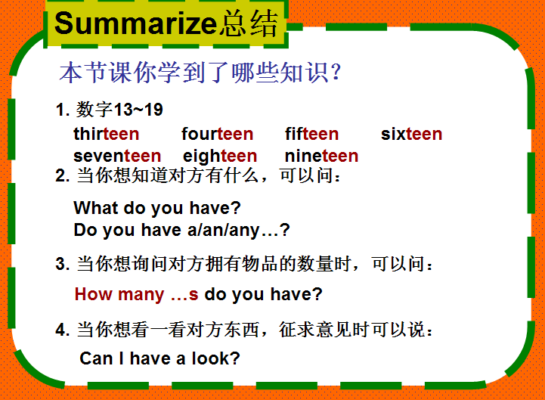

- Homework
(1)Read the story after the tape more than five times
(2).Spell and remember the numbers from 1to19
【设计意图：对本节课的知识点进行回顾总结和梳理，是有效学习的方法之一，学生在这一环节中能对本节课的学习有一个清晰的思路，对后续知识的学习也是一个铺垫。家作的布置兼顾口语与手写，是对知识的延生运用和巩固。】

