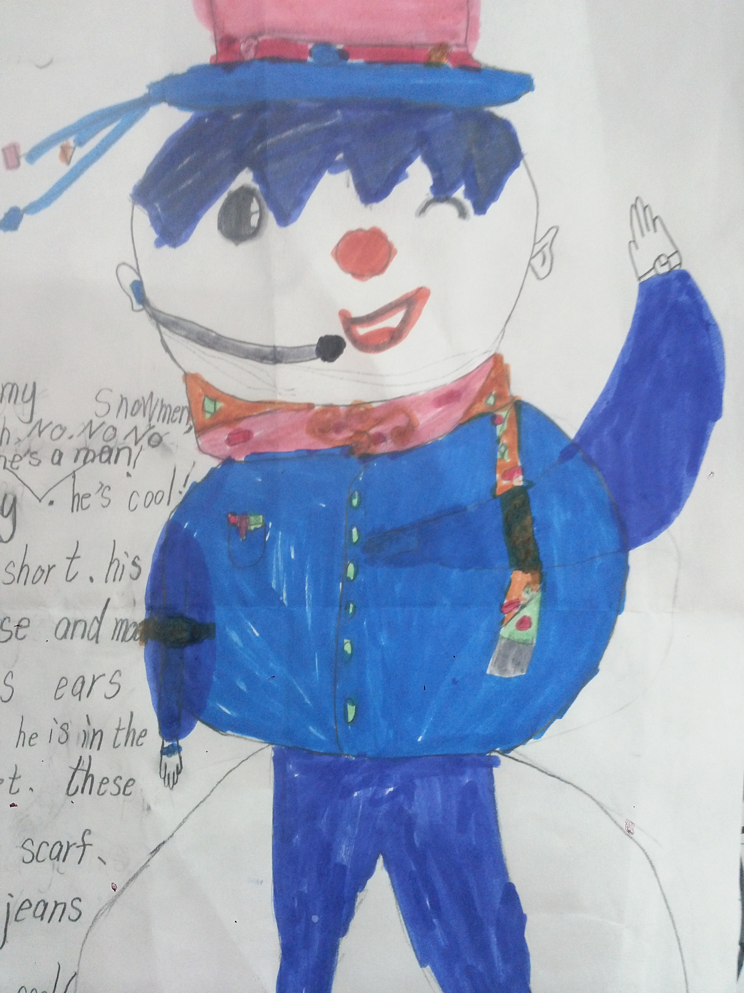I have a snowman, he’s cool boy. His hair is short. His eyes and nose and mouth are big,his ears are small .He is in a blue jacket . Can you see his scarf? It’s colourful .His blue jeans are nice too. He looks so cool!

