第四单元 单元分析
序号 | 内容 | 个 人 设 计 | 备课组集体讨论意见
一 | 单元  教材  分析 | 本单元以描述过去和现在的生活变化为话题，通过运用一般过去时和一般现在时进行对过去和现在生活的比较。要求教会学生学会用英语描述生活的变化，对周围事物进行比较，同时帮助学生了解其他国家过去与现在人们生活的变化和不同。让学生通过现在与过去的对比，了解社会的变化，从而更加珍惜我们现在的生活。 | 本单元的教学中，要注重培养学生的朗读能力和用英语交流的能力。本单元以描述过去和现在的生活变化为话题，通过运用一般过去时和一般现在时进行对过去和现在生活的比较。要求教会学生学会用英语描述生活的变化，对周围事物进行比较，同时帮助学生了解其他国家过去与现在人们生活的变化和不同。让学生通过现在与过去的对比，了解社会的变化，从而更加珍惜我们现在的生活。
二 | 单元  目标  要求 | 1、能听懂、会说、会读和会拼写词汇radio,TV,telephone,office,telephone,e-book,newspaper,wait ,ago, new  2、能听懂、会说、会读和会写句型He could not write.  Mr Brown wrote letters to his friends,  Tom listened to the radio.  She bought things from shops.  She does shopping on the Internet,too.  Bobby is looking out of the window.  3、能听懂、会说、会读词汇then and now,mobile phone,anywhere,spell,with,yesterday,many,letter,Internet,e-friend,Wednesday,sentence,angru  4、能够运用一般过去时与一般现在时描述过去与现在的变化。  5、听读辨认字母组合er在单词中的读音。 | 1、能听懂、会说、会读和会拼写词汇radio,TV,telephone,office,telephone,e-book,newspaper,wait ,ago, new  2、能听懂、会说、会读和会写句型He could not write.  Mr Brown wrote letters to his friends,  Tom listened to the radio.  She bought things from shops.  She does shopping on the Internet,too.  Bobby is looking out of the window.  3、能听懂、会说、会读词汇then and now,mobile phone,anywhere,spell,with,yesterday,many,letter,Internet,e-friend,Wednesday,sentence,angru  4、能够运用一般过去时与一般现在时描述过去与现在的变化。  5、听读辨认字母组合er在单词中的读音。
三 | 单元  设计  意图 | - 本单元的话题是过去和现在，通过对比Mike一家人过去与现在的学习、工作和生活等方面，让学生感受科技如何改变生活。教师可以准备一些有关生活用品和周围环境的老照片，并要求学生准备几张自己婴儿或者幼儿时期的照片，以备课堂活动使用。  - 本单元是在前三个单元的基础上，对一般过去时做进一步呈现，而一般现在时的句型，在教学中，教师要启发学生通过观察、对比等方式，总结归纳两种时态的用法，并尝试在正确的语境中使用。 | 教师尽量创设真实的情境，激发学生学习的欲望。本单元是在前三个单元的基础上，对一般过去时做进一步呈现，而一般现在时的句型，在教学中，教师要启发学生通过观察、对比等方式，总结归纳两种时态的用法，并尝试在正确的语境中使用。。本单元的话题是过去和现在，通过对比Mike一家人过去与现在的学习、工作和生活等方面，让学生感受科技如何改变生活。教师可以准备一些有关生活用品和周围环境的老照片，并要求学生准备几张自己婴儿或者幼儿时期的照片，以备课堂活动使用。
四 | 单元  目标  达成  分析

交往互动式教学设计
课题 |  | Unit4 Then and now |  |  |  |  | 教时 |  | 第一课时
 |  |  |  |  |  |  | 日期 |  | 月 日
一、教学目标：  1.听说读单词then and now ,e-book, mobile phone, newspaper, radio, telephone, e-friend, anywhere, could，并能运用于语句中。  2.掌握动词过去式的发音及用法，会说…years ago,…could/ could not…Now,…  3.能正确地理解并朗读对话内容，在教师的引导和帮助下尝试复述课文内容。  4.通过过去和现在的对比，感受个人的成长和社会的进步。 |  |  |  |  |  | 重 点  与  难 点 |  | 1、能正确地理解并朗读对话内容，在教师的引导和帮助下尝试复述课文内容。  2、能正确使用一般过去时和一般现在时表达过去和现在的事情。
Teaching Procedures
Time | Steps |  |  | Teacher’s activities | Learners’ activities |  |  |  |  | Purpose, Feedbacks &Aims
5  min | Step 1  Warming-up  吸引注意，积累语言 |  |  | 1.T: Do you know the song?  T: Yes, time flies quickly. We are growing up, and the things around us are changing. We know, the world is changing.  2. T: Then what is changing?  Do you have your idea? | Free talk. |  |  |  |  | 师生交流  独立思考，回答教师提问。
25 | 核心过程 |  | Step2  Pre-task  导出目标，生成结构 | A.)1. T: Perfect. I like your ideas. Now I’ll show you a family. Do you know them? Who is he/ she?  2. Then, how about this boy? Yes, this is Mike six years/ Mr Brown twenty years ago/ Mrs Brown twenty years ago/ Mike’s grandpa thirty years ago.  T: （总结）The time before, we can use this word: Then. ( what does it mean?)  T: Today, we are going to learn Unit 4, Then and now.  T: SO ,can you say sth. about Mike’s family? （对比说，is/are, was/were）  T: They have changed a lot. And this lesson, we’ll know more about the changes of Mike’s family. | ( Mike, Mr Brown, Mrs Brown, Mike’s grandpa)  Learn:then |  |  |  |  | 学生观察图片，  师生交流  达成目标二
25 |  |  | Step3  Task 1  回忆相关知识，初步运用结构 | B.1. (图) This boy, he is Mike. Now, he is a young boy. And he can do many things now. Let’s guess, what can he do?  T: Could Mike do all these things six years ago? What could he do? （读could）I give you two fist letters here. Can you guess? What couldn’t he do?  T: So, six years ago, Mike could read….. but he …  T: Can you describe little Mike six years ago and young Mike now?  2. T: And we know, as we people are changing everyday, our life is changing, too. Now let’s listen to the tape, and try to catch: what they did then and what they do now. And remember to tick them quickly. After learning let’s check.  3. Look at Mr Brown. This is Mr Brown twenty years ago. And This is Mr Brown now.  What did he do then and what does he do now?  (1)Read the paragraph quickly, and try to find out the communicate tools.  (2)read the four words. T: They are needed when we want to contact others. So ,which one do you like? And Why?  (3) How about Mr Green? What did he use twenty years ago?  T: Let’s imagine where he did or does these things. Where did he wrote letters/ use the telephone/ write e-mails/ uses the mobile phone?  (4) T: Let’s read this paragraph together. Now, try to describe Mr Brown.T: Then and now, the way to contact people is changing . | He can …  He couldn’t…  师生一起读文本：Mike could read….. but he …  Read the paragraph quickly  Read the four words.  match: wrote letters, used the telephone） How about now? ( match: writes e-mails, uses the mobile phone)  Try to describe Mr Brown. |  |  |  |  | 同伴讨论  观看卡通，集体讨论  达成目标一
25 |  |  | Step4  Task 2  呈现刺激材料，活用结构 | T: Look at the pictures, do you remember her? —Mrs Brown Let’s see what changes have happened on her.  (1) T: What is she doing in the picture?  (2) T: Are you right? Read it please. So maybe she is doing some shopping or chat with her e-friends on the Interenet.  (3)And this is the picture of her twenty years ago. Then she was a schoolgirl. Where did she make friends? And where did she buy things?  (4) Read the text with your partners.  (5) T: Let’s try to fill in the table , OK? 根据表格说一遍。  6. (1)T: And besides these, the way to get news is changing now.  (2) T: How did Mike’s grandpa get news thirty years ago, and how about now?  T: First, let’s look at the two pictures. Watch carefully and try to find the difference.  (3) Read the text together, and try to retell it.  7. Read the whole text together. 8.T: What do you think? You can discuss in groups first. | .  Talk about Mrs Brown.  (解释e-friends)  Read the text with your partners.  It tells us the way to ______ and the way to _______. And the ways are changing now.  How do you get news, boys and girls? ( I get news from_______. )  Ss: Their life is…(colourful, cool , modern, happy…) ,because… |  |  |  |  | 预测二十年前布朗夫人会做什么？独立思考，同伴互助，交流。  达成目标三
25 |  |  | Step5  Task 3  引发期待行为，强化结构 | T: This time, let’s work in 4. Each one chooses a part to read. Then use the phrases on the blackboard to make a report about your part. | (分组练习朗读，然后四人一小组，上台借助板书进行反馈)。 |  |  |  |  | 组内读故事并尝试复述故事，教师适时评价，同伴补充，评价。  达成目标四
10  min | Step6  Post–task  提供反馈评价，巩固结构 |  |  | Homework  1.Listen and read Story time.  2.Retell Story time on P38  3.Bring two photos and think of the changes between two photos on P40. | 1.Listen and read Story time.  2.Retell Story time on P38  3.Bring two photos and think of the changes between two photos on P40.
板书设计 |  |  |  | Unit 4  Then and now  Name …years ago Now  Mike  Mr.Brown  Mrs.Brown  Mike’s grandpa

交往互动式教学设计
课题 |  | Unit4 Then and now |  |  |  |  | 教时 |  | 第二课时
 |  |  |  |  |  |  | 日期 |  | 月 日
一、教学目标：  1. 能够理解并掌握动词过去式的不规则变化及读音。  2. 学生能运用句型…….years ago, I was/ I could (not)/ didn’t……..。  3. 在真实情境中，用所学知识正确比较过去与现在。  4 能正确掌握动词过去式的不规则变化及读音。  5 能用一般现在时和一般过去时的语句来描述自己。  6 能够在课上的活动中发现学习英语的乐趣，乐于去表达说出英语。  7了解过去与现在的变化，体会我们生活的提升。 |  |  |  |  |  | 重 点  与  难 点 |  | 1. 了解掌握动词过去式的转换方式和运用。  2. 运用文中所学的句型等，准确表达出自己的过去和现在。
Teaching Procedures
Time | Steps |  |  | Teacher’s activities | Learners’ activities |  |  |  |  | Purpose, Feedbacks &Aims
5  min | Step 1  Warming-up  吸引注意，积累语言 |  |  | T: What did you do yesteday /last weekend?  T:What do you often do at weekends？  2. Act and say  T: What did I do just now ? | S:I …动词过去式  S:I…动词原形  S: You listened to music just now. |  |  |  |  | 根据提问，回答。  两两操练。  达成目标1
25 | 核心过程 |  | Step2  Pre-task  导出目标，生成结构 | 1. Think and say： T: Think about the changes of Mike’s family and finish the table.  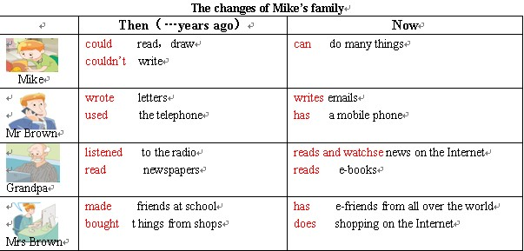 |  |  |  |  |  | 教师引导下，讨论Mike一家在个人能力和信息交流方式上面多年前和现在的变化。  达成目标2
25 |  |  | Step3  Task 1  回忆相关知识，初步运用结构 | 2. Read and learn  T: Look at the pictures and learn the words.  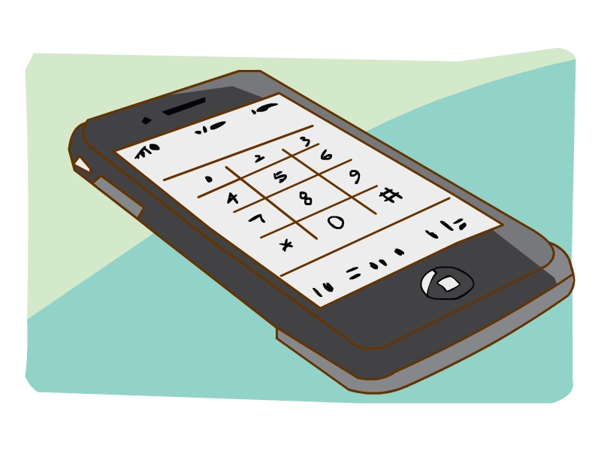  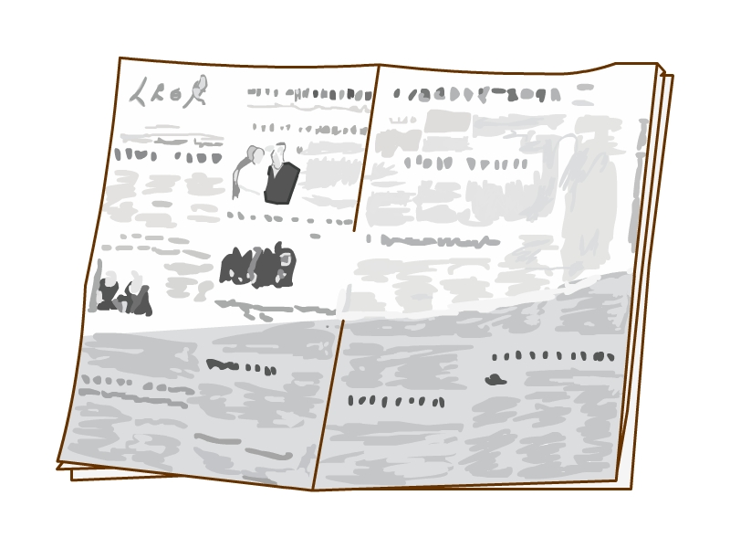  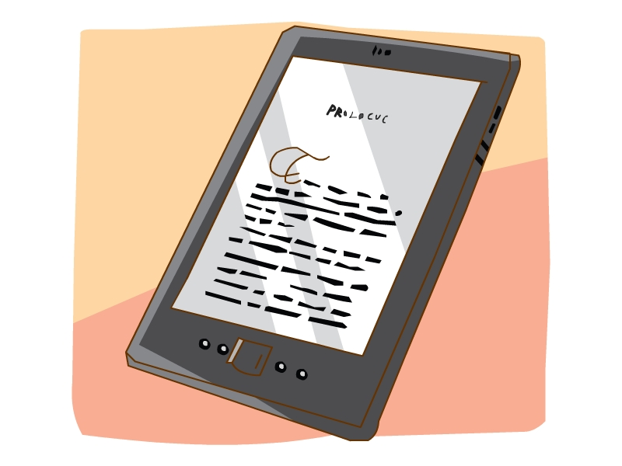  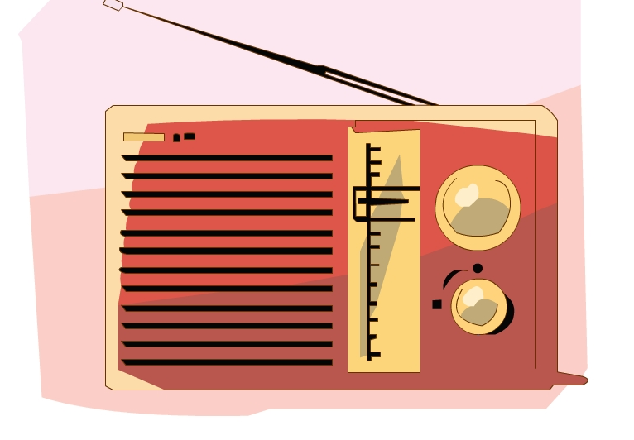  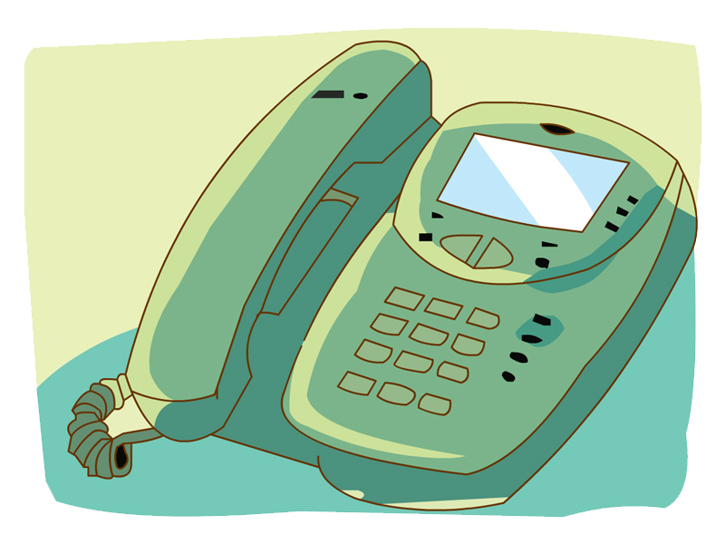    an e-book a mobile phone a newspaper  a radio a telephone a TV  3.Try to use  T: Look at this short passage, use the new words to fill in the blanks.： Twenty years ago ,my mother used the  at home. She couldn’t call people anywhere. Now she  has a .It is easy to take .My father listened to the and read for news in the past ,but now he usually watches news on the Internet .Sometimes he reads newspaper .He also reads .For me ,ten years ago ,I watched at weekends, now I like playing computer games when I’m free . It’s fun. | （师生一起读文本）  总结：In fact, everyone is changing everyday( the changes of people), What they look like is changing(appearance) , and what they can do is changing, too(ability). |  |  |  |  | 独立阅读、思考  指名组交流，巩固新授单词。  达成目标3
25 |  |  | Step4  Task 2  呈现刺激材料，活用结构 | Grammar time : Make sentences  T: There are three types of cards in my hand.They are “When”,“Who”and “What”. We need to put these three arbitrary combined into a sentence . | Eg: S1: twenty years ago  S2: Mr Brown  S3: write letters to his friends  S4: Twenty years ago, Mr Brown wrote letters to his friends. |  |  |  |  | 两两交流/组内交流  组内讨论  达成目标5
25 |  |  | Step5  Task 3  引发期待行为，强化结构 | 1Grammar time : Read and find  （1）Read the sentences with verbs：  a.Ask the students to underline the verbs  b.Ask the students to underline the subjects  Rule：In the past tense,verbs don’t change with subjects.  2Grammar time : Play a game  (1)T: I say the words, you should say the past tense as quickly as you can.  3 Grammar time : Read the irregular verbs  Eg：I (see) a mobile phone under the desk just now .  Lucy (get) up late this morning .  4.Production and Progress  1. Checkout time: Look and write  T: What could they do? What couldn’t they do? | Group of two or more  is/am（was）are（were） can（could）  fly（flew） take（took） see（saw）  go （went） eat（ate） get（got）  do（did）write（wrote）make（made）… |  |  |  |  | 小组交流，推荐一人汇报。  达成目标6
10  min | Step6  Post–task  提供反馈评价，巩固结构 |  |  | 2. Fun time  A. T: Look, here are two photos of me. Twenty years ago, I was a student. I could ride a bike .I couldn’t drive. I didn’t work. Now I’m a teacher. I can drive . I teach you English.  B. T: Let’s say something about “ then and now” of you, and make a comparison table.  3. Checkout time:Think and write  T: Stick a photo of yourself and then write about it .  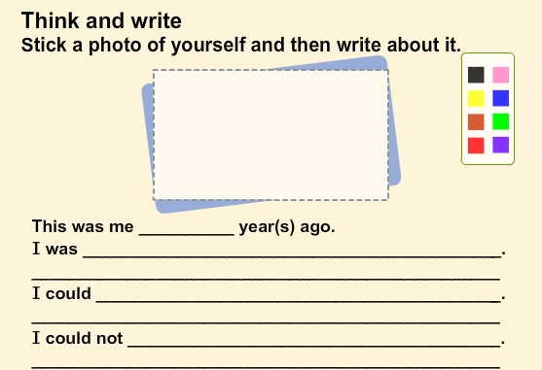 |  |  |  |  |  | 四人一组讨论、交流  教师评价
板书设计 |  |  |  | Unit 4 Then and now  What could you/he/she/ they do?  What couldn’t you /he /she/ they do?

交往互动式教学设计
课题 |  | Unit4 Then and now |  |  |  |  | 教时 |  | 第三课时
 |  |  |  |  |  |  | 日期 |  | 月 日
1、阅读并理解Cartoon time的内容，学会表演,明白Cartoon time 的幽默之处。  2、在前两课的基础上会正确并熟练对比以前和过去, 感受个人的成长和社会的进步。；  3、了解并体会字母组合er在单词中的发音;  4、让学生了解人类的两项重大发明并延伸中国古代的四大发明及其他的发明。 |  |  |  |  |  | 重 点  与  难 点 |  | 阅读并了解相关的Culture time；  在前两课的基础上会正确并熟练对比以前和过去；  让学生了解人类的重大发明，激发学生的求知欲望和远大理想。
Teaching Procedures
Time | Steps |  |  | Teacher’s activities | Learners’ activities |  |  |  |  | Purpose, Feedbacks &Aims
5  min | Step 1  Warming-up  吸引注意，积累语言 |  |  | Watch the video;  Let’s recall the past.  Revision  a、Introduce myself.  b、Introduce themselves.  c、Introduce Clothes 、Food、House and Transportation about the past and the present. | Revision |  |  |  |  | 生生互动  师生互动
25 | 核心过程 |  | Step2  Pre-task  导出目标，生成结构 | Step2: Presentation  1 Sound time  1）Talk and lead-in： Bobby and Sam also learn English at school. This is an English lesson.  Ask: What are they doing now?  2)Try to read the sentences;  3)Explain :er is pronounced as ---  4)Try to say some other words about “er”  5)Read the words together ,then make some new sentences with the words. | They are having an English lesson.  归纳er在单词词尾的发音。 |  |  |  |  | 独立思考再两两交流  指名学生回答  独立思考  指名学生回答  全班互动交流。  两两合作、交流。  达成目标3
25 |  |  | Step3  Task 1  回忆相关知识，初步运用结构 | 2Cartoon time  Watch the cartoon, then answer :Miss Fox gets angry. Why?  Read together and judge.  Read alone and answer: What do you think of Sam and Bobby?  Listen and repeat.  Think and imagine: If you were Miss Fox, what would you say? Read in roles and try to act.  Guess : What are Bobby and Sam talking about? | Single work |  |  |  |  | 师生互动  组内交流  达成目标1
25 |  |  | Step4  Task 2  呈现刺激材料，活用结构 | 3 Culture time  They’re talking about a book called Great inventions.  Ask: What is this? It’s an aeroplane. What about this? It’s a train.  Ask: Who invented the aeroplane and the train? Listen and repeat.  Introduce the first aeroplane and the first train. | Learn and answer  Introduce the first aeroplane and the first train. |  |  |  |  | 通过师生、生生互动激发学生学习兴趣。  达成目标2
25 |  |  | Step5  Task 3  引发期待行为，强化结构 | Step5: Extension  1) The Americans and the British invented the first aeroplane and the first train. And Our Chinese people are even great. Then Introduce the Four Great Inventions of ancient China  2)Share some other inventions.  3）Sum up: Listen carefully in class, we will know a lot and be a useful person！ | Share some other inventions. |  |  |  |  | 组内合作交流。  达成目标4
10  min | Step6  Post–task  提供反馈评价，巩固结构 |  |  | Step6: Homework  1、Read the dialogue with expression and try to recite it.  2 、Surf the Internet and find out some stories about inventions. | Step6: Homework  1、Read the dialogue with expression and try to recite it.  2 、Surf the Internet and find out some stories about inventions. |  |  |  |  | 独立思考完成  小组内同伴交流展示，互帮互纠。指名某组向全班交流。
板书设计 |  |  |  | Unit4 Then and now  (period 3)  ---years ago, I--- er /ə/  Now I--- father brother together  - --invented--- writer letter singer winter  sweater sweater winner

交往互动式教学设计
课题 |  | Unit 4 Then and now |  |  |  |  | 教时 |  | 第四课时
 |  |  |  |  |  |  | 日期 |  | 月 日
1.正确完成书上Checkout中的练习  2.熟练并正确地比较过去与现在。  3.复习并巩固前三课时所学的单词与句型  4.正确使用过去与现在的句型写短文：I’ve grown up! |  |  |  |  |  | 重 点  与  难 点 |  | 复习并巩固前三课时所学的单词与句型  正确使用过去与现在的句型写短文：I’ve grown up!
Teaching Procedures
Time | Steps |  |  | Teacher’s activities | Learners’ activities |  |  |  |  | Purpose, Feedbacks &Aims
5  min | Step 1  Warming-up  吸引注意，积累语言 |  |  | Step1 Show the task  Hello, boys and girls, welcome back again. Nice to see you. Today let’s go on learning this unit. What is the topic?  At this lesson, we’ll have a main task. Look, the task is :Write a passage: I’ve grown up! At the end of this lesson, please try to finish the passage. OK? | Show the task |  |  |  |  | 师生互动  独立思考，回答教师提问。  达成目标1
25 | 核心过程 |  | Step2  Pre-task  导出目标，生成结构 | Step2 Play a game  Firstly, let’s play a game, it’s called: Choose and classify. For me , some words that used in the past and some of them that used in the present. Can you classify them?  You can say like this: In the past, you…. Now, you…  Check. | Play a game  You can say like this: In the past, you…. Now, you… |  |  |  |  | 整班活动。  达成目标2
25 |  |  | Step3  Task 1  回忆相关知识，初步运用结构 | Step3 Revision  1)Just now, you could classify the words that used in the past and the present. Which one do you prefer? That means which one do you like better, life in the past or life today?  You can answer the question in this way:  2) Someone likes the life today, but someone doesn’t. No matter whether we like it or not, we will grow up! Look, this is Mike’s family photo. But what were they like when they were young? What could they do? What couldn’t they do? Let’s take a look.  3) Say something about them according to the photos? Please try to guess from the photos.  T: Look at this baby. Who’s he?  T: Can you say something about him?  T: What else…? | I think life in the past was…Life today is…  Say something about them according to the photos? Please try to guess from the photos.  S: He’s Tim.  S: Tim was one year old. He couldn’t…  S:….. |  |  |  |  | 小组内同伴交流展示，互帮互纠。指名某组向全班交流。  达成目标3
25 |  |  | Step4  Task 2  呈现刺激材料，活用结构 | Now, let's know more about the members in Mike’s family. Open your books, read this part and finish the exercise here.  Let’s check together.  Boys and girls, you should use could and couldn’t correctly.  You know Mike’s family. What about you? Now, it's time for us to write a passage: I’ve grown up! | Single/group work  write a passage: I’ve grown up! |  |  |  |  | 师生全班交流  独立思考，全班交流。  达成目标4
25 |  |  | Step5  Task 3  引发期待行为，强化结构 | You see, everyone has changed a lot .and we can see many changes in our daily life. Can you find more changes in our life.Discuss in groups and then share ideas. | Discuss in groups and then share ideas. |  |  |  |  | 指名回答，其它学生和教师评价.
10  min | Step6  Post–task  提供反馈评价，巩固结构 |  |  | 1.Talk to your friends about the changes happen on you.  2. Memorize the irregular verbs you’ve learnt, and try to know more.  3. Think about more changes of our life, try to say them in English. | 1.Talk to your friends about the changes happen on you.  2. Memorize the irregular verbs you’ve learnt, and try to know more.  3. Think about more changes of our life, try to say them in English. |  |  |  |  | 两两合作、交流。
板书设计 |  |  |  | Unit 4 Then and now  I’ve grown up!

