《Joseph had a little overcoat》
——2017年11月”现代与经典”黄慧执教课堂实录
Step1.Know about the new teacher
S1:Your English name is….
S:You are a fashion lady.
…
T: I bring a picture book for you. It’s very colorful. Expencially, you can find many pictures, many hole in this book.
Step2. 带着想象进入绘本
- Cover of the book.
Q：What can you get from the cover?
S: I can see a duck, a chick, a man has an old coat.
T:May be the man is… The auther is…. He writes some words and draw pictures.
And the title is 《Joseph had a little overcoat》（Read together）
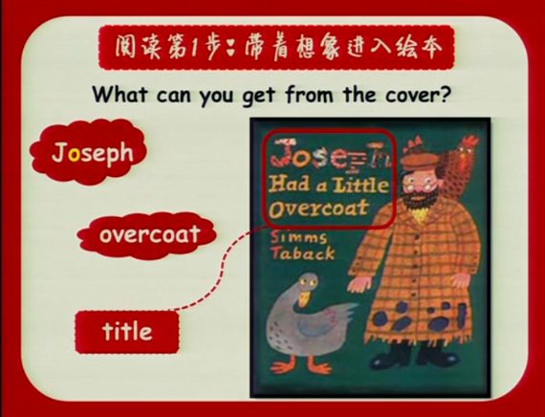
- From the title, who is from the story? Joseph.(Who?) Joseph is a Jewish. They are clever and they all like reading. A lot old Jewish are scientist.Just like Einstein 。
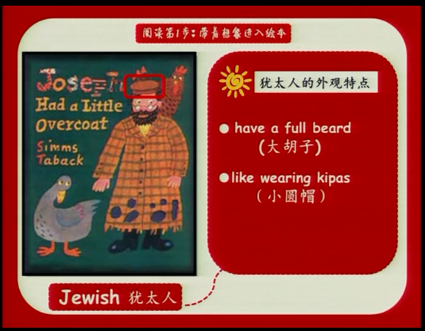
T：Look at his overcoat. How is it？Is it new.Because you can see many holes in it.( old and worm).Do you know worn?

3. Q:I you had a kind of overcoat.It’s very old and worn. What would you do 、
S1：I’ll use it to clean the table.
S2:Maybe I’ll throw it away.
S3: I’ll give other people (poor people)
T: You have some good ideas. Joseph didn’t throw away. He didn’t give... did give it.Maybe he make the coat out of the....
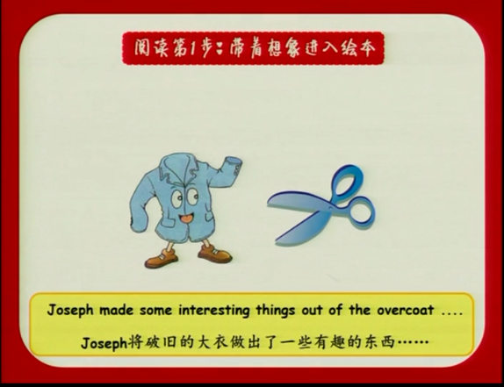
Q: What did he make? Could he make a coat out of a ...
S1：a shirt. S2: a vest.
Ss: He can make a jacket/ a scarf. He can make a pair of shoes.
T: What did he make out of the overcoat.
Ss:buttum/vest/handkerchief.(How can we use handkerchief?clean our face ,hands....）
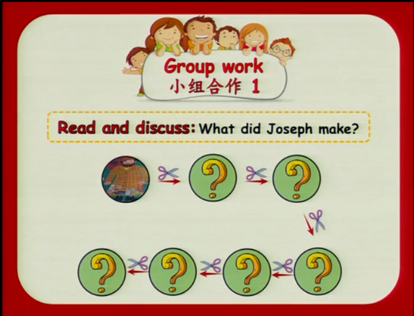
Q:Did he make a scarf out of coat he made a jacket.When the jacket is old and worn ,what did he make ？
Drill： Jaseph had... So... And then....
S1/2/3...
T(小结) All the things are became smaller and smaller .In different things, He enjoyed his happy life.Eg,in this new jacket.
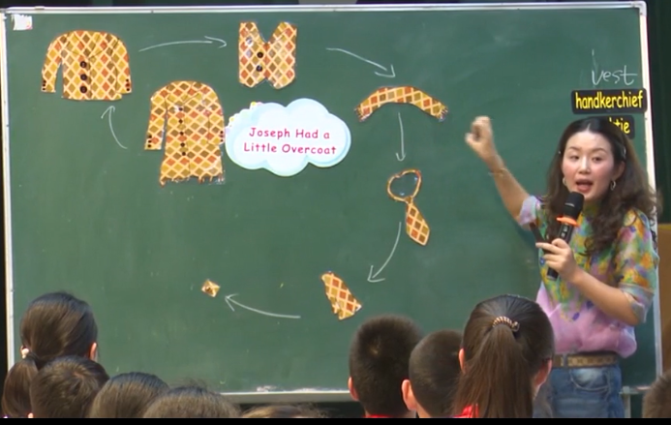
Q:Where is he? What did he do at the fair?
S1； buy sth,maybe some eggs.(阅读策略)
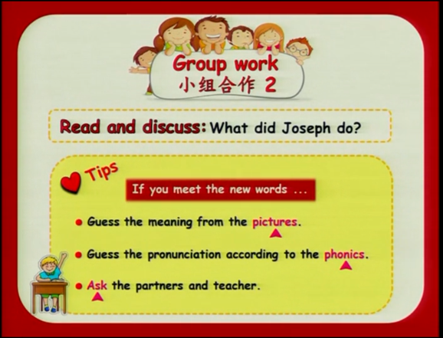
Ss：Share ideas.
Group1:
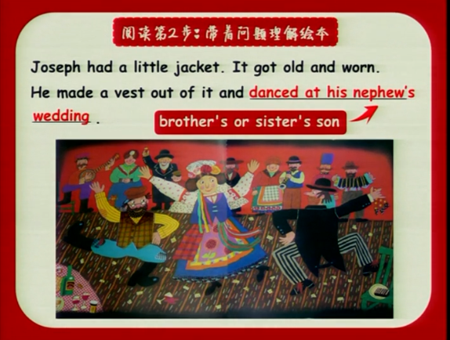
- Nephew.(bother’s or sister’s son)
- Questions about nephew :Where did he dance?
- Read in groups.
Group2、3、4、5

T:He’s happy everyday. Look at the button. When the butten is old and worn. What did he do? Let’s read.
S: He looked sad and what he make a book about himself.
T: He made a book about his... This book show...?
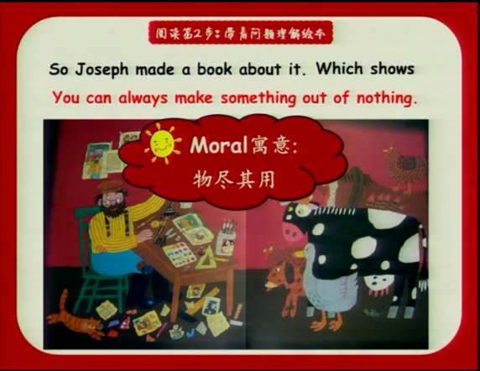
T: Make sth out of thing？
S1：You can无中生有。看似没有用的东西却能做出有用的东西。
S2：It means you can make new things from old things.
Step3. Read.
- Read one by one.
- Q: It’s a long story,but ot easy to know and understand.Why？ Because many things are repeat. Which sentence is repeat?(板书总结)
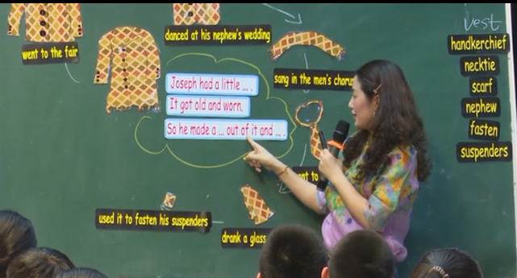
3. Retell the story.
Step4. 带着欣赏与他人分享。
Q:Do you like the main character Joseph? Why?
S1: He is clever。He can make many thing out of a...
S2:He is creative.(创造力)。He make a lot of ...
S3: He is happy.
T：Most Jewish like Jasphon.
Know the auther.
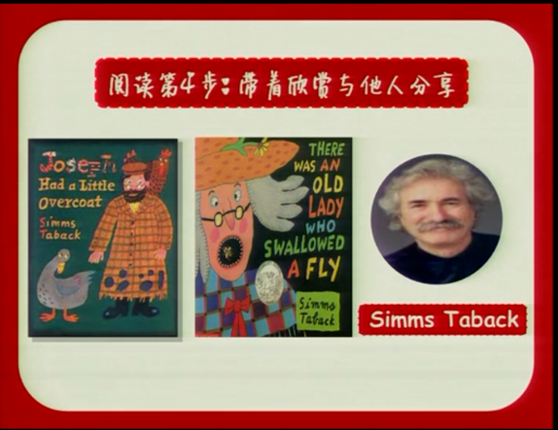
Step5. Homework.
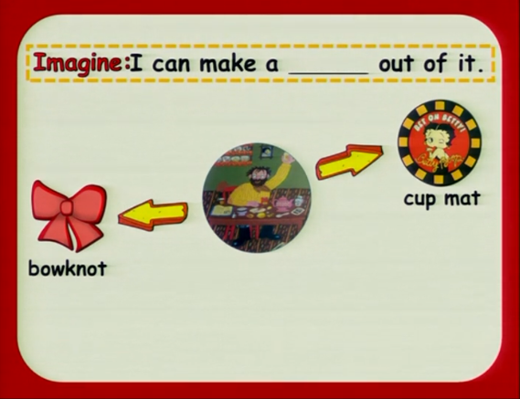

板书：

