小学英语5A Unit7（Period 1）教学设计方案
学校：新北区薛家中心小学 |  | 班级：五（12） |  | 人数：49 | 日期：11 月 29 日
学科：英语 |  | 课题：Unit7 At weekends |  | 教时：第一课时 | 执教：陆文洁
教学目标:
1.学生能听懂、会读、会说visit，chat on the Internet, go to the cinema在文中的意思，能听懂、会读、会说日常交际用语：What do you do at weekends? I …能听懂What does he/she do at weekends?
2.通过看卡通，快速捕捉文章的主要信息。通过细读与思维导图的结合，了解每人所做的事情并理解频度副词在文中的意思。
3.通过朗读文本内容，学生能形成语感，加深对文本信息的理解。
4.通过文本的重构来锻炼学生的语言表达和第三人称的输出。
5.通过创设学生本人的周末活动的教学情境，学生能进一步提升文本理解能力，学会“用英语做事”。
教 学 过 程
教学  环节 | 教师活动 |  | 学生活动 |  |  | 交流方式
Step 1  Warming-up吸引注意，积累语言 | 1. Free talk and lead-in:  Enjoy a song  2.Revision and presentation  - Weekend activities  go... /have.../ play.../...  - Do you want to know my weekends?  Show a calender of October  I ...always/usually/...  4.Talk about ourselves  A:What do you do at weekends?  B:I always/usually/often...  I sometimes.. |  | My weekend  朗读课题At weekends  并理解课题  Yes  Read: always, usually, often, sometimes  Pair work |  |  | 听歌曲，引出课题，复习并聚类呈现一些活动,，并引入与本课相关的句型并感知。  两两合作交流，操练关键句型。  达成目标1
Step2  Pre-task导出目标，生成结构 | Look and say:  We’re talking about our weekends. Our old friends are coming. What are they talking about? |  | Ask and answer  （Self think ）  Weekends |  |  | 通过看图片，猜测图片中人物的活动。  达成目标2
Step3  Task1  回忆相关知识，初步运用结构 | 1.watch and answer  Whose weekends are they talking about?  2. read and fill in the mind map  What does Su Hai do at weekends?  3.read and finish the mind map  What do they do at weekends? |  | Watch and answer  read and fill in  read and finish |  |  | 通过看卡通,聚焦课文。通过细读，写出杨玲的周末作为，再读并完成思维导图并理解频度副词在文中的意思。  达成目标2
Step4  Task2  呈现刺激材料，活用结构 | Reading time  1.Read after the tape.  2.Read in roles. |  | Read the story  （ class work） |  |  | 学生体会到文中人物的快乐周末，快乐地模仿朗读，加深对文本信息的理解。  达成目标3
Step5  Task3  引发期待行为，强化结构 | Sum up  Sum up according to the blackboard  Retell the story time according to the mind map. |  | group work |  |  | 学生根据板书内容选择一个人物来复述课文，从而练习学生对第三人称单数的表达。  达成目标4
Step6  Post –  task提供反馈评价，巩固结构 | - Show time:  Talk about your weekends  - Extension:  Weekends are wonderful.  Enjoy our weekends.  2. Homework  (1) Read the story and talk about their weekends.  (2)Try to share your weekends with your friends. |  | At weekends, I always/usually/often...  I sometimes..  I like.../ I can...very well.  I'm happy at weekends.... |  |  | 通过创设学生本人的周末活动的教学情境，以小语段形式谈论自己的周末活动，享受周末生活的美好。  达成目标5
Step6  Post –  task提供反馈评价，巩固结构 | Homework :  1. Read the story and talk about their weekends.  2. Try to share your weekends with your friends. |  |  |  |  | 通过创设学生本人的周末活动的教学情境，以小语段形式谈论自己的周末活动，享受周末生活的美好。  达成目标5
板书设计：
Unit 7 At weekends
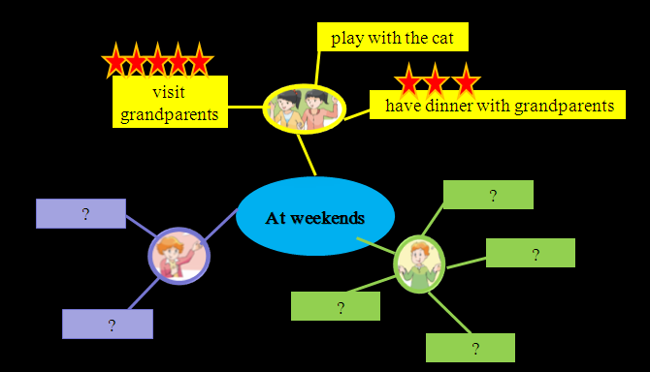

What do you do at weekends?
I always/usually/often/sometimes…

What does … do at weekends?
He/She always/usually/often/sometimes…

课后反思:

