常州市新北区泰山小学二○一四年小学英语模拟考试
听力部分（20％） （满分80分）
一．听录音，选出你所听到的内容 (5%)
( ) 1.A.ball B. tall C. call
( ) 2.A.slow B. know C. show
( ) 3. A. fax B. fat C. front
( ) 4. A. concert B. contest C. country
( ) 5.A.puppet B. public C. popular
( ) 6.A.6:45 B. 7:15 C.7:45
( ) 7.A.January 1 B. June 1 C. July 1
( ) 8.A.go jogging B. go shopping C. go swimming
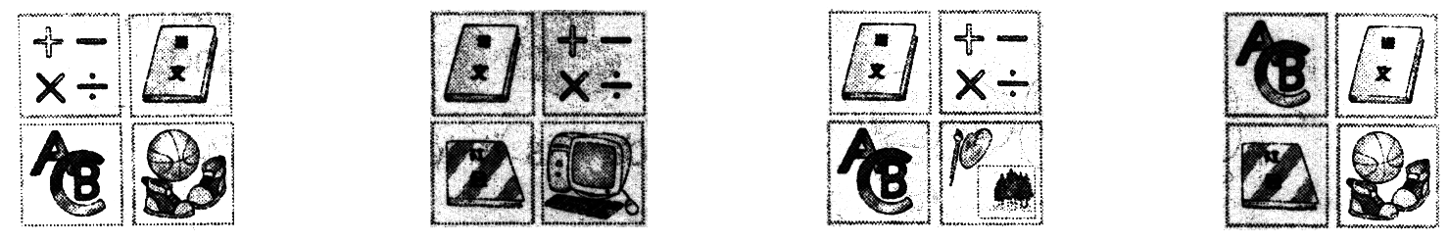
( ) 9.A. B. C. .

( ) 10.A.liutao@Nanjing.com B.liutao@sina.com C.wangtao@Nanjing.com
二．听问句，选择正确的应答语。（5分）
( )1.A. No, thanks. B. Not bad, thanks. C. Thanks a lot.
( )2.A. OK. Gooodbye. B. That's OK. C. OK. Let's start.
( )3. A. On September 10th. B. On October 31 st. C. On December 25th.
( )4. 3 yuan. B. 3 kilos. C. 3 kilometres.
( )5.A. It was cloudy. B. It was smart. C. It was there.
三． 听对话，选择合适的答句。 (5%)
( )1. A. In the classroom. B. In the teachers’ office. C. In Miss Li’s home .
( )2. A. It’s Nancy’s. B. It’s Miss Li’s C. We don’t know.
( )3. A. On the 2nd of June. B. On the 3rd of June. C. On the 4th of June.
( )4. A. Sorry, I don't know. B. Tom is. C. Jack is.
( )5. A. Go to Hongmei Park. B. Water the flowers. C. Keep pandas.
四．听录音，完成句子, 每空一词。(5%)
Wang Bing is a _ boy. He's twelve. He at a primary school in Nanjing. He has two English friends. He often __ letters to them. names are Bill and Bob. They are . They look the . Bill is ten younger than Bob. But Bob is ________ than Bill. Bill is than Bob. That's very interesting. Bill and Bob can a little Chinese.
笔试部分（60％）
一．语音 判断下列各组单词划线部分发音是否相同，相同打“√”，不同打“X”（6分）
( ) 1. work park ( ) 2. here their
( ) 3. outing rowing ( ) 4. morning floor
( ) 5. maps bags ( )6. played cooked
二．英汉互译（10分）
1、第二个男孩 6、summer holidays
2、在……方面需要帮忙 7、help each other
3、一个重盒子 8、plan for the weekend
4、禁止停车 9、fine weather
5、树上的苹果 10、the man behind him
三．选择题（10分）
( ) 1. I get up _______ about seven fifty -five .
A. in B. on C. at
( ) 2. I want _______ a map of China .
A. buy B. to buy C. buying
( ) 3. The man ______ a book in his hand is my uncle .
A. with B. and C. in
( ) 4. A: It’s a white shirt, is it yours ? B: No, ____ is yellow .
A. me B. my C. mine
( ) 5. ______ any men in the room now ?
A. Is there B. Are there C. Were there
( ) 6. Jim’s family ________ not at home yesterday. They went to the park.
A. are B. was C. were
( ) 7 . A: ________ is the book from? B: It’s from Mike.
A. Who B. When C. Whose
( ) 8 Nancy is ________ a dance lesson now. She ________Chinese dances every
Friday afternoon.
A. having, learns B. having, learn C. has, learns
( )9. A: Thank you for your help. B: ___________
A. Really? B. You’re welcome. C. Thank you.
( ) 10. A: __________ B: I’d like some tea.
A. Would you like some tea? B. What can I do for you? C. What’s your hobby? 四. 完成对话。(共10分，每小格1分)
A.阅读对话，根据方框中的提示完成对话，将其序号填在横线上：
A:
A. How much is it?
B. What do you want?
C. Is this green one OK?
D. I’ll take it.
E. Do you like them?
F. How about this one?

B: I'd like a skirt.
A: Here are some skirts.
B: It's nice. But I don't like red.
A:
B: Yes, it's good. ______________?
A: 60 yuan.
B: _______________.
B. 看图完成对话，每空一词：(W=Wang Qiang, L=Liu Tao)
L: Hello, Wang Qiang.
W: Hi, Liu Tao. do you look tired today?
L: Because there a sports meeting in our
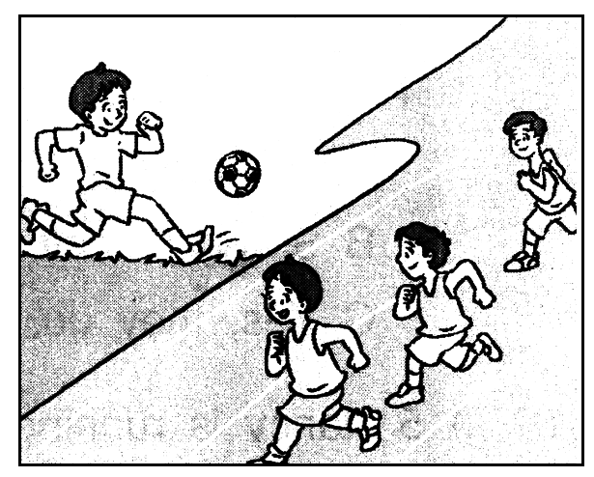
school yesterday.
W: What did you do at the sports meeting?
L: I took part in the race.
W: you run faster than the other boys?
L: Yes. I was No1.
W: You are great! What did you do?
L: I played football.
五．阅读理解：（每小题1分, 共18分）
A.阅读短文，根据首字母提示填写单词：
David l ___ sports very much . H ___ favourite sport is p _____ basketball .
David usually g __ to school at seven o’clock in the morning and p __ basketball with his friends. But he d________ do it yesterday. Because it was r________. He can only w________ basketball games on TV.
B．根据短文判断正误。（正确的写T，错误的写F）
Uncle Li works in a bookshop. The shop is not far from his home. So Uncle Wang seldom(很少)goes to work by bus. He usually goes there by bike, sometimes on foot. Today he goes to work on foot. Now he’s on the way to work. There are some people and some cars in the street. Suddenly one boy comes to him, and gives him a piece of paper that says: “Do you know how to go to the Jin Mei Park. I will meet my grandma at the gate of the park”. Uncle Li looks at him and says, “Can you hear me? Boy? ”The boy says nothing. “Oh, poor boy! He can't speak anything.” He thinks. Then he draws a map for the boy and tells him how to go there.
1.( ) Uncle Li sells (卖)shoes every day.
2.( ) Uncle Li seldom goes to work by bus and sometimes by bike.
3.( ) This morning Uncle Li met a boy . The boy didn’t say anything to him.
4.( ) The boy wanted to meet his grandpa at the gate of the park.
5.( )Uncle Li can tell the boy something by drawing.
C ) 根据短文内容选择正确的答案，并将其序号填入题前括号内。
Last week, there was a car race near Jack’s town. It was a very big race. There were hundreds of people there. Jack and his wife were at the race. They were standing under a big tree. Their daughter Amy was there, too. There were nineteen cars in the race. There were English cars, Chinese cars, German cars and American cars. It was an exciting race. Jack’s friend Tom drove his car very fast. His son waved a yellow cap and shouted(呼喊): ‘Come on, Dad’. His face was red like an apple. Tom kept （保持）driving fast. In the end（最后）, there were seventeen cars behind Tom’s car. The winner was Mike. He was No.1 in the car race.
1. ( ) Where does Jack live? _______________ .
A. A city. B. A town. C. A village.
2. ( )Where was Jack’s wife? _____________ .
A. Yes, she was at the race. B. She was at home. C. She was under the tree.
3. ( ) How many kinds (种)of cars can you see ? .
A. Two B. Three C. Four
4. ( ) What colour is the cap? .
A. Yellow. B. Red. C. Blue.
5. ( ) What place (名次) did Tom get in the car race?
A.No.1 B. No.2 C. No.3

六、话题写作：你从报纸上了解到David想找一位笔友。以“A letter to my penfriend”为题，写一封信给David，与他谈谈你的个人信息、你的学习或爱好等方面的情况，注意写信格式，至少6句。（共6分）
Dear David:

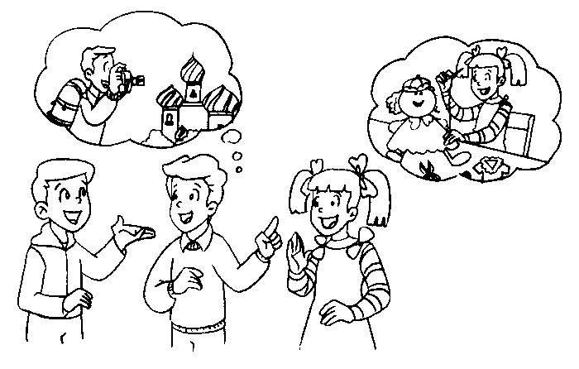
Yours Xxx
听力内容
一 听录音，选出你所听到的内容（听两遍）(5%)
1. tall 2. show 3.fax 4.contest 5.puppet 6. a quarter to seven 7. July 1
B C A B A A C
8. go jogging 9. Chinese, Maths, English and Art B. liutao@sina.com
A C B
二、听问句，选择正确的应答语，听两遍。（5分）
1. How are you today? （B）
2.Shall we begin to sing the song now?（C）
3.When is Halloween?（B）
4.How far is the book shop from here?（C）
5.What was the weather like last Friday ?（A）
三． 听对话，选择合适的答句。（听两遍）(5%)
1. A: Where’s David ?
B: He’s in the classroom .
A: No, he isn’t there now.
B: He was there a moment ago. Perhaps he is helping Miss Li in the office now .
Q: Where was David a moment ago ? ( A )
- A: Look, Nancy ! there’s a pencil under the chair . Whose is it ?
B: I don’t know. Let’s give it to Miss Li.
Q: Whose pencil is it ? ( C )
3. A: Hi, Kate . Tomorrow is my birthday .
B: Is it ? What date is it today ?
A: It’s the 2nd of June .
B: Are you going to have a birthday party ?
A: Sure. Would you like to come to my party ?
B: Of course .
Q: When will Kate go to the party ? ( B )
- Tom and Jack are the same age.
Tom’s birthday is on the first of May. Jack’s birthday is on the second of May.
Q：Who’s older? (B)
5. A：Hi，Mary. Lucy and I will go to Hongmei Park this Sunday。
B：Great. There are many beautiful flowers in it.
A：Yes，and there is a panda in the zoo. We all like pandas。
Q：What will Lucy do？ ( A )
四．听录音，完成句子, 每空一词（听三遍）(5%)
Wang Bin is Chinese boy，He’s twelve。He studies at a primary school in Nanjing。He has tow English friends。He often writes letters to them. Their names are Bill and Bob. They are twins. They look the same. Bill is ten minutes younger than Bob. But Bob is taller than Bill. Bill is stronger than Bob. That’s very interesting. Bill and Bob can speak a little Chinese.

