六上Unit 2 What a day! (The 1st period)
教学内容 | Story time |  | 执教者 | 钮小华
教学目标 | 1. 学生能初步能理解并且会听、会说、会读和会拼写单词及词组：cloudy, rainy, sunny, windy 和会运用句型：It was sunny / cloudy / windy / rainy.  2. 学生能初步听懂并且会说、会读单词show, interesting, weather, high, honey, ant, bee, cloud, sky, rain  3. 学生能初步感知动词过去式的不规则变化及读音  4. 学生能初步感知天气表达的句型  5. 学生能够对英语书写日记格式有一定的了解
教学准备 | 教具准备：单词卡片，课文图片，PPT
教学环节 | 教师活动 | 学生活动 |  | 设计意图
Step1 Per-reading  Step2.  While-reading  Step3  After-reading  Step4  Homework | - Greeting  - Free talk  T: Look at the picture. What was the weather like? Teach: windy, cloudy, rainy  3. T: In different kind of weather, we did different things.  Show many pictures of activities.  The things we did:  Verb Stem:  fly a kite  watch TV  play basketball  draw pictures  4.T: We did different things in different places. Let’s say the places.  Show many pictures of places  5. Let’s play a game: Magic cards  Rule: Pick(挑选) three cards and make some new sentences.  T: If you were the little boy, you could say like this: It was sunny. I played basketball in the playground. Now let’s try.  1. T: The little boy likes doing so many things. Let’s guess: What does Yang Ling like doing?  Teach: diary → diaries(复)  2. T: How to write a diary?  date  weather  special things  3.T: How about Yang Ling’s diary?  ① date 日期  (Show the hole diary)  T: Can you find the date?  What date was it?  T: How to read?  Teach the two ways:  the twentieth of September  September the twentieth  ② weather 天气  ●Watch the cartoon, find the answer.  T: What was the weather like?  ●Find the sentences about the weather.  ●Can you read the sentences?  It was sunny in the morning.  Then, the weather became windy and cloudy.  In the afternoon, there were black clouds in the sky. It rained.  Teach:  become → became（过去式）  cloud → clouds（复数）  rain → rained（过去式）  ③ Special things  ● It was sunny.  Show two pictures:  a. Su Hai, Mike, Liu Tao and Yang Ling went to the park by bike.  b. T: What are these?  Teach: parrots  There was a parrot show in the park.  They saw some interesting parrots.  Teach:  go → went（过去式）  is\am → was（过去式）  see → saw（过去式）  T: If you were Yang Ling, how to write the two things?  ● The weather became  windy and cloudy.  Show a picture.  T: If you were Yang Ling, how to describe?  Teach:  fly → flew（过去式）  ● It was time for lunch .  How about their lunch?  Q1: Read quickly and find out the names of the food.  Teach: dumplings  honey  bring → brought （过去式）  Q2: Could they eat their lunch? Why? Read loudly and find the answer.  We saw some ants on the bread and honey. There were some bees too. We could not eat our lunch.  ● There were black clouds.  It rained.  We were hungry and wet.  Teach: wet 湿的  4. T: What do you think of their day?  T: What about Yang Ling’s feeling?  Teach: What a day!  5. Let’s read the diary.  Do some exercises.  Exercise 1  Read and order  Exercise 2  True or false  Exercise 3  Fill in the blanks  Check out the keys.  - Copy the new words.  2. Try to read the text.  3. Try to write a diary in English. | Ss: It was sunny. (guide)  Ss look at the screen, choose one part to change Verb Stem into Past Tense Form.  Past Tense Form:  flew a kite  watched TV  played basketball  drew pictures  Ss try to say the places:  park  bedroom  playground  classroom  Ss try to describe the cards.  Ss: She likes writing diaries. (guide)  Ss try to say in English.  Ss find the date:  20th September  Ss: It was…  sunny→ windy\ cloudy→ rainy  Ss read and try to underline the sentences.  Ss try to say.  Ss: Su Hai, Mike, Liu Tao and I went to the park by bike.  There was a parrot show in the park.  We saw some interesting parrots.  Ss: We flew kites high in the sky .  Ss: dumplings  honey  bread  drinks  Ss: No, they couldn’t.  Ss: happy  wonderful  bad  interesting  terrible  …  Ss: What a day!  Ss read after the computer.  Ss try to finish the exercises. |  | 将天气、所做之事、地点相结合，先分后合，结合Fun time中的图片，引导学生进行简短的关于一般过去时态的语篇输出，既复习了上一个单元所学习的时态知识，也为本节课的学习作准备。  由猜测杨玲的爱好引出对diary的教学，并通过date，  weather，  special things分层教学，理清脉络，在帮助学生理解课文内容的同时，也学习了英语日记的写法。  随文识字，在教学的过程中简单地  教授新词，不用详细讲解，只用一带而过，不影响课文的理解就可以了。  引导学生自我感知日记中所反映出的真实情感，为What a day!的理解作铺垫。  通过简单的练习，对本课的所学进行巩固，主要是理清文章脉络。
板书设计 | Unit 2 What a day！        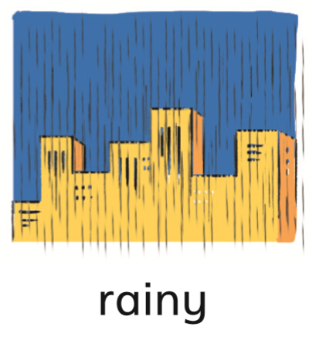
教学反思 | 本课以日记的三要点date，weather，special things逐层展开教学，并以天气的转变为主线贯穿始终。引导学生在理解文章内容，理清主要脉络的同时，也对一般过去时态有了进一步的了解，并对英语日记的写法展开了初步的探究。课文较为简单，学生掌握起来并不困难，只是在动词过去式的变化以及运用上要提醒学生注意。对于英语日记的写作教学也只是浮于表面，需要在下节课时进行详细的探讨。

