8A Unit 7 Reading

**一、导语**

Boys and girls, there’re four seasons in a year and each season has its own beauty. Today, we’ll enjoy the beauty of each season and learn a poem about the seasons of the year as well.

**二、学习目标**

1. 掌握描述不同季节特征和变化的单词与表达。

2. 熟练吟诵诗歌，把握诗歌节奏，感知诗歌的韵律美、语言美。

3. 学习诗歌语言并创作诗歌。

**三、学习过程**

活动一 话题导入

【教师引入】Boys and girls, there’re four beautiful seasons in a year. Which season do you like best? Why?

【学生活动】

课前学唱歌曲“Four seasons in a year”,谈论话题 “Which season do you like best? Why?”录音上传，分享自己观点，倾听他人见解。

活动二 领略四季美

【教师引入】Boys and girls, different people like different seasons just because each season has its own beauty. Now, you can choose your favourite season and enjoy its beauty. For example, if you like autumn best, you can choose the picture “autumn”, and click it. Then read the short passage about it. If you meet the new words, you can guess its meaning according to the pictures and the context or search them in the e-dictionary like this. So enjoy the beauty of your favourite season, and learn the new words and expressions with the help of the e-dictionary. Finally, prepare to introduce your favourite season to the whole class.

【教师活动】巡视课堂，鼓励和指导学生在遇到新词障碍时，根据所提供的图片和上下文的语境等线索来猜测词义，利用网络英汉词典来学习发音、词义、用法，并指导学生如何上台介绍自己最喜欢的季节。

【学生活动】学生选择自己最喜欢的季节并领略它的美，在语篇阅读中遇到新单词时，借助图片和上下文的语境等线索来猜测词义，必要时可利用网络英汉词典来学习新单词的发音、词义、用法，如遇困难可向老师求助。最后，学生上台介绍自己喜欢的季节，并教其他同学学习新单词和表达。

活动三 感知诗歌美

【教师引入】Boys and girls, I also found a poem about the seasons of the year. But it’s not complete. Could you help me complete it and find the right picture?

【学生活动】学生根据上下文的关键词补全诗歌中每一段的第一句话，并找到相匹配的图片，完成后上传，可点赞和校正他人答案。

【教师引入】Here is a video about the poem. Let’s watch it and enjoy the beauty of the poem. Then read the first part. What’s special about “snow”and “grow”? Yes, snow rhymes with grow. Can you find other words that rhyme?

【学生活动】学生观看视频文件，先跟老师共同完成例子，然后圈出诗歌中另外押韵的单词，截屏上传，并用句型_______rhymes with ________进行交流，感受诗歌中的韵律美。

【教师引入】Boys and girls, in the poem, The sentence“Bees and butterflies play among flowers, then hide from the April showers”is my favourite. Because when I read it, I always think of a picture that bees and butterflies are playing happily among the flowers, and when the April showers come, they fly away. Which is your favourite sentence? Underline and share it with us.

【教师活动】巡视课堂，指导学生标注出自己最喜欢的句子，并阐述理由，可通过翻译、找修辞等方式来体会诗歌中的语言美，然后通过网络平台进行交流、分享。

【学生活动】学生先标注出自己最喜欢的句子，然后通过网络平台进行交流、分享。在分享喜欢的原因时可以通过翻译、找修辞来体会诗歌中的语言美。

活动四 争做朗读者

【教师引入】Boys and girls, we have enjoyed the beauty of the poem. We enjoyed its beautiful rhyme and language. So let’s read it differently with feelings. First, read it by yourself, then work in groups of four. Finally, give us a reading show.

【教师活动】巡视课堂，指导学生利用音频文件自主练习朗读，然后四人一小组合作完成朗读秀。鼓励学生尽量用多种形式，如回声等读法。

【学生活动】学生利用音频文件先自主练习朗读，然后四人一小组合作，用自己的方式配乐朗读这首优美的诗歌。最后上台表演朗读秀。

活动五 争当小诗人

【教师引入】Boys and girls, today we first enjoyed the beauty of each season, then we enjoyed the beauty of the poem. At the end of the class, I’d like you to be poets. Would you like to have a try? First, choose the proper two words to complete the poem. Second, work in pairs and complete the poem.

【教师设问】1. Choose the proper two words to complete the poem.

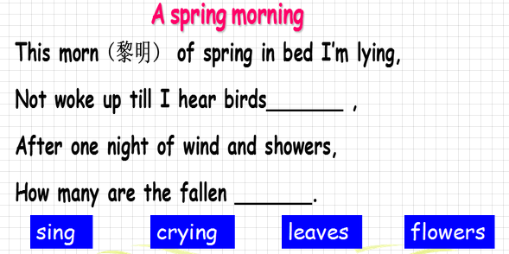

2. Work in pairs and complete the poem.

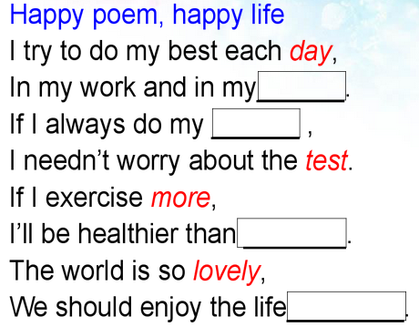

【教师活动】巡视课堂，指导学生在创作诗歌的过程中要注意韵律美和语言美，鼓励学生有多种答案，并说说自己的创作意图。

【学生活动】第一首先自己创作，第二首可以跟同伴互助交流，然后截图上传学习平台，点赞他人答案，或交流分享自己的创作意图。

**四、教师指南**

活动一 话题导入

歌曲热身，引出话题。让学生每人上传录音，交流分享各自的见解，避免了传统课堂上时间和空间的限制，每个学生必须开口交流，如果不会，也可以通过倾听他人进行模仿学习。

活动二 领略四季美

由学生自己选择最喜欢的季节进行语篇学习，利用网络英汉词典进行个性化单词学习，借助图片和上下文的语境等线索来猜测词义，提高阅读技能。介绍环节既是自己学习成果的一次汇报，同时还教其他学生学习新单词和表达，是对传统课堂上教师教授新单词的创新。

活动三 感知诗歌美

利用视频、音频，让学生围绕学习内容进行个性学习，可以反复看、听。利用网络学习平台，使学生及时交流分享学习成果，体会到诗歌中的韵律美、语言美。

活动四 争做朗读者

学生四人一小组，合作配乐朗读这首优美的诗歌，然后进行交流展示，培养合作意识和朗读能力。

活动五 争当小诗人

由易到难，创作诗歌，反馈学生是否注意了诗歌中的韵律美和语言美，展现

学生综合运用语言的能力。

(常州市焦溪初级中学 夏瑜)