Unit 6 At the snack bar (Story time)
武进区洛阳中心小学 杨晔
一．教学目标
1、知识目标：能熟练掌握单词a cup of coffee, a glass of milk, a hamburger, a sandwich, noodles, snack bar
2、技能目标：a. 能熟练掌握句型What would you like? What about you? Anything else?并能用句型和单词谈论想要的食物。
b.能初步掌握Story time，并能模仿朗读。
3、情感目标：a. 学生通过活动能敢于、乐于、善于开口说英语，树立学好英语的信心。
b. 在活动中培养团结协作的精神
二．教学重难点
1. 能熟练掌握单词a cup of coffee, a glass of milk, a hamburger, a sandwich, noodles, snack bar
2. 能熟练掌握句型What would you like? What about you? Anything else?并能用句型和单词谈论想要的食物。
3. 能初步掌握Story time，并能模仿朗读。
三．教学过程
Step1 Greeting & Warm up
1.Enjoy a song: What would you like?
T: What’s this song about?
S: It’s about food and drinks.
T: What food and drinks do you know?
S: Cakes, pies, oranges…
S1: Milk/ A glass of milk.(教授 a glass of)
S2: A sandwich.(教授sandwich)
S3: A hamburger(教授hamburger)
S4:A cup of coffee.(教授A cup of coffee)
S5:Some noodles.(教授noodles)
学生没有提到的新单词，可以放在文本中进行教学。
2. Read the words: a hamburger, a sandwich, some noodles…
Practice in pairs.
Step2 Presentation
T: Where can we buy them?
S: At the snack bar.(教授新单词 snack和bar)
T: Today we are going to learn Unit6 At the snack bar导入课题: At the snack bar
- Look and say
T: Look at the picture, who are they?
S: Mike, Helen and Dad. They are at the snack bar.
- Watch and tick
T:What would they like?
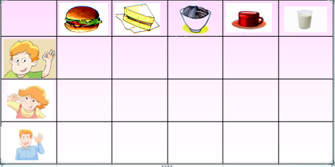
T: What would Mike/ Helen/ Dad like?
S: He/ She would like….(教授没有提到的新单词)
T: What would Mike like?
S: He’d like a hamburger and a glass of milk.
T: What would Helen like?
S: She’d like some noodles.
T: What would dad like?
S: He’d like a sandwich and a cup of coffee.
S: Mike would like… Helen would like… Dad would like…
- Read and underline
T: Read P38 and underline the sentences how they order food.
S1: What would you like?
S2: I’d like…
S3: What about you?
T: I’d like…= I would like…
T: Let’s read and act.(学生依据图片1,2，说一说，演一演)
- Listen and think
T: Look, the waitress is coming. What does she say? Let’s listen.
S: A hamburger, noodles and a glass of milk, please.
T:Then she says: Anything else?(教授新词汇)
S: A sandwich and a cup of coffee.
T: The waitress brings some food and says: Here you are.
S: Thank you.
Step 3 Reading time
①在跟读对话时标注对话的“重读”、“升调”、“降调”、“停顿”等符号，以此培养学生优美的语音语调；
②跟着录音进行模仿
③师生分角色朗读对话
④学生分角色朗读对话；
Step 4 Consolidation
Mike, Helen and their father are at the . Mike would like a glass of______ and a . Helen would like some . Mr. Brown would like a ____________and a cup of . They are .
Step5 Homework:
1.Write down the food you can name, and try to divide them in different ways.
2 Try to act this story with your classmates after class.
板书设计：
Unit 6 At the snack bar
What would you like ?
What about you ?
Anything else?
I’d like …

