教 案 施教时间______ ___
课题 |  | Unit 4Then and now | 第_2_课时 | 主备人 |  | 周锭
教学  目标 |  | 1. 能够理解并掌握动词过去式的不规则变化及读音。  2. 学生能运用句型…….years ago, I was/ I could (not)/ didn’t……..。  3. 在真实情境中，用所学知识正确比较过去与现在。  4. 能用一般现在时和一般过去时的语句来描述自己。
教学  重难点 |  | 1. 了解掌握动词过去式的转换方式和运用。  2. 运用文中所学的句型等，准确表达出自己的过去和现在。  【 3.能够根据时间的不同，准确地运用动词一般形式及动词的过去式。
课前准备 |  | PPT
教学过程 |  |  |  |  | 设计意图及修改
Step1 Free talk & Presentation  1. Free talk  T: What day is/wat it…?  S: It is/was…  T: What date is/was it…?  S: It is/was…  T: How is/was the weather …?  S: It is/was…  T:Where did you go last weekends？  S: …  T: What did you do yesteday /last weekend?  S:…  2. Act and say  T: What did I do just now ?  S: You listened to music just now.  Step 2. Presentation & Practice  1. Think and say  T: Think about the changes of Mike’s family and finish the table.  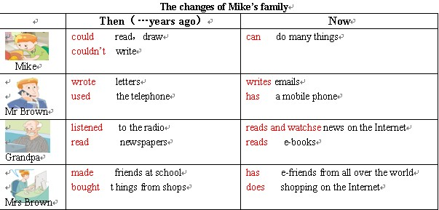  2. Read and learn  T: Look at the pictures and learn the words.  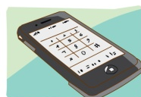  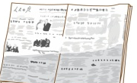    an e-book a mobile phone a newspaper      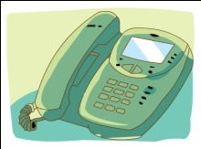  a radio a telephone a TV  3. Try to use  T: Look at this short passage, use the new words to fill in the blanks.  Twenty years ago ,my mother used the  at home.She couldn’t call people anywhere.Now she  has a .It is easy to take .My father listened to the and read for  news in the past ,but now he usually watches news on the Internet .Sometimes he reads newspaper .He also reads .For me ,ten years ago ,I watched at weekends, now I like playing computer games when I’m free . It’s fun.  4. Grammar time : Read and find  （1）Read the sentences with verbs：  a.Ask the students to underline the verbs  b.Ask the students to underline the subjects  Rule：In the past tense,verbs don’t change with subjects.  5. Grammar time : Play a game（Quick response）  (1)T: I say the words, you should say the past tense as quickly as you can.  is/am（was）are（were） can（could）  fly（flew） take（took） see（saw）  go （went） eat（ate） get（got）  do（did）write（wrote）make（made）…  6. Grammar time : Read the irregular verbs  Eg：I (see) a mobile phone under the desk just now .  Lucy (get) up late this morning .  Step 3. Production and Progress  1.Say something about the changes of our life.  Clothes,food,house,transportation.  In the past,we…But now,we…  2. Checkout time: Look and write  T: What could they do? What couldn’t they do?  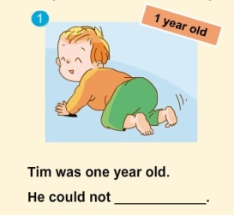  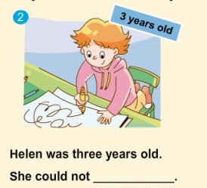  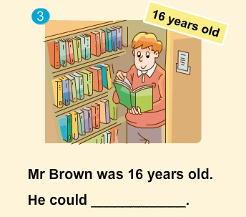  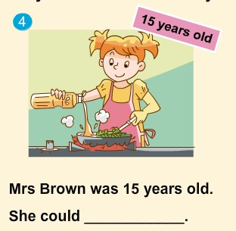  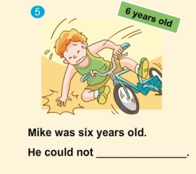  2. Fun time  A. T: Look, here are two photos of me. Twenty years ago, I was a student. I could ride a bike .I couldn’t drive. I didn’t work. Now I’m a teacher. I can drive . I teach you English.  B. T: Let’s say something about “ then and now” of you, and make a comparison table.  Step 4 Homework  1. Talk to your friends about the changes happened to you.  2. Memorize the irregular verbs you’ve learnt, and try to know more.  3.Think about more changes of our life, try to say them in English. |  |  |  |  | 通过相互交谈，让学生学会使用不同的时态进行回答，正确区分时态；并进一步学会用一般过去时进行正确地回答，理解并掌握一般过去时的含义。  教师做动作，如听音乐状，对学生进行提问，引导学生用动词过去式短语进行回答。通过动作，让学生直观感受过去时，并反复操练几次。  通过Story time的学习，学生们对于课文内容有了一定的理解掌握，以填空的方式呈现，让学生再次回忆巩固课文内容。  对表格中出现的单词进一步巩固教学。第一课时，学生对单词掌握不够，在此强化教学，巩固新知。在教授新单词的时候，一定要注意一些字母的发音，比如：radio-“ a”. mobile-“o”……  巩固六个新单词，感知过去与现在的区别，同时让学生把短文中的所有动词都圈出来，让学生自己说说这些单词的意思和区别，老师可以把学生说的总结补充一下，借此强化一般过去时。  出示本部分内容，可以请学生试着先读一读。互相纠正发音，教师可以及时给予帮助。  在读过这些句子后，请学生小组为单位，分别读一读第1、2、3句和第4句，划出动词，并发现这些单词的过去式，有规则直接加ed，也有不规则。  再读句子，划出主语，小组讨论在过去时中动词是否随主语变化。小组交流，教师总结。  利用先学中的动词及动词过去式，教师说出相应的动词或是动词过去式，让学生快速回答对应的动词过去式或是动词。既校对了先学任务，同时又帮助学生使其掌握动词及其过去式的正确发音。  呈现本部分内容，进一步掌握不规则动词的过去式。  通过本板块的练习，让学生对could与couldn’t的使用进一步了解，同学掌握could与couldn’t后加动词原形。  呈现Fun time板块，教师采用自己过去与现在的照片，用句型…….years ago, I was/ I could (not)/ didn’t……..。来介绍自己，对此，学生会很感兴趣，激起他们说的欲望。
  Six | years | ago | , | I | couldn’t write | .
  Twenty | years | ago | , | he | wrote letters | .
   |  |  |  | she | bought things  from shops | .
  Thirty | years | ago | , | they | listened to the  radio for news | .
  am | Was
  is | was
  are | were
  can | could | get | got
  do | did | go | went
  eat | ate | see | saw
  fly | flew | take | took
  read read
板  书  设  计 | Unit 4 Then and now  …years ago,I was…  I could…  I could not…  I didn’t…  Now I am…  I can…

