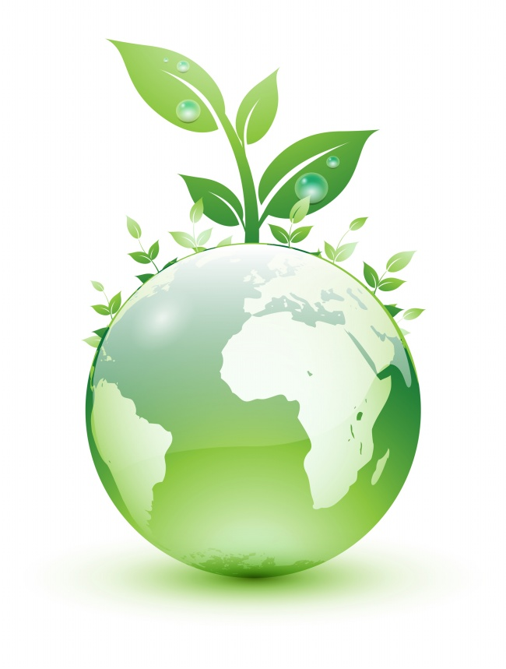

The last drop of human,environmental damage will be tears of remorse after.
Environmental problems are as big as not for individual country or individual people to address. In other word, we have reached the stage that environmental problems be solved for international view. To what extent do you agree or disagree?
In recent years, many nations have become more aware of the environmental issues each nation faces, such as air and water pollution. The question is, are the environmental issues a national problem or an international problem? It is my belief that the environmental issues have grown to the point of becoming an international problem needing international cooperation to resolve.
Because of the differences in environmental policies, resources and technology, international cooperation could provide quicker results and have a greater impact on bringing resolution to environmental problems for nations of differing environmental policies and of lesser resources and technology. By pooling international resources and technology to address the environmental problems, the disadvantaged nations are provided the assistance needed. Otherwise their environmental conditions deteriorate ultimately affecting the resources and environment of the world as a whole.

Pollution of the environment protection of the environment shameful glory
Please do not trample on the grass at the foot of you, because like you, it is there that the sacred mission of a green environment.

