2015～2016学年度第一学期阶段性质量调研
七年级英语试题
2015.11
（考试范围: 至牛津初中英语7上 Unit4）

注意事项：1．本试卷共8页，满分100分。考试时间90分钟。
2．请将答案全部填写在第6—8页的答题纸上，在1-5页上答题无效。

第一卷（共60分）
一、听力（共20小题；每小题1分，满分20分）
A) 听下面10段对话。每段对话后有1个小题，从题中所给的A、B、C 三个选项中选出最佳选项。听完每段对话后，你都有10秒钟的时间来回答有关小题和阅读下一小题。每段对话读两遍。
1. Who is Mary?

2. Where is David this afternoon?
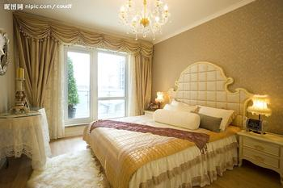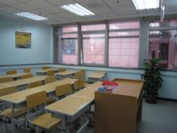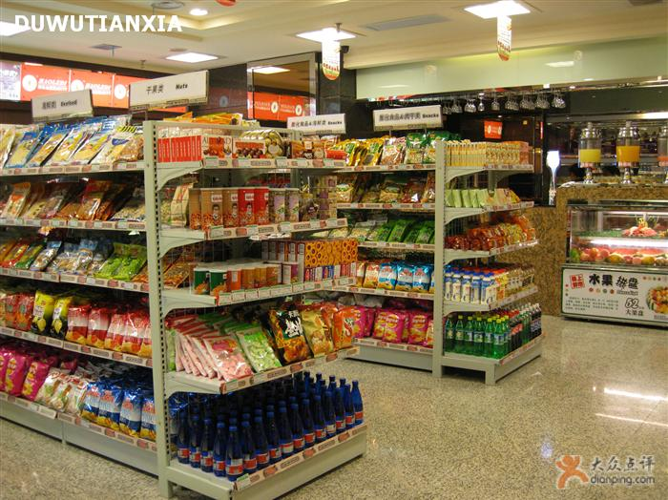
3. What do they usually do after school?
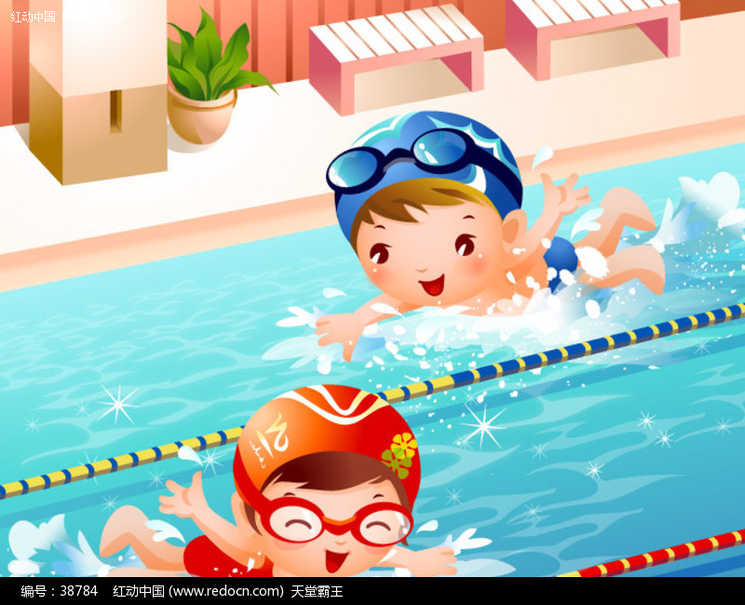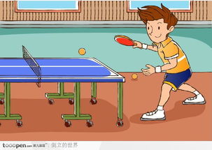
4. How does the girl go to school every day?
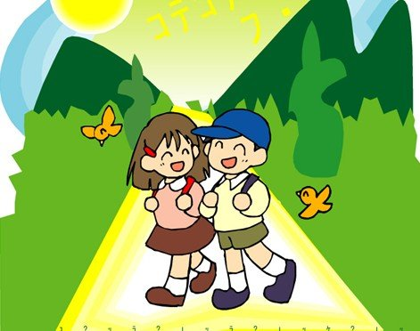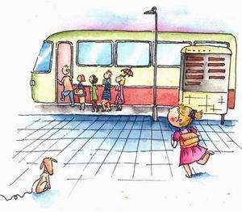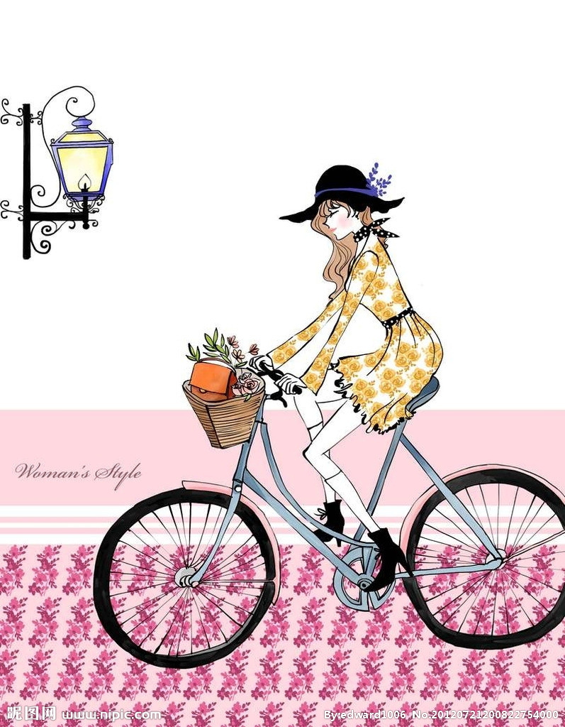
5. How often does the girl go swimming?
A. Every day. B. Twice a week. C. Every week.
6. What does Li Hua do?
A. A doctor. B. A teacher. C. A football player.
7. What would John like to do after school?
A. To watch TV. B. To listen to music. C. To play music.
8. How long does the parents’ meeting last(持续)?
A. 3 hours. B. 2 hours. C. 5 hours.
9. What does Daniel do this evening?
A. To do much work. B. To see a film. C. To watch games.
10. How do they celebrate their grandpa’s birthday?
A. To buy some presents. B. To have a birthday party. C. To go out for a big meal.
B) 听对话或独白。每段对话或独白后有几个小题，从题中所给的A、B、C三个选项中选出最佳选项。听每段对话或独白前，你将有时间阅读相关小题，每小题5秒钟。听完后，每小题你仍有5秒钟的时间来选择你认为最合适的答案。每段对话或独白读两遍。
听第一段对话，回答第11—12小题。
11. What’s the weather like tomorrow?
A. Warm and sunny. B. Cold and rainy. C. Hot and sunny.
12. What’s Peter’s mother doing?
A. Watching TV. B. Shopping. C. Doing some housework.
听第二段独白，完成信息记录表第13—15小题。
Mark and His 13
School | They are in 14 Middle school.
Favourite sports | They like playing 15 at school every day
13. A. Friend B. Brother C. Classmate
14. A. No. 3 B. No. 7 C. No. 13
15. A. football B. basketball C. volleyball
听第三段独白，回答第16—20小题。
16. What time does Jane have breakfast?
A. At 6:30 a.m.. B. At 7:00 a.m.. C. At 8:00 a.m..
17. How does Jane go to school every day?
A. By bike. B. By car. C. By bus.
18. How many classes does Jane have every day?
A. Three. B. Four. C. Seven.
19. Where does Jane like to go after school?
A. To the school.
B. To the playground.
C. To the sport center(运动中心).
20. What does Jane do at 9:00 p.m.?
A. She goes to bed. B. She watches TV. C. She does her homework.
二、情景对话（共5小题；每小题1分，满分5分）
根据对话内容，从下面的选项中选出能填入空白处的最佳选项。选项中有两项为多余选项。
Jim: Hello, Mary.
Mary: Hello, Jim.
- Can you help me?
- That’s my favourite shop.
- It is a nice day, isn’t it?
- Is it near?
- When do you go to the new shop?
- You can get there in ten minutes.
- I’d like to visit my friends this afternoon.
Jim: 21
Mary: Yes, it is.
Jim: I want to go to the new shop this afternoon.
But I don’t know the way. 22
Mary: Of course. What’s the name of the shop?
Jim: It is Bo Ku. 23
Mary: Wait a minute. Oh, look at the map. It is really near.
Turn left at the gate, and then take a No. 5 bus. 24
Jim: Thank you very much. Do you want to go with me?
Mary: Sorry. 25
Jim: All right. Have fun.
三、单项选择（共10小题；每小题1分，满分10分）
从A、B、C、D四个选项中, 选出可以填入空白处的最佳选项。
26. --- _________ the man in white your English teacher, Mr. Brown?
--- No, Mr. Brown _________ glasses.
A. Does; doesn’t wear B. Is; doesn’t wear C. Does; don’t wear D. Is; don’t wear
27. --- Is the boy on the left ________ best friend?
---Yes, he is Simon, the best football player in our class. He always hopes _________ can practice football with _________ after school every day.
A. you; us; him B. your; we; his C. your; us; his D. your; we; him
28. --- Do you always get up _________ 5 a.m. Mrs. Green?
--- Yes. But I get up a little later _________ Sunday mornings.
A. at; in B. in; on C. on; at; D. at; on
29. --- You are playing basketball so well!
--- Thank you! I like it. But I _________ play it these days because my legs hurt(疼痛).
A. seldom B. always C. never D. usually
30. --- _________ Jim _________ football?
--- Yes, he always plays football after school _________ other boys.
A. Is; like; likes B. Does; like; likes C. Does; like; like D. Is; like; like
31. She always _________ newspapers after supper but sometimes she enjoys _________ to music.
A. read; listening B. reads; listening C. reading; listens D. reads; listen
32. --- What a beautiful school!
--- You must be tired after a long trip. Have a good rest first and then I will _________ it.
A. show you around B. let you see C. have fun D. talk about
33. --- Every morning I leave home at 6:30, and I get to school at 7:15.
--- You live _________ from your school.
A. a far way B. away C. a long way D. far away
34. There is only _________ water left(留下), so _________ people can drink it.
A. a few; few B. a little; few C. little; a few D. a little; a little
35. --- Is Grandma at home now? I want to say hello to her.
--- _________ Daniel. I can’t hear you well on the phone.
A. Speak loudly! B. Pardon? C. Say it again! D. What?
四、完形填空（共10小题；每小题1分，满分10分）
阅读下面短文，掌握其大意，然后从每小题所给的A、B、C、D四个选项中，选出可以填入空白处的最佳选项。
Good morning, everyone. I want to 36 you about my neighbor(邻居), Mr. White. There are 37 people in Mr. White’s family. Mr. White is a manager of a big shop. Mrs. White teaches English in a university(大学). Her students like her very much 38 she is interesting. The Whites have two 39 . The son is Tim. He is thirteen. The daughter is Nell. She is twelve. There is also a brown 40 in their family. 41 name is Stella.
Mr. White loves sports and he is good at playing tennis. Mrs. White likes 42 . She draws many beautiful pictures. Tim 43 listening to music. He has many CDs. Justin Bieber is his favorite singer. 44 is Nell’s hobby? She likes doing some 45 . She has a lot of books in her room now. On Sunday, they take their cat to the park and they often have a good time there.
36. A. ask B. say C. tell D. write
37. A. three B. four C. five D. six
38. A. when B. but C. so D. because
39. A. students B. activities C. children D. places
40. A. cat B. rabbit C. dog D. horse
41. A. My B. Your C. Their D. Its
42. A. reading B. gardening C. drawing D. dancing
43. A. follows B. enjoys C. tries D. gives
44. A. What B. How C. Which D. Who
45. A. dancing B. swimming C. cooking D. reading
五、阅读理解（共10小题；每小题1分，满分10分）
阅读下面短文，从各题所给的A、B、C、D四个选项中，选出最佳选项。
A
There are some vegetables in the garden and a big tree near the vegetables. They don’t like each other, because vegetables drink much water, and the tree can’t have enough water to live. He is very angry about that. So he wants to teach vegetables a lesson(教训).
On a very hot day, the big tree doesn’t share its shadow(分享庇荫) with vegetables. It makes vegetables very hot. But there is not enough water to drink. So they soon become very dry. At that time, the gardener(园丁) comes to see these vegetables. He is very sad, because all the vegetables are dry. Then he starts to build a new one.
The vegetables and the big tree can’t drink water any more. The big tree feels very sad, because he uses a wrong way to teach the lesson.
46. Where is the big tree?
A. Near the garden. B. Near the vegetables.
C. Behind the water. D. Behind the water.
47. Why do the vegetables and the tree dislike each other?
A. Because the tree is too tall. B. Because the vegetables are too big.
C. Because they don’t share water with each other.
D. Because they like to play a trick(把戏) on each other.
48. When does the tree teach the vegetables a lesson?
A. On a very cold day. B. On a very hot day.
C. On a very warm day. D. On a very windy day.
49. What does the gardener do after seeing these dry vegetables?
A. He hates the big tree very much. B. He doesn’t like these vegetables.
C. He is very sad about the dry vegetables. D. He starts to build another new garden.
50. Which of the following is TRUE?
A. The big tree doesn’t want to drink any water.
B. The big tree always shares its shadow with vegetables.
C. The big tree and vegetables start to share water with each other.
D. The big tree thinks he is wrong at last.
B
There is a king in the palace(皇宫). Every year, he fixes(修理) his palace to make it look better(更好) than before. One day, the king says, “This year, I must make the palace more perfect(更加完美的). Everyone in my country will praise it.” After a month, the king asks many people to come to the palace and talk about their ideas.
“This is a perfect palace,” says many people. But only a tall man doesn’t say anything. The king wants to know why this man keeps quiet(安静的). So he asks, “Is not my palace perfect?”
The man answers, “My dear king, your palace is very beautiful. But it isn’t perfect. A palace is perfect because the people in it are perfect. You spend(花费) too much time making the palace perfect. Why not spend some time making yourself(你自己)a perfect king?”
The king thinks a lot about it. He thanks the man for his words. After that, he never tries to make the palace perfect again.
51. What does the king like to do most every year?
A. Sleep in the palace. B. Give love to his people.
C. Wear beautiful clothes. D. Fix his palace to make it perfect.
52. The underlined word “praise” means _______ in Chinese.
A. 评论 B. 梦想 C. 赞扬 D. 抚摸
53. What does the tall man think of the palace?
A. Beautiful. B. Perfect. C. Poor. D. Large.
54. What does the tall man want the king to do?
A. Make the palace more perfect. B. Make himself(他自己) more perfect.
C. Thank more about the people. D. Spend less money on the palace.
55. What’s the best title about the passage?
A. A Lazy(懒惰的) King B. How to Have a Perfect Palace
C. A Quiet Man D. How to Be Perfect
六、阅读表达, 每空填一个单词。（共5小题；每小题1分，满分5分）
阅读下面句子，掌握其大意，然后在空白处填入合适的单词，使上下句意思一致。
56. David plays football very well and he is in the scholl team.
David is a _________ of the school football team.
57. Mary is always kind and nice to her classmates, her friends, her teachers and her parents.
Mary _________ gets angry with others.
58. Smith likes to stay in the kitchen to cook different food. It makes him happy.
Cooking is _________ to Smith.
59. John likes music very much and he often goes to concerts(音乐会) in his free time.
John enjoys listening to music when he is _________.
60. There are all kinds of books in the library. You can get any book you like.
You can _________ any book from the library if you like.
2015～2016学年度第一学期阶段性质量调研
七年级英语答题纸
2015.11
第一卷 (共60分)
一、听力（共20小题。每小题1分，满分20分）
题 号 | 1 | 2 | 3 | 4 | 5 | 6 | 7 | 8 | 9 | 10
答 案
题 号 | 11 | 12 | 13 | 14 | 15 | 16 | 17 | 18 | 19 | 20
答 案
二、情景对话（共5小题。每小题1分，满分5分）
题 号 | 21 | 22 | 23 | 24 | 25
答 案
三、单项选择（共10小题。每小题1分，满分10分）
题 号 | 26 | 27 | 28 | 29 | 30 | 31 | 32 | 33 | 34 | 35
答 案
四、完型填空（共10小题。每小题1分，满分10分）
题 号 | 36 | 37 | 38 | 39 | 40 | 41 | 42 | 43 | 44 | 45
答 案
五、阅读理解（共10小题。每小题1分，满分10分）
题 号 | 46 | 47 | 48 | 49 | 50 | 51 | 52 | 53 | 54 | 55
答 案
六、阅读表达（共5小题。每小题1分，满分5分）
56. ___________ 57. ___________ 58. ___________ 59. ___________ 60. ___________
第二卷（共40分）
七、选出每组划线部分发音不同的单词（共5小题；每小题1分，满分5分）
( ) 61. A. use B. ruler C. cute D. music
( ) 62. A. warm B. star C. park D. arm
( ) 63. A. zoo B. cool C. room D. good
( ) 64. A. happy B. carry C. diary D. try
( ) 65. A. enjoys B. takes C. loves D. draws
八、根据句意和所给的中文，写出单词的适当形式（共5小题；每小题1分，满分5分）
66. --- What’s wrong with your pet dog, Peter?
--- There is something wrong with __________ (它) eyes. I’ll ask Doctor Li for help.
67. As __________ (真的) friends, we must help each other and learn from each other.
68. ____________ (购物) is fun, but some men don’t think so.
69. There are no __________ (原因) for you not to do your homework.
70. __________ (生物)is one of the most interesting subjects and I like it best.
九、根据句意，用所给单词的适当形式填空（共6小题；每小题1分，满分6分）
71. Jim said the __________ (hero) names to himself and wanted to learn from them.
72. I hope your dream __________ (come) true when you grow up(长大).
73. I’m so sorry to hear that some people lost their __________ (life) in the big fire.
74. --- What is your favourite subject?
--- I like Maths __________ (good).
75. Why not go ______________ (swim) on such a hot day?
76. --- Shall we ____________ (practise) volleyball after school every day？
--- Of course. To win the match, we have to practise hard.
十、句型转换（共4小题；每格0.5分，满分5分）
77. Millie does after-school activities with her classmates every day.(改为否定句)
Millie __________ __________ after-school activities with her classmates every day.
78. Kate comes from England. (改为一般疑问句并做否定回答)
--- __________ Kate __________ from England? --- No, she __________.
79. Driving me to school takes Dad half an hour every day. (改为同义句)
It __________ Dad half an hour __________ __________ me to school every day.
80. My grandparents seldom go out for meals. (对划线部分提问)
__________ __________ do your grandparents go out for meals?
十一、根据汉语意思完成句子,每格一词（共4小题；每格0.5分，满分9分）
81. 阅读各种各样的书让我感觉愉快。
Reading __________ __________ __________books __________ me __________.
82. 那幢大楼前座落着一幢现代的博物馆。
There is a __________ ______________ __________ __________ __________ the building.
83. 该是把他叫醒的时候了。
It’s time __________ __________ __________ __________.
84. 他喜欢在周末为即将来临的一周做好准备。
He likes __________ __________ for the coming week __________ _____________.
十二、书面表达（满分10分）
假如你是Tommy，来常州某中学做交流生。请根据下面提示给你家乡的朋友Linda写一封
短信，向她介绍你现在的学校生活。
1、学习情况：每天7:30开始上课，下午5:00放学；每天六节课，最喜欢的科目及原因；
2、课外活动：参加校足球队，周三下午练习足球；喜欢读书，经常去图书馆借书；
3、同学：友好；午饭后互相聊天；大家互帮互助，相互学习；
4、感受： … … (至少2点)
要求：1. 内容完整，可适当发挥；
2. 表达清楚，意思连贯、符合逻辑；
3. 70词左右。开头结尾已给，不计入总词数
Dear Linda,
I’d like to tell you something about my new school life.
____________________________________________________________________________(10词)
____________________________________________________________________________(20词)
____________________________________________________________________________(30词)
____________________________________________________________________________(40词)
____________________________________________________________________________(50词)
____________________________________________________________________________(60词)
____________________________________________________________________________(70词)
____________________________________________________________________________(80词)
____________________________________________________________________________(90词)
Best wishes,
Tommy

