学校 | 常州市朝阳桥小学 |  | 学科 | 英语 |  | 班级 | 六1 |  | 人数 | 44
课  题 | Unit7 Summer holiday plans (storytome) |  | 教时 | 第1教时 |  | 执教 | 肖丽 |  | 日期 | 2017.5
一、教学目标：
1、学生能整体感知，理解对话，能正确、流畅地朗读对话，并能尝试复述或对话表演。
2、学生能在故事情景中学习Hong Kong, Taipei, Disneyland, Ocean Park等。
3、学生能在文本中理解并初步运用一般将来时will结构的疑问句句型：Where will … go for the holiday? How long will …stay there? Will … ?等来询问别人的假期计划，并能在情景中使用一般将来时表达假期计划。
4、通过本课的学习，引导学生享受旅行，更加热爱生活。
二、制定依据：
1. 内容分析
本单元的话题为“假期旅行计划”，这个话题对学生来说并不陌生，许多学生都有生活经验的积累。本单元的重点语言点时一般将来时will结构的疑问句句型。学生已经学过be going to 结构的用法，并在前一单元学过will的陈述句句型，这些都为本单元的学习打下了基础。
本课为storytime板块，是本单元的第一教时，是一节对话性文本材料的语篇教学课。故事中涉及的词汇主要有“Hong Kong, Taipei, Disneyland, Ocean Park等。”涉及的重点句型是will结构的疑问句句型：Where will … go for the holiday? How long will …stay there? Will … ?等。本课的核心内容是通过听录音、阅读、对话、猜测等方式理解文本内容、并在此基础上进行模仿朗读、复述或表演。在学习的过程中，让学生逐渐清晰如何询问及交流假期计划，同时，引导学生更加享受旅行，更加热爱生活。
2. 学生分析
本班有44名学生。经过三年的英语学习，学生在英语学习上的差距较大，大多数学生对学习英语较感兴趣，能主动参与学习活动。但也有少数学生学习习惯较差，学习基础薄弱，参与学习活动的热情不高，不善于主动表达。
学生的学习困难可能主要在询问他人假期计划时灵活运用will结构的疑问句型以及表达自己的假期计划。本课试图在开放的情景中，通过猜测、梳理信息、捕捉资源，不断培养学生的阅读能力，并通过朗读、对话、复述、表演等方式提高学生的语用能力。

教 学 过 程
教学环节 |  | 教师活动 |  |  | 学生活动 |  |  | 设计意图
Step 1  Warm up |  | - Play a guessing game  "What holiday is it?"  - Do you like summer holiday?  Why? |  |  | Read and guess  Think and answer:  "I like summer holiday because …" |  |  | 通过猜测游戏引出summer holiday，激发学生的学习兴趣。
Step 2  pre-reading |  | 1．T: I like summer holiday too because I can go travelling during the vacation. Look , these children like travelling too .Who are they?  2. Look，what are they doing?  3. What else can we say?  (The children are talking about their summer holiday plans.) |  |  | They are Mike, Ynag Ling, Su Hai and Liu Tao.  They are talking about their plans for the summer holiday.  Read the sentences. |  |  | 通过图片了解文本人物及谈论的主话题，引出学习主题。
Step 3  While-  reading |  | 1. Learn the cities  (1)Q: Where will they go for the holiday? Can you guess?  (2). Look，they want to visit these cities. Do you know them?  (3) What do you know about these cities? Can you introduce them?  T give a model.  (4) Introduce "Hong Kong"  2.Where will they go for the holiday?  (1) .Listen and number(P70)  (2)Check the answer  3. Talk about Mike's plan  (1).We know Mike will go to London. What else do you want to know about his plan? Can you ask some questions about his plan?  (2)Read and answer  A. How long will Mike stay in London?  Guess: What will he do there?  B. Will Mike go there by train?  Teach: won't=will not  C. Retell Mike's plan  4. Let Ss choose one of their plans to make a dialogue.  5. T : I think their plans are wonderful. What do you think about their plans. |  |  | Ss: Will … go to …?  Maybe they will go to ….  …  Ss: They are Beijing, London, Hong Kong and Taipei.  Ss practice and say something about these cities.  Learn "Ocean park" and "Disneyland"  Listen and number  Talk about their plans together“Mike will go to …Yang Ling will…”  Try to ask some questions about their plans.  Read the questions together.  He will stay there for month.  Answer the question.  Try to retell  Make a dialogue in pairs  Ss think and answer. |  |  | 图片出示四张城市图片，让学生用已有的知识介绍城市，并结合学生的介绍重点了解香港。  整体呈现语篇,培养学生在完整的情景中初步感知文本,并获取关键信息的能力。  通过开放性问题，激发学生已有的知识储备，教师及时捕捉学生生成的资源进行聚类板书，逐步丰富询问假期计划的话语结构。  阅读文本，进一步了解细节，并通过猜测性问答丰富文本内容。  学生尝试用生成的语言，进行编对话，体现用结构过程。  发散学生思维，收集学生资源，聚类板书评价性语言。
Step 4  Post-reading |  | 1. Read the dialogue  2. Let Ss to finish the task.  A: read in roals.  B: Act out their plans.  C: Retell their plans in group.  3. What will they do after the holiday?  (Share travel, share happiness)  4. Talk about their summer holiday plans. |  |  | Read the text  Choose one task to read or act.  Ss think and say.  Practice and say. |  |  | 通过跟读、模仿，培养学生语感。使学生形成正确的语音语调。  根据学生差异安排不同层次任务，让每个学生都有所发展。  通过开放式延伸让学生体会主人公感情。  让学生运用所学知识说说自己的暑假计划，将文本与生活进行勾连，学以致用。
Step 5  Homework |  | 1. Listen and read the story time.  2. Finish the exercise on P70.  3. Make a plan for your summer holiday. |  |  |  |  |  | 通过课后作业培养良好的听说习惯。巩固课堂语言知识，为下节课做准备。
板书设计 |  | Unit 5 signs   London 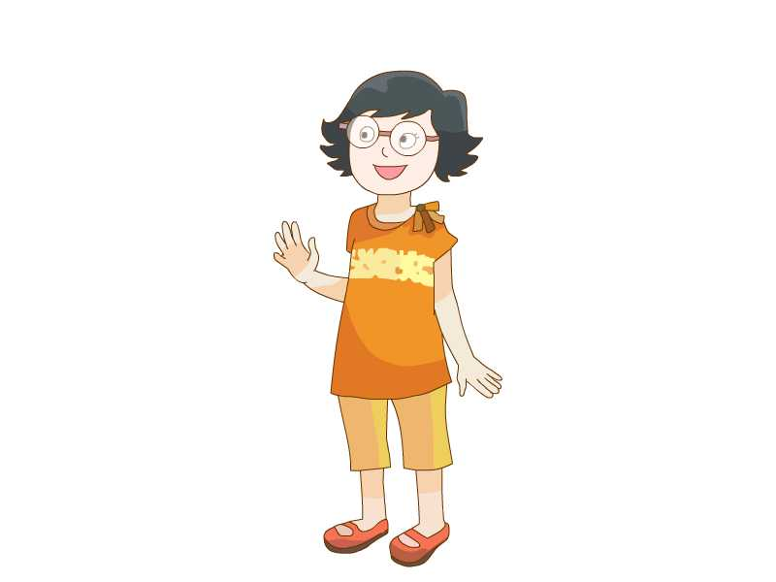 Beijing   Hong Kong 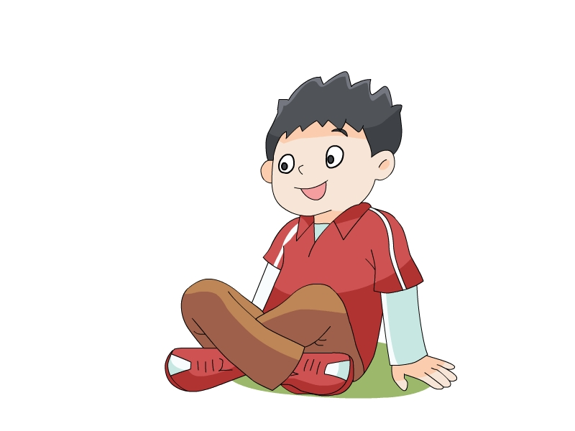 Taipei  Where will ┅go for the holiday?  How long will┅stay there? 学生生成问题  Will ┅ ? ┅
  Sounds great.
  学生生成资源
反思重建

