课题：Unit 6 My e-friend
教学内容 | Story time第一课时 | 课型 | 新授课 |  | 上课  时间
课前分析：
教学目标：
1. 能听懂、会读、会说单词： e-friend, send, to,email, live, study, China,UK,…years old, wait.
2. 能听懂、会读、会说日常用语：Does he/she…?Yes, he/she does. No, he/she doesn’t. Wait a minute.
3. 能正确的理解并朗读课文，在教师的引导和帮助下尝试复述课文内容。
4. 能初步运用本课所学的词汇和句型对自己的朋友或者网友进行综合全面的介绍。
5. 让学生用所学的语言，学会通过网络和其他国家的孩子交朋友。
教学重点：
能正确理解并朗读课文，在教师的帮助下尝试复述课文。
教学难点：
能初步运用本课所学的词汇和句型对自己的朋友或者网友进行综合全面的介绍。
教学准备： PPT
教学设计：  Step 1 : Greeting  1.Greeting.  2.T: I have two friends. Look at the pictures, who are they? Please guess.  Ss: They’re Liu Tao and Wang Bing..  T: (书上P58第一幅图)What are they talking about? Please watch and answer.  Step 2 : Presentation  1.Watch and answer  T:Boys and girls, let's watch and answer: What are they talking about?  ( Peter） (Wang Bing’s e-friend)  Teach:e-friend  揭题：Today we’ll learn Unit 6 My e-friend  2.Read and find  T: About Peter,do you have any questions about him?(年龄，国籍，爱好) Let's read and find : Where does he live?How old is he? What subjects does he like? What does he do after school? What does he like doing ?  Teach: UK,…years old, live, study  3.Try to say（四人小组汇报，介绍Peter的基本情况）:  Think and say P60: Now ,can you say something about Peter? Let’s think and say.  Peter is … e-friend.  He lives in …  He’s … years old.  He .. speak Chinese.  He … Chinese lessons at school.  He studies Chinese …  He likes …  He likes playing …  5. Read and judge.  （1）Liu Tao wants to play basketball with Wang Bing.(F)  (2)Wang Bing wants to send his email first..(T)  (Teach:wait a minute等一会儿,send, email, to)  (3)Wang Bing’s e-friend can speak Chinese.( T)  (4)Peter has Chinese lessons at school.(F)  6..Listen and repeat. (朗读的过程中注意提醒学生模仿一般疑问句和特殊疑问句的语调)  7.选择一种你喜欢的方式读课文  8.Let's retell. 结合板书介绍Peter  Step 3 : Consolidation  Fill in the mind-map and write  根据你所填写的思维导图，结合本课所学语言知识，描述下你的好朋友，可以从姓名、年龄、兴趣和喜爱的学科等方面介绍。不少于5句话。  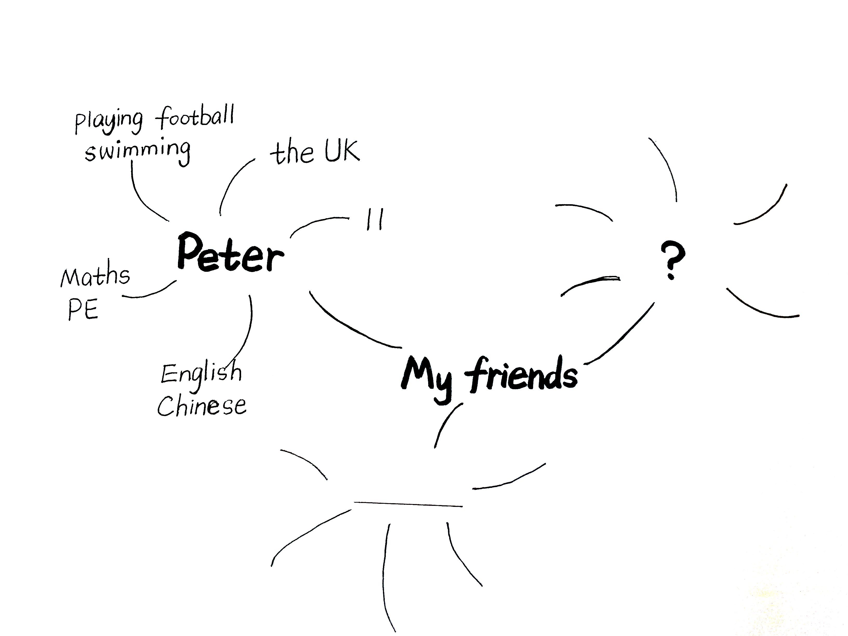  Step4.Homework  1.Read the story time and try to retell.读熟Stoty time并试着复述。  2..Know more national flags and share with your classmates. 认识更多国旗并和同学们一起分享。  3．结合本课所学语言知识，描述下你的好朋友，可以从姓名、年龄、兴趣和喜爱的学科等方面介绍。不少于5句话。带上他/她的照片，下节课交流 |  |  |  | 复备：
教学反思：

