阅读理解专题指导（事实细节题）
所谓细节题，是指原文提到了某事物、现象或理论，题干针对原文具体叙述本身发问。一般包括直接理解题（在原文中可直接找到答案。常用who, what, when, where, why和how等提问或用与此相类似的词填空。说明文和叙述文的思考题有相当于部分是此类题）及语义转化题（需要将题目信息与原文相关信息进行语义上的转换，两者存在表达上的差异，有时需要进行加工或整理后方能得出结论。）抓住文段中的事实和细节是做好该题型的关键，也是做好其它类型问题的基础。这类题型的题干常为：
1) When/Where did the story happen?
2) Which of the following statements is (not) correct?
3) Which of the following statements is (not) mentioned in the passage?
4) Which is the right order of the events given in the passage?
5) All the statements are true except.
该题型几乎都可以在文章中直接找到与答案有关的信息，或是其变体。所以，搜查信息在阅读中非常重要，它包括理解作者在叙述某事时使用的具体事实、数据、图表等细节信息。在一篇短文里大部分篇幅都属于这类围绕主体展开的细节。做这类题一般采用寻读法，即先读题，然后带着问题快速阅读短文，找出与问题有关的词语或句子，再对相关部分进行分析对比，找出答案。弄清细节、准确获取信息，也是把握文章中心思想的前提。
细节专题一：排序题
此类试题的考查形式是在选项中列举一些具体的事实，然后对上面的事实进行排序。要求考生根据动作发生的先后顺序、时间顺序以及句子之间的逻辑关系，找出事件发生、发展的正确顺序。考生可以先找出最早的一个时间和事件，把它作为事件发生的具体点，然后使用排除法将范围一一缩小，从而快速地选出正确答案。
例：In the 19th century England people liked to go to the seaside. In those days, ladies wore long bathing dresses, and men wore bathing suits. Women did not walk about on the beach(沙滩)in their bathing dresses. They hired a bathing machine. A bathing machine was used for changing in, and for taking the bather down to the sea. It cost 2 pence(便士) to hire a machine and an attendant(侍者). When she had paid, the bather climbed up the back steps and got into the bathing machine . Then she changed into her bathing dress. When she had changed, the machine was pulled down to the sea. The bathing machine stoped in the water and the bather went down the front steps into the water. If she did not want to get into the sea, the attendant pulled her in.（1996NMET）
1、In 19th century people who used the bathing machine usually did the following things. Which is the right order for doing them?
a. Changing into bathing clothes b. Getting out of the bathing machine
c. Paying 2 pence d. Getting into the bathing machine
e. Being taken down the beach f. Getting into the water
A. e, d, a, b, f, c B. c, d, a, e, b, f C. c, d, e, a, b, f D. d, a, e, b, f, c
细节专题二：计算题
计算题也是近几年高考中常考的内容，此类试题是在文章中直接表现出来细节事实，有的要经过具体的计算才能够得出正确的答案。具体的计算题可以是对年代的计算、月份的计算或比例的计算等。文章中经常会出现许多数字，它们对解题产生一定的影响。解答此类试题的方法是先来理解文章的大意，然后经过对比、分析、计算等就能够得出正确的答案了。
例：Degree
We offer a wide choice of bachelor’s degrees (学位) for international students, which includes: Arts, Communication Studies, Social Sciences, etc. Bachelor of Music and Bachelor of Education are only for New Zealand citizens, for further information: deg@waikato.ac.nz.
Tuition Fees(学费)
Tuition fees are different from department to department, generally from $5,000 to $6,000 a year. For further information: tui@waikato.ac.nz.
Accommodation(住宿)
You can have a room in a 4-bedroom flat, which will cost about $100 a month with other regular living costs of about $150 a month for one person. For further information: acc@waikato. ac.nz
Health
The Student Health Service provides excellent medical services for students. The Medical Centre is open five days a week, including student holidays with four doctor's and nurses to meet your medical needs. For further information: heal@waikato.ac.nz.
Sports
The Centre is a great place to have sports activities. Trained exercise teachers can help you work out a training plan and keep you active. The sports hall has volleyball, basketball and indoor football courts and a swimming pool as well. There are also a large number of sports clubs at Waikato. For further information: sport@ waikato.ac.nz（2005安徽卷）
1、You have to pay at least ______ a year if you study at the University of Waikato.
A. $5,250 B. $8,000 C. $9,000 D. $11,000
细节专题三：图形题
在有图形试题的阅读理解中，有的图形出现在阅读理解文章中，有的出现在选项中，这些图片的出现增加了试题的直观性，同时也暗含着和文章内容相关的信息。在解答此类试题的时候，一定要把握图形中所暗含的信息，特别是有些事实是通过图片来叙述的，我们可以采用按图寻找正确答案的方法。
例：The Channel Islands are a group of British-owned islands lying in the English Channel(海峡), 10 to 30 miles off the French coast, and 70 to 90 miles from the English coast. There are ten islands with a total land area of 75 square miles and a total population of 123,000. The three largest islands, Jersey, Guernsey, and Alderney, have long been known for the fine breeds(品种)of cattle that are raised on them and named after them.
In earliest known history the islands were considered part of Normandy, which was part of France, but the ruler of Normandy became king of England in 1066, and from then on the islands were looked upon as British land. English control was unbroken until World War II, when the Germans held the islands for five years.
Although people on the islands speak both languages and they are considered English, their customs are more French than English.（2000年北京春季）
1、Which of the following maps gives the right position of the Channel Islands?
Br = Britain Fr = France Ch = Channel Islands
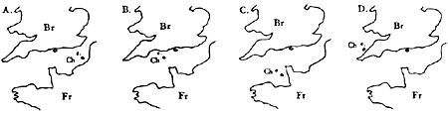
细节专题四：语义转换题
跳读查找法——这也是做事实细节题最基本最常用的方法。在通常情况下，细节题主要考查考生对某句话或某几句话的理解，同学们若能根据题干内容从原文中找到相关的句子，然后进行比较和分析，便可确定最佳答案。
运用跳读查找法时，同学们要特别注意试题（包括选项）与原文之间的适当变换。根据近几年的考题情况来看，现在很少有直接用原文中的句子进行考查和测试的，而通常要进行一定的处理。而这种“处理”主要就是指进行语义转换，其中包括同义变换、概念解析、归纳事实等。请看下面的例子（重庆高考英语试题）：
“My kids really understand solar and earth-heat energy，” says a second-grade teacher in Saugus，California.“Some of them are building solar collectors for their energy course.” These young scientists are part of City Building Educational Program（CBEP），a particular program for kindergarten through twelfth grade that uses the stages of city planning to teach basic reading，writing and math skills，and more.
The children don’t just plan any city. They map and analyze（分析） the housing，energy，and transportation requirements of their own district and foretell its needs in 100 years. With the aid of an architect（建筑师） who visits the classroom once a week，they invent new ways to meet these needs and build models of their creations.“Designing buildings of the future gives children a lot of freedom，”says the teacher who developed this program.“They are able to use their own rich imagination and inventions without fear of blame，because there are no wrong answers in a future context. In fact，as the class enters the final model-building stage of the program，an elected ‘official’ and ‘planning group’ make all the design decisions for the model city，and the teacher steps back and becomes an adviser.”
CBEP is a set of activities，games and imitations that teach the basic steps necessary for problem-solving：observing，analyzing，working out possible answers，and judging them based on the children’s own standards.
1. An architect pays a weekly visit to the classroom________ .
A. to find out kids’ creative ideas B. to discuss with the teacher
C. to give children lecturesD. to help kids with their program
2. Who is the designer of the program?
A. An official.B. An architect.C. A teacher.D. A scientist.
细节专题五：生活应用题
生活应用题要求考生在读懂文章的基础上结合一定的生活常识进行判断。不过，有趣的是，高考有时会出现一些“低级”常识判断题，即无需看懂文章，也可选出最佳答案。请看一个实例（全国卷高考英语试题）：
A child’s birthday party doesn’t have to be a hassle；it can be a basket of fun，according to Beth Anaclerio，an Evaston mother of two，ages 4 and 18 months.
“Having a party at home usually requires a lot of running around on the part of the parents，and often the birthday boy or girl gets lost in wild excitement. But it really doesn’t have to be that way，”said Anaclerio.
Last summer，Anaclerio and her friend Jill Carlisle，a Northbrook mother of a 2-year-old，founded a home party-planning business called“A Party in a Basket”. Their goal is to help parents and children share in the fun part of party planning，like choosing the subject or making a cake，while they take care of everything. Drawing on their experiences as mothers，they have created（制作） 10 ready-to-use，home party packages. Everything a family needs to plan a party，except the cake and ice cream，is delivered to the home in a large basket.
“Our parties are aimed for children 2 to 10，” Anaclerio said，“And they’re very interactive（互动） and creative in that they build a sense of drama based on a subject. For example，at the Soda Shoppe party the guests become waiters and waitresses and build wonderful ice cream creations.”
The standard $ 200 package for eight children includes a basket filled with invitations，gifts，games and prizes，paper goods，a party planner and the like. For more information，call Anaclerio at 708-864-6584 or Carlisle at 708-205-9141.
1.Which of the following is most likely to be a party planner?
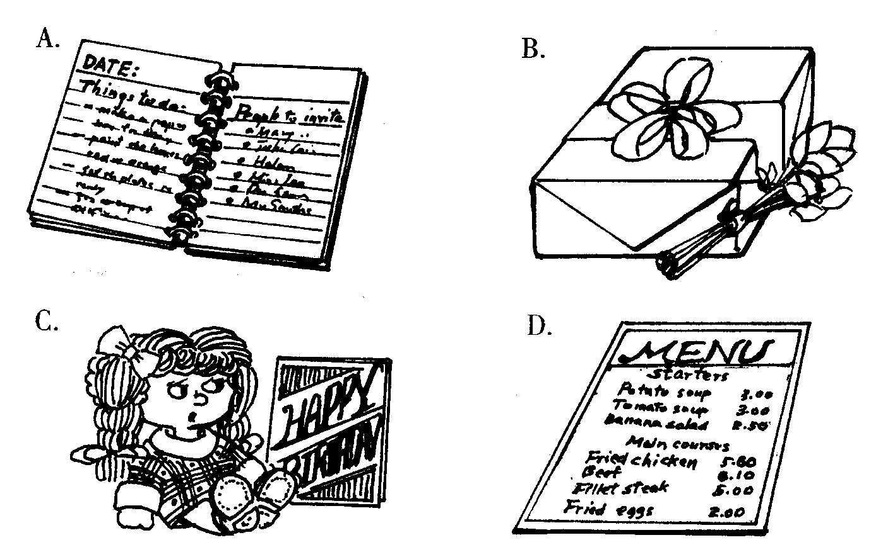
细节专题六：寻找信息题
快速寻找信息题一般为功能阅读题，主要形式有广告、公告、演出信息、航班时间表等。做这类题时没有必要阅读全文，宜采用“题干定位法”。请看下面的例子（浙江高考英语试题）：
Take Action for a Better World：Volunteers Needed
Six months’ preparation in Denmark：Africa studies，team work combined with social work with risk group teenagers.
Six months’ community work in Malawi in People to People Projects：Child Aid，HIV / AIDS. Fights and Teacher Training.
Qualifications（条件）：18 years，hard-working and social engagement.
Please contact us by email：takeaction@ betterworld.com
Part-time Work with Exchange Students
YOUTH International is a non-profit high school foreign exchange student organization. We welcome teenagers from over 80 countries worldwide and provide host families. The Community Representative is a part-time position designed for people with a strong desire to do something rewarding in the community and earn some extra money.
Applicants（申请人） best suited for this work should enjoy teenagers，have a strong interest in cross-cultural communication，and feel comfortable networking. Full training and support will be provided through branch offices throughout the U.S.Positions available in most states.
If interested，please email staff@ youth.org or call 888-123-9872.
International Summer Job
Hi，I am an ESL student in China. I’m 20，quiet and polite，and I speak reasonable English. I’m looking for a summer job in an English-speaking country. I can teach Chinese or do house and garden work，and cook Chinese dishes. Can anybody offer me a job? I don’t need to earn much，just enough in 2 months （July-August） to pay for my return ticket to China. My goal is to improve my English and see a bit more of the world. My email is：ram3462@ hotmail.com.Call for Native Speakers of English
I am looking for native speakers of English to join in an experiment. This experiment is carried out over the Internet. You don’t need any specific knowledge other than understanding and speaking English at a native level. The first task will take you around 15 minutes. After this task，you can decide whether you want to continue the experiment. The tasks involve reading texts and designing questions and answers.
If you are willing to help me，then please email me：club3864@hotmail.com1.
1. Who is suitable to work as a Community Representative in YOUTH International?
A. One who enjoys working with teenagers from different countries.
B. One who hopes to take action in fighting against diseases.
C. One who has a strong desire to improve his or her English.
D. One who wants to earn some pocket money in the program.
2. Where will Jack，a volunteer，receive the training before he is sent to work in Malawi?
A. In some local offices in the US.
B. In an ESL organization in China.
C. In a preparation program in Demark.
D. In an exchange student center in Africa.
3. If Mrs Black in the U.S. hopes to learn some Chinese at home，she may contact.
A. takeation@betterworld.com B. ram3462@hotmail.com
C. club3864@hotmail.com D. staff@youth.org
细节专题七：其它类型
例：Tristan da Cunha, a 38-square-mile island, is the farthest inhabited island in the world, according to the Guinness Book of Records. It is 1,510miles southwest of its nearest neighbor, St. Helena, and 1,950miles west of Africa. Discovered by the Portuguese admiral（葡萄牙海军上将）of the same name in 1506, and settled in 1810, the island belongs to Great Britain and has a population of a few hundred.
Coming in a close second –- and often wrongly mentioned as the most distant land － is Easter Island, which lies 1,260 miles east of its nearest neighbor, Pitcairn Island, and 2,300 miles west of South America.
The mountainous 64-square-mile island was settled around the 5th century, supposedly by people who were lost at sea. They had no connection with the outside world for more than a thousand years, giving them plenty of time to build more than 1,000 huge stone figures, called moai, for which the island is most famous.
On Easter Sunday, 1772, however, settlers from Holland moved in and gave the island its name. Today, 2,000 people live on the Chilean territory （智利领土）. They share on street, a small airport, and a few hours of television per day.（2003年全国）
1、It can be learned from the text that the island of Tristan da Cunha _____________.
A．was named after its discoverer B．got its name from Holland settlers
C．was named by the British government D．got its name from the Guinness Book of Records
2、Which of the following is most famous for moai?
A．Tristan da Cunha. B．Pitcairn Island.． C. Easter Island. D．St. Helena.
3、Which country does Easter Island belong to?
A．Britain. B．Holland. C．Portugal. D．Chile.
例：When she looked ahead. Florence Chadwick saw nothing but a solid wall of fog. Her body was numb. She had been swimming for nearly sixteen hours. Already she was the first woman to swim the English Channel in both directions. Now at the age of 34, her goal was to become the first woman to swim from Catalina to the California coast.
On that fourth of July morning 1952, the sea was like an ice bath and the fog was so dense. She could hardly see her support boats. Sharks cruised toward her figure, only to be driven away by rifle shots. Against the frigid grip of the sea, she struggled on, hour after hour, while millions watched on national television.
Alongside Florence in one of the boats, her mother and here trainer offered encouragement. They told her it wasn’t much farther. But all she could see was fog. They urged her not to quit. She never had… until then. With only a half mile to go, she asked to be pulled out.
1、What does “she never had…”in the third paragraph mean?
A. She had never been so desperate. B. She had never thought of giving it up.
C. She had never seen such thick fog. D. She had never swum across the strait before.
例：Decision-thinking is not unlike poker--- it often matters not only what you think , but also what others think you think and what you think they think you think . The mental process（过程） is similar . Naturally , this card game has often been of considerable interest to people who are , by any standards , good thinkers .
The great mathematician John von Neumann was one of the founders of game theory . In particular , he showed that all games fall into two classes ; there are what he called games of ‘perfect information’, games like chess where the players can't hide anything or play tricks ; they don't win by chance , but by means of logic and skills . Then there are games of ‘imperfect information’, like poker, in which it is impossible to know in advance that one course of action is better than another.
One mistaken idea about business is that it can be treated as a game of perfect information. Quite the reverse, business, politics, life itself are games which we must normally play with very imperfect information. Business decisions are often made with many unknown and unknowable factors（因素）, which would ever puzzle best poker players . But few business people find it comfortable to admit that they are taking a chance , and many still prefer to believe that they are playing chess , not poker.
1、An important factor in a game of imperfect information is _______.
A. rules B. luck C. time D. ideas

