8A Unit8 Reading I
Teaching Aims:
1. Learn some new words.
2. According to the pictures, keywords and context speculate the main ideas.
3. Practise reading skills by learning “An earthquake”.
Step 1 Presentation
Present the new words with pictures and read them aloud.
slight shake loud fear bomb shake direction in all directions
brick come down silent not at all nervous heart beat trapped
mind calm calm down since still alive dark shout at last
daylight safe asleep after find one’s way out
Step 2 Match the words on the left with the meanings on the right.
1. Do part B1 on page 95.
1 shake a finally
2 scream b fall to the ground
3 come down c give a loud high cry
4 silent d not in danger
5 at last e move quickly from side to side, up and down, etc.
6 safe f quiet
2. Check the answer.
Step 3 Presentation[来源:学&科&网Z&X&X&K]
1. Now look at a video. Tell me what kind of disaster it is.
What can you see in the video?
2. Enjoy some pictures and present ‘What is earthquake?’
Step 4 Listening
1. Listen to text and do part B3.
Sandy is telling her classmates about Timmy’s story. Check whether she remembers everything correctly. Write a T if a sentence is true or an F if it is false.
1) Timmy was asleep when the earthquake started.
2) At first, Timmy heard a loud noise like thunder.
3) People ran in the same direction in the street.
4) Timmy was trapped in a dark place after the earthquake stopped.
5) There was not enough space for Timmy to pull himself through.
6) People found Timmy soon after he was trapped.
2. Check the answers.
Step 5 Reading
1. Read paragraph 1 and complete the table.
At first
When it was
What he did
What he heard
How he felt
2. Read paragraph 2 and complete the passage.
The real noise was like ______ under the ground. People ran _________. Timmy tried his best to _____ to the street. Pieces of glass and bricks _____________, and then the walls began to _________, too.
3. Read paragraph 3 and do the following exercises.
1) Timmy _____ after the noise and shaking ended?
A. screamed B. calmed down
C. ran wildly D. cried
2) He could see __________.
A. Anything B. someone around him
C. nothing D. the bright daylight
4. Read paragraph 4 and answer the following questions.
Did he shout for help?
5. Read paragraph 5 and match the sentences.
1) I was trying to find my way out ____
2) I screamed _____
3) Then I heard shouts from _____
4) They quick ______
5) At last, I saw _____
a. Help! Please help! I’m here!
b. move away the bricks.
c. the bright daylight.
d. when I suddenly heard some noise above me.
e. excited people.
Step 6 Exercises
1. Complete part B 2 on page 95.
Timmy put some pictures he drew on his web page. Help Sandy write the correct caption in the blank under each picture. Then put the pictures in the correct order on page 95.
I saw the bright daylight.
I was trapped.
The walls came down.
I screamed for help.
Some people ran out of the building.
The earth started to shake.
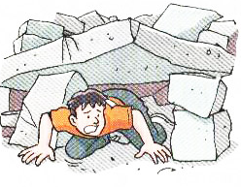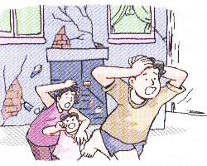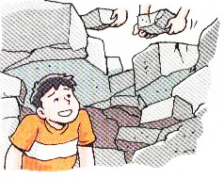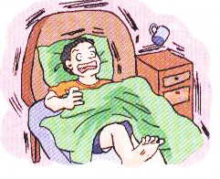
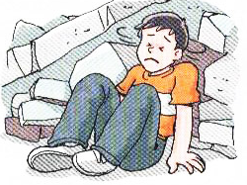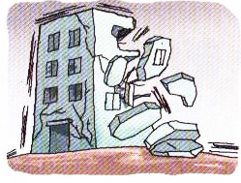
2. Check the answers.
Step 7 Consolidation
Sandy is writing about what happened to Timmy in her diary. Help her complete her diary entry with the words.
beating bricks calm fear mind nervous pulled safe saved sleeping thunder trapped
When the earthquake hit Taiwan in 1999, Timmy was _________. He heard a loud noise like ________. Then the noise became louder, like bombs under the ground. People screamed in _____. Then pieces of glass and ______ fell down.
When the noise and shaking stopped, Timmy was ________ and could not get out. He felt ________ and his heart was ________ fast. A moment of fear went through his ______. Then he tried to _____ down and ______ himself slowly through the dark.
Finally, people came and heard his cry for help. They moved away the bricks and ______ him. Timmy was _____ at last.
Step 8 Discussion
After the earthquake, Timmy has some useful ways of protecting himself in the earthquake. If you are Timmy, what good ways of protecting yourself do you know?
Step 9 Homework
1. Read aloud the article and try to retell the story.
2. Remember the new words in this lesson.

