授课教师 |  |  |  | 陈燕萍 |  |  | 授课时间 | 201512月 15日 | 九（2）
课题 |  |  |  | Unit 8 Detective stories  Comic strip & Welcome to the unit |  |  |  | 课型 |  | New
教学目标 |  | 1. To understand clues about a crime.
2. To read notes on four suspects and decide which suspect is most likely to be
guilty.
重点 |  | Master the new words and useful  expressions. |  |  |  | 难点 |  | Make up a conversation in Part B.
教法及教具 |  |  |  |  | Reading Listening / A tape recorder and some teaching pictures.
教  学  过  程 | 教 学 内 容 |  |  |  |  |  |  |  |  | 个案调整
教  学  过  程 | 教师主导活动 |  |  |  |  |  |  | 学生主体  活动
教  学  过  程 | Step1 Lead-in  T: Look at the pictures and discuss:  - Who are they?  - What are they?  - What is a detective’s job?  Step 2 Welcome to the unit  Ask students to help find out the murder after reading the police’s report and the notes on the suspects.  T: Do you want to be a detective? How to be a detective? Here is a chance for you to try. The Class1, Grade 9 students are playing a game about guessing who the murderer is. We can try together.  T: (Ask students to read information about James Brown.)  1. What’s Dr Brown’s job?  2. Where was he when the murder happened?  3. What is he like?  T: (Ask students to read information about Jimmy White.)  Ask students to fill in the blanks about Jimmy White.  T: (Ask students to read information about Emily Smith.)  Ask students to tell whether the statements about Emily Smith are true or false.  T: (Ask students to read information about Frank Johnson.)  Ask students to do some multiple choices.  Step 3 Discussion  Work in a group of four. Ask students to discuss who is most likely to be the murderer and the reason. Then ask them to draw a picture of the person they think committed the crime in part B, and remind them that there is no right or wrong answers here.  Step 4 Listen to the tape  T: Listen to the tape of Part B on Page 107 and fill in the blanks.  Step 5 Comic Strips  T: Listen to the tape and answer some questions:  1. What is Eddie dressed like?  2. Is Eddie looking for a murderer?  3. What is Eddie looking for?  4. Is Eddie a real detective?  T: Ask students to read the dialogue together.  T: Explain some language points: sb. be dressed like…; go missing.  T: Ask some pairs to act out the dialogue.  Step 6 Homework  1. Discuss the case about Xiaoming with your friends and parents after class;  2. Please write a report on the case. |  |  |  |  |  |  | Discuss and answer the questions.  Answer.  Read the information and answer the questions.  Read and fill in the blanks.  Read the information and tell whether the statements are true or false.  Read the information and do the multiple choices.  Discuss in groups, and write on the paper.  Listen to the tape and fill in the blanks.  Listen and answer questions.  Read the dialogue.  Learn the language points.  Act out the dialogue.
板书设计 |  |  | 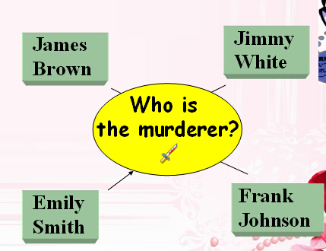
教学札记

