5B Unit 8 At the weekends
邹区东方学校 纪亚利 2014年5月14日
一、教学内容：《牛津小学英语》5B Unit 8 At the weekends 第一课时。
A. Read and say
二、教学目标和要求：
1、知识目标：
（1）能听懂、会说、会读、会写单词和词组：weekend, spend, often, learn…from…, sport, catch, butterfly, butterflies, cartoon，of course, at the weekend, talk about.
（2）能听懂句型并作出回答：How do you\they spend your\their weekends? I\They often …Sometimes I\they … How does he /she spend his\her weekends? He /She often... Sometimes he\she…
（3）能理解、读懂Part A.
2、能力目标：
（1）培养学生用英语思维的能力，以及语言组织能力。
（2）通过直观的情景创设，让学生学会介绍他人的周末活动，并能让学生进一步掌握一般现在时的用法。
3、情感目标：
（1）本堂课的教学内容与学生的周末活动紧密相联，这能激发学生的学习兴趣，培养他们的英语思维能力和良好的学习习惯。同时，培养学生的口头、笔头的表达能力和综合运用英语的能力。
（2）学生喜欢生活，喜欢动画，喜欢英语。
三、教学重难点：
1、能听懂、会说、会读单词和词组：weekend, spend, often, learn…from…, sport, catch, butterfly, butterflies, cartoon, of course, at the weekend, talk about.
2、能听懂句型并作出回答：How do you\they spend your\their weekends? I\They often …Sometimes I\they … How does he \she spend his\her weekends? He \She often... Sometimes he\she…
3、能理解、读懂Part A.
4、学生能进一步掌握一般现在时的用法。
四、教学准备：
PPT课件、板书、人物头像、学生课堂练习等。
五、教学过程：
Step1 Warm up
T: Boys and girls, you know I have some hobbies. I like reading books. I like surfing the Internet, too. Do you have any hobbies, S1?
S1: Yes, I do. I like…ing.
T: Oh, I see. What time do you do it? On Monday? On Tuesday?
S1: On Saturday.
T: Oh, I see. Thank you.
Step2 Presentation and practice
- Learn to say: of course, at the weekend
(1)T: S2, do you have any hobbies?
S2: Yes, I do.
(2)T: You also can say “Of course, I do.”
Read：Of course.
T: of course means “ sure”.
(3)T: S2, what’s your hobby?
S2: I like…ing.
T: What time do you do it?
S2: On Sunday.
T: Why? You are free on Sundays?
S2: Yes. I’m free.
T: I’m free on Saturdays and Sundays, too.
(4)T: (出示五月份的日历)Look at the calendar of May. They are Saturdays and Sundays. ‘On Saturdays and Sundays’ means ‘at the weekends’.
Read : bed pen ten /e/ weekend at the weekend 在周末
(5)T: Today we will learn Unit 8 At the weekends
Read: Unit 8 At the weekends
2、Learn to say: spend one’s weekends
(1)T: (出示weekend, spend) Boys and girls, can you read this word‘spend’？
Read： spend
(2) T: 度过我的周末 spend my weekends
T: How to say “度过你的\他的\她的\我们的\他们的周末”？
S: spend your\his\her\our\their weekends
(3)T: Read together.
Step 3 Read and say
1.整体感知
(1) T: Boys and girls, look! The children are talking about their weekends. How do they spend their weekends? Let’s watch and answer two questions.
Q1: Who likes sport?
Teach: or for short /ɔ:/ sport
A  B 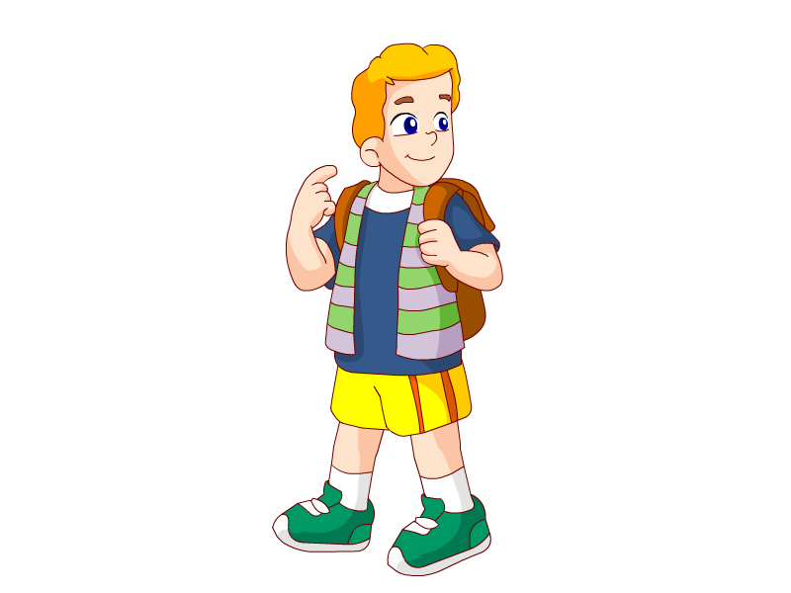 C

Q2: How do Su Hai and Su Yang spend their weekends?
苏海和苏洋怎样度过他们的周末？
They often(经常) . Sometimes they .

 | Sun | Mon | Tue | Wed | Thu | Fri | Sat
usually | √ | √ | √ | √ | √ | √
often | √ | √ | √ | √
sometimes | √ | √
T: I usually go shopping. I often go shopping. Sometimes I go shopping.
Tips: 单词often的意思是“经常，常常”， 表示我们做某一件事时的频率比usually低，但比sometimes高，用图可以这样表示。请同学们在使用过程中注意选择适合自己活动频率的单词。
- watch cartoons B. catch butterflies
C．wash clothes D. clean the rooms
Teach：car afternoon cartoon动画片，卡通
cat watch catch 捉
butterfly butterflies 蝴蝶
2. 细读课文
(1)T: You know Su Hai and Su Yang how to spend their weekends. How about Wang Bing, Mike, Helen and Yang Ling? Please turn to P60-61. Read and tick!

 |  |  |  |  |    | 
often | surf the Internet
often | go climbing
often | watch cartoons
often | go to the park
often | do housework
some-  times | go swimming
some-  times | watch TV
some-  times | catch butterflies
some-  times | play basketball
some-  times | listen to music
some-  times | clean the rooms
some-  times | wash clothes
some-  times | go to the cinema

A: How does … spend his\her weekends?
B: He\She often… Sometimes he\she…
A: How do Su Hai and Su Yang spend their weekends?
B: They often… Sometimes they …
Tips: 当主语是第三人称单数时，动词用三单式。
(2)T: How does Wang Bing spend his weekends?
S: He often surfs the Internet. Sometimes he goes swimming. Sometimes he plays basketball.
T: How does Mike spend his weekends?
S: He often goes climbing. Sometimes he listens to music or goes to the cinema.
T: How does Yang Ling spend her weekends?
S: She often goes to the park. Sometimes she cleans the room and washes clothes.
T: How does Helen spend her weekends?
S: She often does homework. Sometimes she watches TV.
T: How do Su Hai and Su Yang spend their weekends?
S: They often watch cartoons. Sometimes they catch butterflies.
(板书相关词组)
(3)Let’s retell! 看板书复述。
(4)T: Just now, we talk about their weekends.
Teach: walk /ɔ:/ talk talk about谈论，议论
T: 谈论他们的周末 talk about their weekends
谈论我的爱好 talk about my hobbies
谈论这本故事书 talk about this storybook
谈论时间 talk about time
3、Let’s read the text together!
Teach: learn…from…
从网上学到很多 learn a lot from the Internet
从电视上学到很多 learn a lot from the TV
从书上学到很多 learn a lot from the book(s)
向老师学到很多 learn a lot from the teacher(s)
向你学习 learn from you
4、Let’s retell(复述)
It is Friday afternoon. School is over. The students are talking about their weekends. Wang Bing often …Sometimes he…
Step4 Enjoy a cartoon
T: Wonderful! Here’s a present for you! “ Tom and Jerry”
T: The cartoon is about how to catch a mouse. I like this cartoon very much. Do you like it? Do you like cartoons?
Ss: Yes, I do.
T: Good! I hope you love this cartoon.
I hope you love our life.
I hope you can love English, too.
Step5 Homework
1. Listen and repeat part A.
2. Write an e-mail to Miss Ji about your friend’s and your family’s weekends.
Dear Miss Ji,
I often at the weekends. Sometimes I . My good friend, often .
Sometimes he/she .
My parents often .
Sometimes they .
Have a nice weekend!
yours

Step5 Blackboard design
Unit 8 At the weekends
often sometimes
Wang Bing surfs the Internet goes swimming
plays basketball
Mike goes climbing listens to music
goes to the cinema
Yang Ling goes to the park cleans the room
washes clothes
Helen does housework watches TV
Su Hai &Su Yang watch cartoons catch butterflies

