2012年普通高等学校招生全国统一考试（江苏卷）
英 语 试 题
第一部分 听力（共两节，满分20分）
做题时，先将答案标在试卷上。录音内容结束后，你将有两分钟的时间将试卷上的答案转涂到答题卡上。
第一节（共5小题；每小题1分，满分5分）
听下面5段对话。每段对话后有一个小题，从小题中所给的A. B. C三个选项中选出最佳选项，并标在试卷的相应位置。听完每段对话后，你都有10秒钟的时间来回答有关小题和阅读下一小题。每段对话仅读一遍。
例：How much is the shirt?
A. £19. 15 B. £9. 15 C. £9. 18 答案B。
1. Where does this conversation probably take place?
A. In a bookstore. B. In a classroom. C. In a library.
2. At what time will the film begin?
A. 7: 20. B. 7: 15. C. 7: 00.
3. What are the two speakers mainly talking about?
A. Their friend Jane. B. A weekend trip. C. A radio programme.
4. What will the woman probably do?
A. Catch a train. B. See the man off. C. Go shopping.
5. Why did the woman apologize?
A. She made a late delivery. B. She went to the wrong place.
C. She couldn’t take the cake back.
第二节（共15小题，每小题1分，满分15分）
听下面5段对话或独白。每段对话后有几个小题，从题中所给的A、B、C三个选项中选出最佳选项，并标在试卷的相应位置。听每段对话前，你将有时间阅读各个小题，每小题5秒钟；听完后，各小题给出5秒钟的作答时间。每段对话读两遍。
听第6段材料，回答第6、7题。
6. Whose CD is broken?
A. Kathy’s. B. Mum’s. C. Jack’s.
7. What does the boy promise to do for the girl?
A. Buy her a new CD. B. Do some cleaning. C. Give her 10 dollars.
听第7段材料，回答第8、9题。
8. What did the man think of the meal?
A. Just so-so. B. Quite satisfactory. C. A bit disappointing.
9. What was the 15% on the bill paid for?
A. The food. B. The drinks. C. The service.
听第8段材料，回答第10至12题。
10. Why is the man at the shop?
A. To order a camera for his wife. B. To have a camera repaired.
C. To get a camera changed.
11. What colour does the man want?
A. Pink. B. Black. C. Orange.
12. What will the man do afterwards?
A. Make a phone call. B. Wait until further notice.
C. Come again the next day.
听第9段材料，回答第13至16题。
13. What would Joe probably do during the Thanksgiving holiday?
A. Go to a play. B. Stay at home. C. Visit Kingston.
14. What is Ariel going to do in Toronto?
A. Attend a party. B. Meet her aunt. C. See a car show.
15. Why is Ariel in a hurry to leave?
A. To call up Betty. B. To buy some DVDs. C. To pick up Daniel.
16. What might be the relationship between the speakers?
A. Classmates. B. Fellow workers. C. Guide and tourist.
听第10段材料，回答第17至20题。
17. Where does Thomas Manning work?
A. In the Guinness Company. B. At a radio station. C. In a museum.
18. Where did the idea of a book of records come from?
A. A bird-shooting trip. B. A visit to Europe. C. A television talk show.
19. When did Sir Hugh’s first book of records appear?
A. In 1875. B. In 1950. C. In 1955.
20. What are the two speakers going to talk about next?
A. More records of unusual facts. B. The founder of the company.
C. The oldest person in the world.
第二部分 英语知识运用（共两节，满分35分）
第一节 单项填空（共15小题；每小题1分，满分15分）
认真阅读下面各题，从题中所给的A、B、C、D四个选项中，选出最佳选项，并在答题卡上将该项涂黑。
例：It is generally considered unwise to give a child ________ he or she wants.
A. however B. whatever C. whichever D. whenever 答案：B
21. ---Can I help you with it?
--- I appreciate your ________, but I can manage it myself.
A. advice B. question C. offer D. idea
22. After the flooding, people were suffering in that area, ________ urgently needed clean water, medicine and shelter to survive.
A. which B. who C. where D. what
23. Sophia waited for a reply, but ________ came.
A. either B. another C. neither D. none
24. ---Don’t worry, Mum. The doctor said it was only the flu.
--- ________! I’ll tell Dad there’s nothing serious.
A.What a relief B. Congratulations C. How surprising D. I’m so sorry
25. There is little doubt in your mind that he is innocent, ________?
A. is there B. isn’t there C. is he D. isn’t he
26. --- OK, I’ve had enough of it. I give up.
---You can’t ________ your responsibilities.
A. run off with B. run up against C. run out of D. run away from
27. The notice came around two in the afternoon ________ the meeting would be postponed.
A. when B. that C. whether D. how
28. Days later, my brother called to say he was all right, but ________ say where he was.
A. mustn’t B. shouldn’t C. wouldn’t D. mightn’t
29. --- Thank God you’re safe!
---I stepped back, just ________ to avoid the racing car.
A. in time B. in case C. in need D. in vain
30. One’s life has value ________ one brings value to the life of others.
A. so that B. no matter how C. as long as D. except that
31. ________ an important decision more on emotion than on reason, you will regret it sooner or later.
A. Based B. Basing C. Base D. To base
32. The manager is said to have arrived back from Paris where he ________ some European business partners.
A. would meet B. is meeting C. meets D. had met
33. --- Honey, the cat’s stuck in the tree. Can you turn off the TV and get a ladder…?
--- Oh, it jumped off. ________.
A. Never mind B. All right C. No problem D. Take care
34. The president hopes that the people will be better off when he quits than when he ________.
A. has started B. starts C. started D. will start
35. ---Happy birthday!
---Thank you! It’s the best present I _______ for.
A. should have wished B. must have wished
C. may have wished D. could have wished
第二节 完形填空（共20小题；每小题1. 5分，满分30分）
请认真阅读下面的短文，从短文后各题所给的A、B、C、D四个选项中，选出最佳选项，并在答题卡上将该项涂黑。
The concept of solitude (独处) in the digital world is almost non-existent. In the world of digital technology, e-mail, social networking and online video games, information is meant to be 36 . Solitude can be hard to discover 37 it has been given up. In this respect, new technologies have 38 our culture.
The desire to be connected has brought solitude to a(n) 39 as we have known it. People have become so 40 in the world of networks and connections that one can often be contacted 41 they’d rather not be. Today we can talk, text, e-mail, chat and blog (写博客)，not only from our 42 , but from our mobile phones as well.
Most developed nations have become 43 on digital technology simply because they’ve grown accustomed to it, and at this point not 44 it would make them an outsider. 45 , many jobs and careers require people to be 46 . From this point of view, technology has changed the culture of work. Being reachable might feel like a 47 to those who may not want to be able to be contacted at all times.
I suppose the positive side is that solitude is still possible for anyone who 48 wants it. Computers can be shut 49 and mobile phones can be turned off. The ability to be “connected” and “on” has many 50 , as well as disadvantages. Travelers have ended up 51 on mountains, and mobile phones have saved countless lives. They can also make people feel 52 and forced to answer unwanted calls or 53 to unwanted texts.
Attitudes towards our connectedness as a society 54 across generations. Some find today’s technology a gift. Others consider it a curse. Regardless of anyone’s view on the subject, it’s hard to imagine what life would be like 55 daily advancements in technology.
36. A. updated B. received C. shared D. collected
37. A. though B. until C. once D. before
38. A. respected B. shaped C. ignored D. preserved
39. A. edge B. stage C. end D. balance
40. A. sensitive B. intelligent C. considerate D. reachable
41. A. even if B. only if C. as if D. if only
42. A. media B. computers C. databases D. monitors
43. A. bent B. hard C. keen D. dependent
44. A. finding B. using C. protecting D. changing
45. A. Also B. Instead C. Otherwise D. Somehow
46. A. connected B. trained C. recommended D. interested
47. A. pleasure B. benefit C. burden D. disappointment
48. A. slightly B. hardly C. merely D. really
49. A. out B. down C. up D. In
50. A. aspects B. weaknesses C. advantages D. exceptions
51. A. hidden B. lost C. relaxed D. deserted
52. A. trapped B. excited C. confused D. amused
53. A. turn B. submit C. object D. reply
54. A. vary B. arise C. spread D. exist
55. A. beyond B. within C. despite D. without
第三部分 阅读理解（共15小题；每小题2分，满分30分）
请认真阅读下列短文，从短文后各题所给的A、B、C、D四个选项中，选出最佳选项，并在答题卡上将该项涂黑。
A
What Would You Want Most on a Desert Island?
This month’s survey shows people worldwide have a natural understanding of what they would need most if left alone on a desert island: Another person. And one they know well. Respondents (调查对象) in all 16 countries surveyed said their spouse (配偶) or partner would be their first choice to have with them. Perhaps this makes sense: An MP3 player can’t help you find drinking water, your dog can’t help you start a fire and who knows if George Clooney or Penelope Cruz has taken courses in wilderness survival training? Let’s just hope the SOS sign you two build gets spotted sooner rather than later!
“My husband, of course! George Clooney wouldn’t think I’m as pretty as my husband does!”  Roseane, 42, Brazil | “My MP3 player. I would not want my loved ones, including my pet, to be left alone like this.”  Co-Co, 28, China | “My partner should be there to listen to me complain about the fact that we are left alone on an island – probably due to some error he made  Julia, 25, Jordan

Spouse/Partner  82% of the South African women surveyed would most want their husband/partner with them, while just 45% of the Indian women surveyed agreed. | Clooney/Cruz  27% of Russian men surveyed would want a celebrity along. Only 2% of the Mexican men agreed. Less than 18% of women worldwide chose this option.
MP3 Player  This was second choice overall, particularly among Malaysian men, with 32% saying they’d most want an MP3 player with their favorite songs. Just 5% each of Australian and American men agreed | Dog  In France, 28% of respondents older than 45 would most want to be left alone with their dog, while not a single Russian or Malaysian in that age group surveyed would most want Fido along.

56. According to the survey, people left alone on a desert island would most want their ________.
A. MP3 player B. dog C. spouse/partner D. celebrity
57. Which of the following is true about George Clooney?
A. He has been trained in wilderness survival.
B. He may not be able to help you survive.
C. He does not think Roseane is beautiful.
D. He is the choice of most South African women.
58. The survey results are analyzed in terms of the respondents’ ________.
A. sex, age and nationality B. race, nationality and sex
C. marriage, age and race D. age, sex and marriage
B
Deputy Agriculture Secretary Kathleen Merrigan sees an epidemic (流行病) sweeping across America’s farmland. It has little to do with the usual challenges, such as flood, rising fuel prices and crop-eating insects. The country’s farmers are getting older, and there are fewer people standing in line to take their place. National agricultural census (普查) figures show that the fastest-growing group of farmers is the part over 65. Merrigan is afraid the average age will be even higher when the 2012 statistics are completed.
Merrigan, a former college professor, is making stops at universities across the country in hopes of encouraging more students to think about careers in agriculture. Aside from trying to stop the graying of America’s farmers, her work is made tougher by a recent blog posting that put agriculture at No. 1 on a list of “useless” college degrees. Top federal agriculture officials are talking about the posting, and it has the attention of agricultural organizations across the country.
“There couldn’t be anything that’s more incorrect,” Merrigan said. “We know that there aren’t enough qualified graduates to fill the jobs that are out there in American agriculture. “
In addition, a growing world population that some experts predict will require 70% more food production by 2050, she said.
“I truly believe we’re at a golden age of agriculture. Global demand is at an all-time record high, and global supplies are at all-time record lows,” said Matt Rush, director of the Texas Farm Bureau. “Production costs are going to be valuable enough that younger people are going to have the opportunity to be involved in agriculture. “
The Department of Agriculture has programs aimed at developing more farmers and at increasing interest in locally grown food. The National Young Farmers’ Coalition has also been pushing for state and federal policy changes to make it easier for new farmers.
Ryan Best, president of Future Farmers of America, has been living out of a suitcase, traveling the country and visiting with high school students about careers in agriculture. The 21-year-old Best hopes his message --that this is a new time in agriculture-- will motivate the next generation to turn around the statistics. “Never before have we had the innovations (创新) in technology which have led to agriculture in this country being the most efficient it has ever been,” he said. “There’s really a place for everybody to fit in. “
59. What is the new challenge to American agriculture?
A. Fewer and older farmers. B. Higher fuel prices.
C. More natural disasters. D. Lower agricultural output.
60. Why is Merrigan visiting universities across the country?
A. To draw federal agriculture officials’ attention.
B. To select qualified agriculture graduates.
C. To clarify a recent blog posting.
D. To talk more students into farming careers.
61. According to Matt Rush, American agriculture will provide opportunities for younger people because ________.
A. the government will cover production costs
B. global food supplies will be even lower
C. investment in agriculture will be profitable
D. America will increase its food export
62. What do the underlined words “to turn around the statistics” in the last paragraph mean?
A. To re-analyze the result of the national census.
B. To increase agricultural production.
C. To bring down the average age of farmers.
D. To invest more in agriculture.
C
Medical drugs sometimes cause more damage than they cure. One solution to this problem is to put the drugs inside a capsule, protecting them from the body --and the body from them-- until they can be released at just the right spot. There are lots of ways to trigger (引发) this release, including changing temperature, acidity, and so on. But triggers can come with their own risks -- burns, for example. Now, researchers in California have designed what could be a harmless trigger to date: shining near-infrared light (NIR, 近红外线) on the drug in the capsule.
The idea of using light to liberate the drug in the capsule isn’t new. Researchers around the globe have developed polymers (聚合物) and other materials that begin to break down when they absorb either ultraviolet (UV, 紫外线) or visible light. But tissues also readily absorb UV and visible light, which means the drug release can be triggered only near the skin, where the light can reach the capsule. NIR light largely passes through tissues, so researchers have tried to use it as a trigger. But few compounds (化合物) absorb NIR well and go through chemical changes.
That changed last year when Adah Almutairi, a chemist at the University of California, San Diego, reported that she and her colleagues had designed a polymer that breaks down when it absorbs NIR light. Their polymer used a commercially available NIR-absorbing group called o-nitrobenzyl (ONB). When they catch the light, ONB groups fall off the polymer, leading to its breakdown. But ONB is only a so-so NIR absorber, and it could be poisonous to cells when it separates from the polymer.
So Almutairi and her colleagues reported creating a new material for capsules that’s even better. This one consists of a long chain of compounds called cresol groups linked in a polymer. Cresol contains reactive (易反应的) components that make it highly unstable in its polymeric form, a feature Almutairi and her colleagues use to their advantage. After polymerizing the cresols, they cap each reactive component with a light-absorbing compound called Bhc. When the Bhcs absorb NIR light, the reactive groups are exposed and break the long polymer into two short chains. Shining additional light continues this breakdown, potentially releasing any drugs in the capsule. What’s more, Almutairi says, Bhc is 10 times better at absorbing NIR than is ONB and is not poisonous to cells.
63. According to the passage, which of the following could be the best trigger?
A. Temperature change. B. NIR light.
C. Acidity change. D. UV light
64. Why is ONB unsatisfactory?
A. It breaks down when it absorbs NIR light.
B. It falls off the polymer and triggers drug release.
C. It has not come onto the market up till now.
D. It is not effective enough and could be poisonous.
65. Which word can be used to complete the following process of changes?
Bhcs absorb NIR | ＞ | Part of the cresol is ________ | ＞ | Polymer breaks down | ＞ | Drug is released
A. protected B. formed C. exposed D. combined
D
Franz Kafka wrote that “a book must be the axe(斧子) for the frozen sea inside us.” I once shared this sentence with a class of seventh graders, and it didn’t seem to require any explanation.
We’d just finished John Steinbeck’s novel Of Mice and Men. When we read the end together out loud in class, my toughest boy, a star basketball player, wept a little, and so did I. “Are you crying?” one girl asked, as she got out of her chair to take a closer look. “I am,” I told her, “and the funny thing is I’ve read it many times.”
But they understood. When George shoots Lennie, the tragedy is that we realize it was always going to happen. In my 14 years of teaching in a New York City public middle school, I’ve taught kids with imprisoned parents, abusive parents, irresponsible parents; kids who are parents themselves; kids who are homeless; kids who grew up in violent neighbourhoods. They understand, more than I ever will, the novel’s terrible logic -- the giving way of dreams to fate (命运).
For the last seven years, I have worked as a reading enrichment teacher, reading classic works of literature with small groups of students from grades six to eight. I originally proposed this idea to my headmaster after learning that a former excellent student of mine had transferred out of a selective high school -- one that often attracts the literary-minded children of Manhattan’s upper classes -- into a less competitive setting. The daughter of immigrants, with a father in prison, she perhaps felt uncomfortable with her new classmates. I thought additional “cultural capital” could help students like her develop better in high school, where they would unavoidably meet, perhaps for the first time, students who came from homes lined with bookshelves, whose parents had earned Ph. D.’s.
Along with Of Mice and Men, my groups read: Sounder, The Red Pony, Lord of the Flies, Romeo and Juliet and Macbeth. The students didn’t always read from the expected point of view. About The Red Pony, one student said, “it’s about being a man, it’s about manliness.” I had never before seen the parallels between Scarface and Macbeth, nor had I heard Lady Macbeth’s soliloquies (独白) read as raps (说唱) , but both made sense; the interpretations were playful, but serious. Once introduced to Steinbeck’s writing, one boy went on to read The Grapes of Wrath and told me repeatedly how amazing it was that “all these people hate each other, and they’re all white.” His historical view was broadening, his sense of his own country deepening. Year after year, former students visited and told me how prepared they had felt in their first year in college as a result of the classes.
Year after year, however, we are increasing the number of practice tests. We are trying to teach students to read increasingly complex texts, not for emotional punch (碰撞) but for text complexity. Yet, we cannot enrich（充实）the minds of our students by testing them on texts that ignore their hearts. We are teaching them that words do not amaze but confuse. We may succeed in raising test scores, but we will fail to teach them that reading can be transformative and that it belongs to them.
66. The underlined words in Paragraph 1 probably mean that a book helps to ______.
A. realize our dreams B. give support to our life
C. smooth away difficulties D. awake our emotions
67. Why were the students able to understand the novel Of Mice and Men?
A. Because they spent much time reading it.
B. Because they had read the novel before.
C. Because they came from a public school.
D. Because they had similar life experiences.
68. The girl left the selective high school possibly because ________.
A. she was a literary-minded girl B. her parents were immigrants
C. she couldn’t fit in with her class D. her father was then in prison
69. To the author’s surprise, the students read the novels ________.
A. creatively B. passively C. repeatedly D. carelessly
70. The author writes the passage mainly to ________.
A. introduce classic works of literature
B. advocate teaching literature to touch the heart
C. argue for equality among high school students
D. defend the current testing system
第四部分：任务型阅读 (共10小题；每小题1分，满分10分)
请认真阅读下列短文，并根据所读内容在文章后表格中的空格里填入一个最恰当的单词。注意：请将答案写在答题卡上相应题号的横线上。每个空格只填1个单词。
“Happiness Advantage” Effect
In July 2010 Burt’s Bees, a personal-care products company, was going through enormous change as it began a global expansion into 19 new countries. In this kind of high-pressure situation, many leaders bother their assistants with frequent meetings or flood their in-boxes with urgent demands. In doing so, managers lift everyone’s anxiety level, which activates the part of the brain that processes threats and steals resources from the prefrontal cortex (大脑皮层), which is responsible for effective problem solving.
Burt’s Bees’s then-CEO, John Wolfgang, took a different approach. Each day, he’d send out an e-mail praising a team member for work related to global marketing. He’d interrupt his own presentations to remind his managers to talk with their teams about the company’s values. He asked me to further a three-hour session with employees on happiness in the course of the expansion effort. As one member of the senior team told me a year later, Wolfgang’s emphasis on developing positive leadership kept his managers actively involved and loyal as they successfully transformed the company into a global one.
That outcome shouldn’t surprise us. Research shows that when people work with a positive mind-set (思维模式) , performance on nearly every level -- productivity, creativity, involvement -- improves. Yet happiness is perhaps the most misunderstood driver of performance. For one, most people believe that success comes before happiness. “Once I get a promotion, I’ll be happy,” they think. Or, “Once I hit my sales target, I’ll feel great. “ But because success is a moving target -- as soon as you hit your target, you raise it again -- the happiness that results from success does not last long.
In fact, it works the other way around: People who have a positive mind-set perform better in the face of challenge. I call this the “happiness advantage” -- every business outcome shows improvement when the brain is positive. I’ve observed this effect in my role as a researcher and lecturer in 48 countries on the connection between employee happiness and success. And I’m not alone: In an analysis of 225 academic studies, researchers found strong evidence of cause-and-effect relationship between life satisfaction and successful business outcomes.
Another common misunderstanding is that our genetics, our environment, or a combination of the two determines how happy we are. To be sure, both factors have an impact. But one’s general sense of well-being is surprisingly unstable. The habits you form, the way you interact with colleagues, how you think about stress -- all these can be managed to increase your happiness and your chances of success.

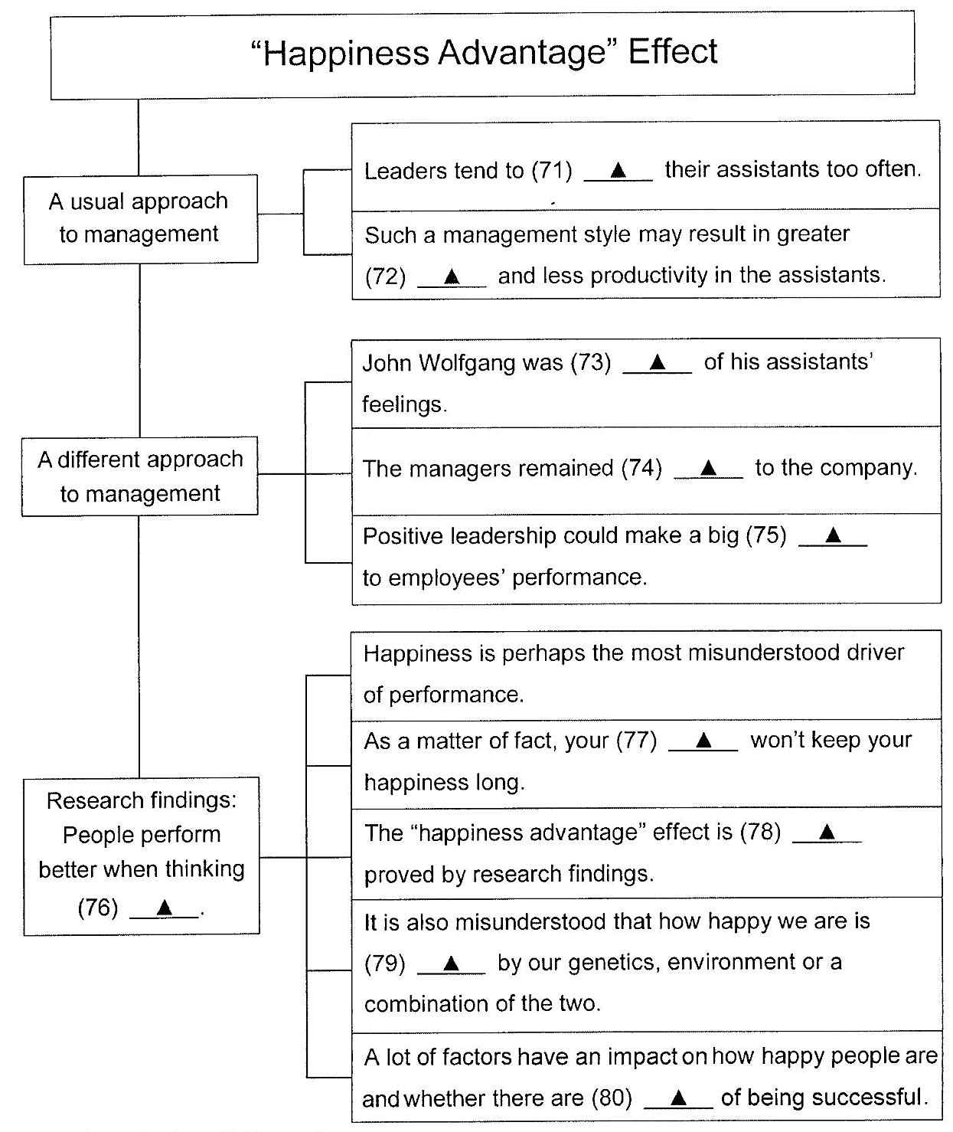
第五部分：书面表达 （满分25分）
81. 生活中冲突时有发生。假设你班同学苏华和李江打篮球时发生争执，导致关系紧张。请你结合此事，并根据以下提示，用英语写一篇短文，向学校英文报 “Happy Teens”专栏投稿。
简要描述事情的经过 | 打篮球、碰撞、争执，等等
分析发生冲突的原因 | 1.遇事不够冷静
分析发生冲突的原因 | 2. ······
谈谈避免冲突的做法 | （请考生根据自己的经历或感想，提出至少两种做法）
注意：
- 对所有要点逐一陈述，适当发挥，不要简单翻译。
- 词数150左右。开关已写好，不计入总数。
- 作文中不得提及有关考生个人身份的任何信息，如校名、人名等。
Conflicts with others are common in everyday life. _______________________

英语试题参考答案
第一部分：（共20小题，每小题1分，共20分）
01. C 02. A 03. B 04. C 05. A 06. C 07. B 08. B 09. C 10. C
11. A 12. B 13. B 14. A 15. C 16. B 17. A 18. A 19. C 20. A
第二部分：共35小题，每小题1分，共35分）
21. C 22. B 23. D 24. A 25. A 26. D 27. B 28. C 29. A 30. C
31. B 32. D 33. A 34. C 35. D 36. C 37. C 38. B 39. C 40. D
41. A 42. B 43. D 44. B 45. A 46. A 47. C 48. D 49. B 50. C
51. B 52. A 53. D 54. A 55. D
第三部分：（共15小题，每小题2分，共30分）
56. C 57. B 58. A 59. A 60. D 61. C 62. C 63. B 64. D 65. C
66. D 67. D 68. C 69. A 70. B
第四部分：（共10小题，每小题1分，共10分）
71. bother/annoy 72. anxiety / concern/worry
73. considerate/ aware/ conscious 74. loyal/faithful/ devoted/ committed
75. difference 76. positively
77. success/achievements 78. strongly
79. determined/decided 80.chances/possibilities/opportunities
第五部分：（满分25分）
Conflicts with others are common in everyday life. During the basketball game yesterday afternoon, Su Hua and Li Jiang bumped into each other, trying to catch the ball. Then they started shouting and yelling, and it turned into a horrible quarrel.
To be honest, it was Su’s fault, but Li was also to blame --- they were not calm enough and both said some really mean things. They cared too much about winning and losing. As a matter of fact, blocking, pushing and bumping are just part of a tough game.
To avoid such conflicts, we should be kind to one another, which is essential to enjoying a harmonious life. It is also a virtue to forgive and forget, especially in such a competitive and stressful society. Instead of blaming each other, we should communicate more and put ourselves in others’ place.
Don’t be self-centred and try to be considerate. We must learn to handle conflicts calmly and wisely. (150 words)

