2014年江苏高考英语试题

第一部分 听力(共两节,满分 20 分)
做题时,先将答案标在试卷上。 录音内容结束后,你将有两分钟的时间将试卷上的答案转涂到答题卡上。
第一节 (共 5 小题;每小题 1 分,满分 5 分)
听下面 5 段对话。 每段对话后有一个小题,从题中所给的 A、B、C 三个选项中选出最佳选项,并标在试卷的相应位置。 听完每段对话后,你都有 10 秒钟的时间来回答有关小题和阅读下一小题。 每段对话仅读一遍。
例: How much is the shirt?
A. £ 19. 15. B. £ 9. 18. C. £ 9. 15.
答案是 C。
1. What does the woman want to do?
A. Find a place. B. Buy a map. C. Get an address.
2. What will the man do for the woman?
A. Repair her car. B. Give her a ride. C. Pick up her aunt.
3. Who might Mr. Peterson be?
A. A new professor. B. A department head. C. A company director.
4. What does the man think of the book?
A. Quite difficult. B. Very interesting. C. Too simple.
5. What are the speakers talking about?
A. Weather. B. Clothes. C. News.
第二节 (共 15 小题;每小题 1 分,满分 15 分)
听下面 5 段对话或独白。 每段对话或独白后有几个小题,从题中所给的 A、B、C 三个选项中选出最佳选项,并标在试卷的相应位置。 听每段对话或独白前,你将有时间阅读各个小题,每小题 5 秒钟;听完后,各小题给出 5 秒钟的作答时间。 每段对话或独白读两遍。
听第 6 段材料,回答第 6、7 题。
6. Why is Harry unwilling to join the woman?
A. He has a pain in his knee. B. He wants to watch TV. C. He is too lazy.
7. What will the woman probably do next?
A. Stay at home. B. Take Harry to hospital. C. Do some exercise.
听第 7 段材料,回答第 8、9 题。
8. When will the man be home from work?
A. At 5:45. B. At 6:15. C. At 6:50.
9. Where will the speakers go?
A. The Green House Cinema. B. The New State Cinema. C. The UME Cinema.
听第 8 段材料,回答第 10 至 12 题。
10. How will the speakers go to New York?
A. By air. B. By taxi. C. By bus.
11. Why are the speakers making the trip?
A. For business. B. For shopping. C. For holiday.
12. What is the probable relationship between the speakers?
A. Driver and passenger. B. Husband and wife. C. Fellow workers.
听第 9 段材料,回答第 13 至 16 题。
13. Where does this conversation probably take place?
A. In a restaurant. B. In an office. C. In a classroom.
14. What does John do now?
A. He’s a trainer. B. He’s a tour guide. C. He’s a college student.
15. How much can a new person earn for the first year?
A. ＄10,500. B. ＄12,000. C. ＄15,000.
16. How many people will the woman hire?
A. Four. B. Three. C. Two.
听第 10 段材料,回答第 17 至 20 题。
17. How long has the speaker lived in a big city?
A. One year. B. Ten years. C. Eighteen years.
18. What is the speaker’s opinion on public transport?
A. It’s comfortable. B. It’s time-saving. C. It’s cheap.
19. What is good about living in a small town?
A. It’s safer. B. It’s healthier. C. It’s more convenient.
20. What kind of life does the speaker seem to like most?
A. Busy. B. Colourful. C. Quiet.
第二部分: 英语知识运用 (共两节, 满分 35 分)
第一节: 单项填空 (共 15 小题; 每小题 1 分, 满分 15 分)
请阅读下面各题, 从题中所给的 A、 B、 C、 D 四个选项中, 选出最佳选项, 并在答题卡上
将该项涂黑。
例: It is generally considered unwise to give a child ________ he or she wants.
A. however B. whatever C. whichever D. whenever
答案是 B。
21. Lessons can be learned to face the future, ________ history cannot be changed.
A. though B. as C. since D. unless
22. The book has helped me greatly in my daily communication, especially at work ________ a good
impression is a must.
A. which B. when C. as D. where
23. —How much do you know about the Youth Olympic Games to be held in Nanjing?
—Well, the media ________ it in a variety of forms.
A. cover B. will cover C. have covered D. covered
24. Tom always goes jogging in the morning and he usually does push-ups too to stay ________.
A. in place B. in order C. in shape D. in fashion
25. Top graduates from universities are ________ by major companies.
A. chased B. registered C. offered D. compensated
26. —What a mess! You are always so lazy!
—I’m not to blame, mum. I am ________ you have made me.
A. how B. what C. that D. who
27. She was put under house arrest two years ago but remained a powerful ________ in last year’s election.
A. symbol B. portrait C. identity D. statue
28. The idea “happiness, ” ________, will not sit still for easy definition.
A. to be rigid B. to be sure C. to be perfect D. to be fair
29. The lecture ________, a lively question-and-answer session followed.
A. being given B. having given C. to be given D. having been given
30. —Dad, I don’t think Oliver the right sort of person for the job.
—I see. I’ll go right away and ________.
A. pay him back B. pay him off C. put him away D. put him off
31. It was sad to me that they, so poor themselves, ________ bring me food.
A. might B. would C. should D. could
32. I can’t meet you on Sunday. I’ll be ________ occupied.
A. also B. just C. nevertheless D. otherwise
33. Legend has it that the origin of the Dragon Boat Festival is to ________ the soul of Qu Yuan.
A. remember B. remind C. recover D. recall
34. Good families are much to all their members, but ________ to none.
A. something B. anything C. everything D. nothing
35. —________ ! Somebody has left the lab door open.
—Don’t look at me.
A. Dear me B. Hi, there C. Thank goodness D. Come on
第二节: 完形填空 (共 20 小题; 每小题 1 分, 满分 20 分)
请阅读下面短文, 从短文后各题所给的 A、B、C、D 四个选项中, 选出最佳选项, 并在答题卡上将该项涂黑。
Dale Carnegie rose from the unknown of a Missouri farm to international fame because he found a way to fill a universal human need.
It was a need that he first 36 back in 1906 when young Dale was a junior at State Teachers College in Warrensburg. To get an 37 , he was struggling against many difficulties. His family was poor. His Dad couldn’t afford the 38 at college, so Dale had to ride horseback 12 miles to attend classes. Study had to be done 39 his farm-work routines. He withdrew from many school activities 40 he didn’t have the time or the 41 . He had only one good suit. He tried 42 the football team, but the coach turned him down for being too 43 . During this period Dale was slowly 44 an inferiority complex (自卑感), which his mother knew could 45 him from achieving his real potential. She 46 that Dale join the debating team, believing that 47 in speaking could give him the confidence and recognition that he needed.
Dale took his mother’s advice, tried desperately and after several attempts 48 made it. This proved to be a 49 point in his life. Speaking before groups did help him gain the 50 he needed. By the time Dale was a senior, he had won every top honor in 51 . Now other students were coming to him for coaching and they, 52 , were winning contests.
Out of this early struggle to 53 his feelings of inferiority, Dale came to understand that the ability to 54 an idea to an audience builds a person’s confidence. And, 55 it, Dale knew he could do anything he wanted to do—and so could others.
36. A. admitted B. filled C. supplied D. recognized
37. A. assignment B. education C. advantage D. instruction
38. A. training B. board C. teaching D. equipment
39. A. between B. during C. over D. through
40. A. while B. when C. because D. though
41. A. permits B. interest C. talent D. clothes
42. A. on B. for C. in D. with
43. A. light B. flexible C. optimistic D. outgoing
44. A. gaining B. achieving C. developing D. obtaining
45. A. prevent B. protect C. save D. free
46. A. suggested B. demanded C. required D. insisted
47. A. presence B. practice C. patience D. potential
48. A. hopefully B. certainly C. finally D. naturally
49. A. key B. breaking C. basic D. turning
50. A. progress B. experience C. competence D. confidence
51. A. horse-riding B. football C. speech D. farming
52. A. in return B. in brief C. in turn D. in fact
53. A. convey B. overcome C. understand D. build
54. A. express B. stress C. contribute D. repeat
55. A. besides B. beyond C. like D. with
第三部分: 阅读理解 (共 15 小题; 每小题 2 分, 满分 30 分)
请阅读下列短文, 从短文后各题所给的 A、B、C、D 四个选项中, 选出最佳选项, 并在答题卡上将该项涂黑。
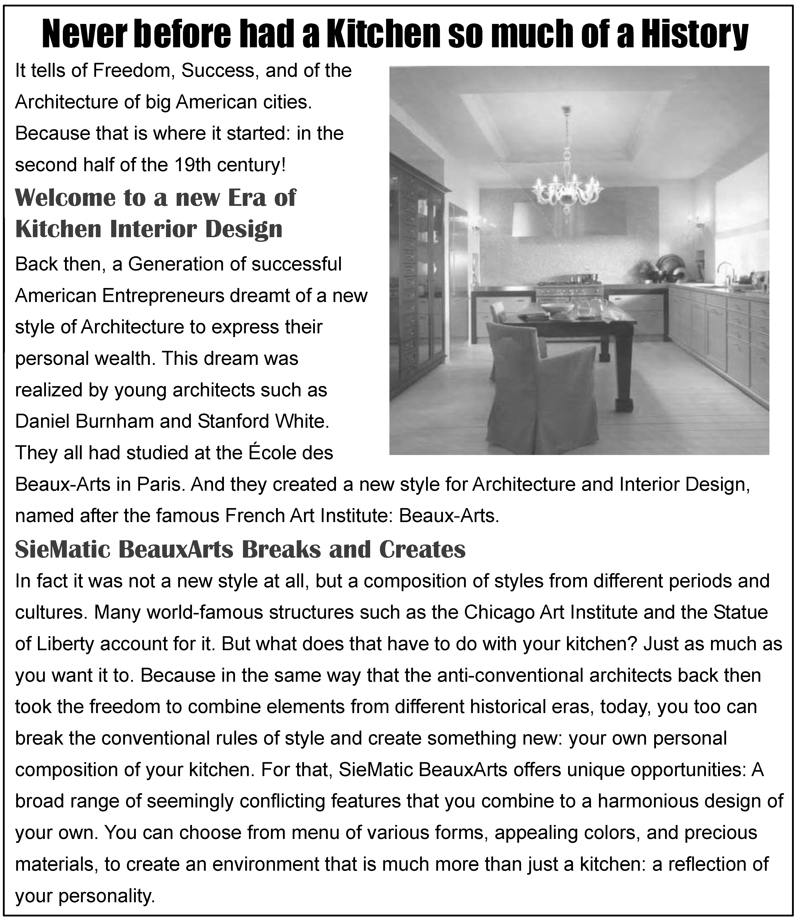
A

56. Why did the BeauxArts style attract American entrepreneurs?
A. It helped display their money status. B. It was created by famous architects.
C. It was named after a famous institute. D. It represented the 19th century urban culture.
57. What is unique of SieMatic BeauxArts?
A. Its designs are anti-conventional.
B. Its designs come from famous structures.
C. Its customers can enjoy their own composition.
D. Its customers can choose from various new styles.
B
However wealthy we may be, we can never find enough hours in the day to do everything we want. Economics deals with this problem through the concept of opportunity cost, which simply refers to whether someone’s time or money could be better spent on something else.
Every hour of our time has a value. For every hour we work at one job we could quite easily be doing another, or be sleeping or watching a film. Each of these options has a different opportunity cost—namely, what they cost us in missed opportunities.
Say you intend to watch a football match but the tickets are expensive and it will take you a couple of hours to get to and from the stadium. Why not, you might reason, watch the game from home and use the leftover money and time to have dinner with friends? This—the alternative use of your cash and time—is the opportunity cost.
For economists, every decision is made by knowledge of what one must forgo—in terms of money and enjoyment—in order to take it up. By knowing precisely what you are receiving and what you are missing out on, you ought to be able to make better-informed, more reasonable decisions. Consider that most famous economic rule of all: there’s no such thing as a free lunch. Even if someone offers to take you out to lunch for free, the time you will spend in the restaurant still costs you something in terms of forgone opportunities.
Some people find the idea of opportunity cost extremely discouraging: imagine spending your entire life calculating whether your time would be better spent elsewhere doing something more profitable or enjoyable. Yet, in a sense it’s human nature to do precisely that—we assess the advantages and disadvantages of decisions all the time.
In the business world, a popular phrase is “value for money.” People want their cash to go as far as possible. However, another is fast obtaining an advantage: “value for time.” The biggest restriction on our resources is the number of hours we can devote to something, so we look to maximize the return we get on our investment of time. By reading this passage you are giving over a bit of your time which could be spent doing other activities, such as sleeping and eating. In return, however, this passage will help you to think like an economist, closely considering the opportunity cost of each of your decisions.
58. According to the passage, the concept of “opportunity cost” is applied to ________.
A. making more money B. taking more opportunities
C. reducing missed opportunities D. weighing the choice of opportunities
59. The “leftover ... time” in Paragraph 3 probably refers to the time ________.
A. spared for watching the match at home B. taken to have dinner with friends
C. spent on the way to and from the match D. saved from not going to watch the match
60. What are forgone opportunities?
A. Opportunities you forget in decision-making. B. Opportunities you give up for better ones.
C. Opportunities you miss accidentally. D. Opportunities you make up for.
C
Most damagingly, anger weakens a person’s ability to think clearly and keep control over his behaviour. The angry person loses objectivity in evaluating the emotional significance of the person or situation that arouses his anger.
Not everyone experiences anger in the same way; what angers one person may amuse another. The specific expression of anger also differs from person to person based on biological and cultural forces. In contemporary culture, physical expressions of anger are generally considered too socially harmful to be tolerated. We no longer regard duels (决斗) as an appropriate expression of anger resulting from one person’s awareness of insulting behaviour on the part of another.
Anger can be identified in the brain, where the electrical activity changes. Under most conditions EEG (脑电图) measures of electrical activity show balanced activity between the right and left prefrontal (额叶前部) areas. Behaviourally this corresponds to the general even-handed disposition (意向) that most of us possess most of the time. But when we are angry the EEG of the right and left prefrontal areas aren’t balanced and, as a result of this, we’re likely to react. And our behavioural response to anger is different from our response to other emotions, whether positive or negative.
Most positive emotions are associated with approach behaviour: we move closer to people we like. Most negative emotions, in contrast, are associated with avoidance behaviour: we move away from people and things that we dislike or that make us anxious. But anger is an exception to this pattern. The angrier we are, the more likely we are to move towards the object of our anger. This corresponds to what psychologists refer to as of ensive anger: the angry person moves closer in order to influence and control the person or situation causing his anger. This approach-and-confront behaviour is accompanied by a leftward prefrontal asymmetry (不对称) of EEG activity. Interestingly, this asymmetry lessens if the angry person can experience empathy (同感) towards the individual who is bringing forth the angry response. In defensive anger, in contrast, the EEG asymmetry is directed to the right and the angry person feels helpless in the face of the anger-inspiring situation.
61. The “duels” example in Paragraph 2 proves that the expression of anger ________.
A. usually has a biological basis B. varies among people
C. is socially and culturally shaped D. influences one’s thinking and evaluation
62. What changes can be found in an angry brain?
A. Balanced electrical activity can be spotted.
B. Unbalanced patterns are found in prefrontal areas.
C. Electrical activity corresponds to one’s behaviour.
D. Electrical activity agrees with one’s disposition.
63. Which of the following is typical of offensive anger?
A. Approaching the source of anger. B. Trying to control what is disliked.
C. Moving away from what is disliked. D. Feeling helpless in the face of anger.
64. What is the key message of the last paragraph?
A. How anger differs from other emotions. B. How anger relates to other emotions.
C. Behavioural responses to anger. D. Behavioural patterns of anger.
D

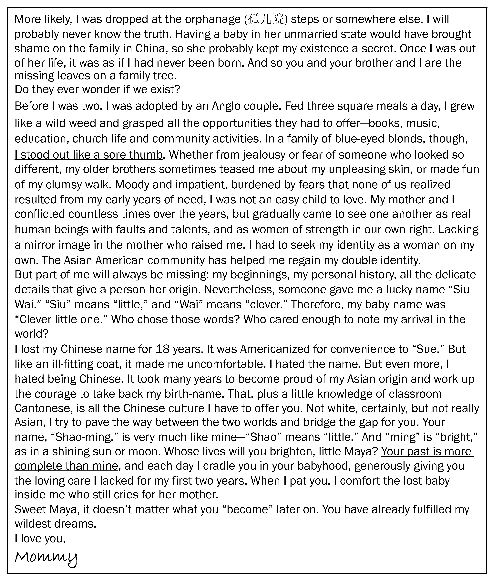

65. Why is June 6, 1990 a special day for Mommy?
A. Her dream of being a mother came true.
B. She found her origin from her Chinese mother.
C. She wrote the letter to her daughter.
D. Her female line was well linked.
66. How does Mommy feel about her being given away?
A. It is bitter and disappointing.
B. It is painful but understandable.
C. She feels sorry but sympathetic.
D. She feels hurt and angry.
67. What does “I stood out like a sore thumb” in Paragraph 5 mean?
A. I walked clumsily out of pains.
B. I was not easy to love due to jealousy.
C. I was impatient out of fear.
D. I looked different from others.
68. What can be inferred from Mommy’s Anglo family life?
A. She used to experience an identity crisis.
B. She fought against her American identity.
C. She forgot the pains of her early years.
D. She kept her love for Asia from childhood.
69. Why did Mommy name her daughter “Shao-ming?”
A. To match her own birth-name.
B. To brighten the lives of the family.
C. To identify her with Chinese origin.
D. To justify her pride in Chinese culture.
70. By “Your past is more complete than mine,” Mommy means ________.
A. her past was completed earlier than Shao-ming’s
B. Shao-ming has got motherly care and a sense of roots
C. her mother didn’t comfort her the way she did Shao-ming
D. her past was spent brokenly, first in Asia, then in the US

第四部分: 任务型阅读 (共 10 小题; 每小题 1 分, 满分 10 分)
请阅读下面短文,并根据所读内容在文章后表格中的空格里填入一个最恰当的单词。
注意: 请将答案写在答题卡上相应题号的横线上。 每个空格只填一个单词。
The expression, “everybody’s doing it,” is very much at the center of the concept of peer pressure. It is a strong influence of a group, especially of children, on members of that group to behave as everybody else does. It can be positive or negative. Most people experience it in some way during their lives.
People are social creatures by nature, and so it is hardly surprising that part of their self-respect comes from the approval of others. This instinct (天性) is why the approval of peers, or the fear of disapproval, is such a powerful force in many people’s lives. It is the same instinct that drives people to dress one way at home and another way at work, or to answer “fine” when a stranger asks “how are you?” even if it is not necessarily true. There is a practical aspect to this: it helps society to function efficiently, and encourages a general level of self-discipline that simplifies day-to-day interaction.
For certain individuals, seeking social acceptance is so important that it becomes like an addiction; in order to satisfy the desire, they may go so far as to abandon their sense of right and wrong. Teens and young adults may feel forced to use drugs, or join gangs that encourage criminal behavior. Mature adults may sometimes feel pressured to cover up illegal activity at the company where they work, or end up in debt because they are unable to hold back the desire to buy a house or car that they can’t afford in an effort to “keep up with the Joneses.”
However, peer pressure is not always negative. A student whose friends are good at academics may be urged to study harder and get good grades. Players on a sports team may feel driven to play harder in order to help the team win. This type of influence can also get a friend off drugs, or to help an adult take up a good habit or drop a bad one. Study groups and class projects are examples of positive peer groups that encourage people to better themselves.
Schools try to teach kids about the dangers of negative peer pressure. They teach kids to stand up and be themselves, and encourage them to politely decline to do things that they believe are wrong. Similarly, it can be helpful to encourage children to greet the beneficial influence of positive peer groups.
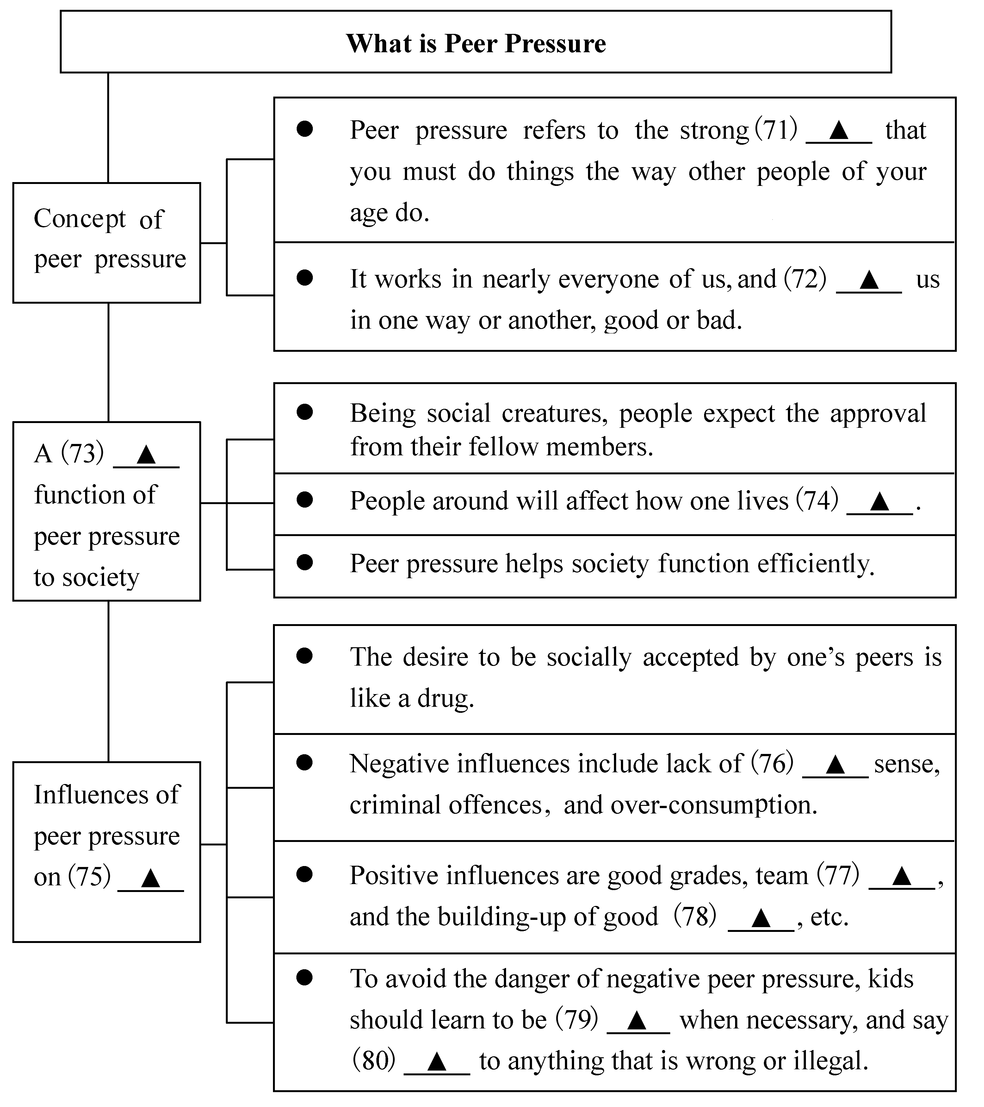

第五部分: 书面表达 (满分 25 分)
81. 请阅读下面短文,并按照要求用英语写一篇 150 词左右的文章。
When we read newspapers, we often come across such English words as “AIDS” and “PK.” When we watch TV, we frequently hear words like “NBA” or “PM2.5.” When we speak, we automatically use words like “OUT” or “Bye-bye.” English words and expressions like these are getting popular. They have already become part of our daily language. And 239 English words have been included in the latest Dictionary of Contemporary Chinese.
The inclusion has started a heated discussion. A group of scholars signed a letter of complaint over the inclusion of these English words, which, they think, goes against Chinese language policies. They not only worry that Chinese is borrowing an increasing number of English words but are also concerned that the inclusion may hurt the dignity of the Chinese language. However, others are in favor of the inclusion because it is hard to say whether it will threaten the Chinese language. They believe the selection is mostly a result of their function and use in daily life.
[写作内容]
1. 用约 30 个单词写出上文概要;
2. 用约 120 个单词发表你的观点,内容包括:
(1)支持或反对汉语词典收录英语词汇;
(2)用 2- 3个理由或论据支撑你的观点。
[写作要求]
1. 可以支持文中任一观点,但必须提供理由或论据;
2. 阐述观点或提供论据时,不能直接引用原文语句;
3. 作文中不能出现真实姓名和学校名称;
4. 不必写标题。
[评分标准]
内容完整,语言规范,语篇连贯,词数适当。

英语试题参考答案
第一部分(共 20 小题;每小题 1 分,共 20 分)
1. A 2. B 3. C 4. B 5. A 6. B 7. C 8. A 9. C 10. A
11. A 12. C 13. B 14. C 15. A 16. C 17. B 18. C 19. A 20. B
第二部分(共 35 小题;每小题 1 分,共 35 分)
21. A 22. D 23. C 24. C 25. A 26. B 27. A 28. B 29. D 30. B
31. C 32. D 33. D 34. C 35. A 36. D 37. B 38. B 39. A 40. C
41. D 42. B 43. A 44. C 45. A 46. A 47. B 48. C 49. D 50. D
51. C 52. C 53. B 54. A 55. D
第三部分(共 15 小题;每小题 2 分,共 30 分)
56. A 57. C 58. D 59. C 60. B 61. C 62. B 63. A 64. D 65. D
66. B 67. D 68. A 69. C 70. B
第四部分(共 10 小题;每小题 1 分,共 10 分)
71. feeling 72. influences 73. practical 74. unconsciously
75. individuals 76. moral 77. spirit 78. habits
79. independent 80. no
第五部分(满分 25 分)
81. 支持:
Today, more and more English words find their way into the Chinese language. Even the Dictionary of Contemporary Chinese includes 239 English words. Some people support it while others do not.
Generally, I am in favour of the inclusion. As the number of English learners is on the rise, it’s not difficult for them to understand these words in Chinese contexts. Besides, it is, on some occasions, more convenient to use English words. Most people nowadays use “IT” instead of its translation “xinxi jishu.” In our global village, we can see that it’s not uncommon for one language to borrow words from other languages. In English, there are many words borrowed from Latin, French, or even Chinese. In fact, Chinese has never stopped taking words from other languages, say, “ganbu” or “minzhu” from Japanese.
So, it’s safe to conclude that it is reasonable to include English which facilitates daily communication.
反对:
With English words getting popular in both media and daily life, a Chinese dictionary has included 239 of them, leaving the public divided into two opposing groups: “For” and “Against.”
I tend to take the “Against” side for two reasons. Firstly, this inclusion has actually polluted our mother tongue. Sooner or later, many English accents will rise and fall with the four Chinese tones. And, rules don’t tell us how to pronounce such English-turned Chinese words as “wifi” and “Out” in a Chinese way! Secondly, such an inclusion may give rise to prejudices of the educated against those with little knowledge of English. Just for one illustration, while college students take “Bye-bye” for granted when parting from each other, it may unconsciously hurt the feelings of someone who is used to “zaijian.”
In short, not only has the inclusion poisoned Chinese, it may also bring about distance between the Chinese people.

