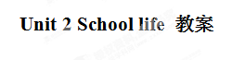
三维目标:
- 知识与技能
- 掌握课本中出现的重点词汇和句型
- 熟练运用副词比较级和最高级的构成和用法
- 熟练运用more/fewer/less...than 和the most/fewest/least进行比较
- 学会谈论不同的学校及各类学生的学校生活
二、过程与方法
通过对比中外各类学校情况,借助课外媒体、材料,反复使用练习,在潜移默化中学好本单元需要掌握的知识点和语言点.
- 情感态度与价值了解中西方学校情况,感受中西方文化如在教育、人文等反面的异同,为理解英语、学好英语奠定基础.
Period 1 Welcome to the unit
Teaching aims and demands:
- Talk about the school life and review the words about school life.
- Learn different words which mean the same thing between British English and American English.
- Learn the differences between British English and American English.
Teaching difficulties and importance:
- Grasp the spelling of British words and American words such as shop and store, lorry and truck, film and movie, football and soccer, and so on.
- Know the differences between British English and American English.
- Grasp the words: British, lorry, eraser, fall, store, truck, movie, soccer
- Grasp the phrases: be cleverer than, be like doing
- Grasp the sentences: Why don’t sb do sth? =Why not do sth? What’s school like?
Teaching preparation: pictures, recorder, computer, and the flags of Britain and England
Teaching steps:
StepⅠLead-in
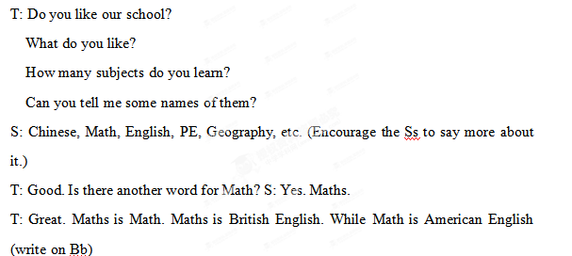StepⅡ Pre-task (Welcome to the unit)
Show the flags of the UK and the USA. Tell them that people speak English in both Britain and the USA, but sometimes they use different words which mean the same thing.
T: I know many boys like playing football. Do you know what it says in American English?
S: Soccer.
T: Do you know the same use of other words? Please give me some examples. Write other right answers of the students on the Bb. Teach the students the new words.
StepⅢ While-task
Task 1 Practise the new words more. Pay attention to the pronunciations and spelling.
Task 2 Finish Part A on Page 23.
Task 3 Write down both the British and American words, then finish Part B.
StepⅣ Comic strips
Do you remember Hobo and Eddie? They are talking about school life. Listen to the tape and answer: What does Eddie think of the school life? Listen again and read after it. Act the dialogue in groups and pairs.
StepⅥ Explanation
1. British / American English 英式/美式英语
2. see a film = watch a film 看电影
- buy sth. for sb.= buy sb. sth 买某物给某人
4. go with you 和你一起去
5. have to work harder 不得不更勤奋工作
6. be like 像……
7. ideal school 理想的学校
Step V Post-task Fill in the blankets
一、用所给动词的适当形式填空。
1. Why don't you ______ (play) basketball with us?
2. Eddie thinks school is like _________ (watch) TV.
3. He’d like _______ (be) a doctor in the future.
二、根据首字母填单词。
1. When f___ comes, the leaves turn yellow.
2."R_____" means "eraser".
3. What are the B______ and American words for these things?
三、翻译。
1. 你理想中的学校是什么样的？
2. 学校生活就像看电视，但是广告较少。
3. 我妈给我买了一台电脑作生日礼物。
Step VI. Homework
1. Remember the new words and language points in this lesson.
2. Preview the new words in Reading.
Period 2 Reading (1)
Teaching aims and demands:
- Know the school lives in British school and American school.
- Learn to read and understand the article with different ways of reading.
- Learn how to understand the writer’s opinion.
Teaching difficulties and importance:
- Know the meanings of the new words: mixed, buddy, language, during, discuss, offer, guy, French, foreign, end, baseball, win
- Understand the meanings of the phrases: in Year 8=in Grade 8，a mixed school, bring in, a Reading Week, the end of sth., as well, twice a week, spend time doing sth, offer sb. help, each other.
- Catch the main information about Lives in a British school and an American school.
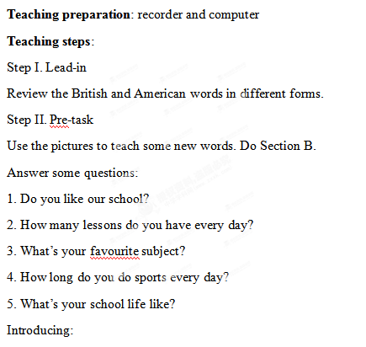
在英国,中等教育通常在11-16岁,并按照year划分（Years7-12）。Year 8相当于中国的8年级。学生16岁时要参加普通教育证书（GCSE）的考试。通过后才能在学校或私立中学接受两年的中等教育，之后要参加Ａ级考试。
美国的中等教育通常分为初中（6th-8th grades）和高中（9th-12th grades）．9th grade 相当于中国的九年级。
Step III. While-task
T: Eddie thinks school is like watching TV. Now John and Nancy are talking about their lives in school. Let’s see if it is like watching TV.
Life in a British school
Task 1 Read Passage 1 and answer:
Who wrote the first passage?
What activity does the school have every year?
Task 2 Read Passage 2 and answer
Who wrote the second passage?
Who else are mentioned(提及) in the passage?
Task 3 Listen to the tape and read after it. Fill in the form.
Task 4 Do Section B3. Check the answers together.
Task 5 Finish Section B2. Check the answers.
Task 6 Read the passages again and complete Part B4.
Step V Homework
Retell Part2 with key words.
Nancy/14 years old/ in Year 8/learn foreign language/ Reading Week/ every year/
John/in 8th grade/twice a week/baseball/every Monday/
buddy club/older students—new students/Tony/listen to his problems /offer him help/hero
Period 3 Reading (2)
Teaching aims and demands:
- Can grasp the words, phrases and language points of the two articles.
- Can retell the lives in a British school and an American school.
Teaching difficulties and importance:
- Some important language points.
- Retell the two articles completely.
Teaching preparation: Computer
Teaching steps:
Step I. Warm-up
T：Do you like your school life?
Why or Why not?
Get the Ss to talk about their school life.
(Divide the students into three groups then have a competition.)
Answer some questions:
Q1. What kind of school does Nancy go to?
Q2.What can students do during the Reading Week?
Q3.What does a buddy usually do?
Q4.How often does John play baseball?
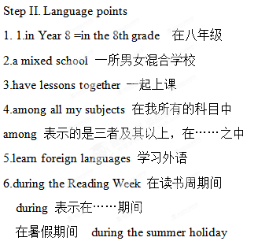
7. borrow books from the library 从图书馆借书
borrow sth from sb 向某人借某物，例如：
我向桑迪借了自行车。
I borrowed the bike from Sandy.
8. bring in books and magazines from home
从家里带来书和杂志
9. read more books than my classmates
比我同学读的书多
more...than... ……比……多，例如：
汤姆的CD比西蒙的多。
Tom has more CDs than Simon.
10.near the end of the week 在阅读周快要结束的时候
near the end of ... 在……快要结束/接近尾声的时候.
例如： 在快到月底的时候 near the end of the month
11. discuss the books with our classmates
discuss sth with sb 和某人谈论……
例如：他经常和父亲谈论学习。
He usually discusses study with his father.
12. Time seems to go faster when we are reading interesting books.
我们在阅读有趣的书籍时，时间似乎过得更快。
seem to do 似乎……
响声好像持续了大约十分钟。
The noise seemed to last for about ten minutes.
when we are reading interesting books 是时间状语从句。
在从句中要用陈述语序代替疑问语序。
13. help new students learn more about the school 帮助新同学更了解学校
14. listen carefully to my problems 认真聆听我的问题
carefully 仔细地，认真地，副词。在本句中用来修饰动词。
15. offer me help 主动给我帮助
offer sb sth 给某人某物. 同义短语offer sth to sb
例如：我们可以向他人提供帮助。
We can offer others help.= We can offer help to others.
16. end earlier than usual 比平时结束的更早
end 动词 结束，还可作名词，表示尽头，末端，结束
17. twice a week 每周两次
注意：就时间的频率提问用 How often?
18. play baseball 打棒球
19. practice doing sth 练习做……，例如：
男孩子们在练习打篮球，女孩子们在练习跳舞。
Boys are practicing playing basketball and girls are practicing dancing.
Task 2 Exercises
1. He is a ____________ man. (Britain)
2. We often practice _________ (play) softball after school.
3. Julie and Sandy are my ________. (hero)
4. How many s________ do you learn at school?
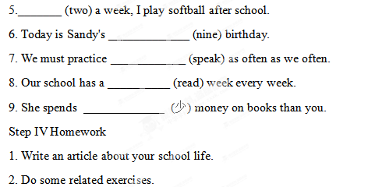
Period 4 Grammar
Teaching aims and demands:
- Compare two things using ‘more…than’, ‘fewer…than’ and ‘less…than’
- Compare more than two things using ‘the most’ for the largest amount and ‘the fewest’/ ‘the least’ for the smallest amount.
- Comparative and superlative adverbs.
Teaching difficulties and importance:
- How to use “more…than‟, “fewer…than‟ and “less…than‟.
- How to use “the most‟ “the fewest‟ and “the least‟.
Teaching preparation: pictures, objects and computer
Teaching steps:
Step I. Presentation
Task 1:
Look at the pictures and answer: （见课件）
Make sentences with“more/fewer than…”
Consolidation:
more/fewer + 可数名词＋than
Task 2:
Look at the pictures and answer(见课件）
Simon has some orange juice in his glass.
Sandy has more orange juice than Simon.
Simon has less orange juice than Sandy.
Talk about Peter and Tom with “more/less than…”
Consolidation:
more/less + 不可数名词＋ than
We can compare the amount of things using more...than, fewer...than and less...than.
Task 3 ：
Look at the pictures and answer(见课件）
The same way to present the most/fewest/least.
Consolidation:
the most/fewest + Countable nouns
the most/least + Uncountable nouns
Task 4: Complete the exercises on Page23.
Step III. Grammar B
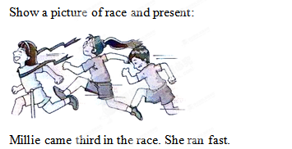
Sandy came second in the race. She ran faster than Millie.
Amy came first in the race. She ran the fastest.
Task 1: We can form comparative and superlative adverbs in the same way we form comparative and superlative adjectives.
Pay attention to this:
Task 2: Finish the exercises on P24.
Step IV Language points
1. come first/second /third
此处 first, second, third作副词用
2. She draws better than any other student in my class.
any 指任何一个，后面的名词student用单数
同义句：
She draws better than the other students in my class.
Step V Exercises
改错
1. Mr. Smith eats the fewest beef.
2. Tom has least sheep of them.
3. Mary has the more bread than her classmate.
4. The students in China have little free time than those in the UK .
5. Cindy has less friends in his new school than in his old school.
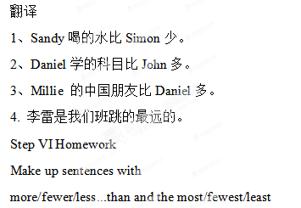
Period 5 Integrated skills
Teaching aims and demands:
- Listen to the conversation and try to collect the information.
- Learn more differences of the school lives between China and foreign countries.
- Review the Grammar we have learned.
Teaching difficulties and importance:
- How to collect the information you need from the conversation.
- Grasp the Grammar masterly.
Teaching preparation: Computer and recorder
Teaching steps:
Step I. Lead-in
Revise the use of“more/fewer/less…than”.
Revise the use of“the most/fewest/least”.
Step II. Pre-task
Questions about our school:1. What’s the name of our school? 2. How many students/teachers/classrooms are there? 3. Do you have much homework to do? How many hours do you need to finish your homework? 4. Do you wear uniforms? Do you like them? Why? 5. Do you do morning exercises? 6. How many days do you have in your summer holiday?
Step III. While-task
Task 1 T: Look at Part A1 and read through the form below.（Make sure the students know what to do next. ）
Play the tape for the students to listen and complete the form.
Play the tape again and check the answers with the students.
Task 2 Free talk: Ask the students to talk about the three schools in a few words according to the lists.
Task 3 Listen to the tape and fill in the rest of the table.
Play the tape again and check the answers with the students.
Task 4. Complete Section A3.Check the answers with the students. Read the passage and point out: have…off, summer holiday, spend time doing sth, more/fewer/less„than,
Task 4 Finish the exercises. Check the answers with the students.
Point out: the most/fewest/least.
Step IV. Free talk
What are your hobbies? How much time can you spend on your hobbies?
Step V. Listen and answer
How much time does Daniel spend on his hobbies every day?
What is Amy's hobby?
Who spends the most time on hobbies?
Task 1. Work in groups and talk about your hobbies.
Use the conversation as a model.
Step VI Language points
1. American students 美国学生
还可以说成：students in American schools
2. summer holiday 暑假
引申：寒假 winter holiday/vacation
3. have fewer weeks off 休息几个星期
have + time + off 表示休息多久.
例如：劳动节我们放三天假。
We have three days off on May Day.
中国学生每年比美国学生少放几个星期的假。
Chinese students have fewer weeks off than American students.
4. spend less time doing homework
花更少的时间做作业
spend time on / doing sth. 花时间做某事.
例如：我每天花半个小时读英语。
I spend half an hour reading English every day.
这幅画花了我三个小时。
I spent three hours on the picture.
5. play chess 下棋
他们经常在一起下棋。
They often play chess together.
6. at most 最多
例如：这些最多能为两千个学生服务。
These can serve two thousand students at most.
Step VII Exercises
一、用所给词的适当形式填空
1. We have an hour for ________ (read) every afternoon.
2. How long did she spend _________ (complete) her homework.
3. Studens in the USA have ______ (little) homework than Chinese students to do.
4. They have half an hour of work to do at ________ (much).
5. Do you wear ________ (uniform) at school?
二、翻译下列句子。
1. 你每天花多少时间在兴趣爱好上？
2. John学的科目比Nancy的少。
3. 美国学生暑假休息的周数比英国学生多。
4. 我每天有一个小时的时间下棋。
Step VIII Homework
1. Remember the new words and the language points in this lesson.
2. Recite the conversation in speak-up.
Period 6 Study skills
Teaching aims and demands:
- Know the meaning of the suffix.
- Know how to form adverbs by adding -ly to some adjectives.
- Know how to form adjectives by adding -ly to some nouns.
Teaching steps:
Step 1. Revision
Task 1
用more/fewer/less...than 填空
1. He has two pens. I have three pens. He has ___ pens ___ me.
2. Sandy has ten yuan. Millie has five yuan. Millie has ____ money ____ Sandy.
3. Kitty spends half an hour on her hobbies.
Daniel spends one and a half hours on his hobbies. Daniel spends ____ time ____ Kitty on hobbies.
Task 2
Talk about your hobbies with your partner:
A: What are your hobbies?
B: I like...
A: How much time do you spend on your hobbies?
B: About...And you?
A: ...
Step 2 Presentation
Task 1
写出下列形容词的副词形式
clear ----
free ----
lucky----
quick----
possible----
happy----
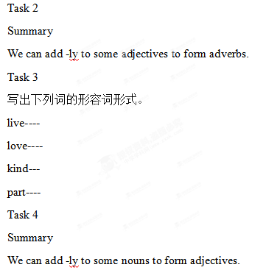
Task 5
Read aloud these new words and phrases.
daily 每日的，日常的
weekly 每周的
quick 快的
through 自始至终， 从头到尾
look through 浏览，快速看看
at first 起初，首先
real 真实的
keep（on）doing sth. 继续，重复做某事
Task 6
Do Section A on Page 27. Check the answers together.
Task 7
Complete Section B and check the answers.
Step 3 Explanation
1. have an English test 进行一次英语测验
have a test 测验
have a monthly test on each subject 每门科目都有月考
2. look through 浏览，快速查看
他快速的浏览了这篇文章。
He looked through the article quickly.
3. learn foreign languages 学习外语
4. at first 首先，起初
同意短语 in the beginning
5. keep writing in English 不停用英语写作
keep (on) doing sth. 表示继续，重复做某事，例如：
继续尝试，你会成功的。
Keep trying, you will be successful.
6. learn to use English this way 通过这种方式学习使用英语
learn to do sth. 学习做某事
我妹妹正在学习弹钢琴。
My sister is learning to play the piano.
way 表示途径，方式，方法
in this way 用这种方法，通过这种途径
Step 4 Exercises
1. I keep _________ (write) in English to improve my English.
2. I will have a _________ (month) test this week.
3. ________ (day) English is a useful book.
4. English is one of her favourite ____________ (subject).
5. The old man learnt ___________ (use) the computer from his grandson.
翻译下列句子。
1. 我父亲快速查看了这封邮件。
2. 起初，我不喜欢喝咖啡。
3. 老师让他继续打扫教室。
4. 明天，我们有一场数学测验。
Step 5 Homework
Remember the new words and the language points in this lesson.
Remember the uses of the suffix -ly.
Period 7 Task
Teaching aims and demands:
- Learn how to finish the questionnaire with personal information.
- Learn to make a timetable according to the questionnaire.
- Learn to write “My ideal school”.
Teaching difficulties and importance:
- How to know about what people like and dislike.
- How to write “My ideal school”.
Teaching preparation: recorder and computer
Teaching steps:
Step I. Lead-in
Revision
写出下列形容词的副词形式
heavy
quick
careful
real
bad
写出下列名词的形容词形式。
month
year
day
love
week
Step II. Pre-task
Present the new words of the lesson.
Step III. While-task
1. Free talk
What time does your school start?
Do you think this is too early or too late?
When do you finish school?
Do you think this is too early or too late?
How long is lunchtime at your school?
Do you like your school uniform? Why or why not?
- Let the students talk about their likes and dislikes about their school.
1. What time does your school day start?
2. Do you think this is too late or too early?
Your ideal time?
3. When do you finish school?
4. Do you think this is too late or too early?
Your ideal time?
5. How long is lunchtime at your school?
Too long or too short?
Your ideal lunch?
6. Do you like your uniform? Why of why not?
7. Below are some subjects, sports and after-school activities. Put a tick(√) in the box next to the ones you like?
Subjects Sports After-school activities
□ Chinese □ Badminton □ Art Club
□ English □ Baskteball □ Chess Club
□ Geography □ Football □ Dance Club
□ History □ Table tennis □ English Club
□ Maths □ Tennis □ Reading Club
□ Physics □ Volleyball □ Singing Club
□ _______ □ ________ □ __________
8. How often do you go on school trips?
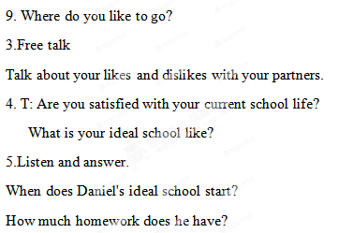
- Read and answer
When does the school finish?
How long is his lunchtime?
How many students are there in each class?
What activity do they do every month?
- Finish the table of Daniel’s ideal school.(见课件）
Step IV. Post-task
Help the students divide the article into four parts and sum up the main ideas of each part. Complete the table. (见课件）
Get the students to talk about their ideal schools.
Help the students write about their ideal schools.
Step V Explanation
1. get up early 很早起床
2. have lots of time for after-school activities
有很多时间做课外活动
3. an hour of homework 一个小时的家庭作业
4. at lunchtime 在午餐时间
5. wear ties 打领带
6. in each class 在每个班级
7. choose subjects to study 选择学习的科目
8. go on a school trip 参加学习旅行、郊游
9. have fun 玩的开心
Step VI Exercises
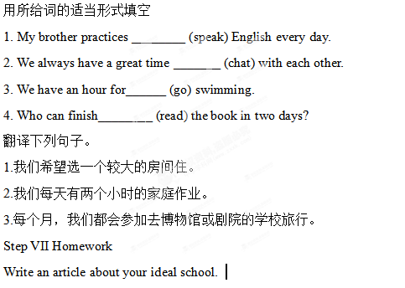

附件1：律师事务所反盗版维权声明
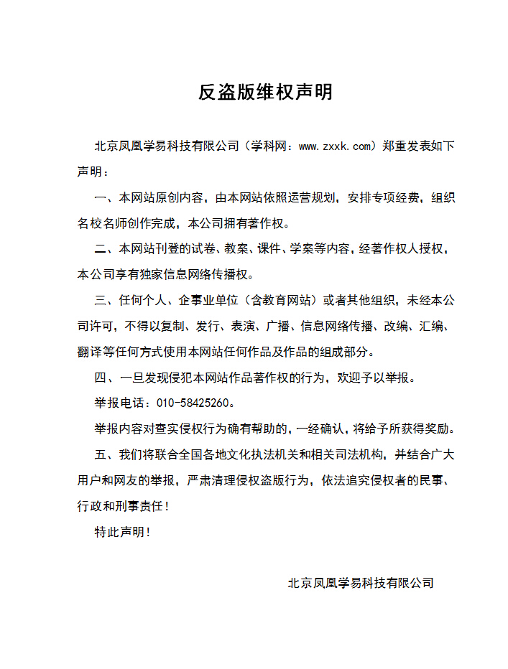
附件2：独家资源交换签约学校名录（放大查看）
学校名录参见：http://www.zxxk.com/wxt/list.aspx?ClassID=3060

