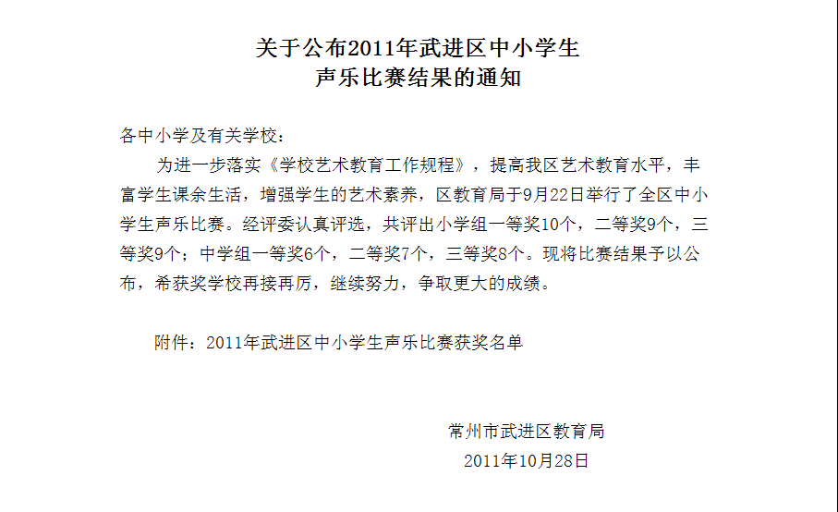
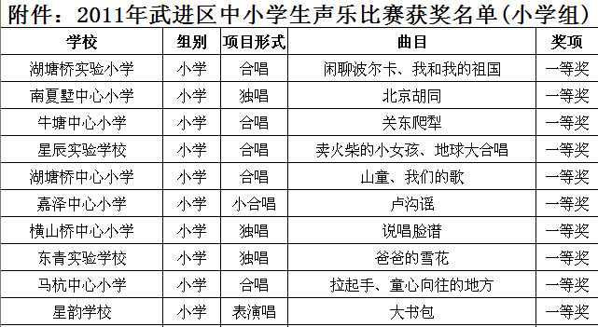

http://www.wjedu.net/node/zgwk_1/2011-10-28/3KFBJBE0E237748.html

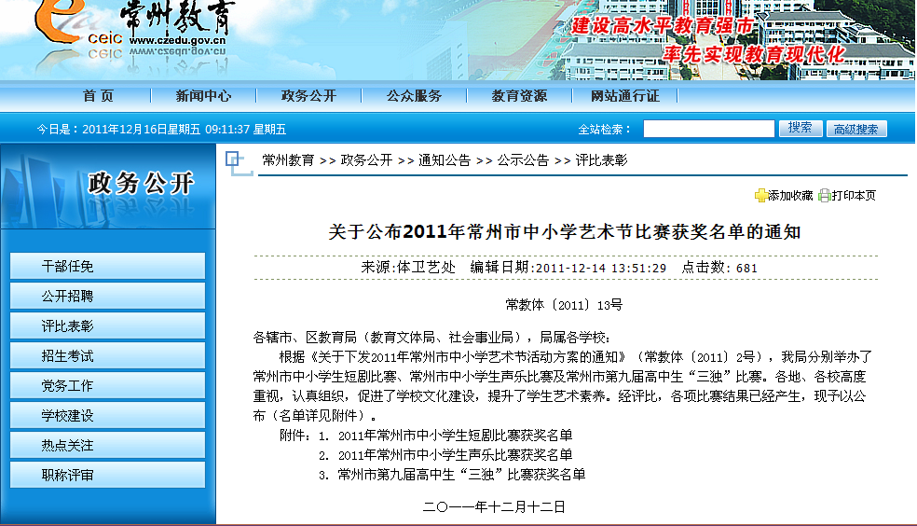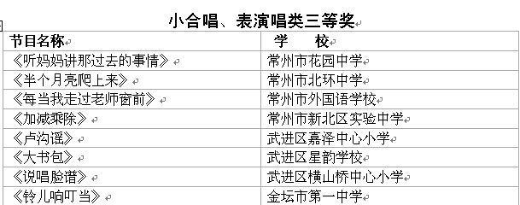

http://www.czedu.gov.cn/disp_4_790_10054492.shtml

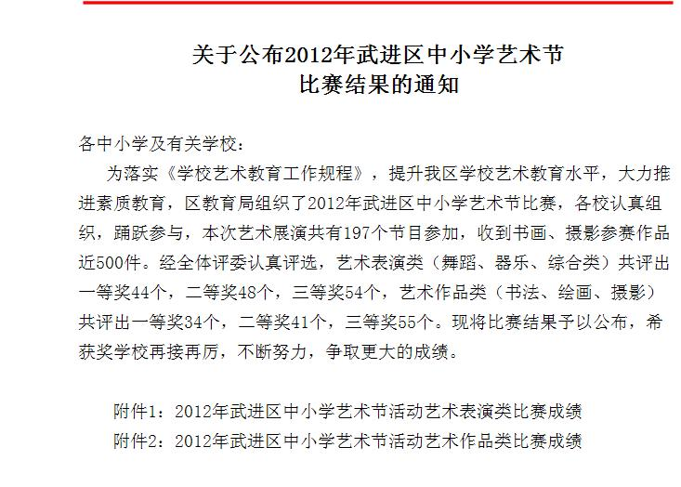

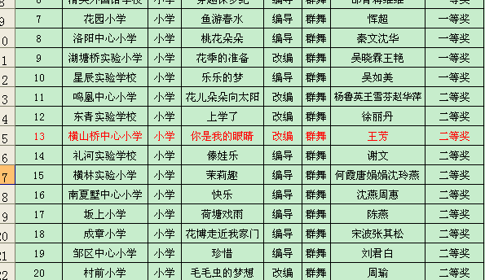

http://www.wjedu.net/node/zgwk_1/2012-6-27/KJIIIJGE2952932.html

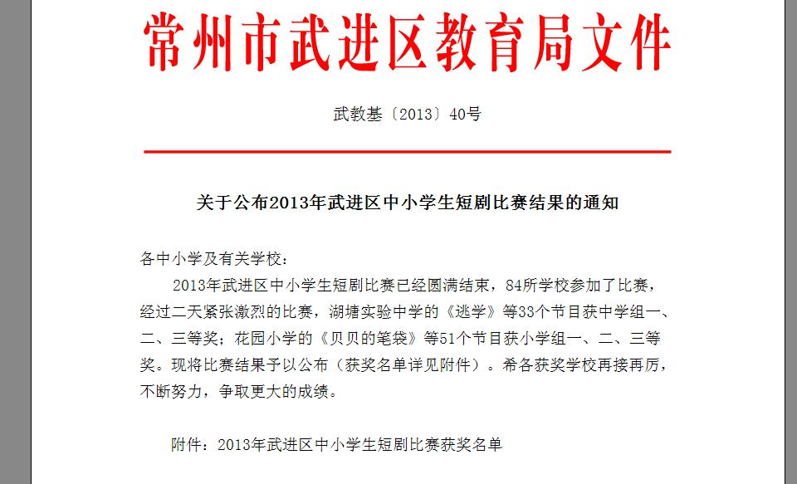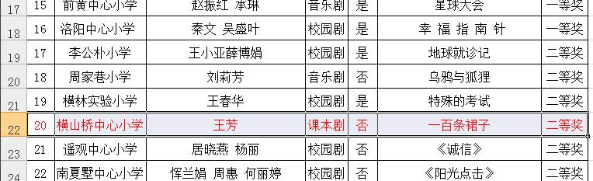

http://www.wjedu.net/node/zgwk_3/2013-6-13/38I7K084CI75926.html

